Sommaire

1 – Les Données

* 1. Dictionnaire de données.
  2. MEA
  3. Schéma Relationnel
  4. Script SQL

2 - Les Fonctionnalités

* 1. Le Backlog : La liste des fonctionnalités
  2. L’arbosressence
  3. Les cas d’utilisation
  4. Les maquettes du site final

1. - Dossier technique

3.1 Focus sur 2 fonctionnalités (pourquoi ?)

3.2 pour chaque fonctionnalités :

3.2.1-capture d’écran

3.2.2-code commenté

4 - Veille sur auto Formation contextualisée

->Resumé + usage

5 - Conduite de projet

5.1 Qui a fait Quoi et Quand

5.2 Compte Rendu de réunion.

* 1. Dictionnaire de données 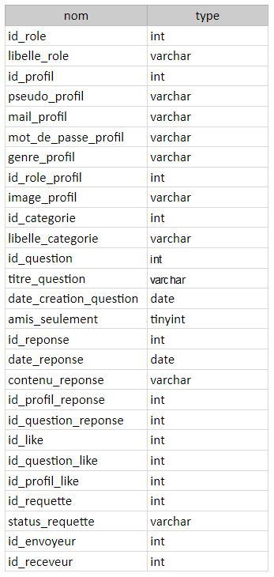

1.2 MEA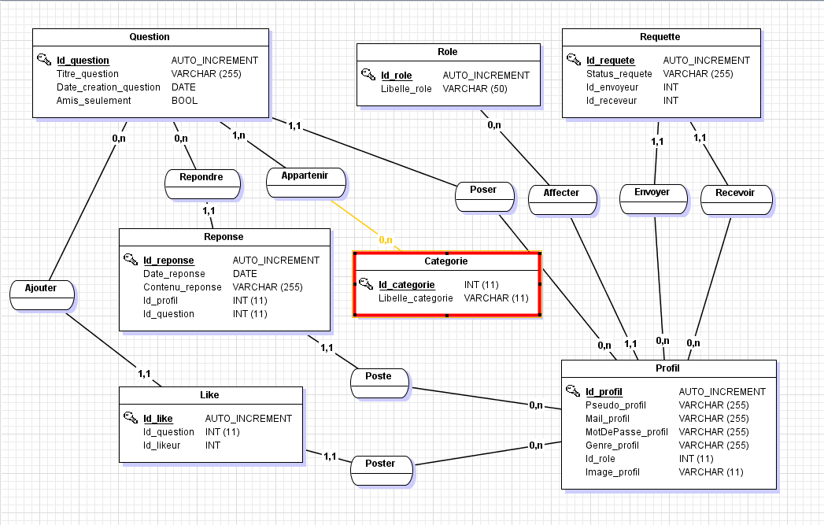

* 1. MLDR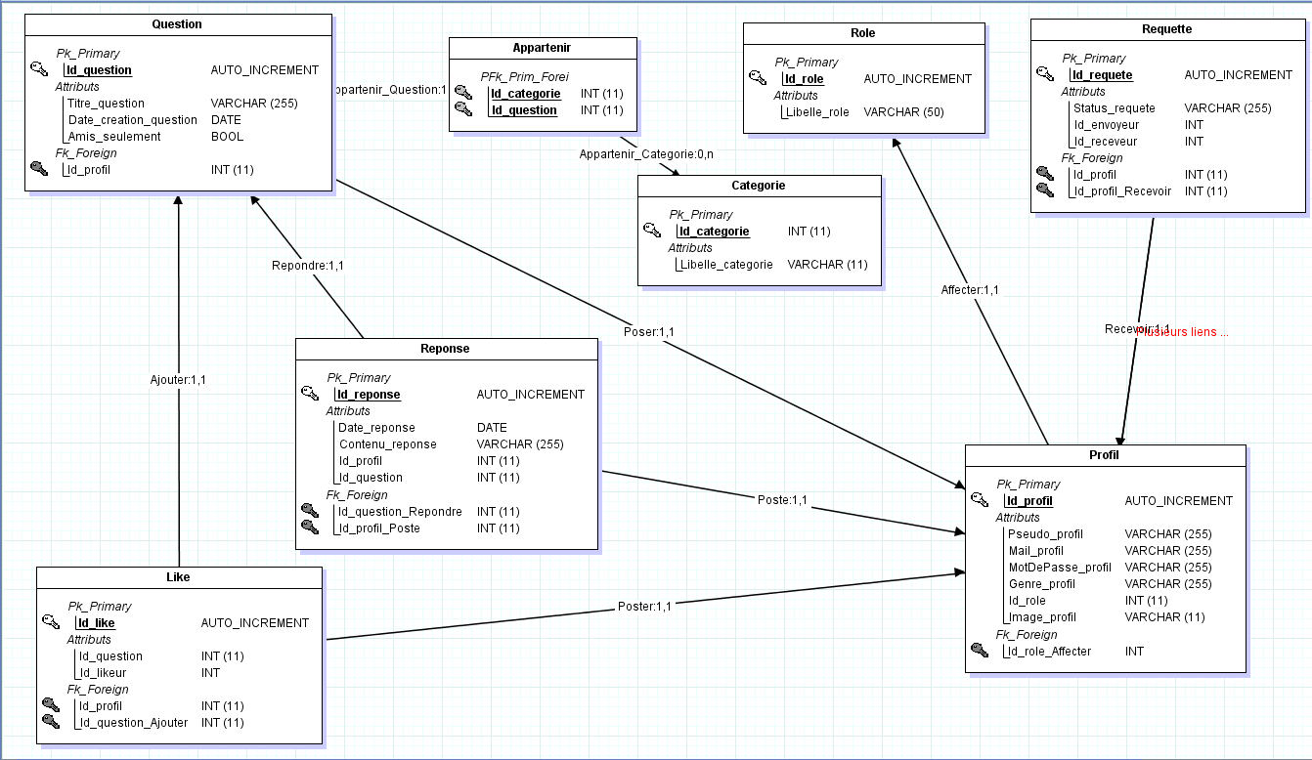
  2. Script Sql

C[REATE](http://localhost/phpmyadmin/url.php?url=https://dev.mysql.com/doc/refman/5.5/en/create-table.html) [TABLE](http://localhost/phpmyadmin/url.php?url=https://dev.mysql.com/doc/refman/5.5/en/create-table.html) [IF](http://localhost/phpmyadmin/url.php?url=https://dev.mysql.com/doc/refman/5.5/en/control-flow-functions.html#function_if) [NOT](http://localhost/phpmyadmin/url.php?url=https://dev.mysql.com/doc/refman/5.5/en/logical-operators.html#operator_not) EXISTS `categorie` ( `Id_categorie` [int](http://localhost/phpmyadmin/url.php?url=https://dev.mysql.com/doc/refman/5.5/en/numeric-types.html)(11) [NOT](http://localhost/phpmyadmin/url.php?url=https://dev.mysql.com/doc/refman/5.5/en/logical-operators.html#operator_not) NULL AUTO_INCREMENT, `Libelle_categorie` [varchar](http://localhost/phpmyadmin/url.php?url=https://dev.mysql.com/doc/refman/5.5/en/string-types.html)(255) [CHARACTER](http://localhost/phpmyadmin/url.php?url=https://dev.mysql.com/doc/refman/5.5/en/charset.html) [SET](http://localhost/phpmyadmin/url.php?url=https://dev.mysql.com/doc/refman/5.5/en/charset.html) latin1 [NOT](http://localhost/phpmyadmin/url.php?url=https://dev.mysql.com/doc/refman/5.5/en/logical-operators.html#operator_not) NULL, PRIMARY KEY (`Id_categorie`) ) ENGINE=InnoDB AUTO_INCREMENT=51 [DEFAULT](http://localhost/phpmyadmin/url.php?url=https://dev.mysql.com/doc/refman/5.5/en/miscellaneous-functions.html#function_default) CHARSET=utf8

[INSERT](http://localhost/phpmyadmin/url.php?url=https://dev.mysql.com/doc/refman/5.5/en/insert.html) INTO `categorie` (`Id_categorie`, `Libelle_categorie`) [VALUES](http://localhost/phpmyadmin/url.php?url=https://dev.mysql.com/doc/refman/5.5/en/miscellaneous-functions.html#function_values) (1, 'automobile'), (2, 'pop culture'), (3, 'nature'), (4, 'cuisine'), (5, 'sciences'), (6, 'art')

[CREATE](http://localhost/phpmyadmin/url.php?url=https://dev.mysql.com/doc/refman/5.5/en/create-table.html) [TABLE](http://localhost/phpmyadmin/url.php?url=https://dev.mysql.com/doc/refman/5.5/en/create-table.html) [IF](http://localhost/phpmyadmin/url.php?url=https://dev.mysql.com/doc/refman/5.5/en/control-flow-functions.html#function_if) [NOT](http://localhost/phpmyadmin/url.php?url=https://dev.mysql.com/doc/refman/5.5/en/logical-operators.html#operator_not) EXISTS `likes` ( `Id_like` [int](http://localhost/phpmyadmin/url.php?url=https://dev.mysql.com/doc/refman/5.5/en/numeric-types.html)(11) [NOT](http://localhost/phpmyadmin/url.php?url=https://dev.mysql.com/doc/refman/5.5/en/logical-operators.html#operator_not) NULL AUTO_INCREMENT, `Id_question` [int](http://localhost/phpmyadmin/url.php?url=https://dev.mysql.com/doc/refman/5.5/en/numeric-types.html)(11) [NOT](http://localhost/phpmyadmin/url.php?url=https://dev.mysql.com/doc/refman/5.5/en/logical-operators.html#operator_not) NULL, `Id_likeur` [int](http://localhost/phpmyadmin/url.php?url=https://dev.mysql.com/doc/refman/5.5/en/numeric-types.html)(11) [NOT](http://localhost/phpmyadmin/url.php?url=https://dev.mysql.com/doc/refman/5.5/en/logical-operators.html#operator_not) NULL, PRIMARY KEY (`Id_like`), KEY `Id_question` (`Id_question`), KEY `Id_likeur` (`Id_likeur`) ) ENGINE=InnoDB AUTO_INCREMENT=6 [DEFAULT](http://localhost/phpmyadmin/url.php?url=https://dev.mysql.com/doc/refman/5.5/en/miscellaneous-functions.html#function_default) CHARSET=latin1

[CREATE](http://localhost/phpmyadmin/url.php?url=https://dev.mysql.com/doc/refman/5.5/en/create-table.html) [TABLE](http://localhost/phpmyadmin/url.php?url=https://dev.mysql.com/doc/refman/5.5/en/create-table.html) [IF](http://localhost/phpmyadmin/url.php?url=https://dev.mysql.com/doc/refman/5.5/en/control-flow-functions.html#function_if) [NOT](http://localhost/phpmyadmin/url.php?url=https://dev.mysql.com/doc/refman/5.5/en/logical-operators.html#operator_not) EXISTS `profil` ( `Id_profil` [int](http://localhost/phpmyadmin/url.php?url=https://dev.mysql.com/doc/refman/5.5/en/numeric-types.html)(11) [NOT](http://localhost/phpmyadmin/url.php?url=https://dev.mysql.com/doc/refman/5.5/en/logical-operators.html#operator_not) NULL AUTO_INCREMENT, `Pseudo_profil` [varchar](http://localhost/phpmyadmin/url.php?url=https://dev.mysql.com/doc/refman/5.5/en/string-types.html)(255) [CHARACTER](http://localhost/phpmyadmin/url.php?url=https://dev.mysql.com/doc/refman/5.5/en/charset.html) [SET](http://localhost/phpmyadmin/url.php?url=https://dev.mysql.com/doc/refman/5.5/en/charset.html) latin1 [NOT](http://localhost/phpmyadmin/url.php?url=https://dev.mysql.com/doc/refman/5.5/en/logical-operators.html#operator_not) NULL, `Mail_profil` [varchar](http://localhost/phpmyadmin/url.php?url=https://dev.mysql.com/doc/refman/5.5/en/string-types.html)(255) [CHARACTER](http://localhost/phpmyadmin/url.php?url=https://dev.mysql.com/doc/refman/5.5/en/charset.html) [SET](http://localhost/phpmyadmin/url.php?url=https://dev.mysql.com/doc/refman/5.5/en/charset.html) latin1 [NOT](http://localhost/phpmyadmin/url.php?url=https://dev.mysql.com/doc/refman/5.5/en/logical-operators.html#operator_not) NULL, `MotDePasse_profil` [varchar](http://localhost/phpmyadmin/url.php?url=https://dev.mysql.com/doc/refman/5.5/en/string-types.html)(255) [CHARACTER](http://localhost/phpmyadmin/url.php?url=https://dev.mysql.com/doc/refman/5.5/en/charset.html) [SET](http://localhost/phpmyadmin/url.php?url=https://dev.mysql.com/doc/refman/5.5/en/charset.html) latin1 [NOT](http://localhost/phpmyadmin/url.php?url=https://dev.mysql.com/doc/refman/5.5/en/logical-operators.html#operator_not) NULL, `Genre_profil` [varchar](http://localhost/phpmyadmin/url.php?url=https://dev.mysql.com/doc/refman/5.5/en/string-types.html)(50) [CHARACTER](http://localhost/phpmyadmin/url.php?url=https://dev.mysql.com/doc/refman/5.5/en/charset.html) [SET](http://localhost/phpmyadmin/url.php?url=https://dev.mysql.com/doc/refman/5.5/en/charset.html) latin1 [NOT](http://localhost/phpmyadmin/url.php?url=https://dev.mysql.com/doc/refman/5.5/en/logical-operators.html#operator_not) NULL, `Id_role` [int](http://localhost/phpmyadmin/url.php?url=https://dev.mysql.com/doc/refman/5.5/en/numeric-types.html)(11) [NOT](http://localhost/phpmyadmin/url.php?url=https://dev.mysql.com/doc/refman/5.5/en/logical-operators.html#operator_not) NULL, `Image_profil` [varchar](http://localhost/phpmyadmin/url.php?url=https://dev.mysql.com/doc/refman/5.5/en/string-types.html)(255) [NOT](http://localhost/phpmyadmin/url.php?url=https://dev.mysql.com/doc/refman/5.5/en/logical-operators.html#operator_not) NULL [DEFAULT](http://localhost/phpmyadmin/url.php?url=https://dev.mysql.com/doc/refman/5.5/en/miscellaneous-functions.html#function_default) 'https://i2.wp.com/yellowsummary.com/wp-content/uploads/2019/02/Icone-profil.png?fit=512%2C512&ssl=1', PRIMARY KEY (`Id_profil`), KEY `#Id_role` (`Id_role`) ) ENGINE=InnoDB AUTO_INCREMENT=26 [DEFAULT](http://localhost/phpmyadmin/url.php?url=https://dev.mysql.com/doc/refman/5.5/en/miscellaneous-functions.html#function_default) CHARSET=utf8

[CREATE](http://localhost/phpmyadmin/url.php?url=https://dev.mysql.com/doc/refman/5.5/en/create-table.html) [TABLE](http://localhost/phpmyadmin/url.php?url=https://dev.mysql.com/doc/refman/5.5/en/create-table.html) [IF](http://localhost/phpmyadmin/url.php?url=https://dev.mysql.com/doc/refman/5.5/en/control-flow-functions.html#function_if) [NOT](http://localhost/phpmyadmin/url.php?url=https://dev.mysql.com/doc/refman/5.5/en/logical-operators.html#operator_not) EXISTS `question` ( `Id_question` [int](http://localhost/phpmyadmin/url.php?url=https://dev.mysql.com/doc/refman/5.5/en/numeric-types.html)(11) [NOT](http://localhost/phpmyadmin/url.php?url=https://dev.mysql.com/doc/refman/5.5/en/logical-operators.html#operator_not) NULL AUTO_INCREMENT, `Titre_question` [varchar](http://localhost/phpmyadmin/url.php?url=https://dev.mysql.com/doc/refman/5.5/en/string-types.html)(255) [CHARACTER](http://localhost/phpmyadmin/url.php?url=https://dev.mysql.com/doc/refman/5.5/en/charset.html) [SET](http://localhost/phpmyadmin/url.php?url=https://dev.mysql.com/doc/refman/5.5/en/charset.html) latin1 [NOT](http://localhost/phpmyadmin/url.php?url=https://dev.mysql.com/doc/refman/5.5/en/logical-operators.html#operator_not) NULL, `Date_creation_question` [date](http://localhost/phpmyadmin/url.php?url=https://dev.mysql.com/doc/refman/5.5/en/date-and-time-types.html) [NOT](http://localhost/phpmyadmin/url.php?url=https://dev.mysql.com/doc/refman/5.5/en/logical-operators.html#operator_not) NULL, `Id_profil` [int](http://localhost/phpmyadmin/url.php?url=https://dev.mysql.com/doc/refman/5.5/en/numeric-types.html)(11) [NOT](http://localhost/phpmyadmin/url.php?url=https://dev.mysql.com/doc/refman/5.5/en/logical-operators.html#operator_not) NULL, `Id_categorie` [int](http://localhost/phpmyadmin/url.php?url=https://dev.mysql.com/doc/refman/5.5/en/numeric-types.html)(11) [NOT](http://localhost/phpmyadmin/url.php?url=https://dev.mysql.com/doc/refman/5.5/en/logical-operators.html#operator_not) NULL, `Amis_seulement` [tinyint](http://localhost/phpmyadmin/url.php?url=https://dev.mysql.com/doc/refman/5.5/en/numeric-types.html)(1) [NOT](http://localhost/phpmyadmin/url.php?url=https://dev.mysql.com/doc/refman/5.5/en/logical-operators.html#operator_not) NULL [DEFAULT](http://localhost/phpmyadmin/url.php?url=https://dev.mysql.com/doc/refman/5.5/en/miscellaneous-functions.html#function_default) '0', PRIMARY KEY (`Id_question`), KEY `#Id_profil` (`Id_profil`), KEY `Id_categorie` (`Id_categorie`) ) ENGINE=InnoDB AUTO_INCREMENT=177 [DEFAULT](http://localhost/phpmyadmin/url.php?url=https://dev.mysql.com/doc/refman/5.5/en/miscellaneous-functions.html#function_default) CHARSET=utf8

[CREATE](http://localhost/phpmyadmin/url.php?url=https://dev.mysql.com/doc/refman/5.5/en/create-table.html) [TABLE](http://localhost/phpmyadmin/url.php?url=https://dev.mysql.com/doc/refman/5.5/en/create-table.html) [IF](http://localhost/phpmyadmin/url.php?url=https://dev.mysql.com/doc/refman/5.5/en/control-flow-functions.html#function_if) [NOT](http://localhost/phpmyadmin/url.php?url=https://dev.mysql.com/doc/refman/5.5/en/logical-operators.html#operator_not) EXISTS `reponse` ( `Id_reponse` [int](http://localhost/phpmyadmin/url.php?url=https://dev.mysql.com/doc/refman/5.5/en/numeric-types.html)(11) [NOT](http://localhost/phpmyadmin/url.php?url=https://dev.mysql.com/doc/refman/5.5/en/logical-operators.html#operator_not) NULL AUTO_INCREMENT, `Contenu_reponse` [varchar](http://localhost/phpmyadmin/url.php?url=https://dev.mysql.com/doc/refman/5.5/en/string-types.html)(255) [CHARACTER](http://localhost/phpmyadmin/url.php?url=https://dev.mysql.com/doc/refman/5.5/en/charset.html) [SET](http://localhost/phpmyadmin/url.php?url=https://dev.mysql.com/doc/refman/5.5/en/charset.html) latin1 [NOT](http://localhost/phpmyadmin/url.php?url=https://dev.mysql.com/doc/refman/5.5/en/logical-operators.html#operator_not) NULL, `Date_reponse` [date](http://localhost/phpmyadmin/url.php?url=https://dev.mysql.com/doc/refman/5.5/en/date-and-time-types.html) [NOT](http://localhost/phpmyadmin/url.php?url=https://dev.mysql.com/doc/refman/5.5/en/logical-operators.html#operator_not) NULL, `Id_profil` [int](http://localhost/phpmyadmin/url.php?url=https://dev.mysql.com/doc/refman/5.5/en/numeric-types.html)(11) [NOT](http://localhost/phpmyadmin/url.php?url=https://dev.mysql.com/doc/refman/5.5/en/logical-operators.html#operator_not) NULL, `Id_question` [int](http://localhost/phpmyadmin/url.php?url=https://dev.mysql.com/doc/refman/5.5/en/numeric-types.html)(11) [NOT](http://localhost/phpmyadmin/url.php?url=https://dev.mysql.com/doc/refman/5.5/en/logical-operators.html#operator_not) NULL, PRIMARY KEY (`Id_reponse`), KEY `#Id_profil` (`Id_profil`), KEY `#Id_question` (`Id_question`) ) ENGINE=InnoDB AUTO_INCREMENT=2 [DEFAULT](http://localhost/phpmyadmin/url.php?url=https://dev.mysql.com/doc/refman/5.5/en/miscellaneous-functions.html#function_default) CHARSET=utf8

[CREATE](http://localhost/phpmyadmin/url.php?url=https://dev.mysql.com/doc/refman/5.5/en/create-table.html) [TABLE](http://localhost/phpmyadmin/url.php?url=https://dev.mysql.com/doc/refman/5.5/en/create-table.html) [IF](http://localhost/phpmyadmin/url.php?url=https://dev.mysql.com/doc/refman/5.5/en/control-flow-functions.html#function_if) [NOT](http://localhost/phpmyadmin/url.php?url=https://dev.mysql.com/doc/refman/5.5/en/logical-operators.html#operator_not) EXISTS `requete` ( `Id_requete` [int](http://localhost/phpmyadmin/url.php?url=https://dev.mysql.com/doc/refman/5.5/en/numeric-types.html)(11) [NOT](http://localhost/phpmyadmin/url.php?url=https://dev.mysql.com/doc/refman/5.5/en/logical-operators.html#operator_not) NULL AUTO_INCREMENT, `Status_requete` [varchar](http://localhost/phpmyadmin/url.php?url=https://dev.mysql.com/doc/refman/5.5/en/string-types.html)(255) [NOT](http://localhost/phpmyadmin/url.php?url=https://dev.mysql.com/doc/refman/5.5/en/logical-operators.html#operator_not) NULL [DEFAULT](http://localhost/phpmyadmin/url.php?url=https://dev.mysql.com/doc/refman/5.5/en/miscellaneous-functions.html#function_default) 'attente', `Id_envoyeur` [int](http://localhost/phpmyadmin/url.php?url=https://dev.mysql.com/doc/refman/5.5/en/numeric-types.html)(11) [NOT](http://localhost/phpmyadmin/url.php?url=https://dev.mysql.com/doc/refman/5.5/en/logical-operators.html#operator_not) NULL, `Id_receveur` [int](http://localhost/phpmyadmin/url.php?url=https://dev.mysql.com/doc/refman/5.5/en/numeric-types.html)(11) [NOT](http://localhost/phpmyadmin/url.php?url=https://dev.mysql.com/doc/refman/5.5/en/logical-operators.html#operator_not) NULL, PRIMARY KEY (`Id_requete`), KEY `Id_envoyeur` (`Id_envoyeur`), KEY `Id_receveur` (`Id_receveur`) ) ENGINE=InnoDB AUTO_INCREMENT=3 [DEFAULT](http://localhost/phpmyadmin/url.php?url=https://dev.mysql.com/doc/refman/5.5/en/miscellaneous-functions.html#function_default) CHARSET=latin1

[CREATE](http://localhost/phpmyadmin/url.php?url=https://dev.mysql.com/doc/refman/5.5/en/create-table.html) [TABLE](http://localhost/phpmyadmin/url.php?url=https://dev.mysql.com/doc/refman/5.5/en/create-table.html) [IF](http://localhost/phpmyadmin/url.php?url=https://dev.mysql.com/doc/refman/5.5/en/control-flow-functions.html#function_if) [NOT](http://localhost/phpmyadmin/url.php?url=https://dev.mysql.com/doc/refman/5.5/en/logical-operators.html#operator_not) EXISTS `role` ( `Id_role` [int](http://localhost/phpmyadmin/url.php?url=https://dev.mysql.com/doc/refman/5.5/en/numeric-types.html)(11) [NOT](http://localhost/phpmyadmin/url.php?url=https://dev.mysql.com/doc/refman/5.5/en/logical-operators.html#operator_not) NULL AUTO_INCREMENT, `Libelle_role` [varchar](http://localhost/phpmyadmin/url.php?url=https://dev.mysql.com/doc/refman/5.5/en/string-types.html)(50) [CHARACTER](http://localhost/phpmyadmin/url.php?url=https://dev.mysql.com/doc/refman/5.5/en/charset.html) [SET](http://localhost/phpmyadmin/url.php?url=https://dev.mysql.com/doc/refman/5.5/en/charset.html) latin1 [NOT](http://localhost/phpmyadmin/url.php?url=https://dev.mysql.com/doc/refman/5.5/en/logical-operators.html#operator_not) NULL, PRIMARY KEY (`Id_role`) ) ENGINE=InnoDB AUTO_INCREMENT=3 [DEFAULT](http://localhost/phpmyadmin/url.php?url=https://dev.mysql.com/doc/refman/5.5/en/miscellaneous-functions.html#function_default) CHARSET=utf8

[INSERT](http://localhost/phpmyadmin/url.php?url=https://dev.mysql.com/doc/refman/5.5/en/insert.html) INTO `role` (`Id_role`, `Libelle_role`) [VALUES](http://localhost/phpmyadmin/url.php?url=https://dev.mysql.com/doc/refman/5.5/en/miscellaneous-functions.html#function_values) (1, 'utilisateur'), (2, 'administrateur')

[ALTER](http://localhost/phpmyadmin/url.php?url=https://dev.mysql.com/doc/refman/5.5/en/alter-table.html) [TABLE](http://localhost/phpmyadmin/url.php?url=https://dev.mysql.com/doc/refman/5.5/en/alter-table.html) `likes` ADD CONSTRAINT `likes_ibfk_1` FOREIGN KEY (`Id_likeur`) REFERENCES `profil` (`Id_profil`)

[ALTER](http://localhost/phpmyadmin/url.php?url=https://dev.mysql.com/doc/refman/5.5/en/alter-table.html) [TABLE](http://localhost/phpmyadmin/url.php?url=https://dev.mysql.com/doc/refman/5.5/en/alter-table.html) `profil` ADD CONSTRAINT `FK_#Id_role` FOREIGN KEY (`Id_role`) REFERENCES `role` (`Id_role`)

[ALTER](http://localhost/phpmyadmin/url.php?url=https://dev.mysql.com/doc/refman/5.5/en/alter-table.html) [TABLE](http://localhost/phpmyadmin/url.php?url=https://dev.mysql.com/doc/refman/5.5/en/alter-table.html) `reponse` ADD CONSTRAINT `FK_#Id_profil2` FOREIGN KEY (`Id_profil`) REFERENCES `profil` (`Id_profil`), ADD CONSTRAINT `FK_#Id_question` FOREIGN KEY (`Id_question`) REFERENCES `question` (`Id_question`)

[ALTER](http://localhost/phpmyadmin/url.php?url=https://dev.mysql.com/doc/refman/5.5/en/alter-table.html) [TABLE](http://localhost/phpmyadmin/url.php?url=https://dev.mysql.com/doc/refman/5.5/en/alter-table.html) `requete` ADD CONSTRAINT `requete_ibfk_1` FOREIGN KEY (`Id_envoyeur`) REFERENCES `profil` (`Id_profil`), ADD CONSTRAINT `requete_ibfk_2` FOREIGN KEY (`Id_receveur`) REFERENCES `profil` (`Id_profil`)

2.1 Backlogs

- créer un compte

- se connecter/déconnecter

- poser des question

- répondre à des question

- mettre des "j'aime" à des question

- ajouter des amis

- poser des questions uniquement à nos amis

- modifier les informations du profil

- se désinscrire

2.2 Arborescence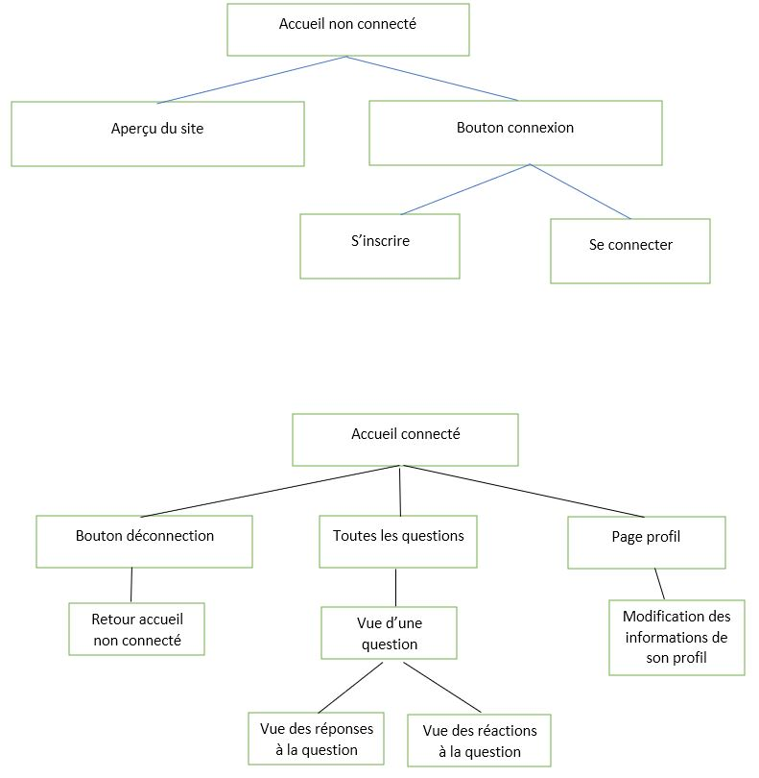

2.3 Les cas d’utilisation

Créer une question



Répondre à une question

Mettre un "j'aime" sur une question

Modifier les informations de son profil

Envoyer une demande d'ami

Accepter une demande d'ami

Se désinscrire / déconnecter

2.4 Maquettes finales

Page d'affichage des questions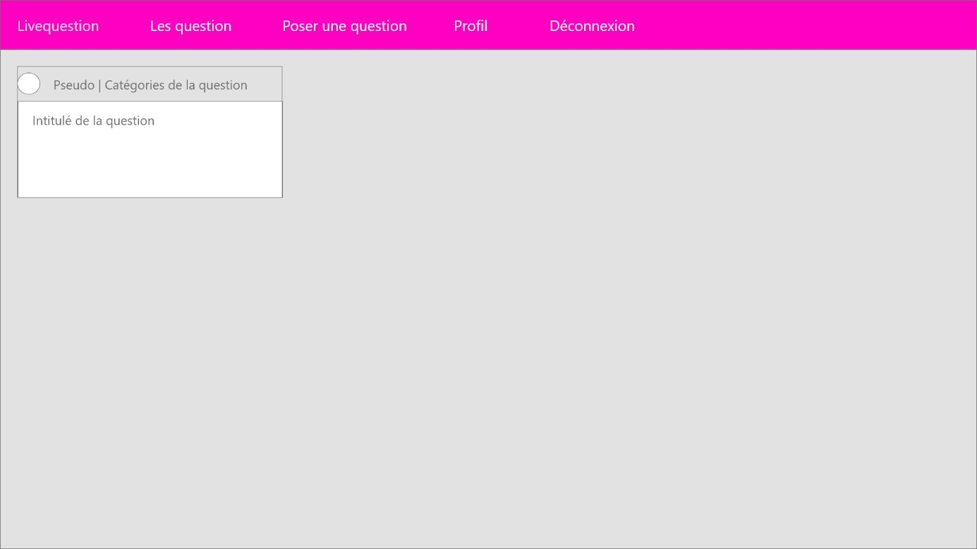

Page d'affichage d'une question

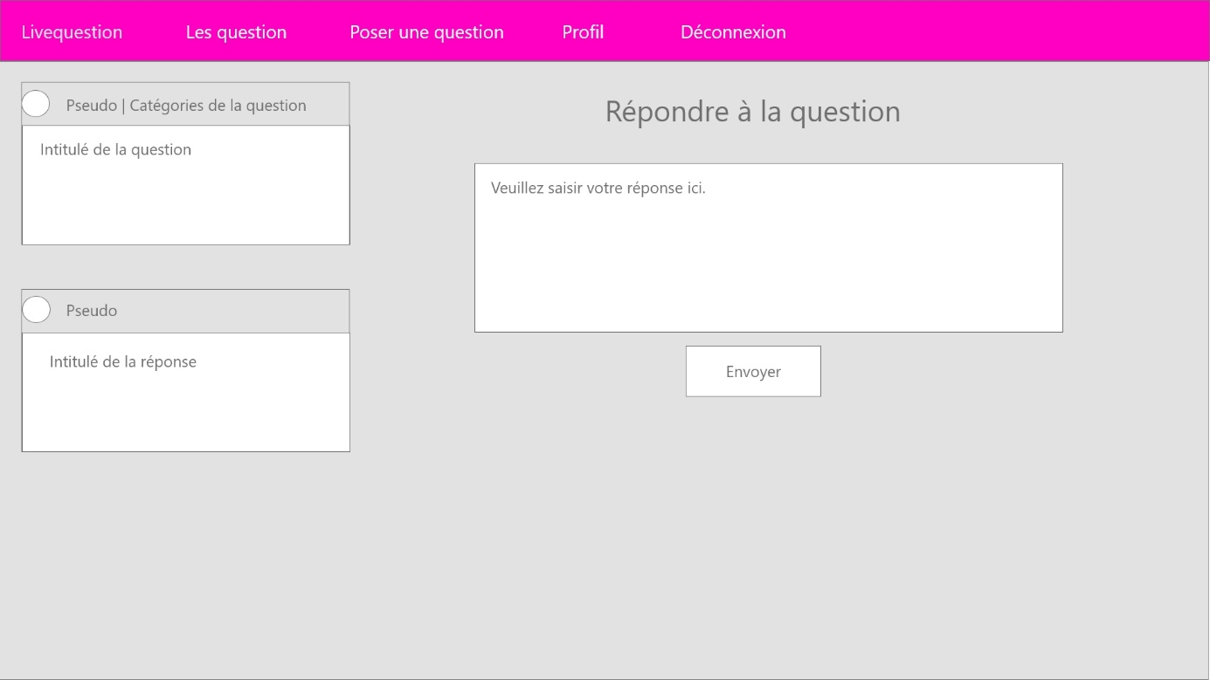

Page du profil

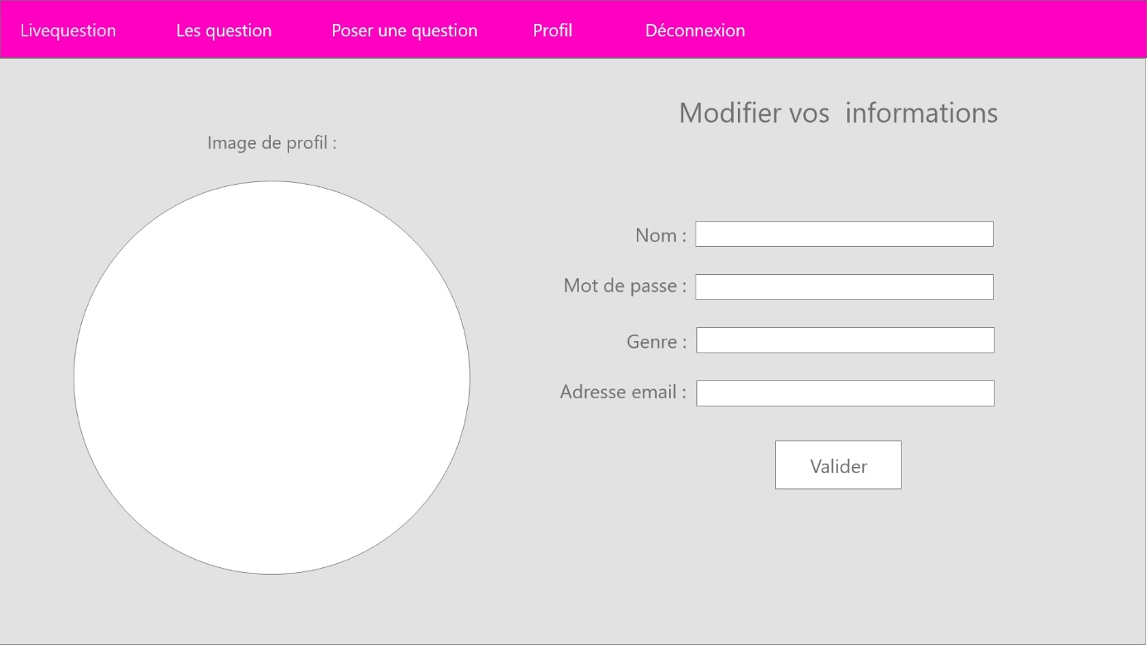

3.1 focus sur 2 fonctionnalités

poser une question à ses amis

En cochant une case, nous pouvons poser une question uniquement à nos amis

modifier les informations du profil

Nous pouvons changer à partir de la page profil nos informations personnelles.

3.2.1 Captures

poser une question à ses amis

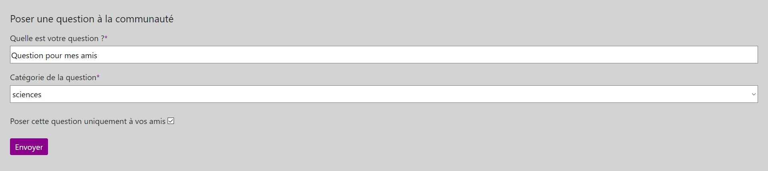

modifier les informations du profil

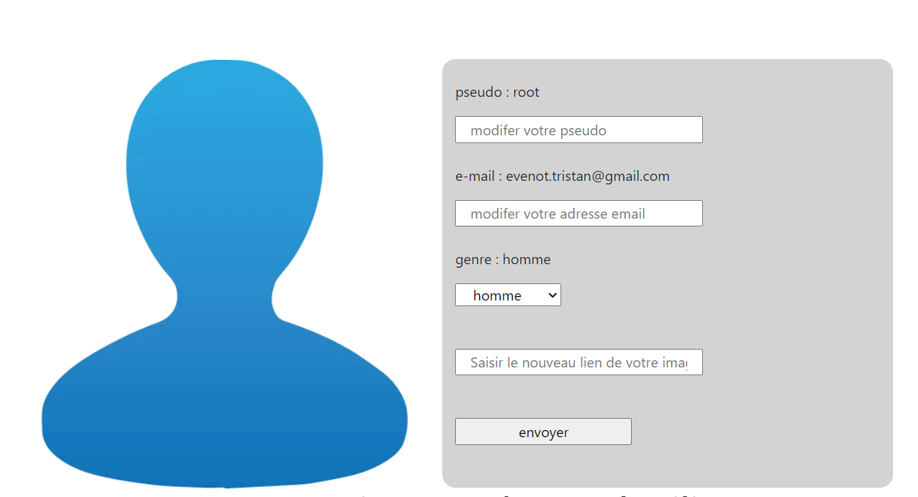

3.2.2 Code Commenté

poser une question à ses amis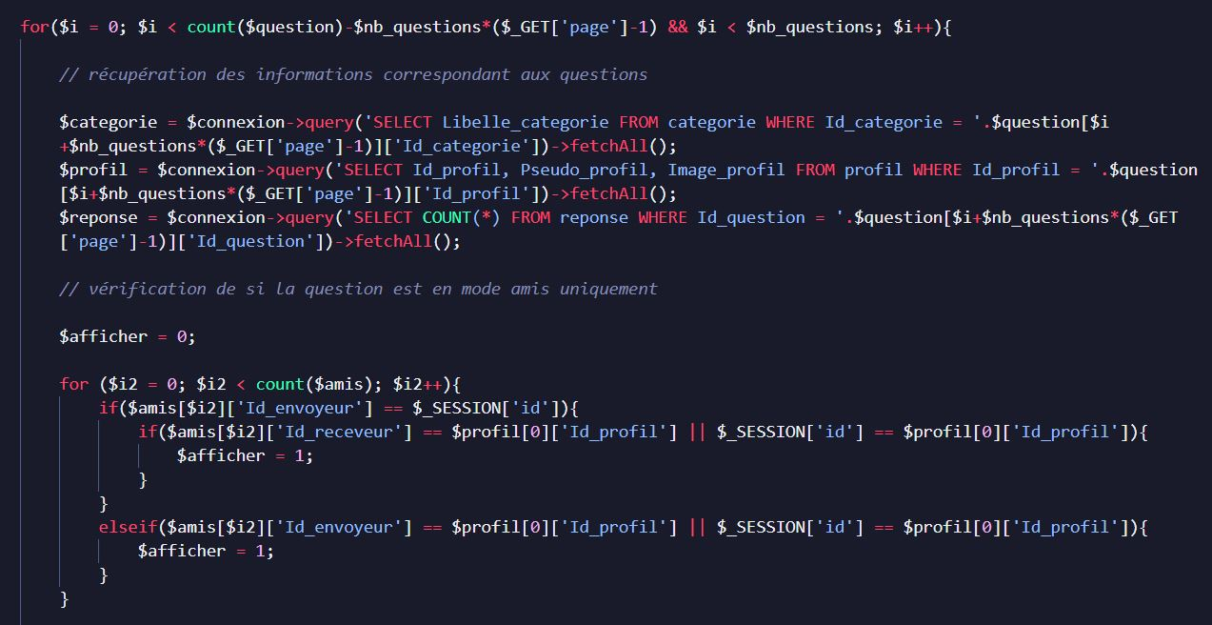

modifier les informations du profil

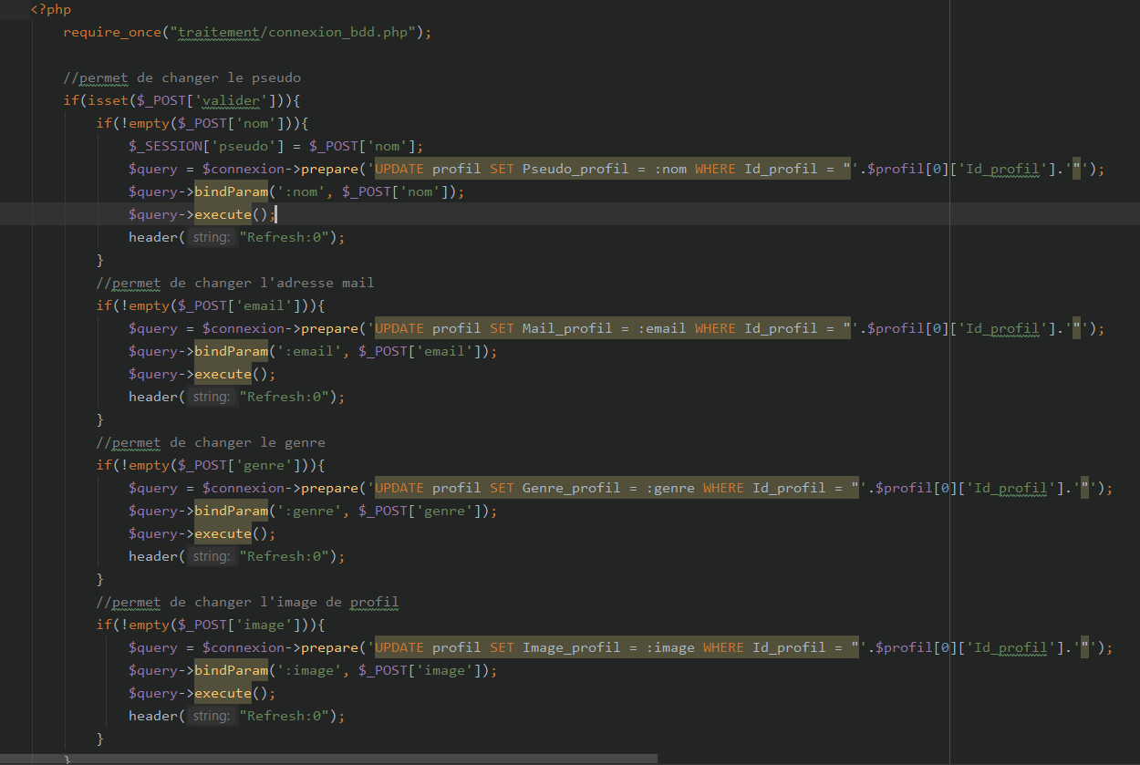

4.1 Résumé + usage

J’ai réalisé beaucoup de veilles sur le php lorsque je ne savais pas comment faire, notamment grâce à la documentation officielle de php disponible sur internet, ou alors je demandais l’aide de mes camarades.

5.1 Qui a fait Quoi et Quand

La répartition des taches du projet est disponible ici : <https://github.com/LeoBruant/Livequestion/issues>

5.2 Compte Rendu de réunion.

Réunions sur discord pour discuter de ce qu’il reste à faire et demander qui a des problèmes pour pouvoir l’aider.