

**Ho Chi Minh, 01/7/2020**

**Lecturer: Huynh Xuan Phung**

**Members: Phan Vinh Loc 17110049**

**Nguyen Tan Loc 17110048**

**Truong Viet Hoang 17110033**

**TOPIC: STUDENT’S PROJECT MANAGEMENT**

**HO CHI MINH UNIVERSITY OF TECHNOLOGY AND EDUCATION**

**BỘ GIÁO DỤC VÀ ĐÀO TẠO  
TRƯỜNG ĐẠI HỌC KINH BẮC**

**SUBJECT: WINDOW PROGRAMMING**

**FINAL PROJECT**

**Score**

|  |  |  |  |
| --- | --- | --- | --- |
| Criteria | Content | Presentation | Overall |
| Score |  |  |  |

Observations of Instructor

Evaluation:

Nguyen Tan Loc:   
Truong Viet Hoang:   
Phan Vinh Loc:

Teacher Guide

Phung

Huynh Xuan Phung

**Contents:**

List of figures: 5

List of tables: 6

Chapter 1: Program Overview 7

1.1 About the Project 7

1.1.1 Purpose 7

1.1.2 Requirements 7

1.1.3 Project Analysis 7

1.1.4 Expected Interface 7

1.1.5 Technical Requirements 7

1.1.6 Technology and Tool 8

Chapter 2: Work Assignment 8

2.1. Work Plan 8

2.2 Work Assignment 8

Chapter 3: Design Software 9

3.1 Design Interface 9

3.1.1 Program Interface 9

10

3.1.2 Interface Specification 13

3.2 Design Class 15

3.2.1 Sample list of classes used in the program 15

3.2.2 The sample table describes the methods in a class 16

3.2 Design Database 18

3.3.1 Database Diagram 18

3.3.2 Database Specification and Field Decsription 18

Chapter 4: Install and Test 21

21

Chapter 5: Conclusion and Development Direction 39

5.1 Conclusion 39

5.2 Development Direction 39

Reference 40

*List of figures:*

Figure 1: Login Interface 9

Figure 2: Interface of user when log in successful (Home Page) 9

Figure 3: Form Student’s Information 10

Figure 4: Form Lecture’s Information 10

Figure 5: Form Project 11

Figure 6: Form Project Detail 11

Figure 7: Form Progress of Student 12

Figure 8: Test 1 20

Figure 9: Test 2 21

Figure 10: Test 3 22

Figure 11: Test 4 22

Figure 12: Test 5 23

Figure 13: Test 6 23

Figure 14: Test 7 24

Figure 15: Test 8 24

Figure 16: Test 9 25

Figure 17: Test 10 25

Figure 18: Test 11 26

Figure 19: Test 12 26

Figure 20: Test 13 27

Figure 21: Test 14 27

Figure 22: Test 15 28

Figure 23: Test 16 28

Figure 24: Test 17 29

Figure 25: Test 18 30

Figure 26: Test 19 31

Figure 27: Test 20 32

Figure 28: Test 21 33

Figure 29: Test 22 34

Figure 30: Test 23 35

Figure 31: Test 24 36

Figure 32: Test 25 37

# *List of tables:*

Table 1: Interface Specification 12

Table 2: Design Class 14

Table 3: The sample table describes the method in a class 15

Table 4: UserLogin 17

Table 5: Student 17

Table 6: Lecture 18

Table 7: Project 19

Table 8: Progress 20

Table 9: ProjectManagemnet 20

# 

# 

# Chapter 1: Program Overview

## About the Project

* Design and build object-oriented software to create t software which can manage the student’s project

### Purpose

* Help instructor can manage the student’s project
* We can know the owner of the project
* We can know the instructor of the project
* We can know the detail of the project

### Requirements

* Manage student’s information
* Instructors (Lecture)
* Project’s information and report

### Project Analysis

* Building object – oriented software
* The output of data is the application

### Expected Interface

This project includes the following forms:

* Student
* Lecture
* Project

### Technical Requirements

- Fulfilling the requirements set out by the project

- Application of object-oriented programming

- Software capacity is light, stable running

### 1.1.6 Technology and Tool

- Design Graphical User Interface (GUI) by Visual Studio 2019 (Tool)

- Design View Model and Data Model by Visual Studio 2019 (Code C#)

- Building software on EntityFramework.6.2.0

- SQL Server

# Chapter 2: Work Assignment

## 2.1. Work Plan

|  |  |  |
| --- | --- | --- |
| **Week** | **Date** | **Work** |
| Week 10 | 02/06 | Design Data Base But Wrong |
| Week 11 | 09/06 | Design Data Base |
| Week 12 | 16/06 | Design Class + GUI |
| Week 13 | 23/06 | Design View Model and Data Model |
| Week 14 | 30/06 | Finish |

## 2.2 Work Assignment

|  |  |  |  |
| --- | --- | --- | --- |
| **Number Order** | **Name of student** | **Description** | **Contribute (%)** |
| 1 | Nguyen Tan Loc | Design Class | 40% |
| 2 | Truong Viet Hoang | Design GUI, Function Login | 30% |
| 3 | Phan Vinh Loc | Design Data Base Install and Test Write Report | 30% |

# Chapter 3: Design Software

## 3.1 Design Interface

### Program Interface

Student name: Truong Viet Hoang

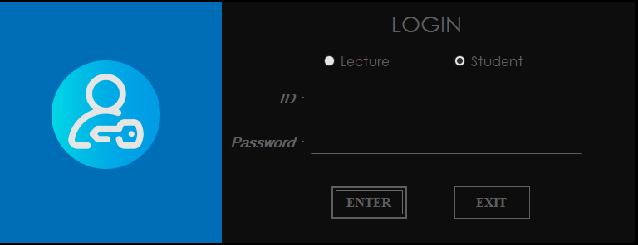

Figure 1: Login Interface

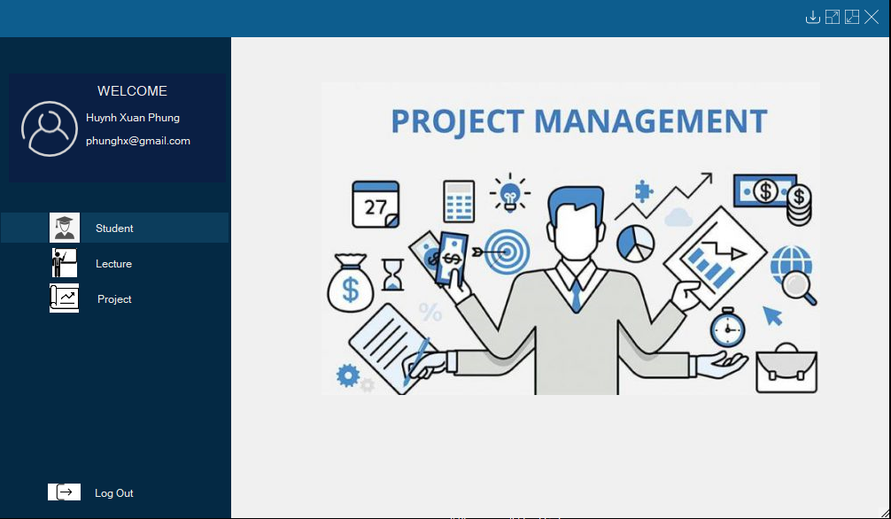

Figure 2: Interface of user when log in successful (Home Page)

# 

Figure 3: Form Student’s Information

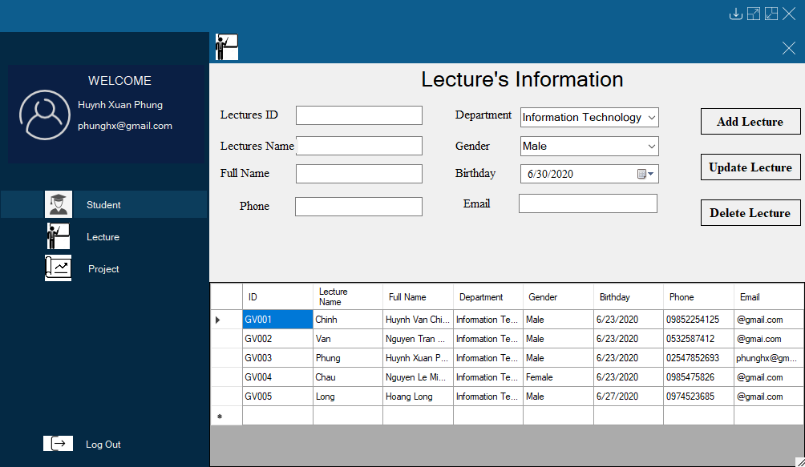

Figure 4: Form Lecture’s Information

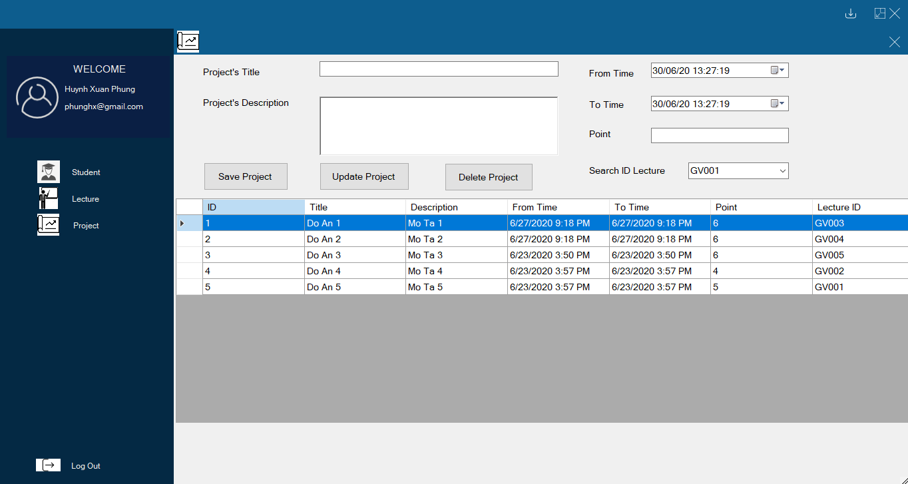

Figure 5: Form Project

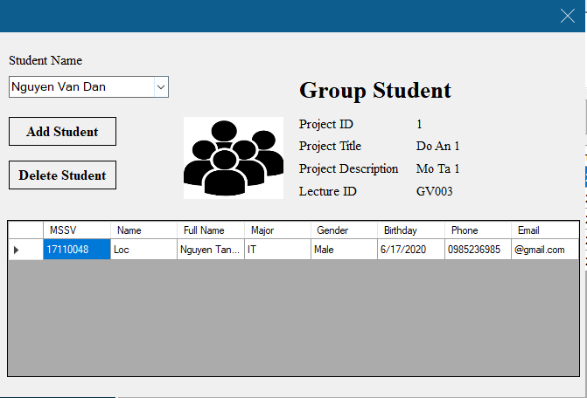

Figure 6: Form Project Detail

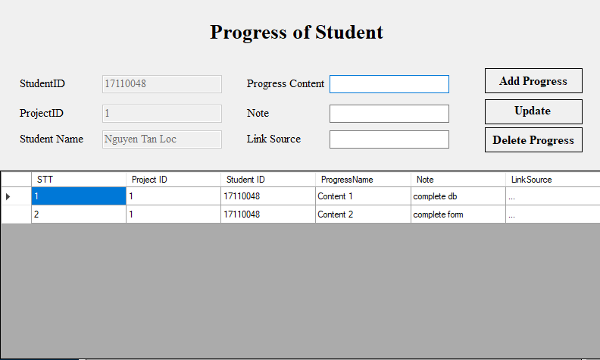

Figure 7: Form Progress of Student

About Interface of Student such as Lecture but can’t Add, Update And Delete, etc. The student just can view

### Interface Specification

Table 1: Interface Specification

|  |  |  |
| --- | --- | --- |
| **Form** | **Type of button** | **Purpose** |
| Login Form | Radio Button (Select Role) | Allow you select type of user to login |
| Button (Login) | Check your ID and password after that let you log in |
| Button (Exit) | You can exit the program when you don’t use |
| Home page Form | Button (Student) | Let you enter in student form and edit on it |
| Button (Lecture) | Let you enter in lecture form and edit on it |
| Button (Project) | Let you enter in project form and edit on it |
| Button (Log out) | Allow log your account out and you can log in with another account |
| Student’s Information Form | Button (Add Student) | Allow you add information of new student |
| Button (Update Student) | Allow you edit information of the student who is added |
| Button (Delete Student) | Allow you delete information of the student |
| Lecture’s Information Form | Button (Add lecture) | Allow you add information of new lecture |
| Button (Update lecture) | Allow you edit information of the lecture who is added |
| Button (Delete lecture) | Allow you delete information of the lecture |
| Project Form | Button (Add project) | Allow you add information of new project |
| Button (Update project) | Allow you edit information of the project which is added |
| Button (Delete project) | Allow you delete information of the project |
| Project Detail Form | Combo box (List of students who are had information in Student Form) | Allow you select the name of student |
| Button (Add Student) | Add the student you choose in the combo box into the project which you chosen before |
| Button (Delete Student) | Delete the student you choose in the data grid view of the project which you chosen before |
| Progress of Student Form | Button (Add progress) | Allow you access into the project’s progress and add progress for student |
| Button (Update progress) | Allow you access into the project’s progress and update progress for student |
| Button (Delete progress) | Allow you access into the project’s progress and delete progress for student |

## 3.2 Design Class

### 3.2.1 Sample list of classes used in the program

Student name: Nguyen Tan Loc

Table 2: Design Class

|  |  |  |
| --- | --- | --- |
| **TT** | **Class name**  **Inheritance or lead**  **export from (specify name**  **base class) – if have** | **Purpose** |
| 1 | * Class UserLogin | Before using the program, the user must create a login account |
| 2 | * Class Lecture * Foreign Key IDLoginL references UserLogin(ID) | Store information of lecturer and decentralization for teachers when creating accounts (Lecturers have the right to use the add, edit, delete functions) |
| 3 | * Class Student * Foreign Key IDLogin references UserLogin(ID) | Store information of students and decentralization for students when creating accounts (Students only have permission to view) |
| 4 | * Class Project * Foreign Key L_ID references Lecture(L_ID) | Store information of project and save the name of that project lecturer |
| 5 | * Class ProjectManagement * Foreign Key P_ID references Project(P_ID) * Foreign Key S_ID references Student(S_ID) * Set P_ID and S_ID is primary key that get all the information of Project and Student | From this table we can save the project information, know the name of the lecturer and the teacher can create groups for students. |
| 6 | * Class Progress * Foreign Key P_ID references ProjectManagement (P_ID) * Foreign Key S_ID references ProjectManagement (S_ID) * Set P_ID and S_ID is primary key that get the ID of Project and Student | Every student needs to record the process of completing the project. Get the ID of Project and Student to know what projects students do, lecturer, and what each student can do |

### 3.2.2 The sample table describes the methods in a class

Student name: Nguyen Tan Loc

Table 3: The sample table describes the method in a class

|  |  |  |  |
| --- | --- | --- | --- |
| **TT** | **Method** | **Purpose** | **File name, line number containing the declaration** |
| 1 | public static Student getStudentInfomationAfterLogin(string idLogin) Input: idLogin Output: If class Students have IDLogin == idLogin => return Student | Check if the student class has an account that matches the ID of the UserLogin class.  If identical then return student  Else error note | DBProjectStudent/Controller/StudentController.cs (159) |
| 2 | public static List<Progress> listProgressOfStudent(int P_ID,string S_ID) Input: P_ID, S_ID Output: list Progress of Student | Find the ID student done ID project is to record the project completion process | DBProjectStudent/Controller/StudentController.cs (150) |
| 3 | public static List<Student> getStudentDetail() Input: nothing Output: list Student | Get all full name student that lecturer create group | DBProjectStudent/Controller/StudentController.cs (134) |
| 4 | public static List<Student> getAllStudentbyIDproject(int idproject) Input: idproject Output: list student | Show the group student working on that project | DBProjectStudent/Controller/ ProjectManagementController.cs (42) |
| 5 | public static Lecture getLectureInfomationAfterLogin(string idLogin) Input: idLogin Output: If class Lecturer have IDLogin == idLogin => return Lecturer | Check if the lecturer class has an account that matches the ID of the UserLogin class.  If identical then return lecturer  Else error note | DBProjectStudent/Controller/LectureController.cs (128) |

## Design Database

Student Name: Phan Vinh Loc

### 3.3.1 Database Diagram

### 3.3.2 Database Specification and Field Decsription

Table 4: UserLogin

|  |  |  |
| --- | --- | --- |
| Column name | Data Type | Note |
| ID | Varchar(20) |  |
| Pass | Varchar(20) |  |
| Roleuser | Varchar(10) |  |

Table 5: Student

|  |  |  |
| --- | --- | --- |
| Column name | Data Type | Note |
| S_ID | Varchar(20) | Student ID |
| S_Name | Nvarchar(100) | Student Name |
| S_Fullname | Varchar(50) | Student Fullname |
| S_Major | Varchar(50) | Student Major |
| S_Birthday | Varchar(50) | Student Birthday |
| S_Phone | Varchar(50) | Student Phone |
| S_Email | Varchar(50) | Student Email |
| S_Gender | Varchar(50) | Student Gender |
| ID | int | ID Login |

Table 6: Lecture

|  |  |  |
| --- | --- | --- |
| Column name | Data Type | Note |
| L_ID | Varchar(20) | Lecture ID |
| L_Name | Nvarchar(100) | Lecture Name |
| L_Fullname | Varchar(50) | Lecture Fullname |
| L_Department | Varchar(50) | Lecture Department |
| L_Birthday | Datetime | Lecture Birthday |
| L_Phone | Varchar(50) | Lecture Phone |
| L_Email | Varchar(50) | Lecture Email |
| L_Gender | Varchar(50) | Lecture Gender |
| ID | int | ID Login |

Table 7: Project

|  |  |  |
| --- | --- | --- |
| Column name | Data Type | Note |
| P_ID | int | Project ID |
| P_Title | Nvarchar(100) | Project Tile |
| P_Description | Nvarchar(200) | Project Description |
| P_Fromtime | datetime | Project Fromtime |
| P_Totime | datetime | Project Totime |
| P_Point | Varchar(10) | Project Point |
| L_ID | Varchar(20) | Lecture ID |

Table 8: Progress

|  |  |  |
| --- | --- | --- |
| Column name | Data Type | Note |
| STT | Nvarchar(50) | Number order |
| P_ID | int |  |
| Progress Name | Nvarchar(100) |  |
| Note | Nvarchar(100) |  |
| Link Source | Nvarchar(100) |  |

Table 9: ProjectManagemnet

|  |  |  |
| --- | --- | --- |
| Column name | Data Type | Note |
| P_ID | int |  |
| S_ID | Varchar(20) |  |

# Chapter 4: Install and Test

# 

Figure 8: Test 1

Test form Student’s Information  
Add 1 Student  
Before Add

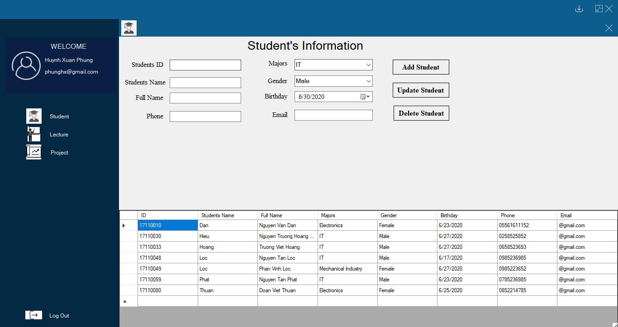

Figure 9: Test 2

After Add  
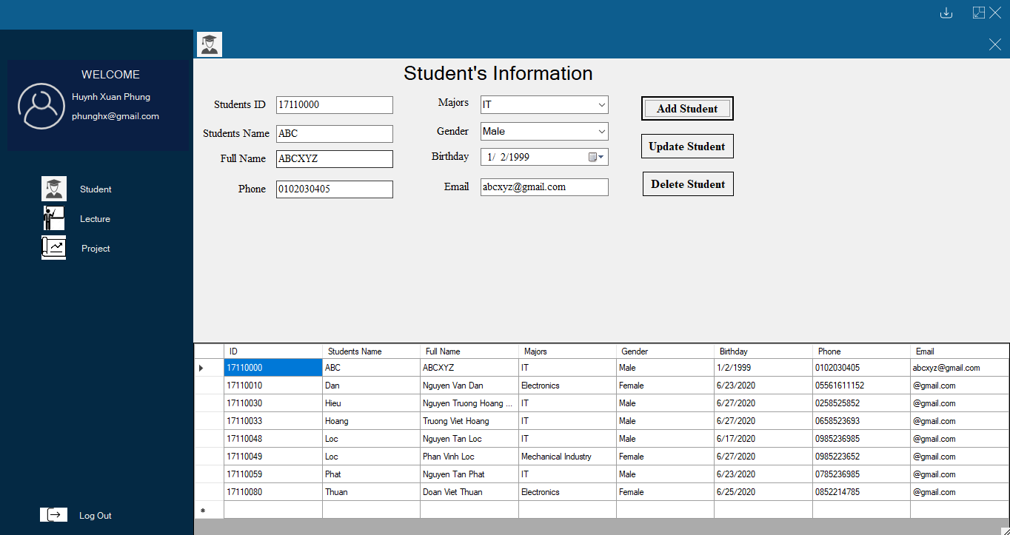

Figure 10: Test 3

Update 1 Student 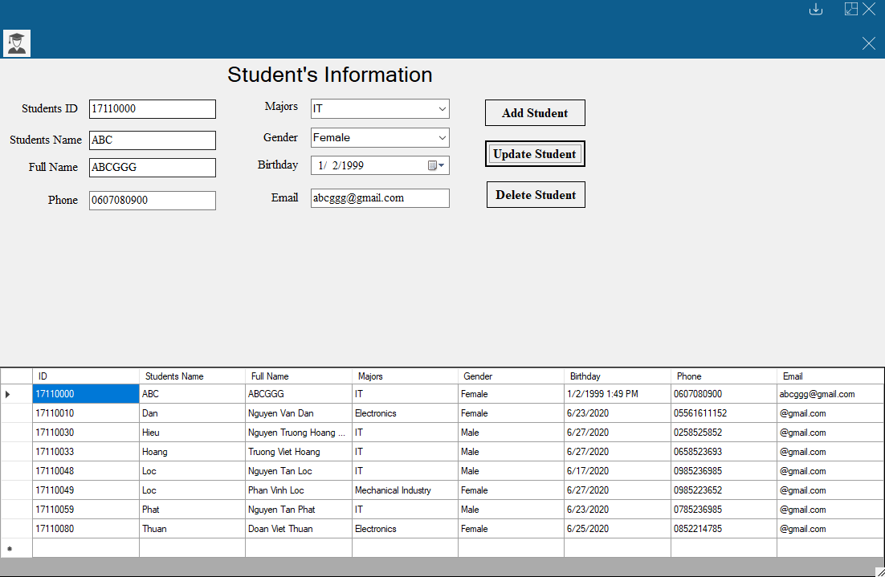

Figure 11: Test 4

Delete 1 Student  
Before Delete

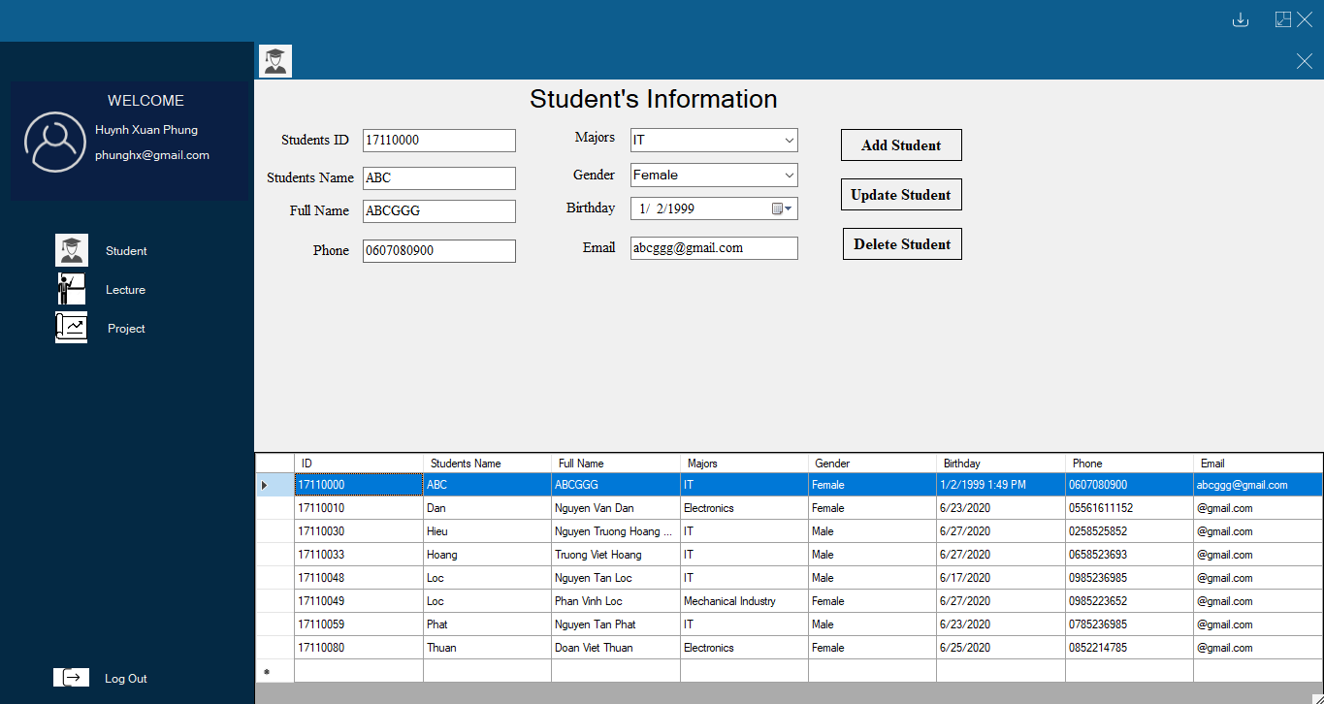

Figure 12: Test 5

After Delete

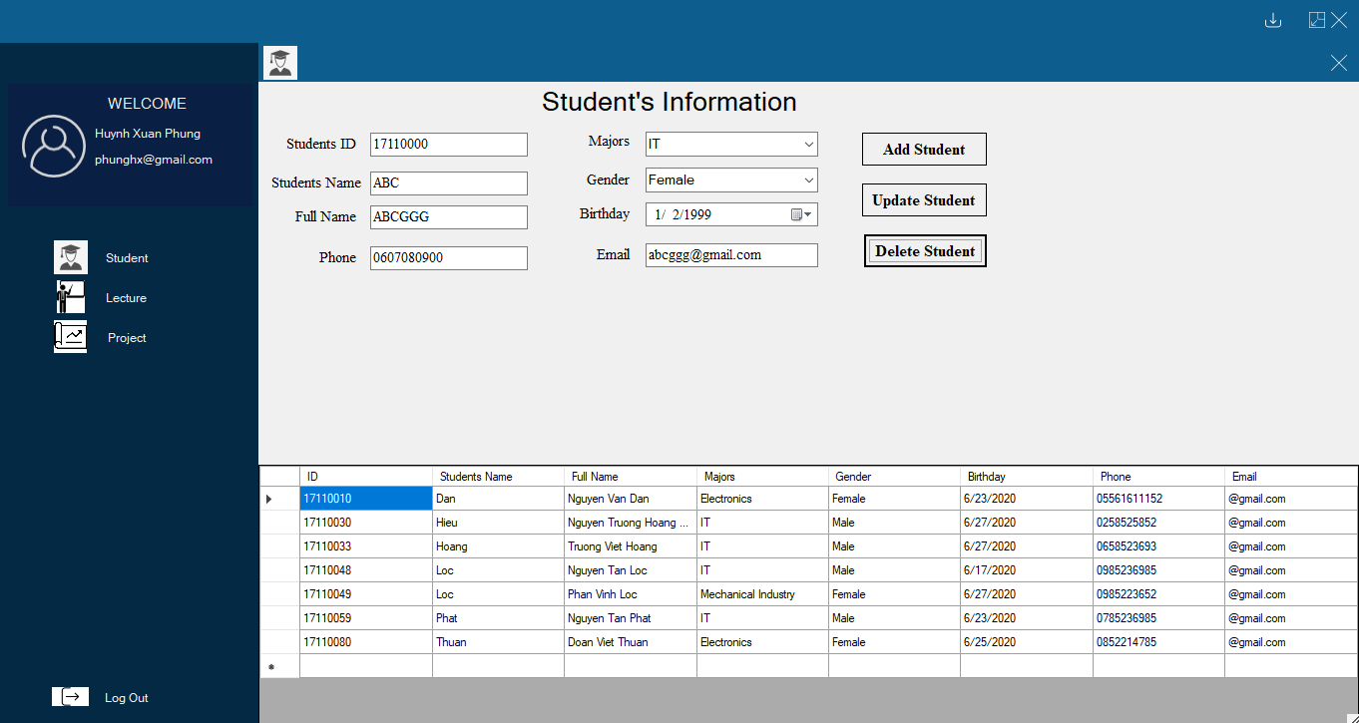

Figure 13: Test 6

Test form Lecture’s Information  
Add 1 Lecture  
Before Add

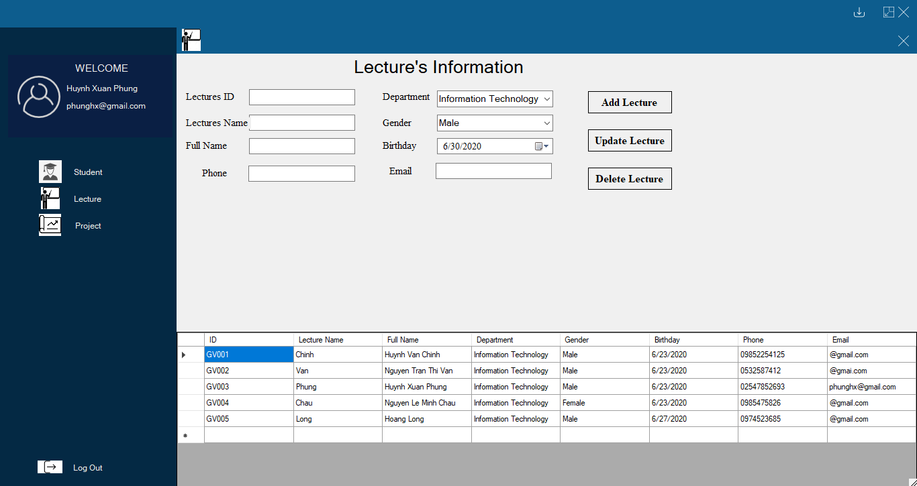

Figure 14: Test 7

After Add

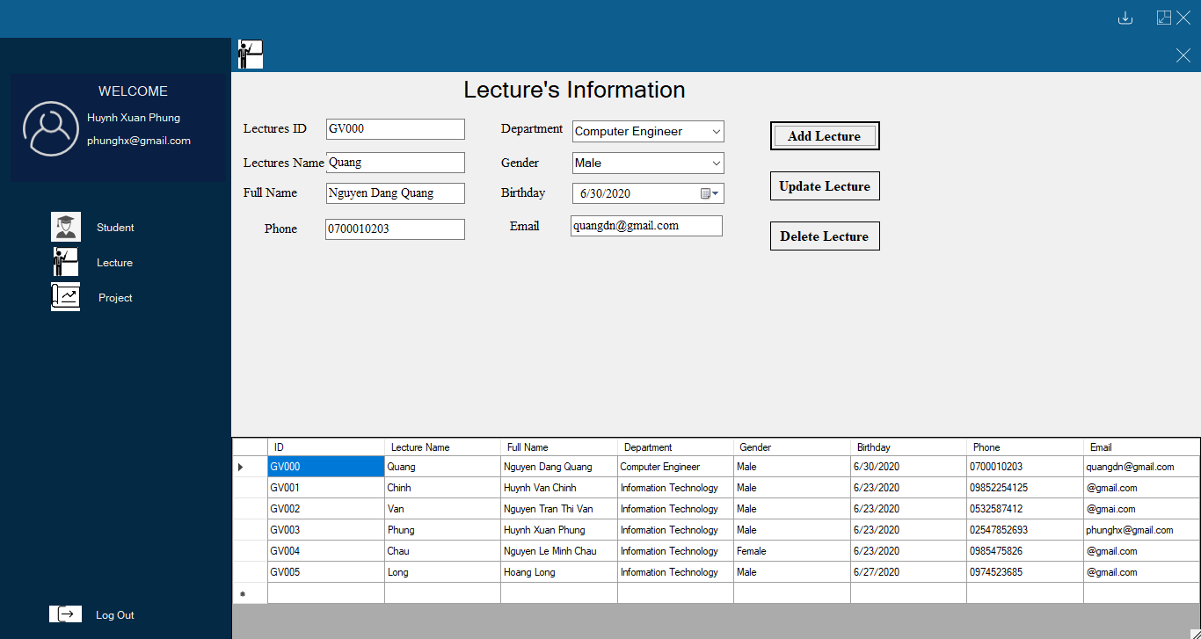

Figure 15: Test 8

Update 1 Lecture

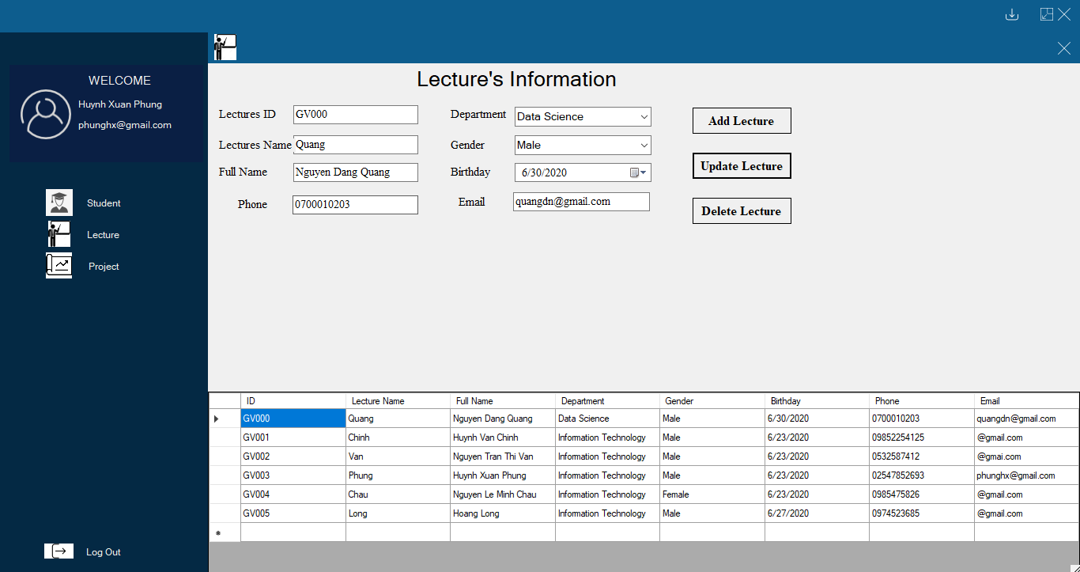

Figure 16: Test 9

Delete 1 Lecture  
Before Delete

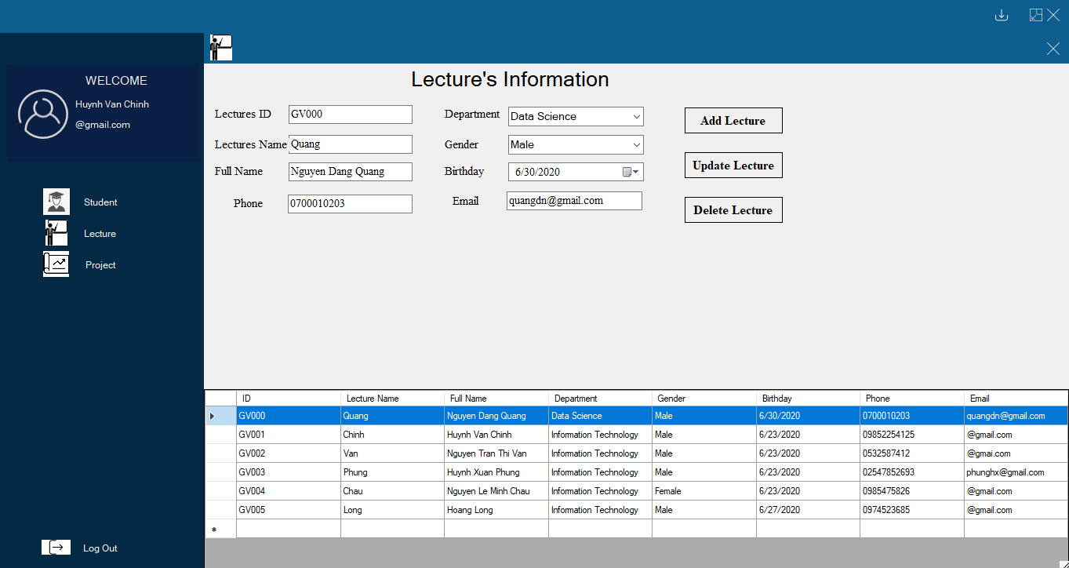

Figure 17: Test 10

After Delete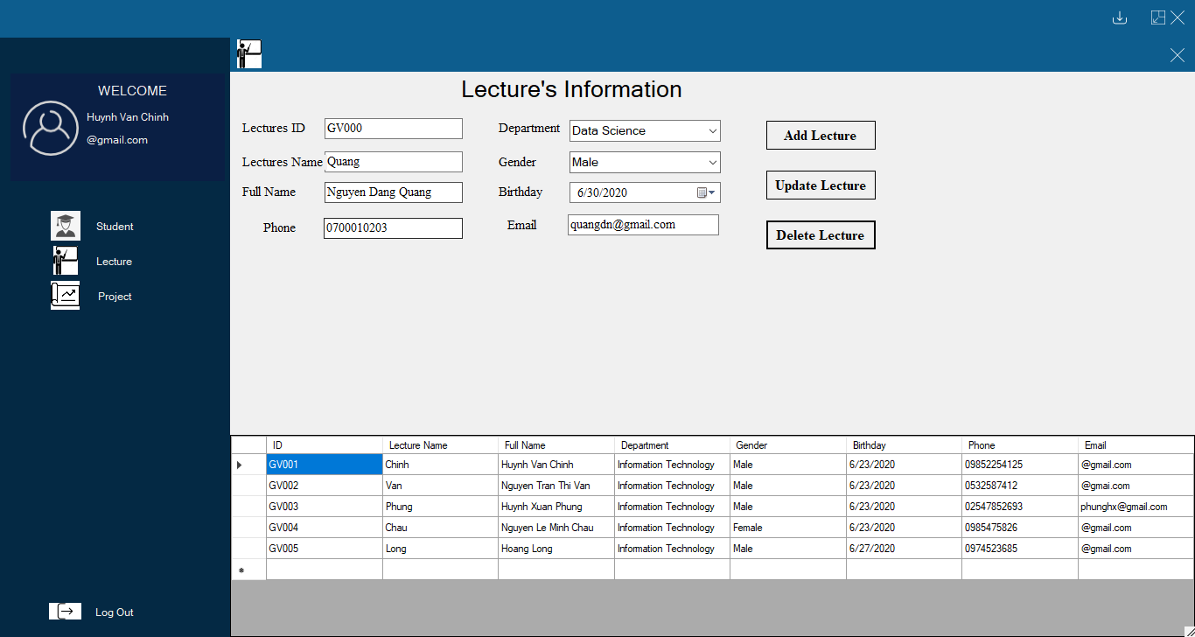

Figure 18: Test 11

Test form Project  
Add 1 project  
Before Add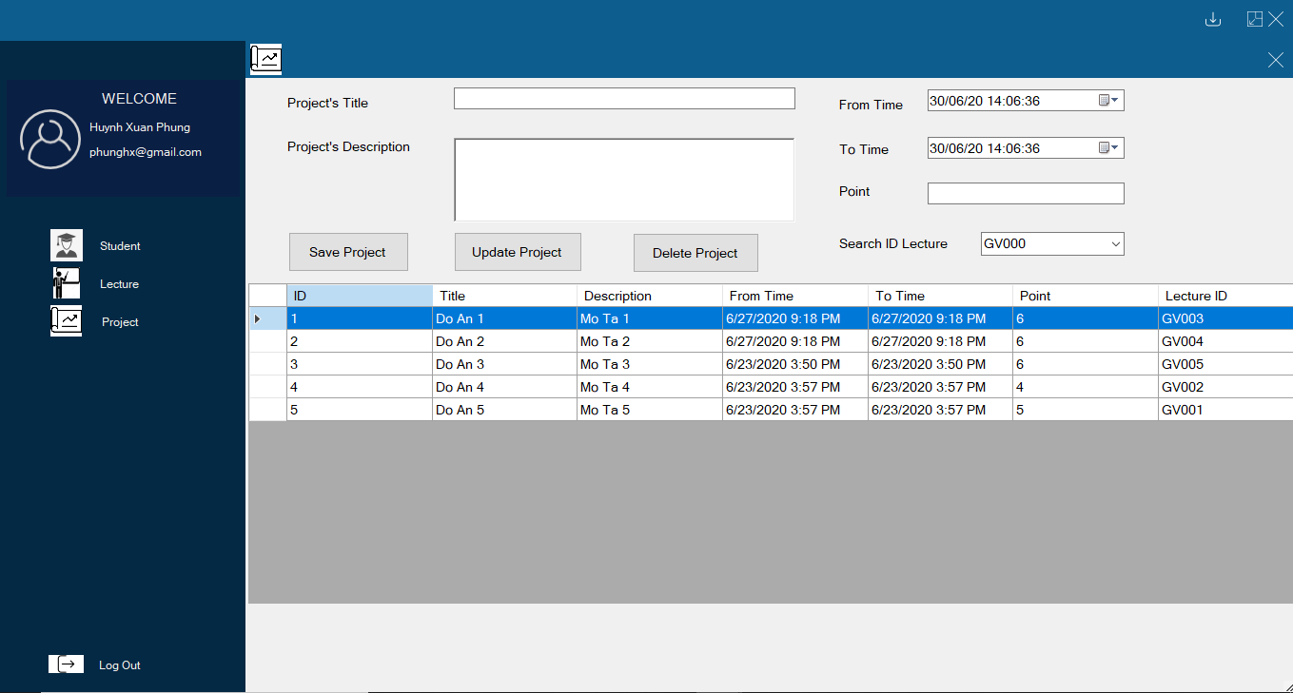

Figure 19: Test 12

After Add

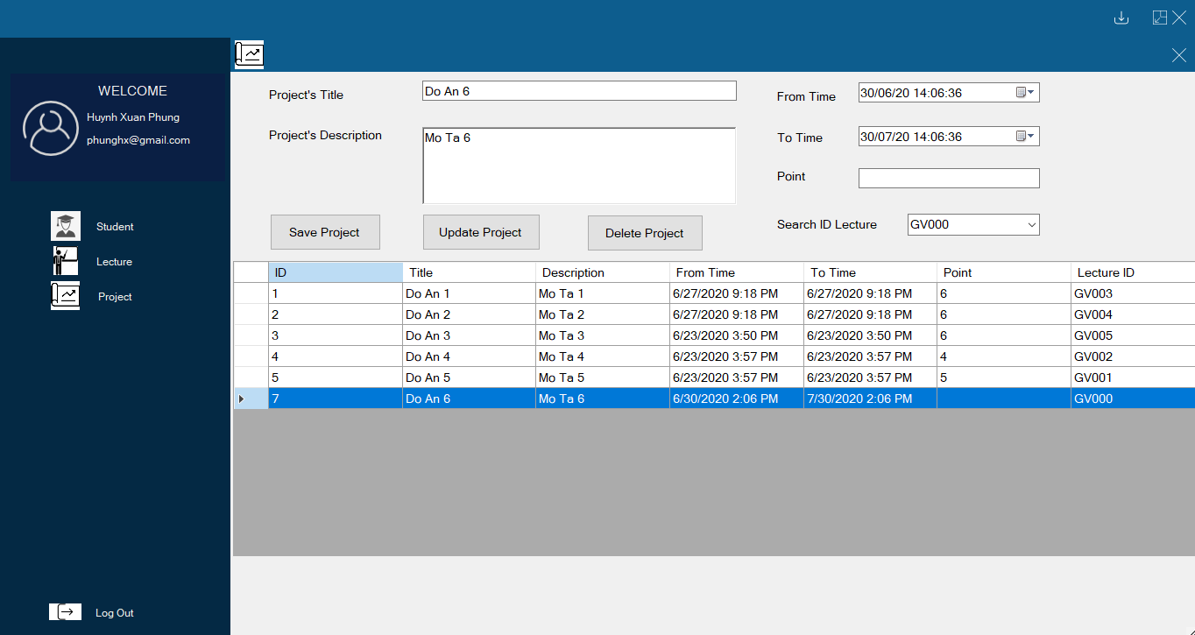

Figure 20: Test 13

Update 1 Project

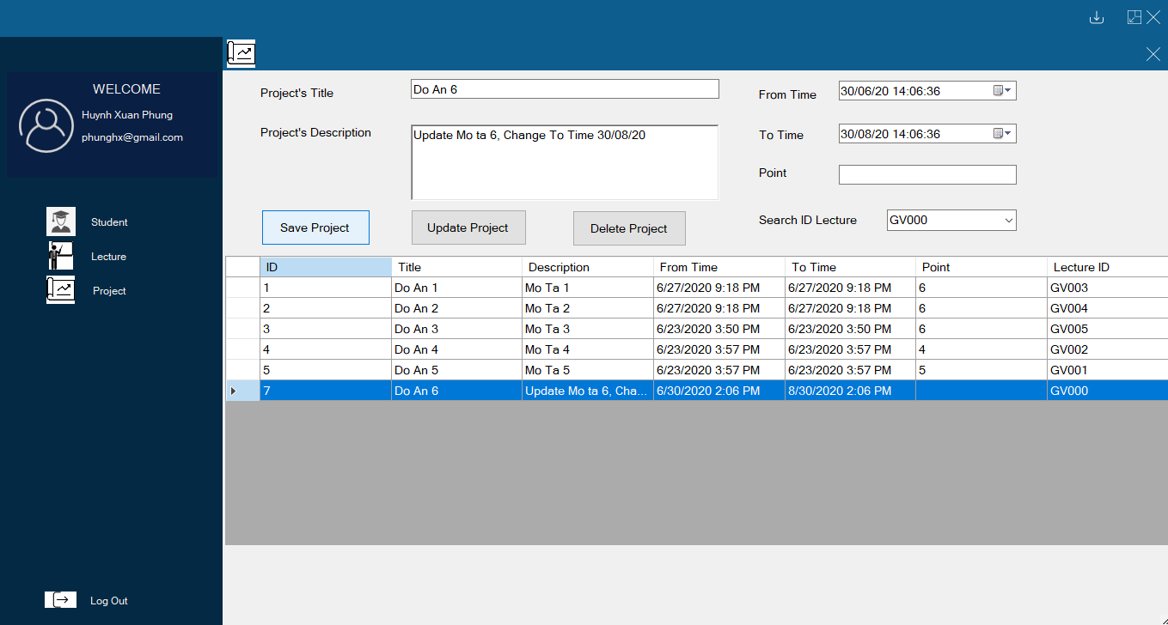

Figure 21: Test 14

Delete 1 Project  
Before Delete

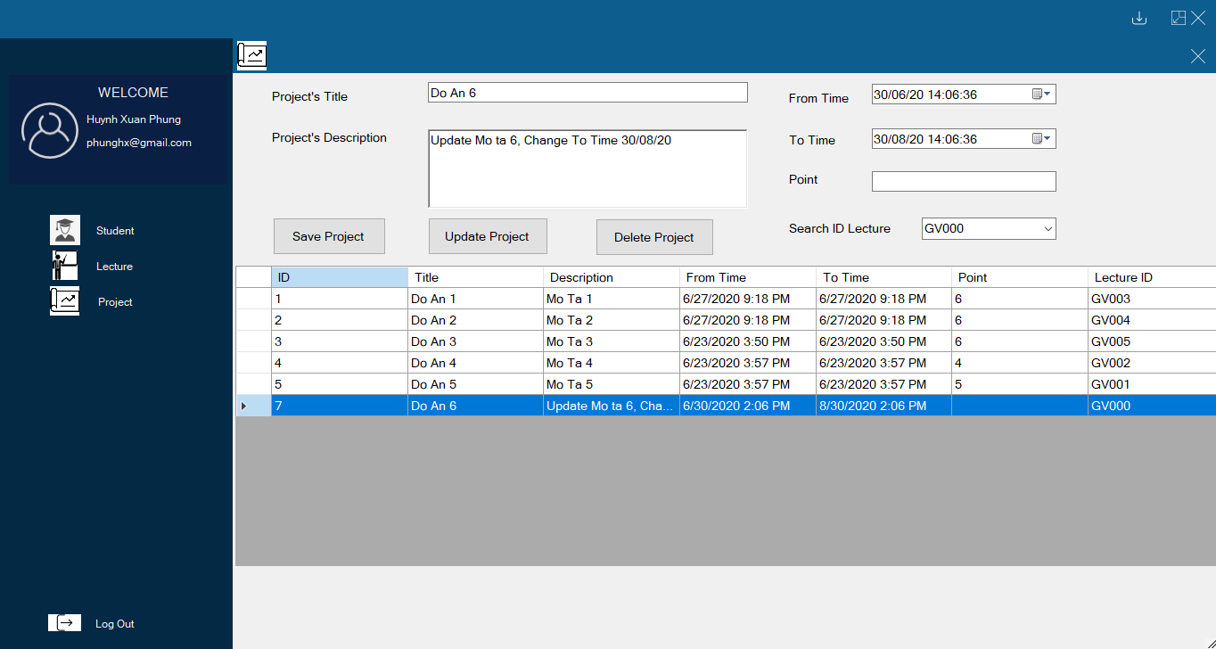

Figure 22: Test 15

After Delete

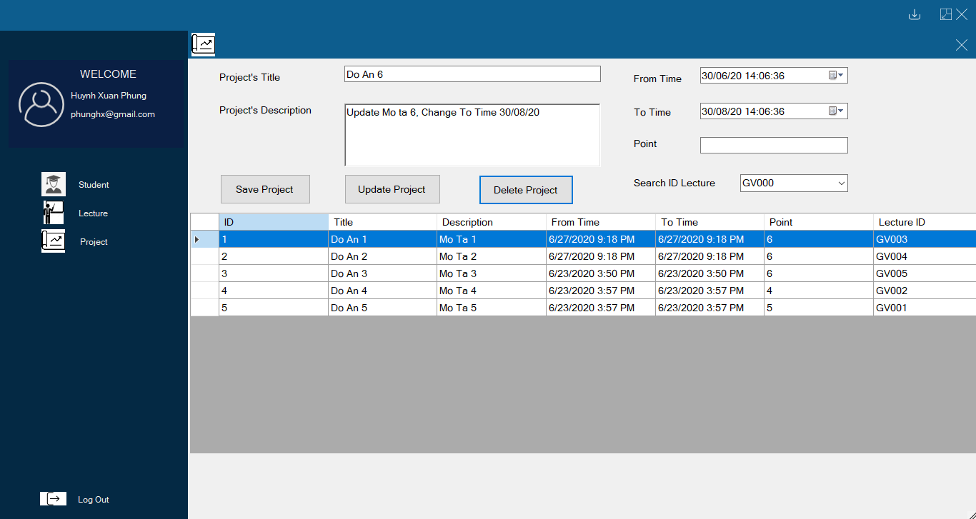

Figure 23: Test 16

Test form Project Detail  
Add 1 Student in Project Detail  
Before Add

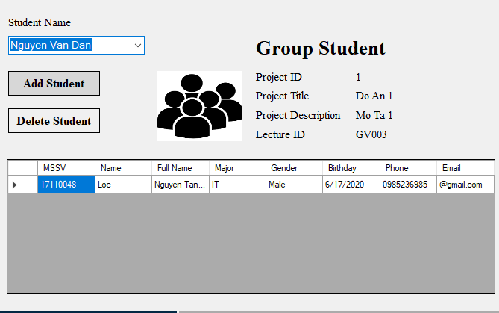

Figure 24: Test 17

After Add

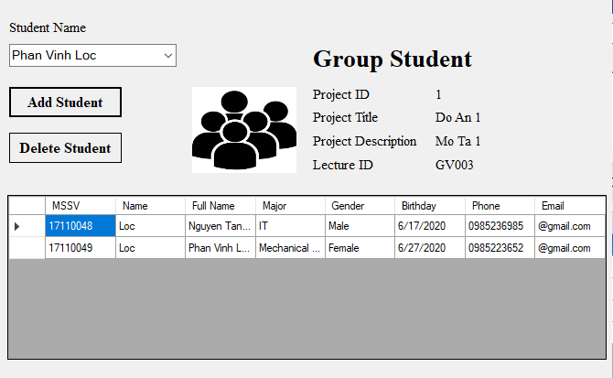

Figure 25: Test 18

Delete 1 Student in Project Detail  
Before Delete

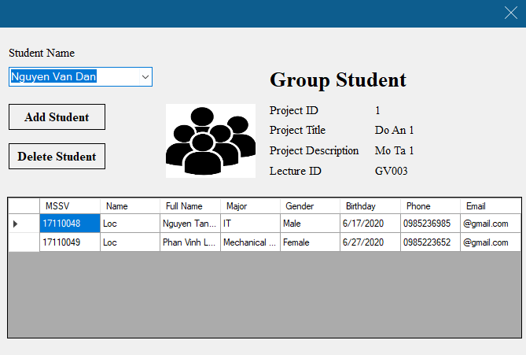

Figure 26: Test 19

After Delete

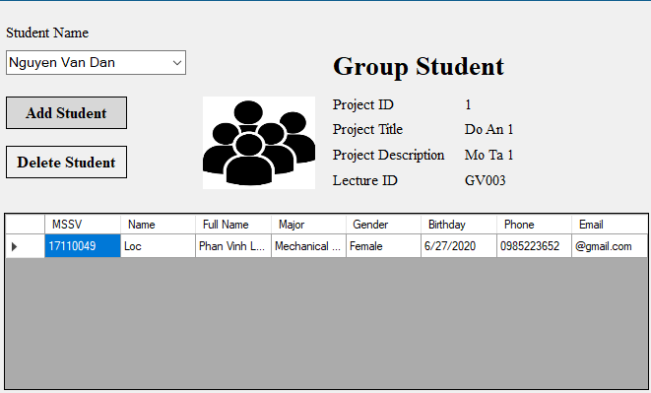

Figure 27: Test 20

Test form Progress Detail  
Add 1 Progress  
Before Add

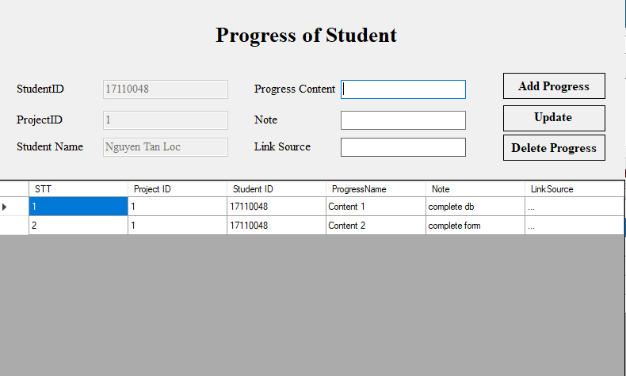

Figure 28: Test 21

After Add

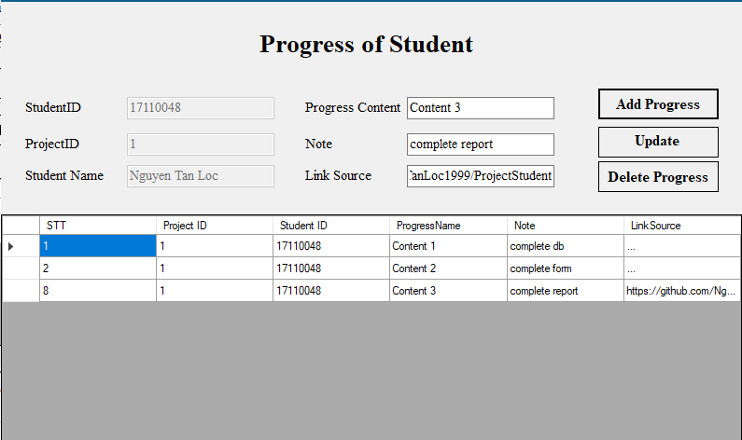

Figure 29: Test 22

Update 1 Progress

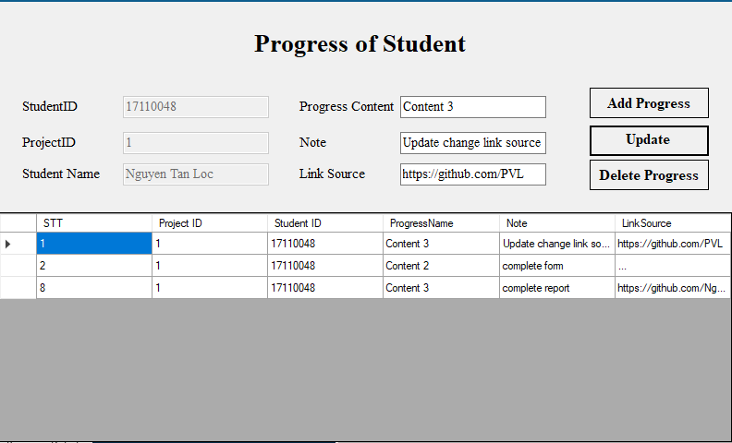

Figure 30: Test 23

Delete 1 Progress  
Before Delete

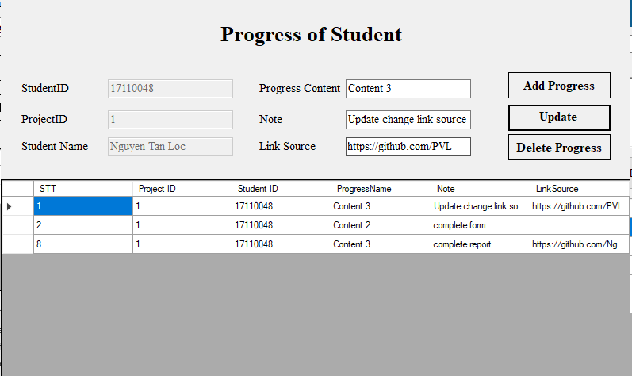

Figure 31: Test 24

After Delete

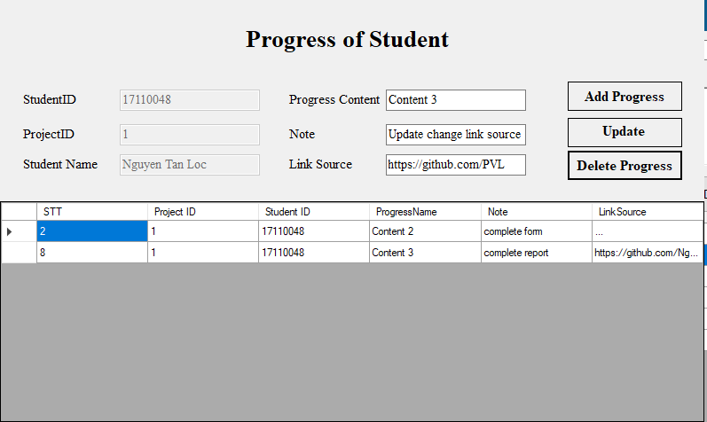

Figure 32: Test 25

# Chapter 5: Conclusion and Development Direction

## 5.1 Conclusion

Basically, the team commented that its software solved 95% of the requirements set by the project. Following are the advantages and disadvantages of the software:

* Advantages:   
  The interface is neat, accessible, and easy to get acquainted.  
  Capacity quite light  
  The program consumes very little system resources when operating.  
  The program runs stably, gives accurate results, does not crash in the process of executing user requests.
* Disadvantages:

Hard to use LinQ  
Lack of Report in part Requirements

## 5.2 Development Direction

* - Write more function Report in part Requirements  
  - Write more function which can show all the project of any student/lecture in 1 course

# Reference

# We used the knowledge Mr. Phung taught to complete the project.

# There are references sql query on google.com

# The specifically is on the website: stackoverflow.com