|  |
| --- |
|  |
| **RTL_EXERCISE_1 BOUND FLASHER** |
|  |
| |  |  | | --- | --- | | Author | Nguyễn Tấn Thiên | | ID | 19522266 | | Date | 2022/11/6 | | Version | 1.2 | |
|  |
|  |

|  |
| --- |
|  |

Contents

1. Interface 2

2. Functional implementation. 3

3. Internal implementation. 5

3.1. Overall. 5

3.2. State Machine 5

4. History 7

# 1. Interface

|  |
| --- |
| **bound_flash**  flick  16  lamp  rst_n  clk |
| Figure 1: the figure of Bound Flasher System |

|  |  |  |  |
| --- | --- | --- | --- |
| Signal | Width | In/Out | Description |
| clk | 1 | In | Clock signal – Active High. The state of system is operated at positive edge of the clock signal |
| rst_n | 1 | In | Reset signal – Active Low. The system will return to initial state when rst_n = 0. |
| flick | 1 | In | Flick signal. To start the system or return to previous state. |
| lamp | 16 | Out | Output 16 lamp. |

Table 1: Description of signals in Bound Flasher

# 2. Functional implementation.

* Implement a 16-bits LEDs system
* System’s Operation base on three input signal
  + Reset
  + Clock
  + Flick
* The system specification
* Clock signal is provided for system inspire of function status. The function operate state’s transition at positive edge of the clock signal.
* Reset signal:
* LOW-ACTIVE Reset = 0: System is restarted to Initial State.
* HIGH-ACTIVE Reset = 1: System is started with initial state.
* Flick signal: special input for controlling state transfer.

At the initial state, all lamps are OFF. If flick signal is ACTIVE (set 1), the flasher start operating:

* + 1. The lamps are turned ON gradually from lamp[0]to lamp[5]**.**
    2. The lamps are turned OFF gradually from lamp[5] **(max)** to lamp[0] **(min)**.
    3. The lamps are turned ON gradually from lamp[0]to lamp[10].
    4. The lamps are turned OFF gradually from lamp[10] **(max)** to lamp[5] **(min)**.
    5. The lamps are turned ON gradually from lamp[5] to lamp[15].
    6. Finally, the lamps are turned OFF gradually from lamp[15] to lamp[0], return to initial state.

Additional condition:

* At each kickback point (lamp[5] and lamp[10]), if flick signal is ACTIVE, the lamps will turn OFF gradually again to the **min** lamp of the previous state, then continue operation as above description.

For simple, kickback point is considered only when the lamps are turned ON gradually, except the first state.

* Some insulations:
* When flick = 0 at kickback points

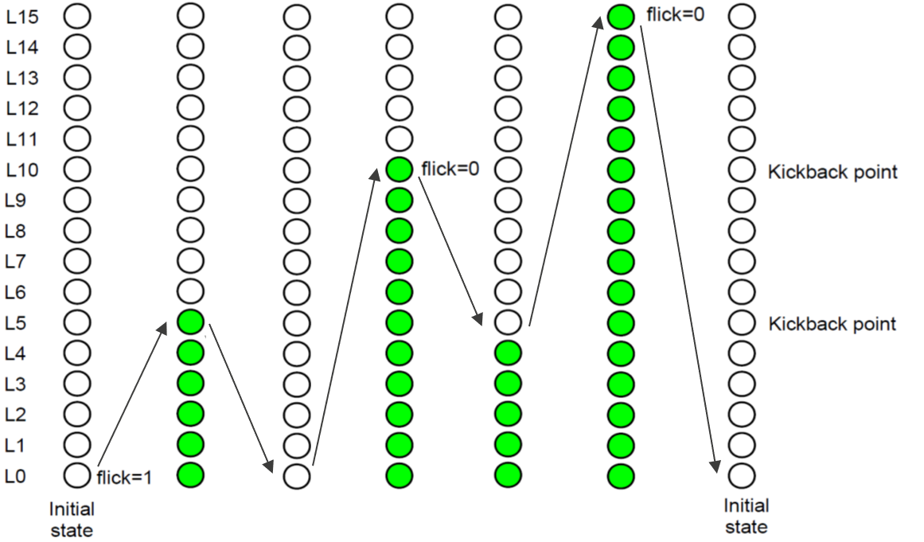

* When flick = 1 at kickback points (lamp[10])

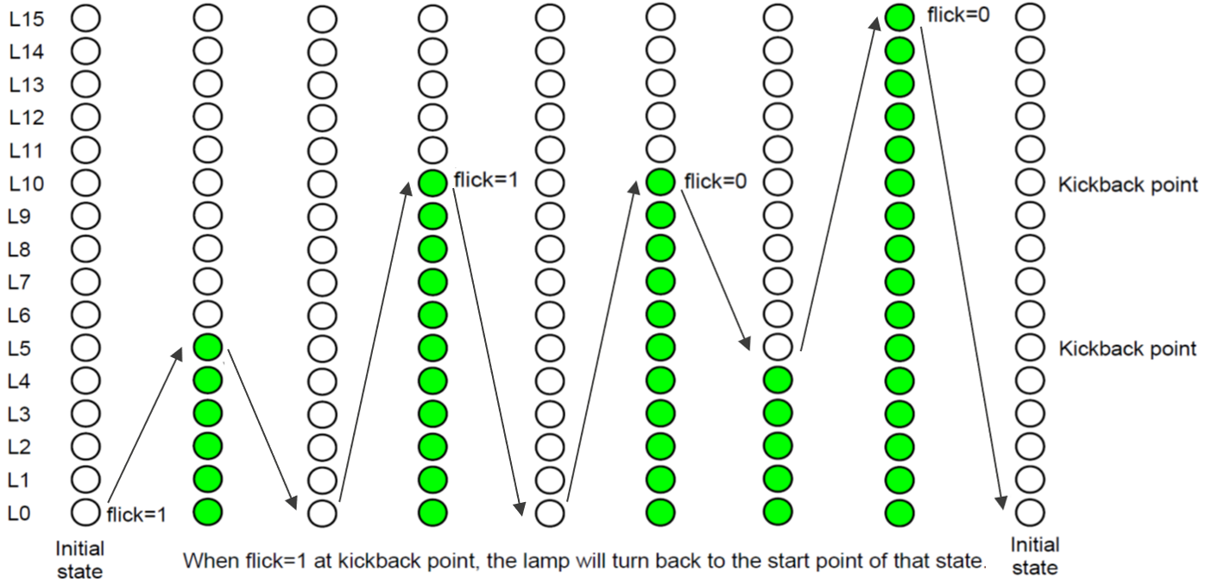

# 3. Internal implementation.

## 3.1. Overall.

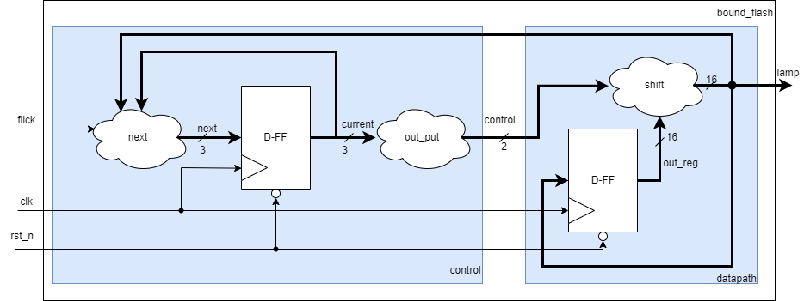

Figure 3.1: Block diagram of Bound Flasher

|  |  |  |  |  |  |  |  |  |  |  |  |  |  |  |  |  |  |  |  |  |
| --- | --- | --- | --- | --- | --- | --- | --- | --- | --- | --- | --- | --- | --- | --- | --- | --- | --- | --- | --- | --- |
| |  |  |  |  | | --- | --- | --- | --- | | Signal | Width | In/Out | Description | | clk | 1 | In | Clock signal – Active High. | | rst_n | 1 | In | Reset signal – Active Low. | | flick | 1 | In | Flick signal. | | lamp | 16 | Out | Output 16 lamp. | |

Table 3.1: Block diagram of Bound Flasher Description

## 3.2. State Machine

When rst_n == 1’b0, current state of state machine will change state to INIIT.

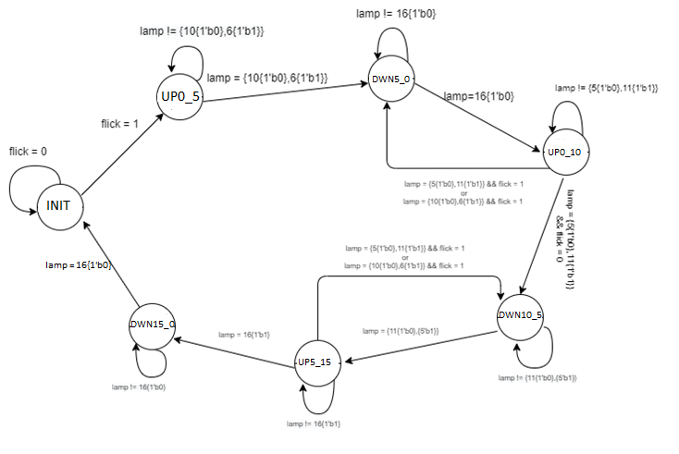

Figure 3.2: State Machine of Bound Flasher

|  |  |  |  |
| --- | --- | --- | --- |
| Signal | Width | In/Out | Description |
| flick | 1 | In | Flick signal. To start the system or return to previous state. |
| lamp | 16 | In | Value of lamp to determine state lamp turn on or turn of. |

Table 3.2: variable name of State machine

|  |  |
| --- | --- |
| State name | Description |
| INIT | This is initial state of bound_flasher.  At this state, all the lamps will be 0. |
| UP0_5 | This state is when lamps turn on gradually from 16’b 0000_0000_0000_0001 to 16’b 0000_0000_0011_1111. |
| DWN5_0 | This state is when lamps turn off gradually from 16’b 0000_0000_0011_1111 to 16’b 0000_0000_0000_0000. |
| UP0_10 | This state is when lamps turn on gradually from 16’b 0000_0000_0000_0001 to 16’b 0000_0111_1111_1111. |
| DWN10_5 | This state is when lamps turn off gradually from 16’b 0000_0111_1111_1111 to 16’b 0000_0000_0001_1111. |
| UP5_15 | This state is when lamps turn on gradually from 16’b 0000_0000_0011_1111 to 16’b 1111_1111_1111_1111. |
| DWN15_0 | This state is when lamps turn off gradually from 16’b 1111_1111_1111_1111to 16’b 0000_0000_0000_0000. Then back to INIT state. |

Table 3.3: state name of State machine

# 4. History

|  |  |  |  |
| --- | --- | --- | --- |
| Date | Author | Modified part | Description |
| 2022/11/8 | Nguyễn Tấn Thiên | All | New creation |
| 2022/12/3 | Nguyễn Tấn Thiên | State machine  Internal implementation  Interface | Diagran of state machine.  Block diagran of bound_flash.  Change name of interface. |
|  |  |  |  |
|  |  |  |  |