IC TRAINING CENTER VIET NAM
FUNDAMENTAL IC DESIGN AND VERIFICATION COURSE


FINAL PROJECT
TIMER IP DESIGN SPECIFICATION

Student: NGUYEN THANH LUAN
Class: IC32
Instructor: VU NGOC TUYEN

Contents
LIST OF TABLES 3
LIST OF FIGURES 3
1. Overview 1
1.1. Introduction 1
1.2. Main features 1
1.3. Block diagram 2
1.4. Interface signals 2
2.Register Specification 4
2.1. Register Summary 4
2.2. Timer Control Register (TCR) 4
2.3. Timer Data Register 0 (TDR0) 5
2.4. Timer Data Register 1 (TDR1) 5
2.5. Timer Compare Register 0 (TCMP0) 6
2.6. Timer Compare Register 1 (TCMP1) 6
2.7. Timer Interrupt Enable Register (TIER) 7
2.8. Timer Interrupt Status Register (TISR) 7
2.9. Timer Halt Control Status Register (THCSR) 8
3. Functional Description 9
3.1. APB slave 9
3.2. Control Counter 11
3.2. Counter-64b 17
3.4. Interrupt 20
4. History 22

LIST OF TABLES
Table 1: Interface signals of timer IP 2
Table 2: Register Summary 4
Table 3. Timer Control Register (TCR) 4
Table 4: Timer Data Register 0 (TDR0) 5
Table 5. Timer Data Register 1 (TDR1) 6
Table 6. Timer Compare Register 0 (TCMP0) 6
Table 7. Timer Compare Register 1 (TCMP1) 6
Table 8. Timer Interrupt Enable Register (TIER) 7
Table 9. Timer Interrupt Status Register (TISR) 7
Table 10. Timer Halt Control Status Register (THCSR) 8

LIST OF FIGURES
Figure 1: block diagram of Timer IP 2
Figure 2. TCR waveform 5
Figure 3. TCR logic design 6
Figure 4. TCMP0 logic design 8
Figure 5. sub-logic diagram generate wr_en_TCMP0 in TIMER_TOP 8
Figure 6. TCMP1 logic design 10
Figure 7. sub-logic diagram generate wr_en_TCMP1 in TIMER_TOP 10
Figure 8. THCSR logic diagram 13
Figure 9. APB Slave timing 14
Figure 10. APB slave logic diagram for generating wr_en and rd_en signal 15
Figure 11. APB slave logic diagram for generating tim_pslverr 15
Figure 12. Subdiagrams for generating is_tcr_write, div_change and en_change signal 16
Figure 13. Convert input signals into internal signals in timer_top 16
Figure 14. Control Counter timing 18
Figure 15. Halt Mode timing 19
Figure 16. Control Counter logic diagram 20
Figure 17. Internal Counter logic diagram 21
Figure 18. Generate increase_cnt signal 21
Figure 19. cnt_clr generator logic diagram 22
Figure 20. halt_active signal generator 23
Figure 21. Counter-64b timing 24
Figure 22. Counter 64-b logic diagram 25
Figure 23. TDR0 and TDR1 logic diagram 25
Figure 24. tdr0/1_wr_en logic diagram 26
Figure 25. interrupt timing 27
Figure 26. Interrupt logic diagram 27
Figure 27. Support signal for the interrupt logic diagram 28

1. Overview

1.1. Introduction
The Timer IP is an essential module integrated into the chip to generate accurate timing intervals or control the timing of various internal circuit operations. For this final project, the timer module is customized from the CLINT (Core Local Interruptor) module found in industrial RISC-V architectures. Its primary function is to generate hardware interrupts based on specific user-defined settings.
The Timer IP can be utilized in a diverse range of system applications, including:
- Pulse Generation: Creating precise timing pulses for external or internal triggers.
- Delay Generation: Implementing controlled wait periods within system operations.
- Event Generation: Signaling specific hardware events at programmed intervals.
- PWM (Pulse Width Modulation) Generation: Controlling power or signaling through modulated pulse widths.
- Interrupt Generation: The core application of this project, used to notify the CPU when the 64-bit counter reaches a programmed threshold.

1.2. Main features
The timer has the following features:
- 64-bit count-up ▪ 12-bit address
- Register set is configured via APB bus (IP is APB slave).
- Support level:
  - Support wait state (1 cycle is enough) and error handling
  - Support byte access
  - Support halt (stop) in debug mode
- Timer uses an active low async reset.
- Counter can be counted based on the system clock or divided up to 256.
- Support timer interrupt (can be enabled or disabled)

1.3. Block diagram
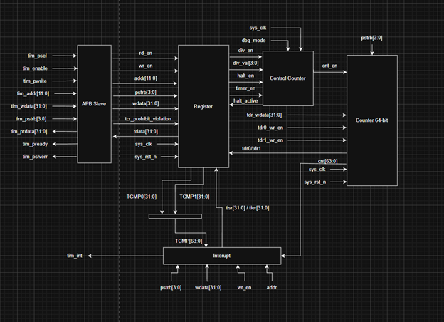
Figure 1: block diagram of Timer IP
This TIMER IP will have five main blocks: APB Slave, Register, Interrupt, Control Counter, and Counter-64bit.
- APB Slave: all the input signals will go through this block first, and the output will be all the internal signals of the Timer IP. This block also prevents some input errors and supports the wait state.
- Register Block: consists of TCR, TCMP0, TCMP1, THCSR. Each register has its main functional usage. The design of each register will be demonstrated in the section below.
- Control Counter block: its job is to generate the cnt_en signal for the Counter 64-bit and support the halt mode for the TIMER IP.
- Counter 64-bit: this module includes 2 registers, TDR0 and TDR1, which are used to store the value of the counter.

1.4. Interface signals
Table 1: Interface signals of timer IP
Signal name | Width | Direction | Description
sys_clk | 1 | I | System clock signal for TIMER IP
sys_rst_n | 1 | I | System low-active reset signal for TIMER IP
tim_psel | 1 | I | Peripheral Select signal. This shows that the TIMER IP has been selected for data transfer.
tim_pwrite | 1 | I | Peripheral Write signal. It is High when wanting to write, and it is Low when waiting to read from registers.
tim_penable | 1 | I | Peripheral Enable. Using for sencond access phase for supporting waiting state.
tim_paddr [11:0] | 12 | I | Peripheral Address Signal. This signal will drive the address to write to the register at that address | read value from register at that address
tim_pwdata[31:0] | 32 | I | Peripheral Write data. Data for being written to the register.
tim_prdata[31:0] | 32 | O | Peripheral read data. Data we read from the register.
tim_pstrb[3:0] | 4 | I | Peripheral Strobe signal. Specifies which byte lanes of the write data bus contain valid information for the register update.
tim_pready | 1 | O | Peripheral Ready Signal. Used to extend APB transfer cycle (support waiting state).
tim_pslverr | 1 | O | Peripheral Slvave Error. Indicates a transfer failure.
tim_int | 1 | O | Interrupt Signal. This is High when the intterupt occur in the Interrupt block.
dbg_mode | 1 | I | Debug mode signal. This signal is used for using halt mode.

2.Register Specification

2.1. Register Summary
Table 2: Register Summary
Offset | Abbreviation | Register name
0x00 | TCR | Timer Control Register
0x04 | TDR0 | Timer Data Register 0
0x08 | TDR1 | Timer Data Register 1
0x0C | TCMP0 | Timer Compare Register 0
0x10 | TCMP1 | Timer Compare Register 1
0x14 | TIER | Timer Interrupt Enable Register
0x18 | TISR | Timer Interrupt Status Register
0x1C | THCSR | Timer Halt Control Status Register
Others | Reserved

2.2. Timer Control Register (TCR)
Offset address: 0x0
Reset value: 0x0000_0100
31 | 30 | 29 | 28 | 27 | 26 | 25 | 24 | 23 | 22 | 21 | 20 | 19 | 18 | 17 | 16
Reserved

15 | 14 | 13 | 12 | 11 | 10 | 9 | 8 | 7 | 6 | 5 | 4 | 3 | 2 | 1 | 0
Reserved |  |  |  | DIV_VAL[3:0] |  |  |  | Reserved |  |  |  |  |  | DIV_  EN | TIM_  EN
 |  |  |  | rw |  |  |  |  |  |  |  |  |  | rw | rw

Table 3. Timer Control Register (TCR)
Bit | Name | Type | Default value | Description
31:12 | Reserved | RO | 20’b0 | Reserved
11:8 | DIV_VAL[3:0] | RW | 4’b0001 | Counter control mode setting:  - 4’b0000: Counting speed is not divided  - 4’b0001: Counting speed is divided by 2 (default)  - 4’b0010: Counting speed is divided by 4  - 4’b0011: Counting speed is divided by 8  - 4’b0100: Counting speed is divided by 16  - 4’b0101: Counting speed is divided by 32  - 4’b0110: Counting speed is divided by 64  - 4’b0111: Counting speed is divided by 128  - 4’b1000: Counting speed is divided by 256  - Others is prohibited to be written  div_val is prohibited to change when timer_en is High. Access is error response in this case.
7:2 | Reserved | RO | 6’b0 | Reserved
1 | DIV_EN | RW | 1’b0 | Counter control mode enables  - 0: Disable. Counter counts with normal speed based on the system clock  - 1: Enable. The counting speed of the counter is controlled based on div_val  div_en is prohibited to change when timer_en is High. Access is error response in this case.
0 | TIM_EN | RW | 1’b0 | Timer enable  - 0: Disable. Counter does not count  - 1: Enable. Counter starts counting.  Timer_en changes from High to Low will initialize the TDR0/1 to their initial value.

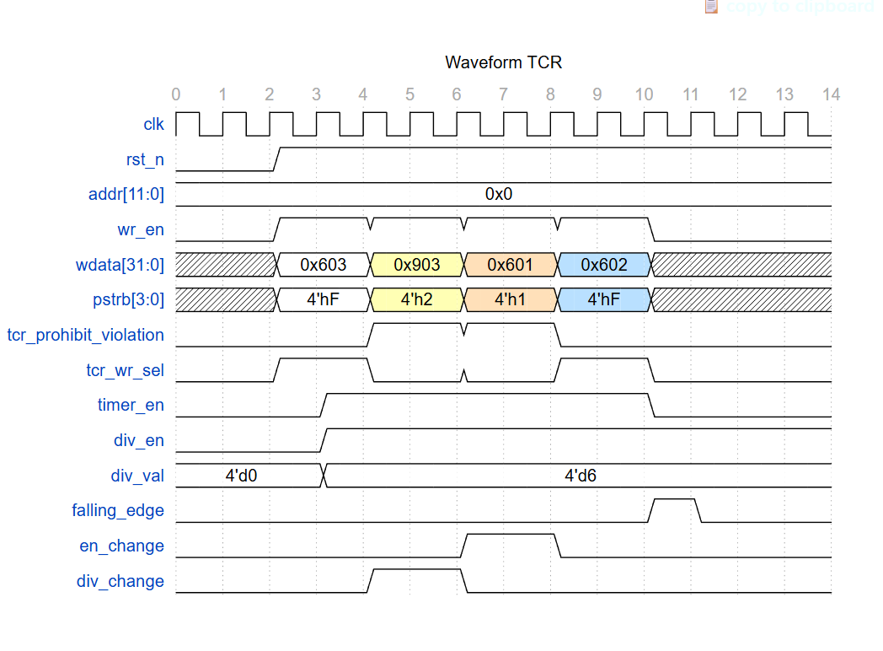
Figure 2. TCR waveform

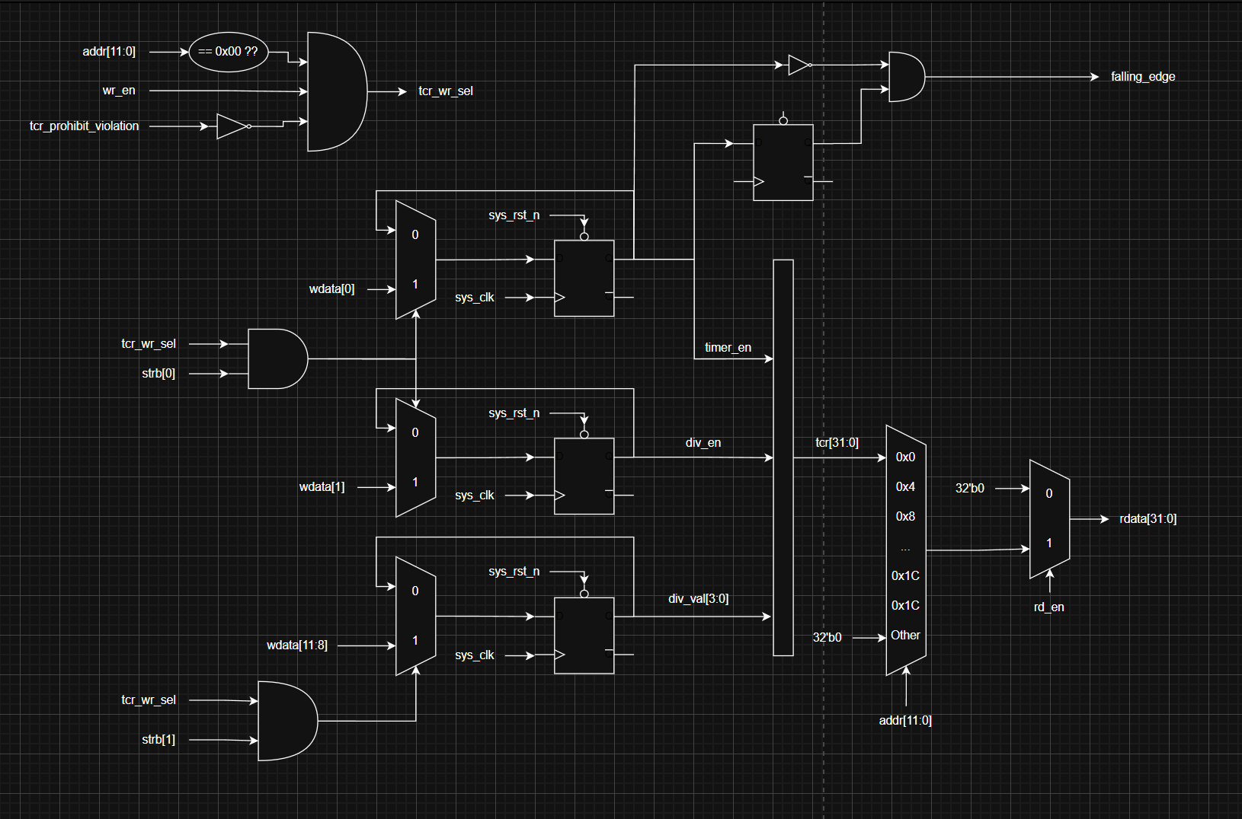
Figure 3. TCR logic design

2.3. Timer Data Register 0 (TDR0)
Offset address: 0x4
Reset value: 0x0000_0000
31 | 30 | 29 | 28 | 27 | 26 | 25 | 24 | 23 | 22 | 21 | 20 | 19 | 18 | 17 | 16
rw

15 | 14 | 13 | 12 | 11 | 10 | 9 | 8 | 7 | 6 | 5 | 4 | 3 | 2 | 1 | 0
rw

Table 4: Timer Data Register 0 (TDR0)
Bit | Name | Type | Default value | Description
31:0 | TDR0 | RW | 32’h0000_0000 | Lower 32-bit of 64-bit counter  The value of this register is clear to the initial value when timer_en changes from High to Low.

2.4. Timer Data Register 1 (TDR1)
Offset address: 0x8
Reset value: 0x0000_0000
31 | 30 | 29 | 28 | 27 | 26 | 25 | 24 | 23 | 22 | 21 | 20 | 19 | 18 | 17 | 16
rw

15 | 14 | 13 | 12 | 11 | 10 | 9 | 8 | 7 | 6 | 5 | 4 | 3 | 2 | 1 | 0
rw

Table 5. Timer Data Register 1 (TDR1)
Bit | Name | Type | Default value | Description
31:0 | TDR1 | RW | 32’h0000_0000 | Upper 32-bit of 64-bit counter  The value of this register is clear to the initial value when timer_en changes from High to Low.

2.5. Timer Compare Register 0 (TCMP0)
Offset address: 0xC
Reset value: 0xFFFF_FFFF
31 | 30 | 29 | 28 | 27 | 26 | 25 | 24 | 23 | 22 | 21 | 20 | 19 | 18 | 17 | 16
rw

15 | 14 | 13 | 12 | 11 | 10 | 9 | 8 | 7 | 6 | 5 | 4 | 3 | 2 | 1 | 0
rw

Table 6. Timer Compare Register 0 (TCMP0)
Bit | Name | Type | Default value | Description
31:0 | TCMP0 | RW | 32’hFFFF_FFFFF | Lower 32-bit of 64-bit compare value.  The interrupt pending bit is asserted when counter value is equal to compare value.
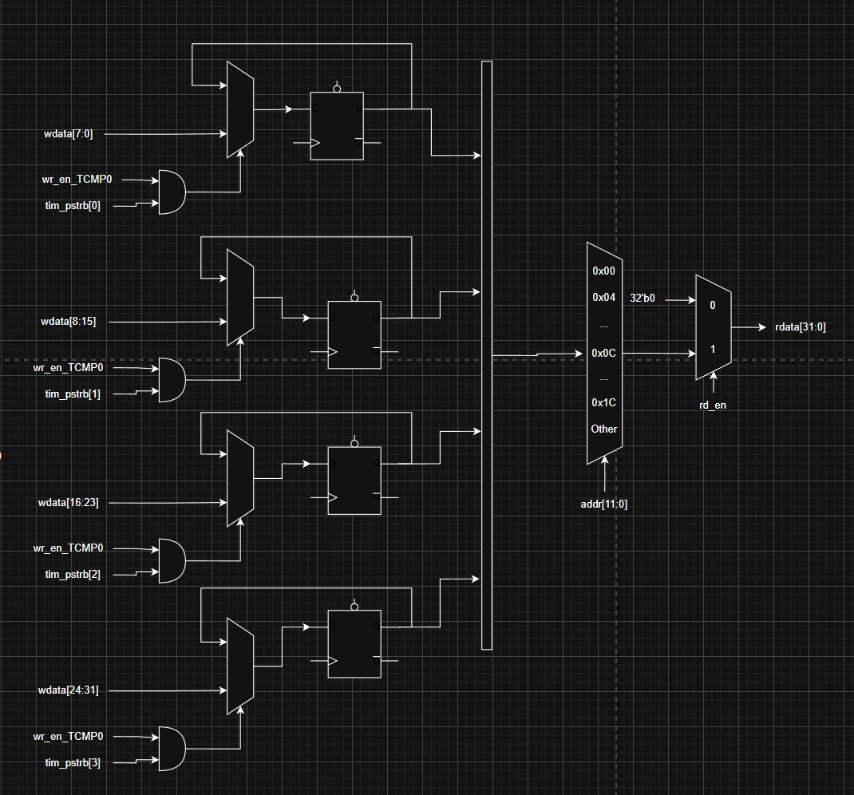
Figure 4. TCMP0 logic design
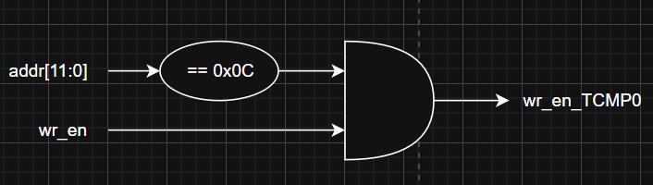
Figure 5. sub-logic diagram generate wr_en_TCMP0 in TIMER_TOP

2.6. Timer Compare Register 1 (TCMP1)
Offset address: 0x10
Reset value: 0xFFFF_FFFFF
31 | 30 | 29 | 28 | 27 | 26 | 25 | 24 | 23 | 22 | 21 | 20 | 19 | 18 | 17 | 16
rw

15 | 14 | 13 | 12 | 11 | 10 | 9 | 8 | 7 | 6 | 5 | 4 | 3 | 2 | 1 | 0
rw

Table 7. Timer Compare Register 1 (TCMP1)
Bit | Name | Type | Default value | Description
31:0 | TCMP1 | RW | 32’hFFFF_FFFF | Lower 32-bit of 64-bit compare value.  The interrupt pending bit is asserted when counter value is equal to compare value.

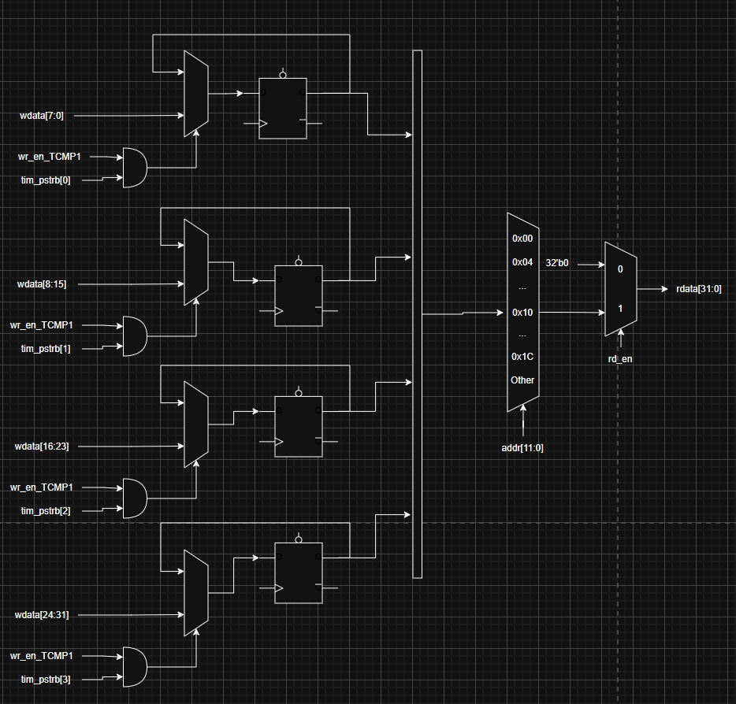
Figure 6. TCMP1 logic design
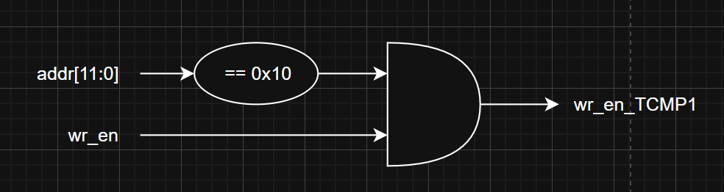
Figure 7. sub-logic diagram generate wr_en_TCMP1 in TIMER_TOP

2.7. Timer Interrupt Enable Register (TIER)
Offset address: 0x14
Reset value: 0x0000_0000
31 | 30 | 29 | 28 | 27 | 26 | 25 | 24 | 23 | 22 | 21 | 20 | 19 | 18 | 17 | 16
Reserved
ro

15 | 14 | 13 | 12 | 11 | 10 | 9 | 8 | 7 | 6 | 5 | 4 | 3 | 2 | 1 | 0
Reserved |  |  |  |  |  |  |  |  |  |  |  |  |  |  | Int_en
ro |  |  |  |  |  |  |  |  |  |  |  |  |  |  | rw

Table 8. Timer Interrupt Enable Register (TIER)
Bit | Name | Type | Default value | Description
31:1 | Reserved | RO | 31’b0 | Reserved
0 | int_en | RW | 1’b0 | Timer interrupt enable  - 0: Timer interrupt is disabled.  - 1: Timer interrupt is enabled.  When this bit is 0, no timer interrupt is output.  When this bit is 1, timer interrupt pending bit can be output (interrupt pending bit is set when counter value equals the compare value).  Clearing this bit to 0 while the interrupt is asserting will mask the interrupt to 0, but does not affect the interrupt pending bit (TISR.int_st bit).

2.8. Timer Interrupt Status Register (TISR)
Offset address: 0x18
Reset value: 0x0000_0000
31 | 30 | 29 | 28 | 27 | 26 | 25 | 24 | 23 | 22 | 21 | 20 | 19 | 18 | 17 | 16
Reserved
ro

15 | 14 | 13 | 12 | 11 | 10 | 9 | 8 | 7 | 6 | 5 | 4 | 3 | 2 | 1 | 0
Reserved |  |  |  |  |  |  |  |  |  |  |  |  |  |  | int_st
ro |  |  |  |  |  |  |  |  |  |  |  |  |  |  | rw1c

Table 9. Timer Interrupt Status Register (TISR)
Bit | Name | Type | Default value | Description
31:1 | Reserved | RO | 31’b0 | Reserved
0 | int_st | RW1C | 1’b0 | Timer interrupt trigger condition status bit (interrupt pending bit)  - 0: the interrupt trigger condition does not occur.  - 1: the interrupt trigger condition occurred.  Write 1 when this bit is 1 to clear it to 0.  Writing 0 when this bit is 1 has no effect. Write to this bit when it is 0 has no effect.  Note 1: When the interrupt trigger condition occurred (counter reached the compare value), the counter continues to count normally.  Note 2: The clear condition has the highest priority.

2.9. Timer Halt Control Status Register (THCSR)
Offset address: 0x1C
Reset value: 0x0000_0000
31 | 30 | 29 | 28 | 27 | 26 | 25 | 24 | 23 | 22 | 21 | 20 | 19 | 18 | 17 | 16
Reserved
ro

15 | 14 | 13 | 12 | 11 | 10 | 9 | 8 | 7 | 6 | 5 | 4 | 3 | 2 | 1 | 0
Reserved |  |  |  |  |  |  |  |  |  |  |  |  |  | halt_ack | halt_req
ro |  |  |  |  |  |  |  |  |  |  |  |  |  | ro | rw

Table 10. Timer Halt Control Status Register (THCSR)
Bit | Name | Type | Default value | Description
31:2 | Reserved | RO | 30’b0 | Reserved
1 | halt_ack | RO | 1’b0 | Timer halt acknowledge  0: timer is not halted  1: timer is halted  Timer accepts the halt request only in the debug mode, indicated by debug_mode input signal.
0 | halt_req | RW | 1’b0 | Timer halt request  0: no halt req  1: timer is requested to halt

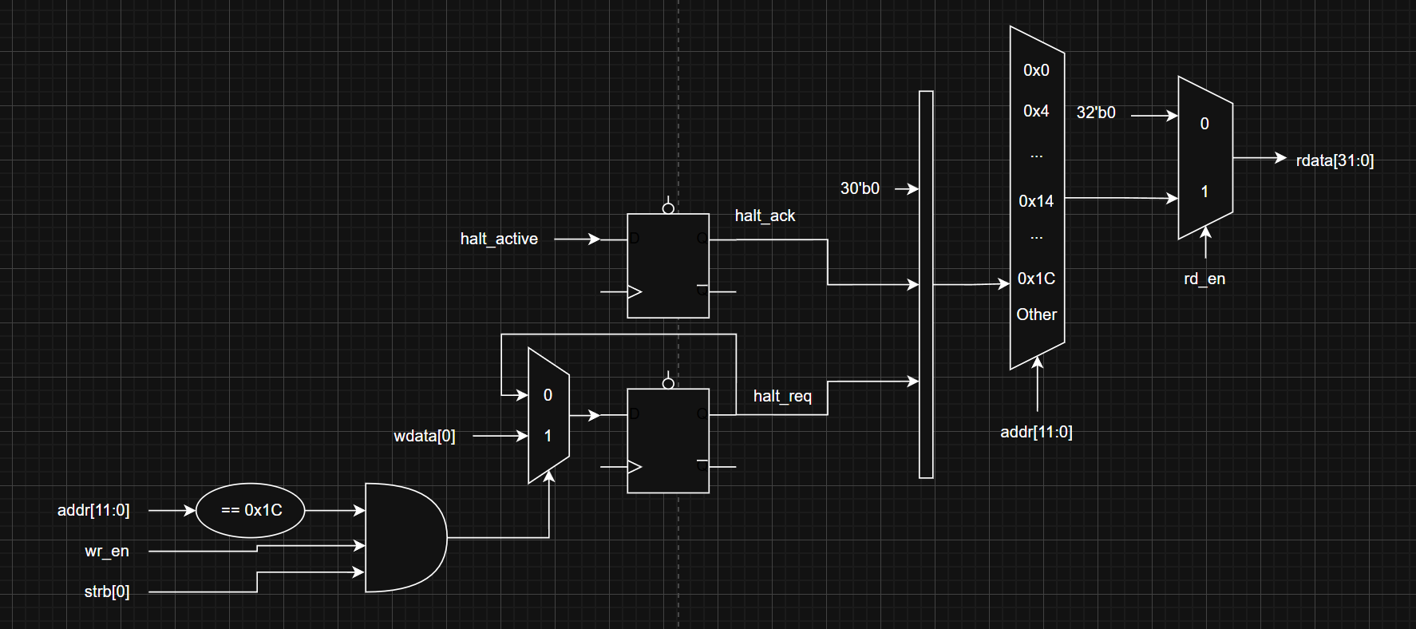
Figure 8. THCSR logic diagram

3. Functional Description

3.1. APB slave
The Timer IP uses an APB slave interface to receive configurations from the user and communicate with the system bus. This APB slave supports advanced features, including:
- 12-bit width address bus.
- 32-bit width read/write data bus.
- Support for a 1-cycle wait state (tim_pready).
- Support for error handling (tim_pslverr) to prevent prohibited accesses.
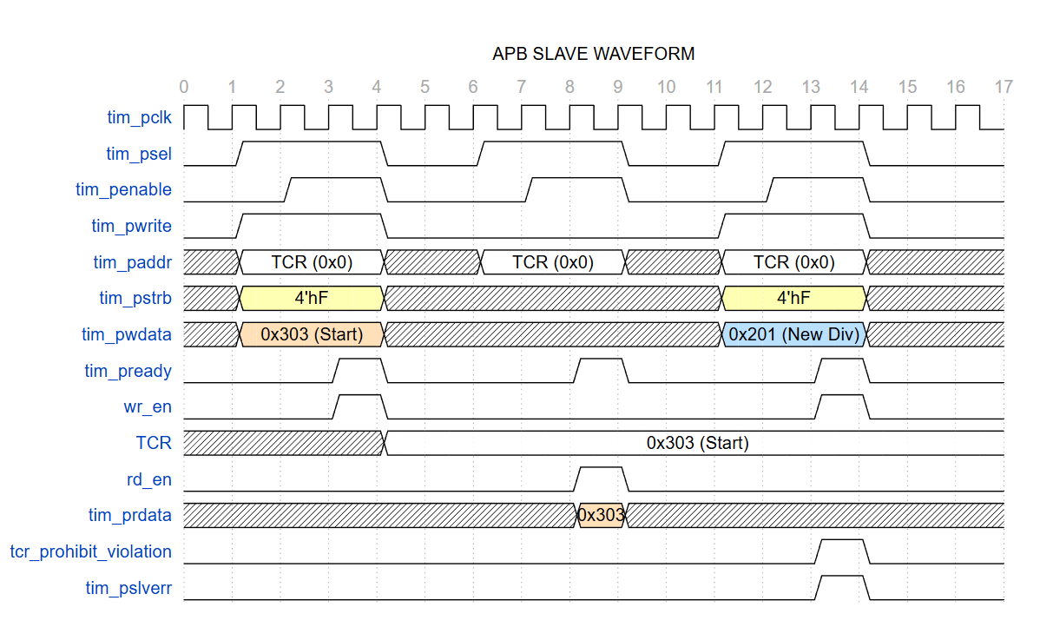
Figure 9. APB Slave timing
Case 1: create a wr_en signal by setting tim_psel, tim_penable, and tim_pwrite to High & after 1 cycle, the wr_en signal goes to High (support 1 cycle wait state). Additionally, the value 0x303 is written to the TCR & the timer_en is High after another cycle.
Case 2: Create a rd_en signal. Setting the tim_psel, tim_penable signals to High, the rd_en signal will go High after 1 cycle & the data will be read from the TCR. It will stop reading data when the rd_en goes Low again.
Case 3: create tcr_prohibit_violation and tim_plsverr signal. The timer_en in the TCR is now High because of the writing state before. Now, when I overwrite the new TCR.div_val, it should throw an error response back, which turns the tcr_prohibit_violation & tim_pslverr signals on.
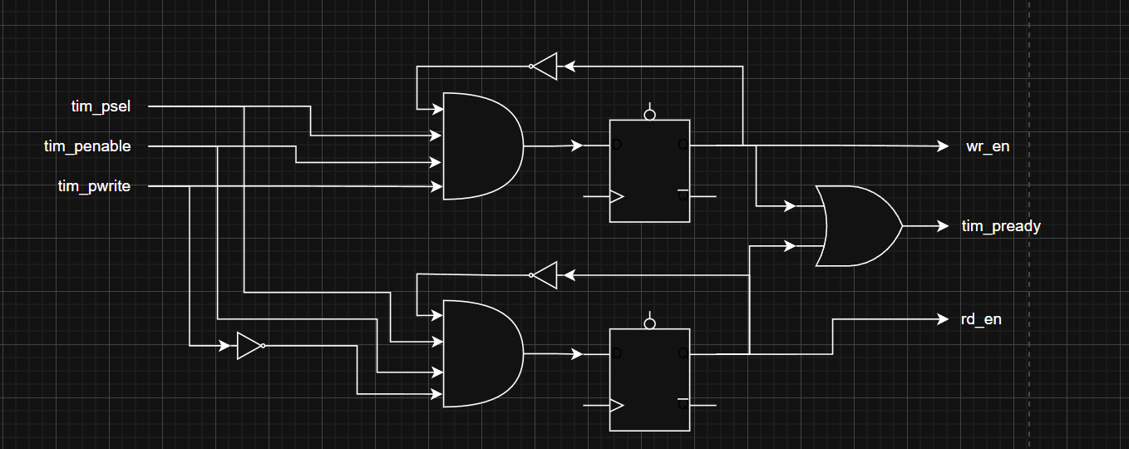
Figure 10. APB slave logic diagram for generating wr_en and rd_en signal
The logic generating the wr_en and rd_en signals follows a nearly identical structure:
- wr_en (next state) = tim_psel & tim_penable & tim_pwrite & ~wr_en
- rd_en (next state) = tim_psel & tim_penable & ~tim_pwrite & ~rd_en
Once either the wr_en or rd_en signal is asserted, the tim_pready signal is driven High via an OR gate. This transmits a ready response back to the Master, confirming that the slave is executing the read or write operation.
Furthermore, the design utilizes D-Flip Flops (D-FF) to intentionally introduce a 1-cycle wait state. This delay guarantees address and data stability on the bus, effectively minimizing the risk of timing violations and unexpected errors.
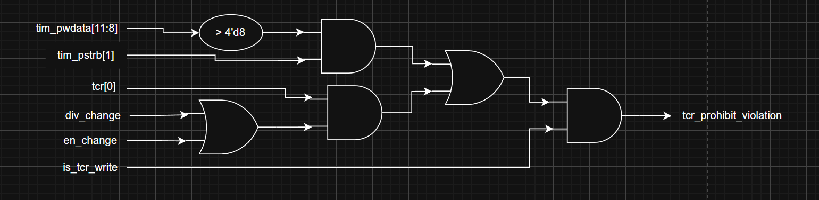
Figure 11. APB slave logic diagram for generating tim_pslverr
This diagram shows how to generate the tim_pslverr signal which handle some errors while accessing to read or write value to registers. The tim_pslverr will response when:
- div_en changes when timer_en is High
- div_val changes when timer_en is High
- div_val input is greater than 8
Here is some subdiagrams for creating div_change, en_change, is_tcr_write signal for the main logic diagram
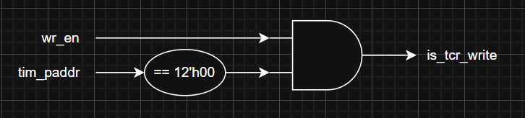
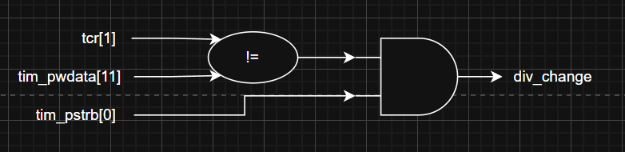
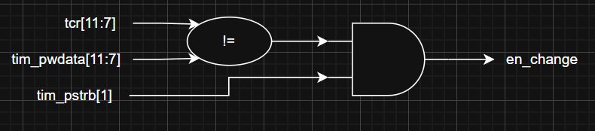
Figure 12. Subdiagrams for generating is_tcr_write, div_change and en_change signal

Other input signals will be directly connected with internal signal for the timer_top.
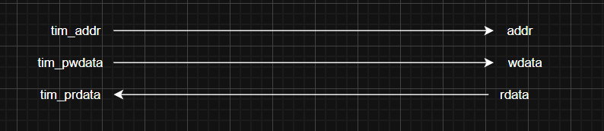
Figure 13. Convert input signals into internal signals in timer_top

3.2. Control Counter
This logic block consumes the following inputs: div_val[3:0], timer_en, div_en, halt_req, and dbg_mode. Its primary purpose is to generate the actual_cnt_en signal, which determines exactly when the 64-bit counter increments.
The control logic is divided into two main functional areas:
- Frequency Divisor Logic
  - A internal 8-bit divisor counter (cnt_prev) tracks the number of system clock cycles
  - A multiplexer selects a limit[7:0] value (ranging from 8'd0 to 8'd255) based on the div_val[3:0] setting from the TCR register
  - When div_en & timer_en is active, a comparator checks if cnt_prev has reached the selected limit. Once reached, a cnt_clr signal is generated to reset the internal divisor counter, and cnt_en is generated.
- Halt and Enable Gating
  - Enable Logic: The cnt_en signal is high if
timer_en is high and div_en is low
timer_en, div_en are all high & div_val is equal to 0
timer_en; div_en are all high, cnt_prev reaches the limit[7:0] & div_val != 0
  - Halt Mode:
The module supports a hardware halt feature. When both dbg_mode is high, and halt_req is set via the THCSR register, the halt_active signal is asserted. At that point, the module stops cnt_en and holds the inner counter.
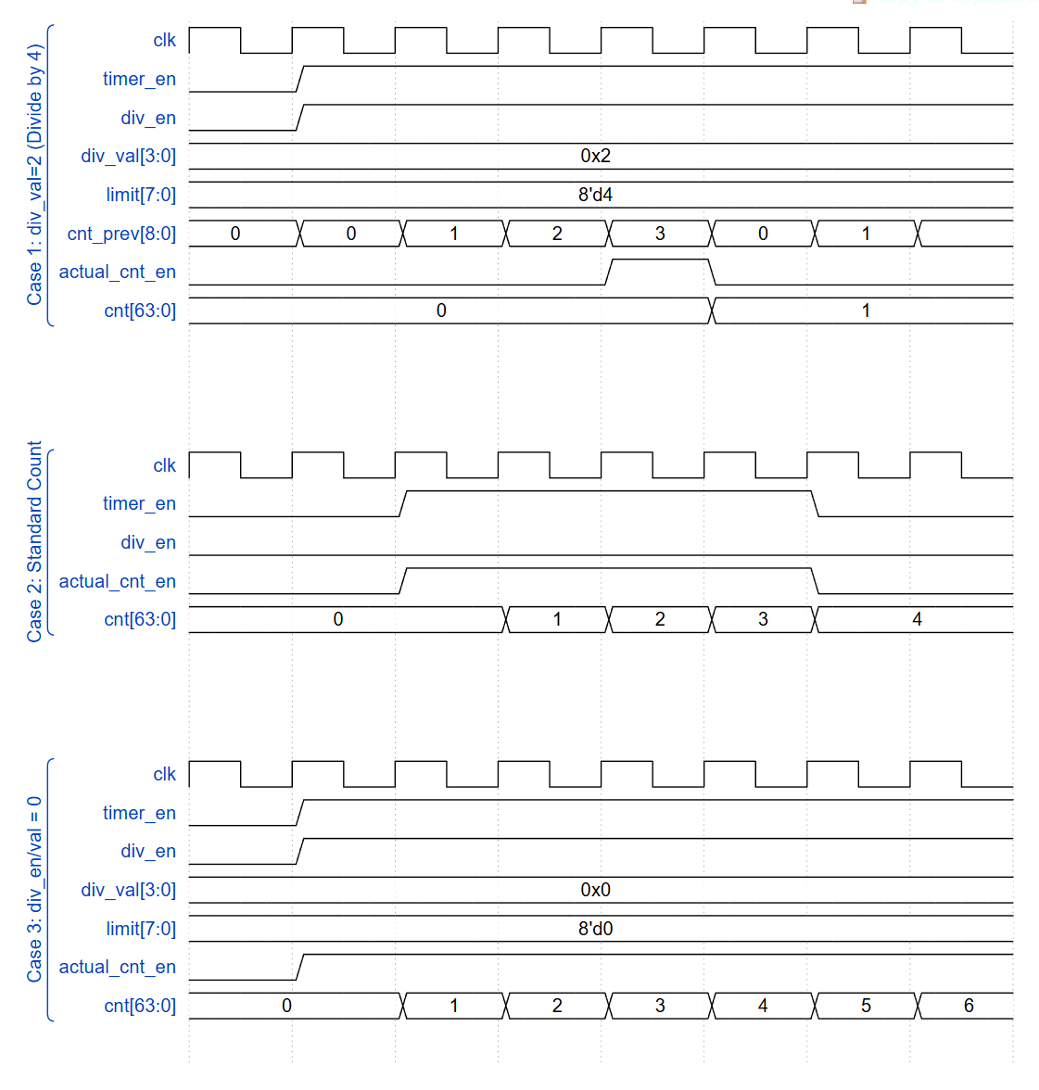
Figure 14. Control Counter timing
Case 1: Control Mode (Divide by 4)
timer_en = 1 & div_en = 1 & div_val = 4'b0010
These signals configure the multiplexer to set the limit[7:0] to a value of 3. With the div_en, the internal counter cnt_prev begins incrementing on each clock cycle. Once cnt_prev matches the selected limit, the actual_cnt_en signal is asserted for a single cycle. This pulse then triggers the 64-bit counter, causing cnt[63:0] to increase at one-fourth the speed of the system clock.
Case 2: Standard Count (Default Mode)
timer_en = 1 & div_en = 0
In this mode, the low div_en signal bypasses the divisor logic through the internal gate structure. This setup causes actual_cnt_en to be asserted immediately whenever timer_en is high. Consequently, the cnt[63:0] increases on every rising edge of the system clock, operating at full speed.
Case 3: Control Mode (No Division)
timer_en = 1 & div_en = 1 & div_val = 4'b0000
In this case, the prescaler comparison logic is bypassed. A dedicated AND gate directly evaluates the condition where timer_en, div_en, and div_val == 4'b0000 are all true. When this condition is met, this AND gate outputs a high signal that passes through the subsequent OR gate, continuously asserting the cnt_en signal. This allows the main timer counter to increment at the full system clock rate, effectively providing no frequency division.
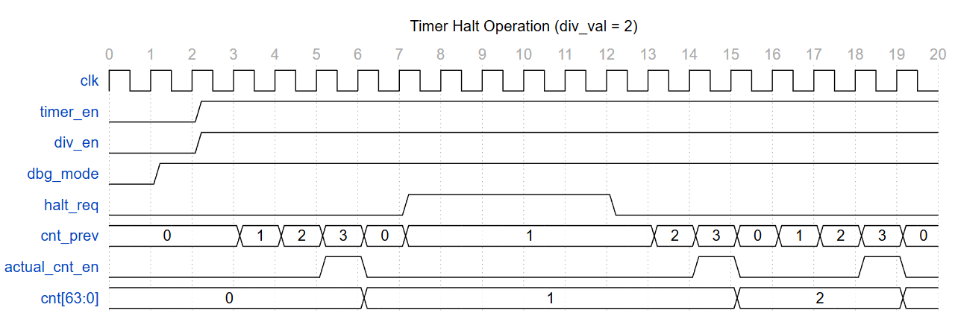
Figure 15. Halt Mode timing
Case 4: Halt Mode:
timer_en = 1 & div_en = 1 & dbg_mode = 1 & halt_req = 1
These signals trigger the halt mechanism within the control logic while the timer is operating in control mode. When both dbg_mode and halt_req are high, the halt_active signal is asserted. This signal gates the output AND gate, forcing actual_cnt_en to 0 regardless of whether the internal cnt_prev matches the limit[7:0]. As a result, the cnt[63:0] freezes its current value and stops incrementing until the halt_req is cleared.
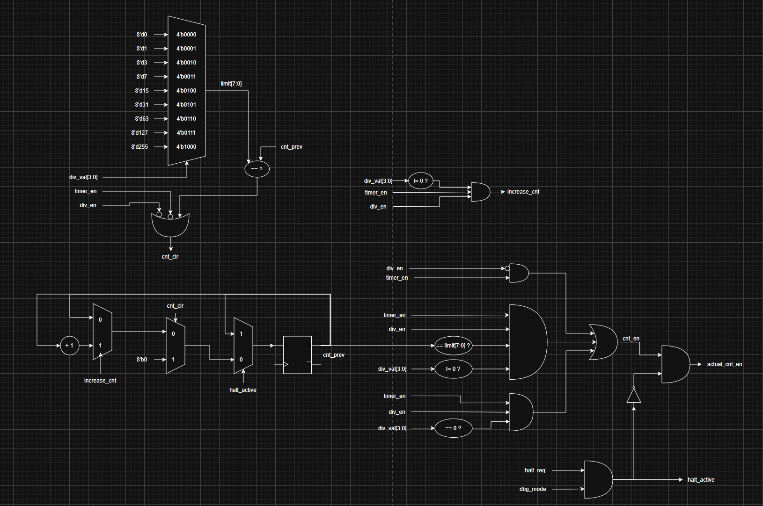
Figure 16. Control Counter logic diagram
In this logic diagram, we can see that the conditions for the cnt_en are:
cnt_en = div_en & timer_en
cnt_en = timer_en & div_en & (cnt_prev == limit) & (div_val != 0)
cnt_en = timer_en & div_en & (div_val == 0)
However, to have actual_cnt_en, we have to check whether halt_active is High or not. When the halt_active signal is Low, the actual_cnt_en equals cnt_en; otherwise, it will force the actual_cnt_en to Low.
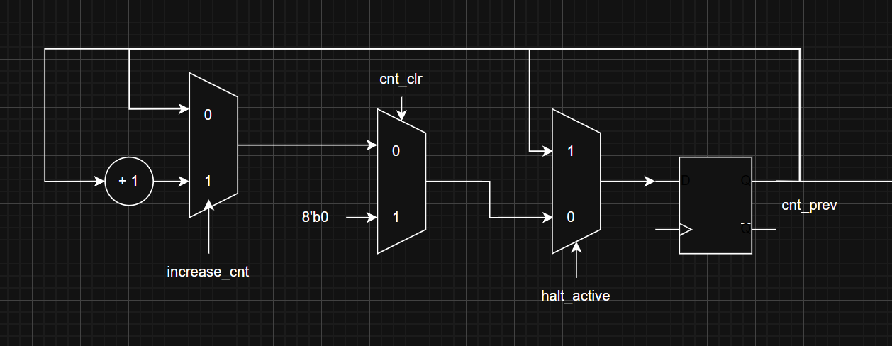
Figure 17. Internal Counter logic diagram
This Internal Counter generates the cnt_prev for the comparison with the limit[7:0]. It will be held when the halt_active is High. The cnt_clr signal will reset the internal counter and put it into the initial state. When increase_cnt is High, the cnt_prev will increase by cycles. Otherwise, it will be held.
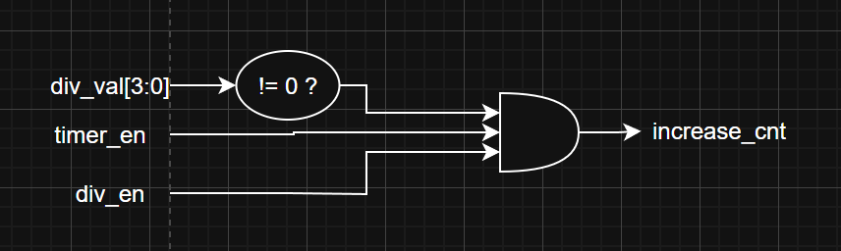
Figure 18. Generate increase_cnt signal
This increase_cnt signal acts as a qualified enable for the internal frequency divider, ensuring the counter only increments when timer_en signal is High, the div_en signal is High, and div_val != 0 is True. By passing these three mandatory conditions through an AND gate, the signal effectively prevents invalid "divide-by-zero" operations and ensures the counter remains stable and synchronized only when all system requirements for clock division are fully met.
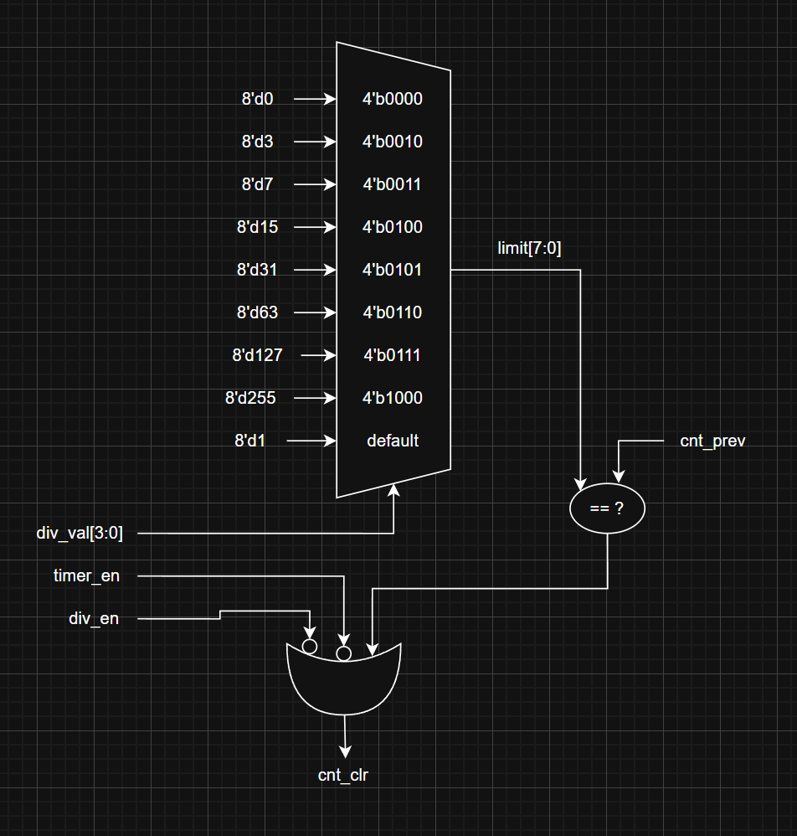
Figure 19. cnt_clr generator logic diagram
This cnt_clr logic diagram shows how to generate the cnt_clr signal. The cnt_clr is generated when the (cnt_prev == limit) or timer_en is Low, or div_en is Low. Moreover, the diagram also shows how to set the limit[7:0]. Each input value of div_val will set the limit[7:0]. When timer_en is High, the div_val cannot be changed because there is a part in the APB to stop the new input while the timer_en is High.
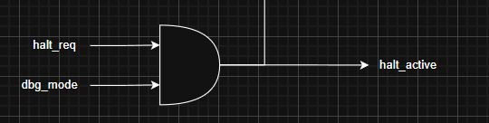
Figure 20. halt_active signal generator
The halt_active signal is generated when both the halt_req signal from the THCSR register and the external dbg_mode signal are High. When halt_active is asserted, it immediately interrupts the cnt_en signal and holds the value of the internal counter within the Control Counter module.

3.2. Counter-64b
The counter_64b is the core timing engine of the IP, responsible for maintaining a 64-bit count-up value. It is architecturally split into two 32-bit registers to interface with the 32-bit APB bus.
The counter consists of several integrated logic blocks:
- TDR0 (Timer Data Register 0): This register stores the lower 32 bits of the total 64-bit count. It is also designed for byte-accessing mode
- TDR1 (Timer Data Register 1): This register stores the upper 32 bits of the total 64-bit count. It is also designed for byte-accessing mode
- 64-bit Incrementer: An internal adder calculates cnt[63:0] + 1 continuously
- Control Gating: The counter only updates its value when the cnt_en signal is asserted
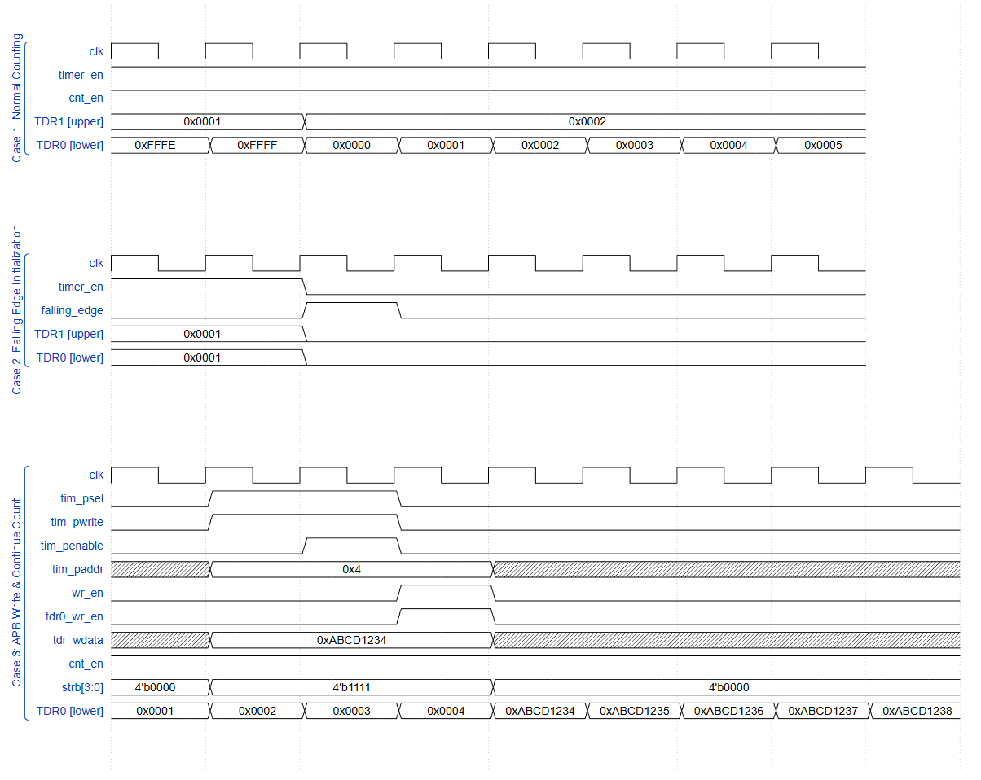
Figure 21. Counter-64b timing

Case 1: Normal Counting
timer_en = 1 & cnt_en = 1
The 64-bit counter increments in every clock cycle. The TDR0 stores the lower 32 bits of cnt[63:0]. On the other hand, the TDR1 stores the upper 32 bits of the cnt[63:0]. When the overflow occurs in a register, the value in the register automatically resets to the initial value.
Case 2: Falling Edge Initialization
timer_en = 1 → 0
When the falling_edge, which is equal to (timer_en & timer_en_delay), turns on, both registers, TDR0/1, are reset to their initial value, which is 0x0000_0000.
Case 3: APB Write & Continue Count
tdr0_wr_en = 1 & cnt_en = 1
The priority of tdr_wdata is higher, so after 1 cycle, the value of TDR0 is set to the new value. Then the counter continues counting. The same with the TDR1.
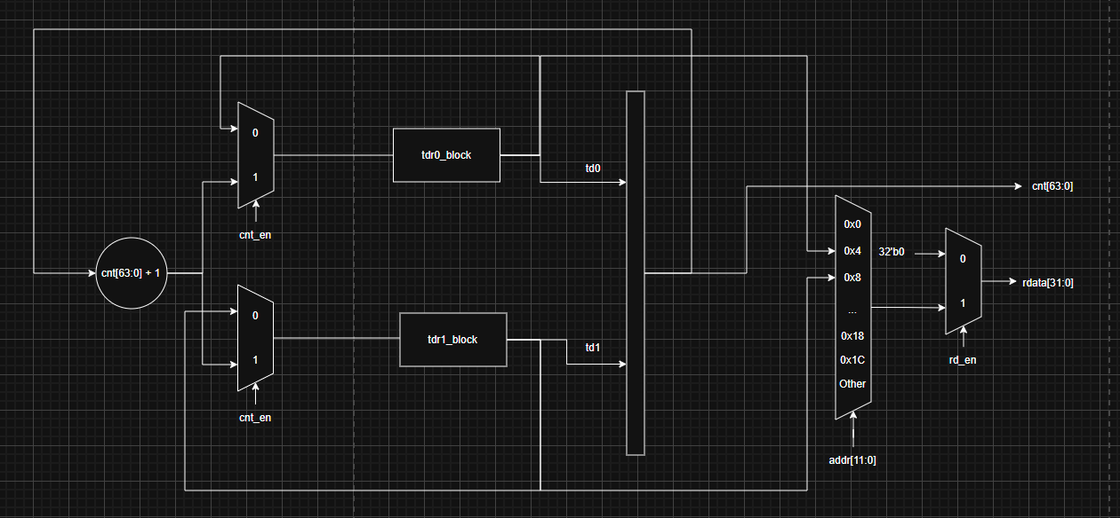
Figure 22. Counter 64-b logic diagram
In this Counter-64b logic diagram, we can see that there are 2 registers, TDR0 and TDR1. From the diagram, we can understand that if the cnt_en is High, for each cycle, the cnt[63:0] increases by 1 unit. We separate the cnt into 2 parts; the lower 32 bits go into the TDR0 register, and the upper 32 bits go into the TDR1 register for storing.
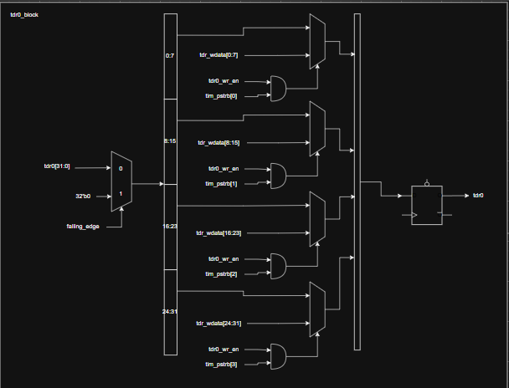 | 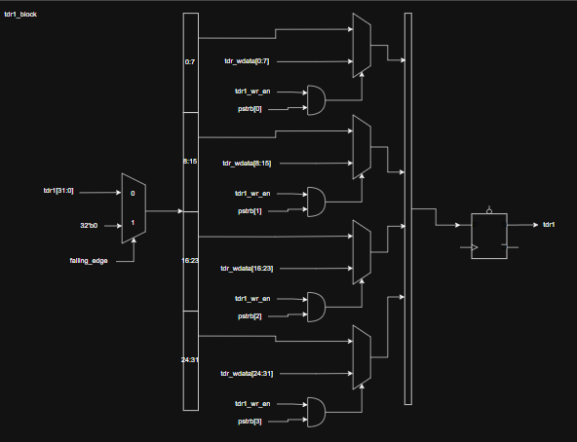
Figure 23. TDR0 and TDR1 logic diagram
In the TDR0/1 block, the highest priority is now the write mode. When a write data signal is present, the data will be written directly into the TDR0/1 register. If a falling_edge signal occurs, the TDR0/1 values will be reset to their initial state. If there are both failling_edge signal and a wdata mode, the register will select the wdata to store. Additionally, the registers continue to support byte access mode through strb[3:0].
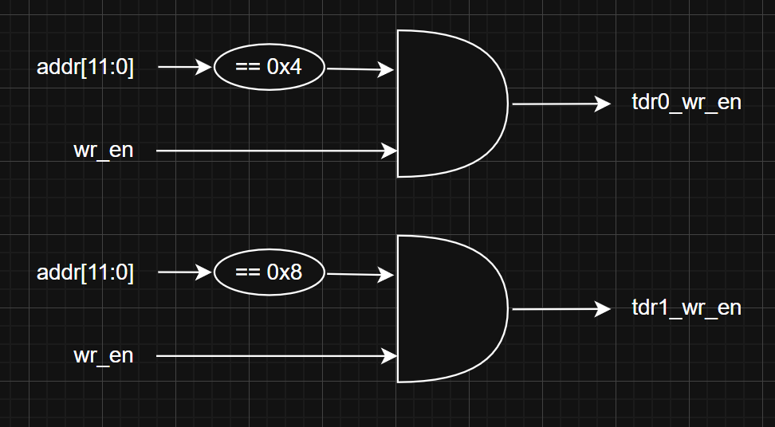
Figure 24. tdr0/1_wr_en logic diagram
This diagram shows how to generate the tdr0/1_wr_en.
The logic is tdr0/1_wr_en = (addr == 0x4/0x8) && wr_en

3.4. Interrupt
The Interrupt Block manages the generation, enabling, and clearing of the timer interrupt signal (tim_int). It ensures that the CPU is notified when the 64-bit counter reaches a user-defined threshold.
The logic is composed of three primary hardware structures:
- TIER (Timer Interrupt Enable Register)
- TISR (Timer Interrupt Status Register)
- Combinational Logic Part to generate the tim_int signal.
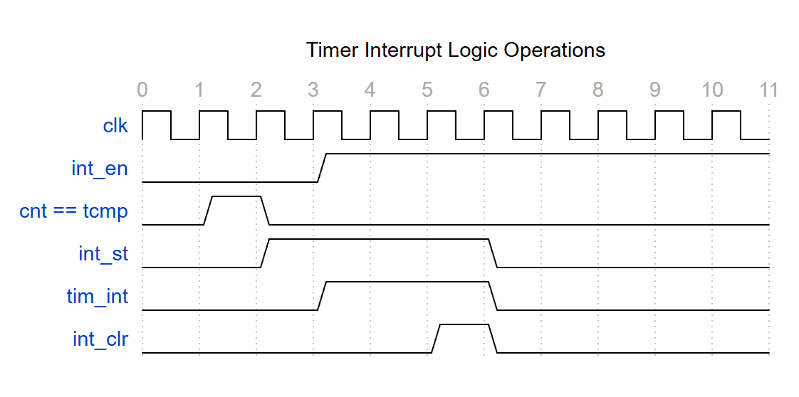
Figure 25. interrupt timing
In this waveform, we can see that tim_int is High when both int_en & int_st are High. These signals are got from the TISR and TIER registers, which are described above.
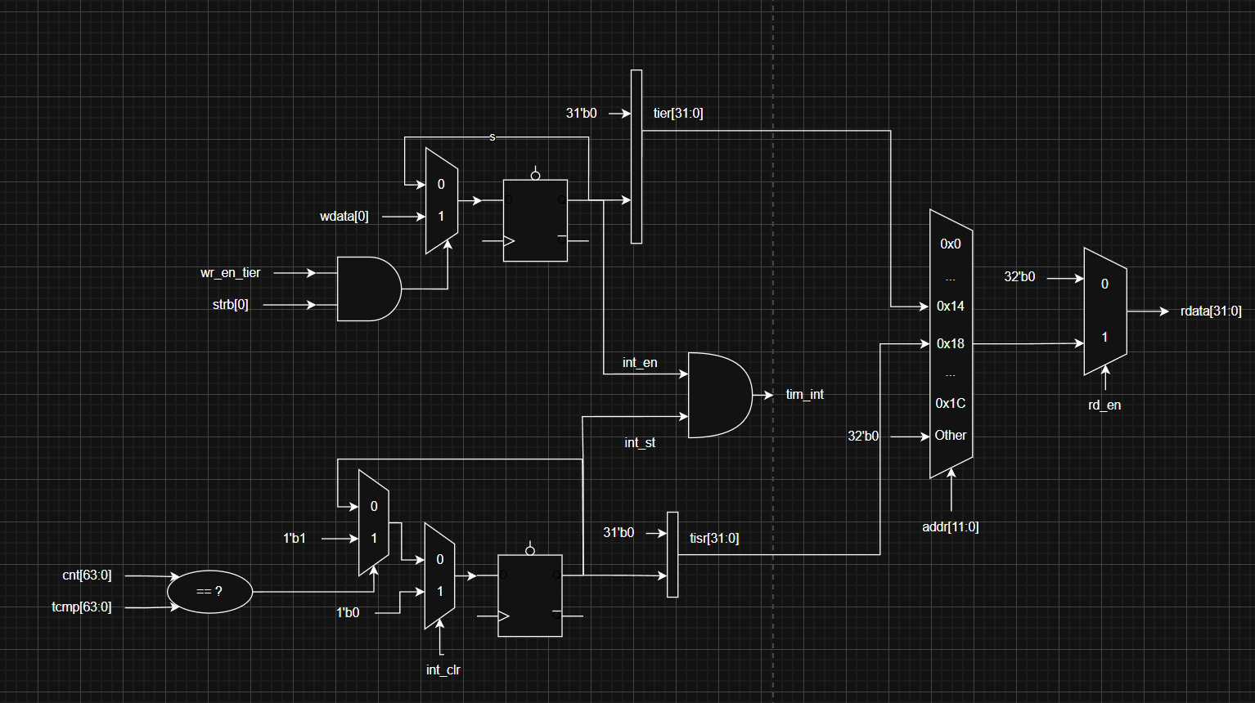
Figure 26. Interrupt logic diagram
From the interrupt logic diagram, we can see both the TISR and the TIER registers. There are int_en and int_st from both registers, and the logic for the tim_int signal = int_en & int_st.
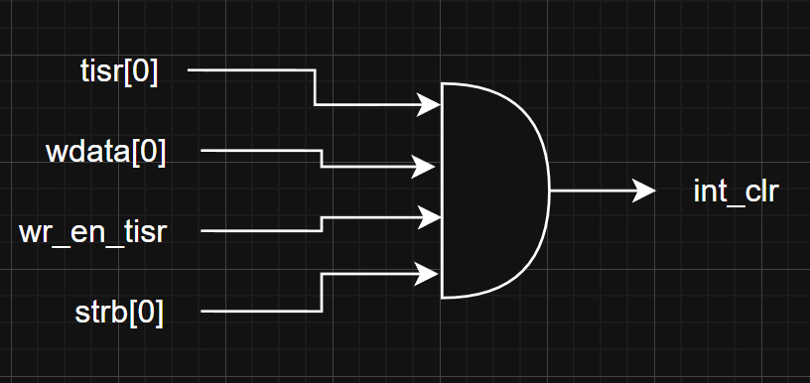
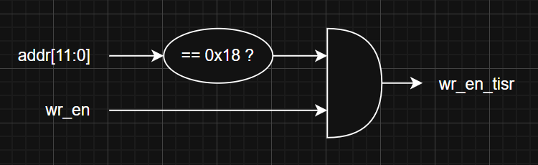
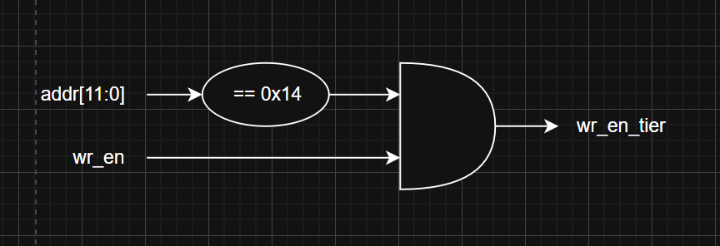
Figure 27. Support signal for the interrupt logic diagram

4. History
Date | Version | Description | Author
12/3/2026 | 1.0 | Newly created | Nguyen Thanh Luan
17/3/2026 | 1.1 | Fixing APB, Control Counter, Counter-64b | Nguyen Thanh Luan
20/3/2026 | 1.2 | Fixing the int_clr signal in the interrupt module. Fixing the TDR0/1 register priority statement. Fixing the waiting state APB Slave | Nguyen Thanh Luan
04/04/2026 | 1.3 | Fixing APB | Nguyen Thanh Luan
05/04/2026 | 1.4 | Addition TCR, TCMP0/1, THCSR logic diagram and waveform | Nguyen Thanh Luan

