Nguyễn Thanh Nhứt

MSSV: 21140001

Thực hành Tuần 3

Link github: <https://github.com/NguyenThanhNhut13/NewTechnology_Lab>

TẠO UPLOAD FILE/FOLDER S3

Tạo Bucket:

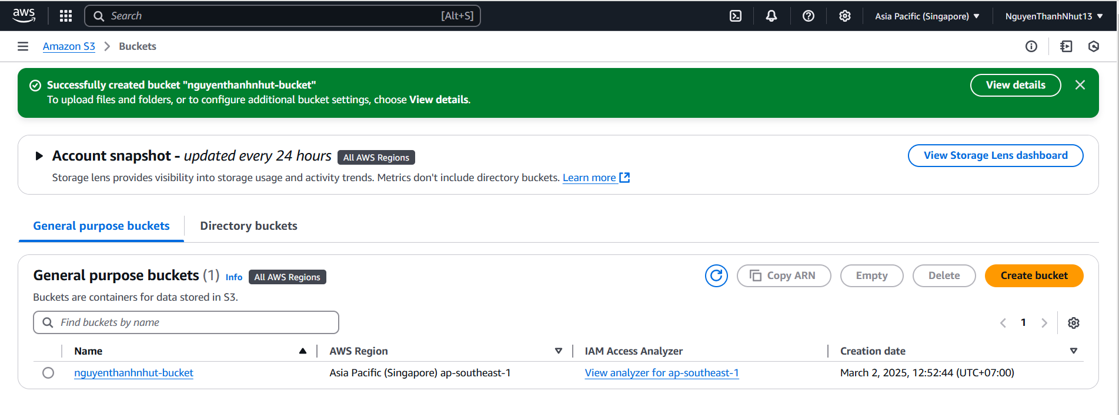

Upload file hoặc folder:  
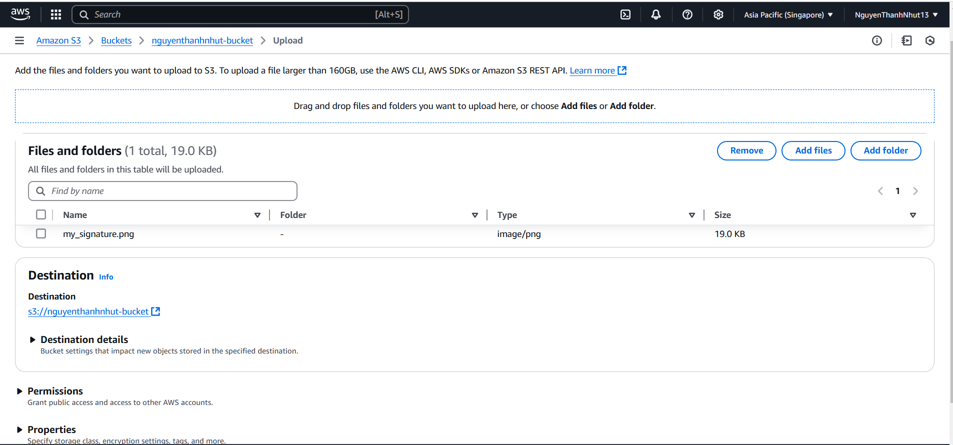

Permission:

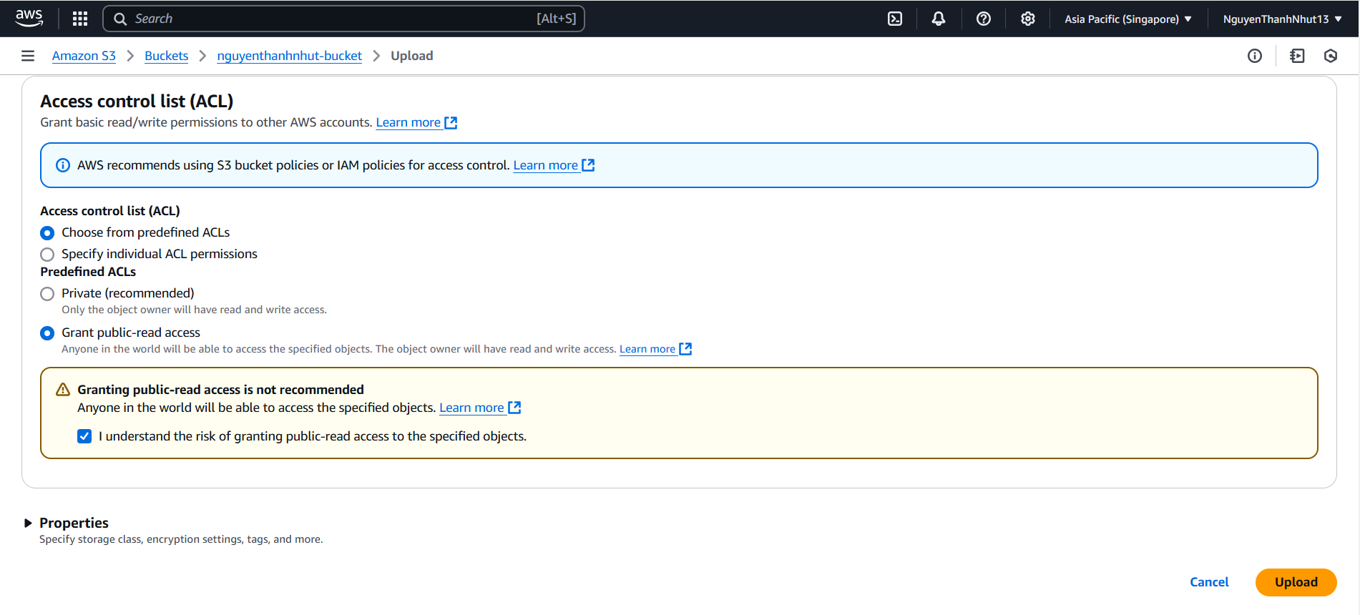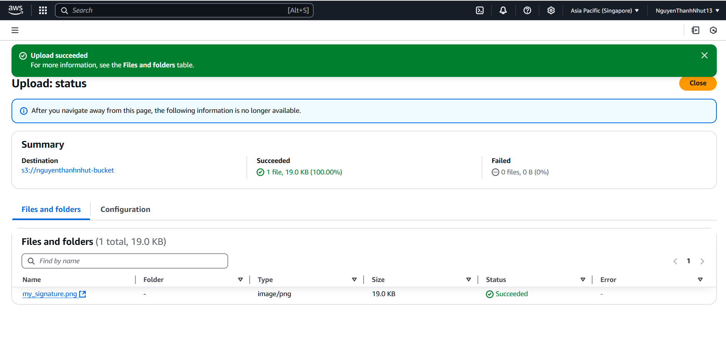

Edit premission files:

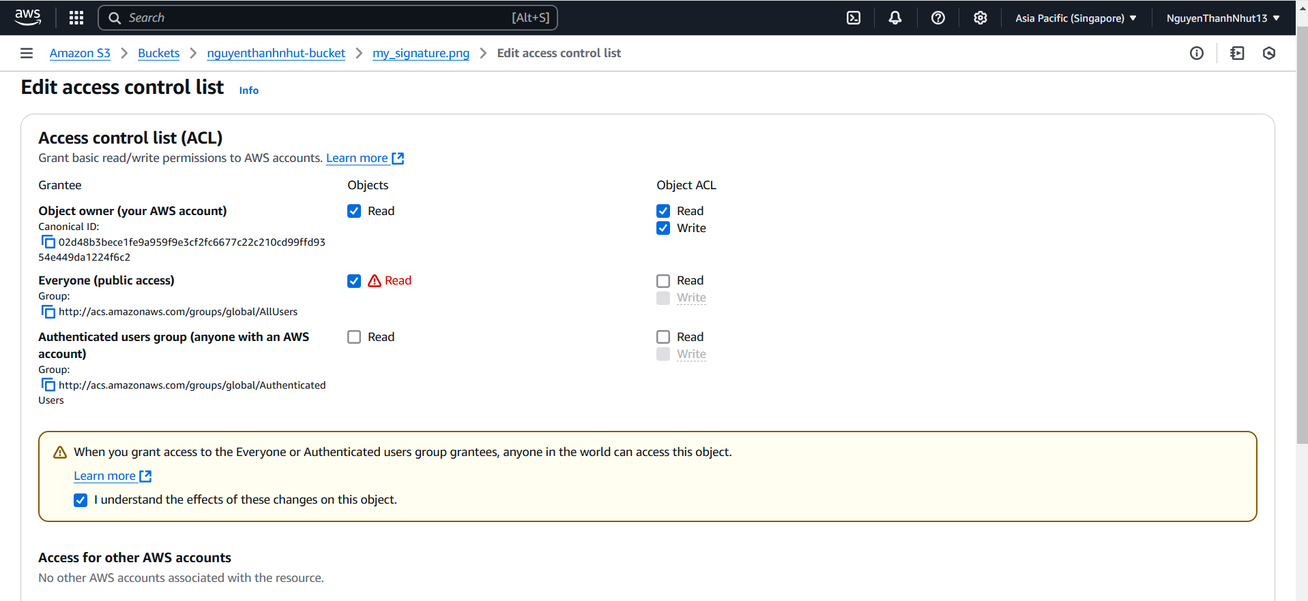

Open file in browser:

