The IT World

Professor: Duy Dang Pham Thien

Student: Nguyen The Minh

# TABLE OF CONTENT

Contents

TABLE OF CONTENT 2

Team profile 3

Team name 3

My personality test result [1] 3

Team profile 5

Tools 5

The link to my website 5

The link to the Github Repository 5

My comment on Github 6

Project Ideas 6

Overview 6

Motivation 6

Description 6

Tool and technologies 7

Skill required 7

Outcome 7

IT technologies 8

Artificial intelligent and machine learning 8

What does it do? 8

What is the likely impact? 9

How will this affect you? 9

Natural Language processing and chatterbots 10

What does it do? 10

What is the likely impact? 11

How will this affect you? 11

IT work 12

Reference 14

# Team profile

## Team name

When other people look at our team, the first thing they will be looking at is the name of our name that is why we must choose the name that will suit our group the best. It should be able to represent all our member or suit the interest of all the members. As for me, I would want the name of the group that I work in have the name “colen”. What that group name means is that try harder. It a reminder for everyone in my team to work hard and a hope for the group that my group will always try their best to finish the assignment and bring home the best result.

## My personality test result [1]

* Myers-Briggs test [2]

The result for the online Myers-Briggs test is that I am ISTP kind of person. It is like an observer but also the fastest person to join in and work to solve the problem. This kind of person is look at the core of the problem and solve it with all the information they got and not distracted by all the things around them. They do not solve problems with feeling but with knowledge and facts. They are like an observer and will be helping people when they need a helping hand.

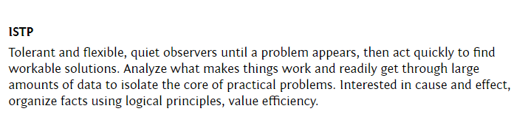

* Online learning style test result [3]

The result for my learning style online is that I am a Visual and Tactile learner. This learning style is more realistic and revolve around seeing, working with what I am learning. Once I saw it or work with it, I can remember it much better than just simply knowing and understanding about it. I also often. After learning about it, I will try to form a link between all of them in my mind or just solving it in my mind until I find a solution. That does not mean I am bad at learning just by listening because my auditory stat is also around 30% which is really close to the other 2. The result is that I can learn best by seeing, touching, feeling and reminiscent about it in my head later but just listening and dreaming of all the possibilities is still possible. (Nguyen The Minh, 2020)

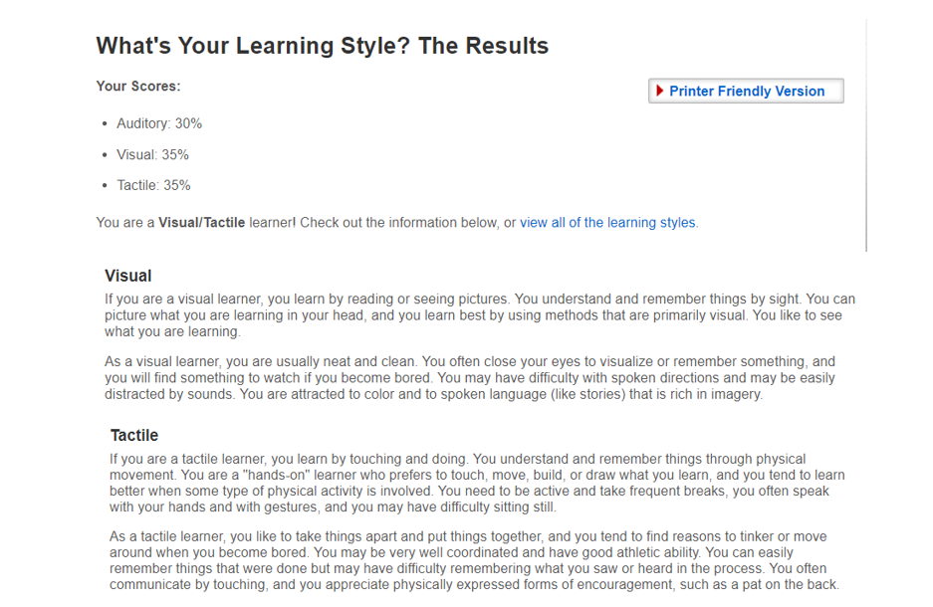

* The big five personality test [4]

This test summarize all of my personalities into 5 biggest points. It shows me that I am a creative, adaptive, calm, optimistic and always devote myself for the other. It is correct since it is depending on all the questions that I answered when I do the test. This test highlight that I am really devoting myself to the other and is listening to the other too much. It is somewhat true since I am always ready to take in more works to carry the team and easy sway by other opinion. Even when I am 100% sure of the answer, I can still maybe be sway if the other side is persistant enough. Moreover, I am also not too friendly to new people and it is true. I only sociable to the friends I already know but making new one by starting a conversation is closely impossible for me. Nevertheless, once the conversation start, I can say that I will (Nguyen The Minh, 2020)

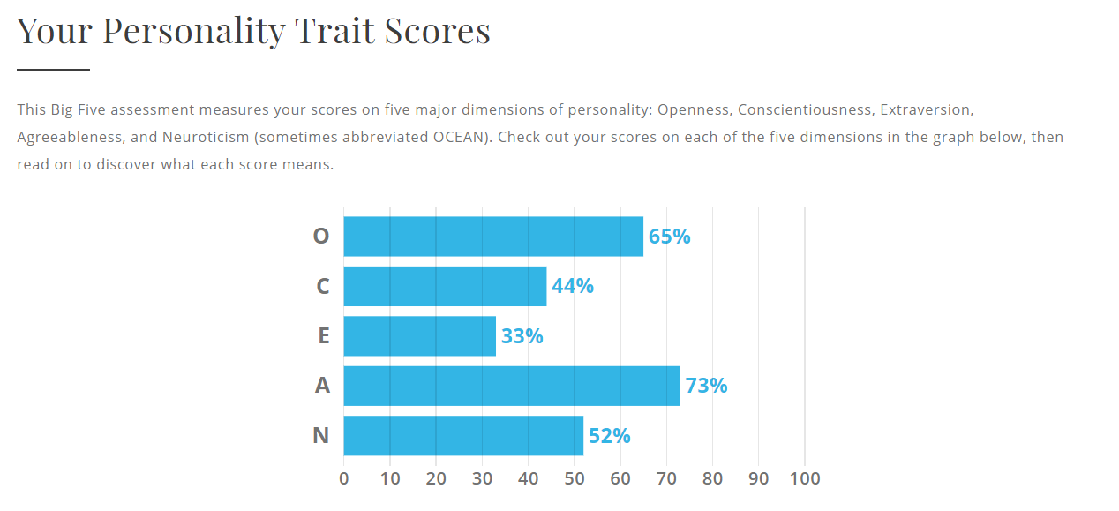

## Team profile

After taking the personality test, I have somewhat figure out my personality and my desired teammate. The very first teammate that I really want is a leader. I am more likely to be an observer from the Myers-Brigg test, but I am not too good at leading, so I really want to have a good leader. I can guarantee to finish my task on time and willing to help other teammates. I would also love to have the teammates who are energetic so that our group and conversation will go smoothly when we are working together. Other than that, I believe I can work just fine with every member’s personality if it is not observer since whenever they are in trouble, I am willing to help. It would be helpful if the there is somebody with the ability to dream and think of lots of new idea is good. I am a visual and tactical learner which resolve around seeing things and be able work based on that so it would be nice if there is someone to come up with ideas for the group. Having that person would make our work much better than just people follow the guideline. In conclusion, it would be nice if there are people that I mentioned above, however, even if there are not any, I will still do my best to bring home the best result. I am an adaptive, calm, and willing to devote myself so I believe I can work with everyone just fine. That is the team that I would love to have and work with for the final work and in the future project.

# Tools

## The link to my website

<https://nguyentheminh196.github.io/>

## The link to the Github Repository

<https://github.com/NguyenTheMinh196/NguyenTheMinh196.github.io>

## My comment on Github

I can see why people choose Github[5] over Google Drive when you are working in the same project. When we are coding, there are many cases that a few lines of code can mess up everything in your program and Github perfectly counter it. It has many good applications which are perfect for working on the program such as branching and command for push and pull. It also helpful because the leader can control what information is being add to the main program which help him to have the ability to know exactly what the program can do and what is its’ feature. However, it is more complicated comparing to GoogleDrive and it is closely attached to coding so I suggest that only programmer should use it while normal people can still use Google Drive. The reason that Github is being complicated is because coding is complicated and should be managed properly or else everyone work will be ruined.

# Project Ideas

## Overview

The project that I want to be working on is a personal Assistant AI on our computer which are like Alexa or Siri. This is an AI that can listen to our demand and carry it out. However, since mine knowledge and ability are still low, creating an advance AI that can learn and be better every time I converse is impossible for now. What I can create is just the hard code for the “AI” to know exactly what I want by listening to what I said and execute the command. It is like a FAQ chatterbot, but it can do much better than just answering some questions.

## Motivation

I have had deep passion for AI since it is what awake and promote my curiosity for IT and it is also my aim for learning IT. Moreover, the AI industry is currently a hot topic right now with everything in the world can be slowly replace by AI. Do you know that compare to last year, the global AI market in 2020 is expected grow up to nearly 54% in software market each year?[6] The personal AI that I want to developed is also a good start for those who are interested in learning about to get the general idea of what this all about. Moreover, it can be a good step for me to and everyone to understand the basic of a personal assistant AI.

## Description

Since I will be approaching the bare minimum of the AI personal assistant like Siri, I will be needing it to have the ability to recognize my speech and do what I want it to do. Firstly, it must have the ability to understand my speech to it and give me back a result by talking back to me. The AI speech can also be change depend on how you prefer it to be. It might not a natural conversation, but it will be surrounding what you want to do such as “search” for a fact or look at the time. After getting the question, it will proceed to the next step which is to analyze my question and give back an answer or start using the command to answer my demand. The command I give will be vary so the AI must also have various of feature to satisfy my desire.

The second most important feature for the personal assistant is be able to answer normal question and be able to search for information from Wikipedia. When we have any question or wanting to open a web, we ask the AI for it to open that tab or answer the question with information coming from online. It will be able my question however, it will only be taking information from Wikipedia, but it is still usable for most information we require when we are asking for AI. When opening the web, most likely that I will only be able to call out for the website that I have already code for the AI to recognize because AI might misinterpret what I say and open the wrong website.

The last feature for the AI is the ability to answer some common questions that require common knowledge. If we are asking common question such as “How are you?”, “What is your name?” or “What can you do?” then the AI do not need to take any information to answer those question but only need to look through the code to answer those. The questions that need information such as asking for date, time or the weather forecast will be available. For the question asking about the date and time, the AI will be depending on the date and time of your computer to give you the answer. However, the question such as asking about the weather will require the program to run an algorithm that will return an answer to our question based on wolfram alpha language. After running it, it will give us answer to our question if it is something inside the algorithm that is doable to for the program.

The regular personal assistant bot such as Alexa or Siri can do much more than just that, however, that might be out of scope for the current me.

## Tool and technologies

The tool I work with this time will be using Python [7] and its libraries. This is a simple task and there are many Python libraries that support this action which make Python perfect for creating a simple program like this. As for the tool for me to write code with, I am using Window operating system. As for the code editor, I will be using Pycharm [8] because it is a tool built especially for python programming. Moreover, we will be needed to be able to use a special library to turn our AI to an app that can be used.

## Skill required

The first skill that you must have when you are doing this program is the ability to work with Python and have some minimum experience with it. We will also be working with many different libraries so you should be able to understand how this library work and what it does to do the project. However, these are not hard to learn and understand. There are many explanations online for the libraries and what you needed to do was researching and some practices to get used to it.

## Outcome

If the project become successful, I will be able to create the first version of personal assistant AI for my personal use and for another student. This could also be a good reference for all the student who are still unclear about AI and want to learn more about it. It might not be too advance, but it is the kind that can give you the general idea of what it can do.

# Feedback:

## Vo Khai Minh’s feedback

Your idea is really fit for the course that we are taking, however I think we could add some more feature to improve the overall project. To be honest, your project has a lot of potential, not just for yourself but the for the industry as well. This is obviously not an original idea, but it is a good step to walk into the AI world, to improve this a little bit more, you should make it online so some can see your work and add a feedback section so they can show you can update your project.

## Bui Nguyen Ngoc Tuan’s feedback

Your idea is going to be a helper to people, as to what you said, it is a personal assistant. AI is one of the most discussed topics at the moment in the IT world, and you choose to base your idea on it. This would be doable if we had the knowledge as well as the time given. As for this project, it is almost impossible for us in our freshman year to be creating the personal assistant AI without any help for the experts. Nevertheless, your idea would exceed people’s expectation if conducted successfully.

## Vo Tran Khanh Linh’s feedback

I like your idea; indeed, AI is a thing that all of us discuss about recently. We can find a lot videos online showing how to create an AI chatterbot like that, but we can do something to customize it, maybe creating a function for user to teach the bot like the user say “why it is raining today” and the robot will reply “because you have a bad day” or just fact according to the users’ wishes. Afterward, that information then will be stored in our database. Or the users can make commands not only in English but also in other languages? You could also add the ability to translate if it is possible

## Nguyen Phuong Nam’s feedback

Brilliant idea. In fact, AI assistant is always the future of IT industry and what we aim for. There are already AI software recent years such as android voice assistant, IOS Siri,etc. But overall, no one use them because of its’ engine are not smart enough.  Hopefully, your project will distinguish from the others where the AI robot can smarter and be a useful part of human’s life in the future. However, this will be a complicated program so make sure that your knowledge able to run an AI assistant.

## Reflection

About making mine personal assistant to be online and be given feedback by people online is an obvious thing that I will do since this is not a project for myself and it can be used everywhere. Moreover, it is a personal assistant but can be change depend on where I use it. For example, if I used it on my computer, I would make it so that it will have many abilities that involve with computer, however, if I put it in something such as the number 4 in SST, only some application is needed such as chatting, greeting, face recognition while things like going to websites is not necessary. As for the ability to make such an AI, it is not much of a problem since we have yet to deal with the ability to learn of AI yet. It is true that we will not be exploring every ability of this AI just yet, but it will fit our coding experiment. It is like working on a chatterbot instead of an advance AI for now. As for customizing the bot, I am sure to be able to customize it, however, for it to give an answer depend on our mood might be troublesome. As for translation, I am sure there is a library in Python for it but I have yet to have a deeper look into it just yet. Nevertheless, it might be useful for many people if I add such feature to the AI. As for creating a distinguish project comparing to Siri and other is honestly a troublesome task to do. By all means, Siri and such are advance AI that is simple but has many uses which is why it is being trusted by big company such as Apple. However, it is not completely impossible to do such a task, but it requires time, effort, and knowledge.

# IT technologies

## Artificial intelligent and machine learning

### What does it do?

Artificial intelligent and machine learning is one of the most well-known branches of IT. Nowadays, there is almost no one who is not aware of AI industry and its growth. Most of company is applying AI at every place they could, and it range from technology company like Google to most factory using company to do dangerous work. Nevertheless, it is still in its growth period and exploding around the world. AI market is expected to grow up to 54% in the software market [6] and 12,3% in the global market [9] in 2020 despite the COVID-19 epidemic circumstance. Moreover, this is when we have only reach to some certain depth of this branch. If we are talking about AI, it is expected that it will be having the ability to do the same as a human. Although we are approaching it and slowly getting better at making a machine that can have a conversation with human, for it to be able to do just like a human is still faraway. As AI is continuing to intervene with our lives, we should also learn about it and adapt to it. From smart home, self-driving car to face recognition at your workplace, AI is already becoming a part of everybody life so rejecting their advance is not a good decision. Moreover, it is expected that AI can do a much better job than human as they make less mistake, require no salary and can work if they are fixed regularly so it became a perfect work force for every company. That is why you should be getting used to AI and know its capability to be able to understand about its impact.

For the next 3 years, AI will only grow bigger and bigger. As I said before, it is still in the growing phase for this branch. For the past years, it has made it mark in many companies as costumer service, product and even worker. However, that is only the beginning for the industry as it will continue to grow bigger. It can be said that we are entering the age of AI. In 3 years, I do not think we will be able to create the perfect AI just yet, but we can still slowly create more AI application in our daily life. The problem currently with AI is that it is usually much more advance and usually become a package that goes with expensive such as self-driving car or smart home. For common customer service such as chatbot is easy to make and use. The reason for that is that it does not require much space and knowledge to build one for yourself. However, if we are talking about advance AI as the one, I said above, it requires complex algorithm, a lot of data and tools which made it not available for everyone just yet so I thought that maybe in 3 years, the AI will be more accessible by more people. Nevertheless, we will still be advancing to create many better applications for AI but the most important is still the accessibility for the common people. However, for it to be a reality, technology must become more advance than the current situation. For example, for a smart home to have all application, you need to combine many technologies together such as cybersecurity, natural language processing, cloud computer and other application. Advancing and make the product as cheap as possible so that the common people can manage is the aim of every technology that can apply to household appliances.

### What is the likely impact?

As the technology will become more and more advance, human life will also change according to it. You might not notice about how it is changing it every day because of its price, or it is just not intervening with your life just yet. However, it will soon begin to appear in your life from your home, your workspace to the road you are walking every day. Out of them, the first place where the changes will be is at your workplace. You might not need the technology nowadays or not able to afford them currently, but your company can, and they also want to use the AI in their industry. The reason for why the company wants to use AI is because they do not need salary, does not get tired and does the work properly. That is why the one who will be affected the most will be people working on a job that can be replaced by an AI machine. “The bottom 90 percent, especially the bottom 50 percent of the world in terms of income or education, will be badly hurt with job displacement” [10] (Thomas 2019, The impact of AI on society). As the quote from up there, most people who are working in common places such as factory will most likely will be replaced by AI because of their usefulness. As it progresses later, most repetitive will be replace since AI can learn as time went on and do those work much better than normal human. However, as it replaces many jobs in the future, many jobs will also be born because of it. Nevertheless, all the new jobs will require you to have knowledge. In other word, we are entering a time when knowledge is power while the work that does not require you to have knowledge is slowly disappearing.

### How will this affect you?

AI has a deep influence on me since it is the reason why I choose to follow the road to learn programming. Moreover, AI has already somewhat affected everyone lives and including me. One of the examples for application that use AI that has great impact is YouTube and Google. Have you ever wondered why once you click on a video; YouTube will always show you video like that one for the next few days? Or maybe that one time you look at the book online and after that, google keep on giving you advertisement about that book having discount or similar. That is all being done by an AI that is developed by their respected company. As the technology advance, the society will change with it. However, it will most likely that it will not come soon since it will take a while for, we will be able to reach the future where I will be greatly influenced by it. Furthermore, I also do not think that my parent job will be replaced by them in any time soon until they retired. However, it will affect me and my friend since we are currently adapting to them for the future. Many jobs in the future will be resolving around them so it is knowledge that we must learn about to be prepare for the future. As for my family, with AI program getting better and better, people lives’ quality will also get better so my parents might be able to have a good time as they retire. Did you know that AI can diagnose disease correctly up to 87% of the cases while professional only got to diagnose correctly up to 86%?[11] With that in mind, I believe having an AI can help my family to have a better condition while resting after retired. AI in the future will most likely will improve everybody life and you will be able to see its influence everywhere you go.

## Natural Language processing and chatterbots

### What does it do?

This might be one of the most simple and easy to understand branch out of all the branches in the technology industry. However, at the same time, it is one of the hardest and important one to be able to fully develop it. Natural Language processing and chatterbot is easy to build since there are many websites that supported such action. When using such an easy way, the most you will be able to build out of it is a bot that answer questions that has been recorded and lead a pre-recorded conversation or a program that can only roughly translate word by word. This technology is very common in the world right now. You can see its’ presence in almost every shop or company website that you can think of. Even if the chatterbot or the natural language process of that shop is not too advanced yet, it can still help you to solve some of the basic problems or guide you to find the correct person for help. Currently, the chatterbot does not advance too much compare to the past since it is currently in a good condition where it can be used everywhere. However, the natural processing language is still undergoing for development since even Alexa, one of the famous AI developed by Amazon, sometimes fail to understand what you said. What you need to do now is to understand how these technologies work as every company should have at least one. This is a very good movement for all business in the world since it is cost-effective and useful for everyone.

In the future, the technologies that should be cared about the most should be natural language processing so that it can understand you in most situation. The reason why it seems like a simple task is a demanding request because for a human, to understand or able to hear everything someone said is still an impossible task even if you know that language. The reason is because of the accent, how they pronounce, noise in the background, etc. That is why, in the next 3 years, people should be focusing on natural language processing for it to be able to interpret our word. Moreover, they can also develop the technology to not only work with many different languages but also different accent. We can also develop it to be able to recognize our face no matter how far we are or how loud our surrounding is if they can hear us. After we managed to make development to natural language processing, we can look forward to developing chatterbot. Currently, everyone can make the simplest chatterbot which can answer questions that you have already setup from before. However, if you want to have an advance chatterbot that can understand what you want, you need to spend more time to create it. As for the future, for a chatterbot that can talk to you and always deliver the suitable answer to our need and to every customer should be the aim. Nevertheless, with the current machine learning development, it is something that can be achieved in 3 years. As for natural language processing, for the next 3 years to achieve such achievement is also doable. However, for a machine to record all language in the word is too complicated and expensive for the requirement of a normal human being. That is why we should be focus on the ability to interpret people no matter how bad their pronunciation is at the time. I believe that in 3 years, we will be able to achieve such feat with how fast technology are advancing.

### What is the likely impact?

If in the far future, there will be a device that can translate every language to the other, we will be able to talk to other no matter who they are, and it will bring people together. It will be a big step toward the idea of globalization that has appeared at least once in every child’s dream. For the chatterbot, they will be able to understand and answer our questions and needs much better than now. With the two being developed, although it sounds easy, but it will bring impact to the whole world. It will be changing the core of every human interaction which is communication. From every question can be answer by the chatterbot to the ability to talk with the translating device no matter which language you speak with. The people who are affected the most will be people dealing with language and communication in a company. It is true that machine might never be able to complete replace all the ability of people. However, most of the people can be replace by machine since they do a much better job than people in many cases. People shopping or having problem can now easily find what they want without much problem when chatting with the bot since they know everything. Moreover, people working, studying, or living oversea can also have no problem communicating with the ability to talk in every language. There will be more job related to maintaining and developing the device however, there will be some jobs that will be lost. Shopkeepers, Guide, etc. can be replace in the future by chatterbot and only when problem happen will there be needed a human. Nevertheless, this movement will give the world open so many chances for the future students as they don’t have to be worry about not be able to not being able to talk properly when studying oversea. There will be people who disagree with such movement but by all mean, this movement is a good thing for the world to finally reach common ground.

### How will this affect you?

In the far future, every person life will most likely be caught in the movement of these technology development if they succeed in making it a reality. If most people have the device to translate when they go oversea, the need for learning another language will be lessened. Nevertheless, learning it will still give us the ability to speak the language with emotion much better than machine. That does not mean that my life will be inconvenient with this movement because it will open so much opportunity for me. Furthermore, with the development of chatterbot, it will lead to the application of it in every single corner in the world. I will also need to learn about this movement to learn about the as this will be needed in most business not just related to programming. Everything that is simple in the future such as a question or asking about common problems will be solved by program while complicated things can be solved by professional. As technology advance, the boundary will blur but will not completely disappear so people life and satisfactory will grow. With the help of chatterbot, it will help to increase the living standard for all the people around me. For example, at that time, you will no longer needed to find the item you are looking for online but only need to tell the name or what you are looking for and then the bot will process your word and find it for you. It will help you save every second of your time.

# IT work

1: Please tell us about your IT work. What exactly do you do?

In IT, first, I’m an educator teaching software engineering and IT especially things around performance, data analysis, data structure, algorithm and a range of software engineering, super testing, and software implementation. On education, I’m also do research, experiment about high-performance computing, cloud computing, distributed computing, and AI. To summary, my field of expertise is computer science across the whole range from data structure and algorithm to performance analysis, machine learning and AI.

2. Which industry are you working in currently?

The field is Computer Science, and the industry is IT. Specifically, it is about high-performance computing

3. Is there anything you work with other than Computer Science such as engineering?

No, the work I is pretty much about Computer Science and software engineering. If you talk about my hobby, I spend time on various things like physic and literature. In term of sport, I do not play football anymore, but I do play table tennis like ping pong. I go to gym when I can, hopefully, today, and also, I like swimming, not much lately but yeah. I do it randomly especially toward the end of the year, I had a lot of work but yeah, randomly.

4. What kind of people do you usually interact with when you are doing your work?

Student, for sure, other academics, industry partners, people working in the IT industry, and everybody else. But mostly students and other academic, so I spent 80% of my time working with students and other academics.

5. For example, you are working on a data project, who would you usually work with? Like people specialize in software/ website developer or people like that?

Well, when it comes to student, it is usually students who are do data science and machine learning here in RMIT, but when I am in Australia, I mostly work with other researchers and scientists especially people who do computational science. I work with people in my field which is high computational computing and other lecturers in the field computer science and software engineering. I do not work with people working with web development that much. Publishing your work to the website is just one way to deliver it. Most of the time, we deliver it through a software. Sometimes, we publish our work through web portal but now, I do not work with web people a lot. Because my work is usually high-performance computing so it is usually on cloud, on high performance computing furniture such as supercomputer or cluster and lately just a piece of software that can run on desktop.

6. What is your interaction with clients or investors?

If this is about research activity, and we have some partners. For example, we will visit the doctors at the tropical disease hospital, if they have some problems or issue, we will think of some potential solutions, we, the student here will build our project and get the student to solve the problems. Most of the time, we will be going out looking for problem to solve and assigned/provided the problem that we are trying to solve as project.

7. What is the good site/ place to find the problems or you will be contacting with the investors?

For this, we must be maintaining our network. Network here could be people in the industry, people from the other institute, people from other field like in Australia, I talk to other scientist who do physic, chemistry, biomedicine, or people from other organization like hospital. I need to maintain a network like that and occasionally, we chat, we catch up, we discuss the problems and solutions and if we found out there is something in common then we tried to ask them to do something together. Normally, we do it in the form of research project, if we can get funding for that project, then we can go on and deliver some solutions.

8. What aspect of your work that you usually spent most of the time on?

In RMIT Vietnam, it is pretty much teaching. I spent most of the time to think of new problem for students to solve. I tried spending a lot of time to make sure the material that I give to the student are understandable, traceable and of course, learnable. I spent a lot of time interacting with students like you and especially students who are doing project with me. Not just capstone project but also course project and things like that as well. That spent about 70% my time here in RMIT, the rest of the time, I spent on reading research paper, get to keep myself ahead of the field. I also interact to keep my network with other.

9. In the case of doing a normal project, what work do you think is the hardest?

If we have a project to publish and started, depend on the size of the project, for example, if the project require myself and 4-5 students, I think the hardest part will be communication. Communication here is not just about planning meeting and things like that, communication here is about how I can conceive my idea and if the students can understand and deliver the work for that idea. Infrastructure for the project is the second hardest part. My work here not just in RMIT but also in elsewhere, Australia, require resources, high performance computing resources like supercomputer, cloud computing resources, etc. So finding the resources for the project is very hard. And finally, communication, After the research, we must produce an outcome such as the research paper, etc.

10. Can you share an example of your work to explain your work in the IT industry?

My work in IT industry is pretty much about problem solving. I talk to people to find the problem and solve it. That is my work in a nutshell. To solve a problem, you need to know your context, have a background, and for that, you have to keep studying, learning and building your expertise, that is why me and other academics in the school keep reading not just new research paper but also new article to see what people are doing nowadays. And then we have to try to connect the dot. If I learn about a new technology for example, I want to see how it can be applied, what are the application. Once I can see how the technology can be applied, I want to see how the application are useful for certain people. After that, I can ask to publish a research project. It is important for us to not only learn about new technology but also see how we can improve such technology. When we read a research paper for example, there is some new idea in there, people have implemented some new idea. We can evaluate the idea and read that to see if I believe in this idea or technology, is it something we can do better? We have to constantly look for better solution when you can to see if you can apply the solution to something useful which is really hard. That’s my job, keep reading more, talk to more people, get to see more application, see more problems to solve and solve more problems. For example, here is a capstone project that we are doing with the students in SST. We have a lot of data on social media like Facebook, Instagram and other. Nowadays, people do not just use Facebook to share information but also to share idea and opinions. There is a big amount of opinion data about things like restaurants, shops. So, a lot of people share idea about where to find good foods, good clothes and where not to find good foods, where foods will be terrible. So, I work with student to see if we can get such data, what can we do with it. Of course, we want to get comments from users from the internet and identify where the data is useful for the business. For example, we can have a restaurant and they have some customers already, after that, they see some decline in customer. There are a lot of good comment about that place but also a lot of bad comments. If you receive the comment or look through the comment, you can find something interesting. Like last week I came, the noodle was great, but this week is terrible. After seeing that, the owner knows that they since last week, they change the cook and it seems that the cooks didn’t do that well. For small business, you can see that quite easily but for big business, you will receive hundreds of comments everyday and it will be impossible for the owner to find such comment and know about what need to be change. So, we want to build a system where we can read the comment automatically, rate them, and then find the key word automatically that point to the problem in your business then that will be very useful for your business. That is why we built the platform called social listening platform.  Social listening here meant listening to the media platform and we look through the comment from the user and then we have machine learning to rate the comment. For example, this comment here is 0 while the other is 5. After that, we can identify the negative rating one and the positive. Using the negative rating one, we want to see what can be changed. For example, there are 1000 ratings of 0-1 or 0-2 which is bad, and you can’t look through everything by yourself. That is how the machine will look at it for you like it will detect the flaws and tell you that turn out, a lot of people complain about dirty space, little space, no parking, etc. After that, you can make recommendation to the business owner through that system. You can also see the positive comment as well.

# Reference

[1]: Minh, N. T., 2020, ‘An analysis of personality theory’, Unpublished paper, RMIT University, Melbourne.

[2]: The Myers and Briggs Foundation 1962, *my MBTI personality type*, MBTI ® Basics, Isabel Briggs Myers. Viewed 14/11/2020. Available at:  <https://www.myersbriggs.org/my-mbti-personality-type/mbti-basics>

[3]: Pennsylvania Higher Education Assistance Agency, 2020, *learning style quiz,* Pennsylvania Higher Education Assistance Agency. Viewed 14/11/2020. Available at: <http://www.educationplanner.org/students/self-assessments/learning-styles-quiz.shtml>

[4]: Truity, 2020, *The Big Five Personality Test*, Truity, viewed 14/11/2020. Available at: <https://www.truity.com/test/big-five-personality-test>

[5]: Wanstrath, C., P. J., H., Preston-Werner, T. and Chacon, S.,2020. *Github*. Viewed 18 November 2020. Available at: <https://git-scm.com/downloads>

[6]: Shanhong, L., 2020. *Forecast Growth of The Artificial Intelligence (AI) Software Market Worldwide From 2019 To 2025*. p.A single page. Viewed 10 December 2020. Available at: <https://www.statista.com/statistics/607960/worldwide-artificial-intelligence-market-growth/#:~:text=In%202020%2C%20the%20global%20AI,to%20learn%20and%20solve%20problems>

[7]: Van Rossum, G., 1995. *Python*. Amsterdam: Python Software Foundation.

[8]: JetBrains, 2010, *PyCharm*. The Czech Republic: JetBrains

[9]: Wilvin, C. and Michael, S., 2020 *IDC Forecasts Strong 12.3% Growth For AI Market In 2020 Amidst Challenging Circumstances*. Framingham: IDC, p.A single page. Viewed 10 December 2020. Available at: <https://www.idc.com/getdoc.jsp?containerId=prUS46757920#:~:text=04%20Aug%202020-,IDC%20Forecasts%20Strong%2012.3%25%20Growth%20for%20AI%20Market%20in%202020,increase%20of%2012.3%25%20over%202019>.

[10]: Mike, T., 2020. *The Future of Artificial Intelligence*. BuiltIn. Viewed 10 December 2020. Available at <https://builtin.com/artificial-intelligence/artificial-intelligence-future>

[11]: Sandoiu, A., 2019. AI Just As Good At Diagnosing Illness As Humans. Medicalnewstoday.com. Viewed 10 December 2020. Available at: <https://www.medicalnewstoday.com/articles/326460>

W