Practice 1 Answer: Order Schedule List Screen Development
- Auto-generate with the following steps.
- “Table manager”
Add all the tables to be used.
Select ST_ORDER from the table list, and auto-generate a screen by selecting Menu⇒Screen⇒Open.

- “Screen auto-generation setting (detailed)”
Add a table from “Table” tab. Set “Relation name” and “Outer join”.
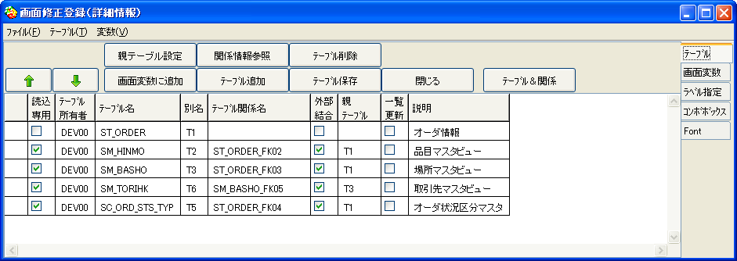

- “Screen auto-generation setting (detailed)”
Add variables from “Variable” tab.
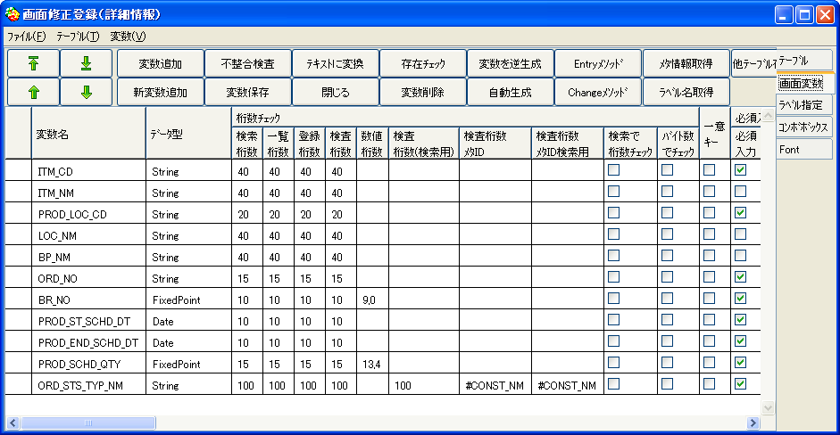

  - Add screen variables from “Variable” tab.
  - Remove all the variables unnecessary for Search/List.
  - Sort the variables in the order to display.
  - Check “Used group” and “Include search condition” for the following fields.
    - ITM_CD (Item Code)
    - PROD_LOC_CD (Plant Location Code),
    - PROD_ST_SCHD_DT (Production Start Plan Date)
    - PROD_END_SCHD_DT (Production Complete Plan Date)
  - Select “Search combo box”.
  - Check “List update read only” for all the variables.
  - Save variables.

Variable | Used by search | Include search condition | List update read only | Display label | Search combo box | Search CR | Search Not make String Not use LIKE
ITM_CD | Check | Check | Check | Item Code | ITM_CDALLDynamic
ITM_NM |  |  | Check | Item Name
PROD_LOC_CD | Check | Check | Check | Plant Location Code | LOC_CD
LOC_NM |  |  | Check | Location Name
BP_NM |  |  | Check | Business Partner Name
ORD_NO |  |  | Check | Order No
BR_NO |  |  | Check | Branch No
PROD_ST_SCHD_DT | Check | Check | Check | Production Start Plan Date |  | Check | Check
PROD_END_SCHD_DT | Check | Check | Check | Production Complete Plan Date |  |  | Check
PROD_SCHD_QTY |  |  | Check | Production Plan Quantity
ORD_STS_TYP_NM |  |  | Check | Order Status

- “Screen auto-generation setting (auto-generation setting)”
Change settings for Auto-Generation.
  - Change Generation Pattern to “Search/List” in “Generation” tab, and save.
  - Change the number of rows to 10 in “List” tab.

- “Screen auto-generation setting (auto-generation of SQL)”
Check all except “Select” and close.

- “Screen auto-generation setting (button information)”
Check “Unused” for all the buttons except “Search” and save.

- “Screen auto-generation setting”
Perform auto-generate again.

Practice 2 Answer: Inventory Summary Screen (by item location) Development
- Auto-generate with the following steps.
- “Table manager”
Add all the tables to be used.
*SM_HINMO and SM_BASHO are added in Practice 1, and only ST_ZAIKO needs to be added.
Select ST_ZAIKO from the table list, and select “Menu⇒Screen⇒Open”, and auto-generate screens.

- “Screen auto-generation setting (detailed)”
Add tables from “Table” tab. Set table relationships and join criteria.
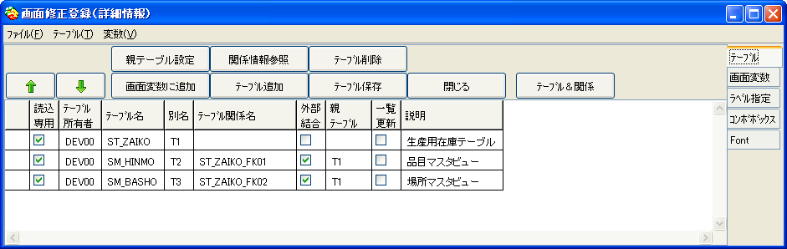

- “Screen auto-generation setting (detailed)”
Add variables from “Variable” tab.
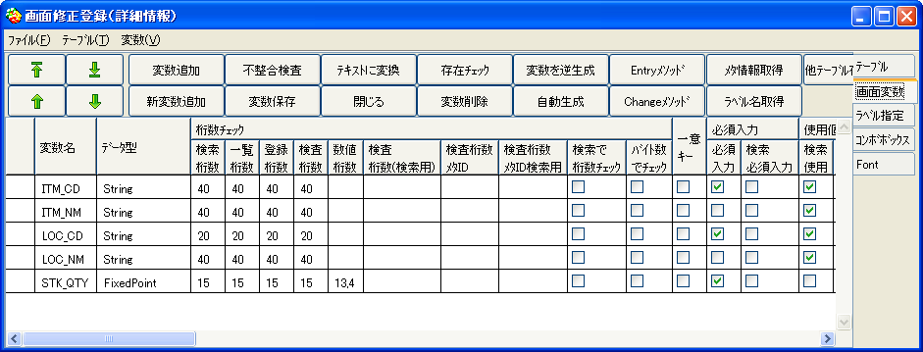
  - Add variables from “Variable” tab.
  - Remove variables unnecessary for Search/List.
  - Sort variables in the order to display.
  - Check “Used by search” and “Include search condition” for ITM_CD (Item Code), ITM_NM (Item Name), LOC_CD (Location Code), LOC_NM Location Name).
  - Select “Search combo box”.
  - Check “Search read only” for Item Name and Location Name.
  - Check “List update read only” for all the variables.
  - Check “Search trigger” for Item Name and Location Name.
  - Check “Search CR” for Location Code.
  - Save the variables.

Variable | Used by search | Include search condition | Search trigger | List update read only | Display Label | Search combo box | Search CR
ITM_CD | Check | Check | Check | Check | Item Code | ITM_CDALLDynamic
ITM_NM | Check |  |  | Check | Item Name
LOC_CD | Check | Check | Check | Check | Location Code | LOC_CD | Check
LOC_NM | Check |  |  | Check | Location Name
STK_QTY |  |  |  | Check | Total Quantity

- “Screen auto-generation setting (auto-generation setting)”
Change Auto-Generation Settings.
  - Change “Generation pattern” to “Search/List” in Generation tab, and save.
  - Change the number of row to 10 in “List” tab.

- “Screen auto-generation setting (auto-generation of SQL)”
Check all excel “Select”.

- “Screen auto-generation setting (trigger setting)”
Create triggers.
Trigger name | Extraction | Setting | Radio Button
ITM_CD | ITM_CD | ITM_NM | Search group
LOC_CD | LOC_CD | LOC_NM | Search group

- “Edit SQL (for search)”
Set total quantities.
  - Check “Column Replacement” for Inventory Quantity in “Variables settings” tab.
  - Enter “SUM (T1.STK_QTY)” in “Replacement statement” for total quantities.
  - Setup “GROUP BY priority”.
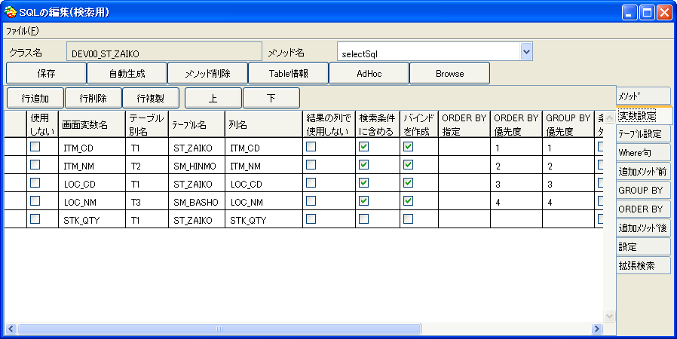

“Screen auto-generation setting (button information)”
  - Check “Unused” for the buttons except “Search”, and save.
  - Create buttons for Item Master and Location Master to navigate screens.
Button label | Button ID | Group | Unused | Button Type | Screen class
Search | #doSearch | #Search |  | #ActionButton
Add | #doAddList | #List | Check | #ActionButton
Delete | #doDeleteList | #List | Check | #ActionButton
Update | #doUpdateList | #List | Check | #ActionButton
Item Master | #Item Master | #List |  | #LinkedDetail | #BCOMM_CM_HINMO
Location Master | #Location Master | #List |  | #LinkedDetail | #BCOMM_CM_BASHO
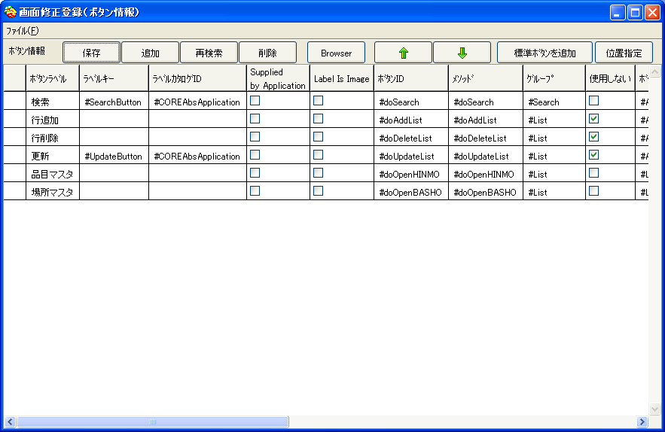

- “Screen auto-generation setting”
Perform Auto-Generate again.

