Practice 1: Order Schedule List Screen Development
- Objective
  - To create a new screen using FrameManager.

- Functionality
  - Auto-generate a screen to retrieve data from Order table (ST_ORDER).
    - Tables: ST_ORDER (main table)
SM_HINMO
SM_BASHO
SM_TORIHK
SC_ORD_STS_TYP

    - Auto-Generation Pattern: Search/List
    - Button: Search
  - Class details
Create a class inheriting from “SEISANProjectApplication” class.

  - Screen details
    - Search section (search constraint)
Search Constraint/Variables (Display Name) | Field Type | Search Pattern
ITM_CD (Item Code) | Combo Box (ITM_CDALLDynamic) | Like
PROD_LOC_CD (Plant Location Code) | Combo Box (LOC_CD) | Like
PROD_ST_SCHD_DT (Production Start Plan Date) | Input Field | Complete (=)
PROD_END_SCHD_DT(Production Complete Plan Date) | Input Field | Complete (=)

    - List (fields)
Display Fields/Variables (Display Name)) | Field Type | Table Name
ITM_CD (Item Code) | Input Field (read-only) | ST_ORDER
ITM_NM (Item Name) | Input Field (read-only) | *
PROD_LOC_CD (Plant Location Code) | Input Field (read-only) | ST_ORDER
LOC_NM (Plant Location Name) | Input Field (read-only) | SM_BASHO
BP_NM (Business Partner Name) | Input Field (read-only) | SM_TORIHK
ORD_NO (Order Number) | Input Field (read-only) | ST_ORDER
BR_NO (Branch Number) | Input Field (read-only) | ST_ORDER
PROD_ST_SCHD_DT (Production Start Plan Date) | Input Field (read-only) | ST_ORDER
PROD_END_SCHD_DT (Production Complete Plan Date) | Input Field (read-only) | ST_ORDER
PROD_SCHD_QTY (Production Plan Quantity) | Input Field (read-only) | ST_ORDER
ORD_STS_TYP_NM (Order Status) | Input Field (read-only) | SC_ORD_STS_TYP
*Use ST_ORDER if exists in ST_ORDER,. Otherwise use SM_HINMO.
    - Table relationships
Display Fields/Variables (Display Name) | Relationship Name | Relationship
ITM_NM (Item Name) | ST_ORDER_FK02 | ST_ORDER.ITM_CD  - SM_HINMO.ITM_CD
LOC_NM (Plant Location Name) | ST_ORDER_FK03 | ST_ORDER.PROD_LOC_CD  - SM_BASHO.LOC_CD
BP_NM (Business Partner Name) | SM_BASHO_FK05 | SM_BASHO.BP_CD  - SM_TORIHK. BP_CD
ORD_STS_TYP (Order Status) | ST_ORDER_FK04 | ST_ORDER. ORD_STS_TYP  - SC_ ORD_STS_TYP. ORD_STS_TYP

  - Screen image
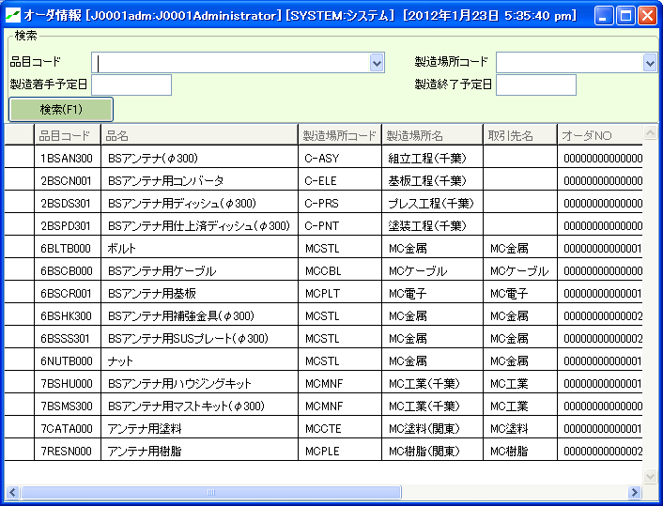

- Hint
  - Auto-generate ST_ORDER from “Table manager” screen.
Use “Search/List” for auto-generation pattern.
Set 10 for the number of rows for the list.

  - Auto-generate only “Select” statement for SQL.

  - Use NVL for ITM_NM (Item Name) field in the list.

  - Make sure to set “Table Relationship Name” when adding new tables. In this practice, you don’t need to create a new relationship.
Table relationships for the most of the standard tables are already defined as a framework.

  - You don’t need to create a new combo box for search. Please use an existing one.

  - Remove fields (screen variables) unnecessary to display.
*Click “Delete variable” button in Screen auto-generation setting (detailed).

  - In case there is no change in the screen layout after the settings are complete, remove “WindowSpec” and perform auto-generate again.

Practice 2: Inventory Summary Screen (by item location) Development
- Objective
  - Create a new screen using FrameManager.

- Functionality
  - Auto-generate a screen to retrieve data from Inventory table (ST_ZAIKO).
    - Tables: ST_ZAIKO (main table)
SM_HINMO
SM_BASHO

    - Auto-Generation Pattern: Search/List
    - Button to use: Search
    - Buttons to add:
“Item Master”: Navigate to Item Master (class name: BCOMM_CM_HINMO) screen
“Location Master”: Navigate to Location Master (class name: BCOMM_CM_BASHO)

  - Class details
Create a subclass inheriting from “SEISANProjectApplication” class.

  - Screen details
    - Search section (search criteria)
Search Criteria/Variables (Display Name) | Field Type | Search Pattern | Note
ITM_CD (Item Code) | Combo box (ITM_CDALLDynamic) | Like
ITM_NM (Item Name) | Input field (read-only) |  | By trigger
LOC_CD (Location Code) | Combo box (LOC_CD) | Like
LOC_NM (Location Name) | Input field (read-only) |  | By trigger

    - List (fields)
Display Fields/Variables (Display Name) | Field Type | Table Name
ITM_CD (Item Code) | Input field (read-only) | ST_ZAIKO
ITM_NM (Item Name) | Input field (read-only) | SM_HINMO
LOC_CD (Location Code) | Input field (read-only) | ST_ZAIKO
LOC_NM (Location Name) | Input field (read-only) | SM_BASHO
STK_QTY (Total Quantity) | Input field (read-only) | *
*Total quantity is a total inventory quantity by location.
Use STK_QTY for a variable and edit SQL.
    - Table relationship
Display Fields/Variables (Display Name) | Relationship Name | Relationship
ITM_NM (Item Name) | ST_ZAIKO_FK01 | ST_ZAIKO.ITM_CD  - SM_HINMO.ITM_CD
LOC_NM (Location Name) | ST_ZAIKO_FK02 | ST_ZAIKO.PROD_LOC_CD  - SM_BASHO.LOC_CD

  - Screen image
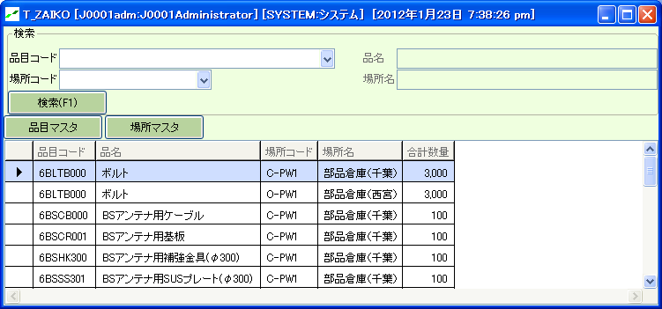

- Hint
  - Use SQL grouping function “SUM” to total inventory quantities.
To “Edit SQL (for search)”, use “Replace column” and “Replaced sentence” in “Variable settings” tab.
When you use grouping functions, you’ll need to list all the fields except those in grouping functions in “GROUP BY” tab.
Set “GROUP BY priority” in “Variable settings” tab, or enter SQL in “GROUP BY” tab.

  - Create “ITM_NM (Item Name)” and “LOC_NM (Location Name)” in the search section as read-only.
*Auto-set by triggers.

