Exercise: The MyTime Class

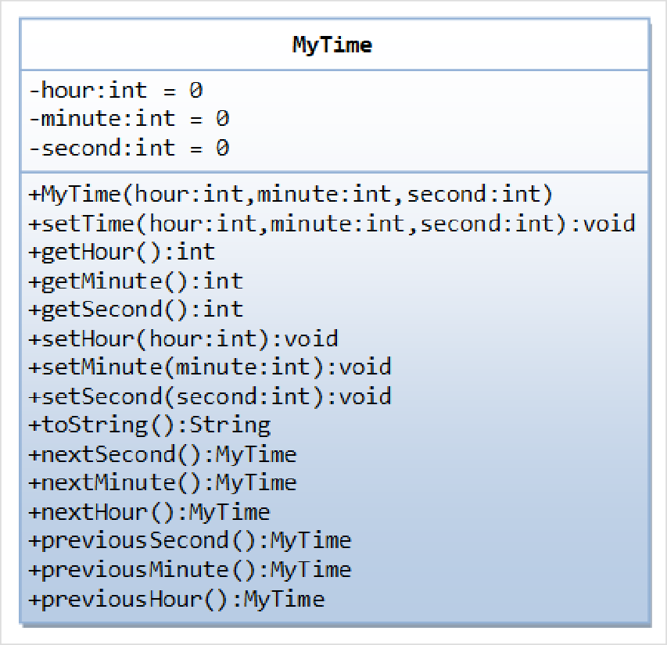
A class called MyTime, which models a time instance, is designed as shown in the class diagram.
It contains the following private
instance variables:
hour: between 0 to 23.
minute: between 0 to 59.
Second: between 0 to 59.
The constructor shall invoke the setTime() method ﴾to be described later﴿ to set the instance variable.
It contains the following public
methods:
setTime(int hour, int minute, int second): It shall check if the given hour, minute and second are valid before setting the instance variables.
﴾Advanced: Otherwise, it shall throw an
IllegalArgumentException with the message "Invalid hour, minute, or second!".﴿
Setters setHour(int hour), setMinute(int minute), setSecond(int second): It shall check if the parameters are valid, similar to the above.
Getters getHour(), getMinute(), getSecond(). toString(): returns "HH:MM:SS".
nextSecond(): Update this instance to the next second and return this instance. Take note that the
nextSecond() of 23:59:59 is 00:00:00.
nextMinute(), nextHour(), previousSecond(), previousMinute(), previousHour(): similar to the above.
Write the code for the MyTime class. Also write a test program ﴾called TestMyTime﴿ to test all the methods defined in the MyTime class.

Exercise: The MyDate Class

A class called MyDate, which models a date instance, is defined as shown in the class diagram. The MyDate class contains the following private instance variables:
year ﴾int﴿: Between 1 to 9999.
month ﴾int﴿: Between 1 ﴾Jan﴿ to 12 ﴾Dec﴿.
day ﴾int﴿: Between 1 to 28|29|30|31, where the last day depends on the month and whether it is a leap year for Feb ﴾28|29﴿.
It also contains the following private static variables ﴾drawn with underlined in the class diagram﴿:
strMonths ﴾String[]﴿, strDays ﴾String[]﴿, and dayInMonths ﴾int[]﴿: static variables, initialized as shown, which are used in the methods.

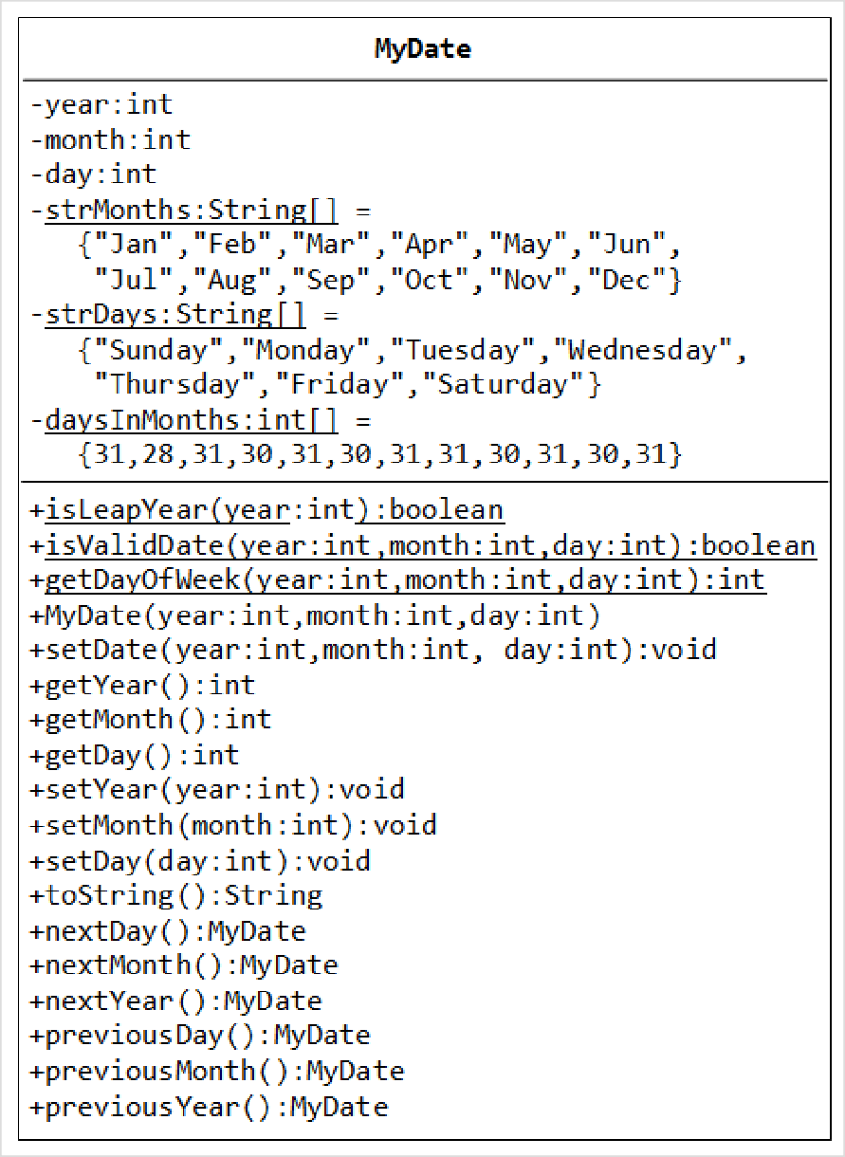
The MyDate class has the following public static methods ﴾drawn with underlined in the class diagram﴿:
isLeapYear(int year):
returns true if the given year is a leap year. A year is a leap year if it is divisible by 4 but not by 100, or it is divisible by 400.
isValidDate(int year, int month, int day): returns true if the given year, month, and day constitute a valid date. Assume that year is between 1 and 9999, month is between 1
﴾Jan﴿ to 12 ﴾Dec﴿ and day shall be between 1 and 28|29|30|31 depending on the month and whether it is a leap year on Feb.
getDayOfWeek(int year, int month, int day): returns the day of the week, where 0 for Sun, 1 for Mon, ..., 6 for Sat, for
the given date. Assume that the date is valid. Read the earlier exercise on how to determine the day of the week ﴾or Wiki "Determination of the day of the week"﴿.
The MyDate class has one
constructor, which takes 3 parameters: year, month and day. It shall invoke setDate() method ﴾to be described later﴿ to set the instance variables.
The MyDate class has the following public methods:
setDate(int year, int month, int day): It shall invoke the static method isValidDate() to verify that the given year, month and day constitute a valid date.
﴾Advanced: Otherwise, it shall throw an IllegalArgumentException with the message "Invalid year, month, or day!".﴿
setYear(int year): It shall verify that the given year is between 1 and 9999.
﴾Advanced: Otherwise, it shall throw an IllegalArgumentException with the message "Invalid year!".﴿
setMonth(int month): It shall verify that the given month is between 1 and 12.
﴾Advanced: Otherwise, it shall throw an IllegalArgumentException with the message "Invalid month!".﴿
setDay(int day): It shall verify that the given day is between 1 and dayMax, where dayMax depends on the
month and whether it is a leap year for Feb.
﴾Advanced: Otherwise, it shall throw an IllegalArgumentException with the message "Invalid month!".﴿
getYear(), getMonth(), getDay(): return the value for the year, month and day, respectively.

toString(): returns a date string in the format "xxxday d mmm yyyy", e.g., "Tuesday 14 Feb 2012".
nextDay(): update this instance to the next day and return this instance. Take note that nextDay() for 31 Dec 2000 shall be 1 Jan 2001.
nextMonth(): update this instance to the next month and return this instance. Take note that nextMonth()
for 31 Oct 2012 shall be 30 Nov 2012.
nextYear(): update this instance to the next year and return this instance. Take note that nextYear() for
29 Feb 2012 shall be 28 Feb 2013.
﴾Advanced: throw an IllegalStateException with the message "Year out of range!" if year > 9999.﴿
previousDay(), previousMonth(), previousYear(): similar to the above.
Write the code for the MyDate class.
Use the following test statements to test the MyDate class:
MyDate d1 = new MyDate(2012, 2, 28); System.out.println(d1); // Tuesday 28 Feb 2012
System.out.println(d1.nextDay()); // Wednesday 29 Feb 2012
System.out.println(d1.nextDay()); // Thursday 1 Mar 2012
System.out.println(d1.nextMonth()); // Sunday 1 Apr 2012
System.out.println(d1.nextYear()); // Monday 1 Apr 2013

MyDate d2 = new MyDate(2012, 1, 2);
System.out.println(d2); // Monday 2 Jan 2012
System.out.println(d2.previousDay()); // Sunday 1 Jan 2012
System.out.println(d2.previousDay()); // Saturday 31 Dec 2011
System.out.println(d2.previousMonth()); // Wednesday 30 Nov 2011
System.out.println(d2.previousYear()); // Tuesday 30 Nov 2010

MyDate d3 = new MyDate(2012, 2, 29); System.out.println(d3.previousYear()); // Monday 28 Feb 2011

// MyDate d4 = new MyDate(2099, 11, 31); // Invalid year, month, or day!
// MyDate d5 = new MyDate(2011, 2, 29); // Invalid year, month, or day!
Write a test program that tests the nextDay() in a loop, by printing the dates from 28 Dec 2011 to 2 Mar 2012.

