Tarjan | SCC algorithm (depth first search) O(V+E)
Dijkstra | Shortest path (greedy)
Karatsuba | Fast mult (D&C)
Kruskal/Prim | MST (greedy)
S. Cook | SAT is NP-complete
R. Karp | 21 NP-complete problems
Rivest/Shamir/Adleman | RSA cryptosystem

Greedy | Dijkstra, Kruskal, Prim, Huffman
Divide & Conq | Karatsuba, mergesort, FFT, closest pair
Dynamic Prog | LCS, Floyd-Warshall, Bellman-Ford, knapsack, Fib

P, NP, NP-Complete

  - P: class of problems solvable by deterministic algorithms in poly time.
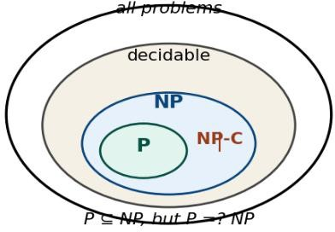
    - NP: solvable by nondeterministic algorithms in poly time.
    - P ⊆ NP. Open: P
=? NP.
    - A ≤ₘ B: ∃ poly-time computable f s.t.
∀x, x ∈ A ⟺ f(x) ∈ B.
    - A is NP-complete: (1) A ∈ NP, (2)
∀ B ∈ NP, B ≤ₘ A.

A is NP-hard:
condition (2) only.

Four Reduction

Lemmas
- A ≤ₘ B, B ≤ₘ C ⟹ A ≤ₘ C (transitivity)
- A ≤ₘ B, B ∈ P ⟹ A ∈ P (P-closure)
- A ≤ₘ B, B ∈ NP ⟹ A ∈ NP (NP-closure)
- A ≤ₘ B ⟹ Aᶜ ≤ₘ Bᶜ (complement)
- Guess/Check Template (prove A ∈ NP)
input: x
guess: certificate y with |y| ≤ poly(|x|)
check: predicate(x, y) in det. poly time

self-loops).

DAG Path Counting (DP)

count_walks(G, v0, v1): order ← topo_sort(G) N[v] ← 1 if v=v0 else 0 for u in order:
for u→v: N[v] += N[u]
return N[v1] # O(V+E)

DAG Path Counting Variants
Even-length walks: state = (node, parity). E[v] += O[u], O[v] += E[u] for each edge u→v. Return E[v₁].
More reds than greens (HW): state = (node, red_count, green_count).
Update tuple along each colored edge. Sum entries with red > green.

SCC Application Cheat Table
Connected? all of G forms ONE SCC.
Is DAG? every SCC is a single node (no

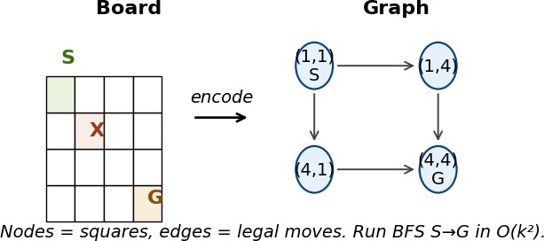

Nodes: non-forbidden squares. Edges: legal moves. BFS for reachability. O(k²).

Local Propagation (DFA walk count)

Count walks of length L in a DFA: each node i has count Nᵢ. Update all in parallel:
N′ⱼ = Σᵢ Nᵢ over edges i→j. Repeat L times.
# Example: walks of len 10 in DFA

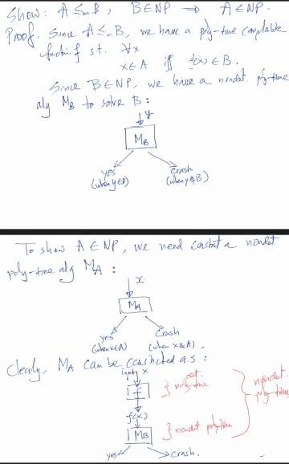
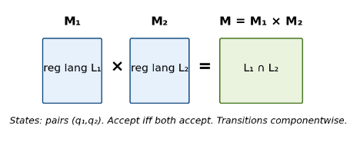
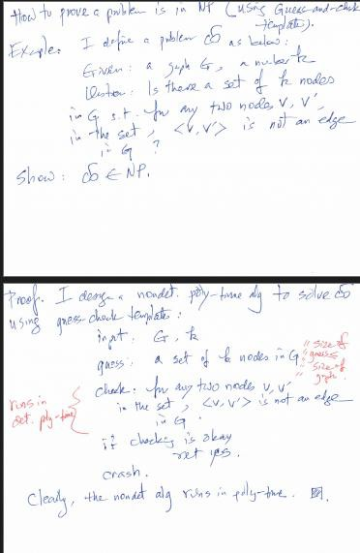
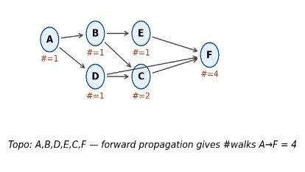
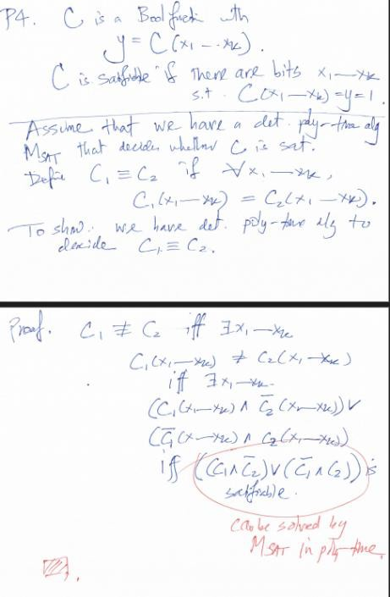
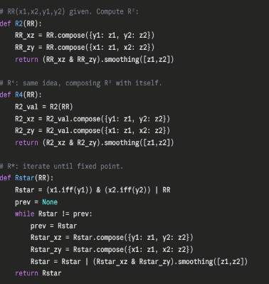
if check ok: return YES else: crash
Key: guess size ≤ input size. Check must be deterministic poly time.

Encoding Size Trap (Unary vs Digits)
UNARY n: "111...1" → input size = n. So O(n²) trial division is poly. Unary FACT ∈ P (no guess needed).
DIGIT n: input size = log₁₀ n. O(n²) is exponential. FACT (digits) only known to be in NP (guess p,q,r ≤ n).

NP-Complete Problem Lineup
Known NP-complete: SAT, 3SAT, Independent Set (IDSET), Vertex Cover (VC), Hamiltonian Cycle (HC), TSP.
Status unknown: Graph Isomorphism (GI), FACT (digit form).
Outside NP (decidable but harder): EXPSPACE-complete, undecidable problems (halting).
States: (q₁, q₂). Trans: δ((q₁,q₂),a) = (δ₁(q₁,a), δ₂(q₂,a)). Accept iff both. Recognizes L₁
∩ L₂.

LCS with Pattern Recipe
Mα × Mβ × M_pattern = M (finite) M is DAG → run longest path
ω-walk hits v₂ ∞-often? reachable looping SCC contains v₂.
Walk covers all nodes (HW#3)? SCC condensation is a "line".
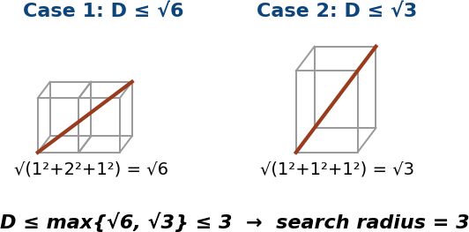

  - n³ planes in n×n×n cube, dist ≥ 1.
  - Pigeonhole: each unit ≤1 plane (D ≤ √6) OR some unit ≥2 (D ≤ √3).
  - D ≤ 3 → search radius 3, bounded candidates per plane.
  - Bucket trick: plane (1.32, 4.7, 2.88) → unit (1, 4, 2). O(n³).

18. BDD Project (PyEDA)
N = [1, 0, 0, 0] # start at node 0 for step in range(10):
N' = [0]*4
for each edge i→j: N'[j] += N[i]
N = N'
return sum(N[f] for f in finals)

Min-Product Path

Log trick: log(∏wᵢ) = Σ log(wᵢ). Run Dijkstra on log weights (≥ 0 since wᵢ ≥ 1). Or
modify Dijkstra: × instead of +, init dist[src]=1.

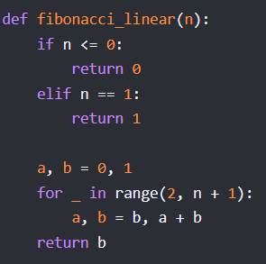
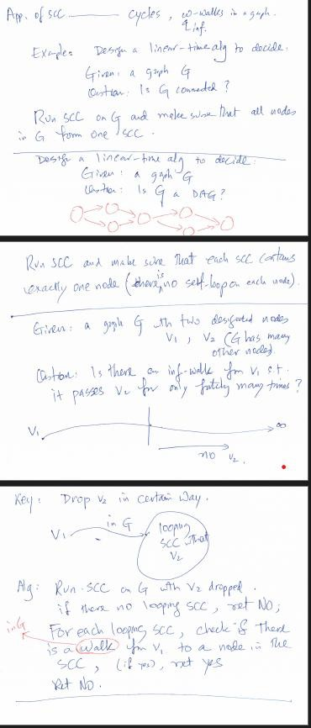
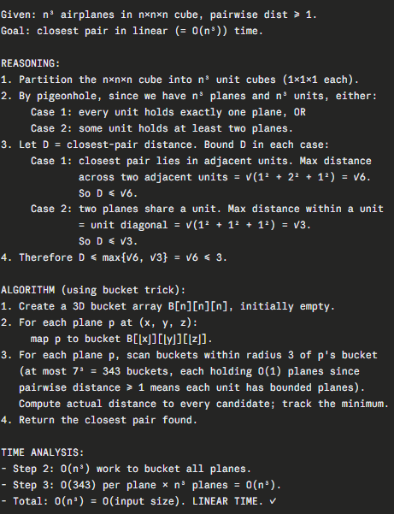
ω-Walk Examples (SCC Apps)
Q: ω-walk from v₁ hits v₂ infinitely, hits v₃ only

finitely?
Drop v₃ from G. Run SCC. Find looping SCC reachable from v₁ that contains v₂.
Return YES iff such SCC exists.
Q: ω-walk hits v₂ ∞-often AND v₃ ∞-often? Find looping SCC reachable from v₁ that contains BOTH v₂ and v₃.

FACT in NP (digit form)
Given n in digits (size = log n), show: ∃ p,q,r ≥ 2 with n = pqr is in NP.
input n (in digits)
guess p, q, r each ≤ n
(each is poly bits)
check p,q,r ≥ 2 AND p·q·r = n (multiply: poly time) if ok: YES, else crash
- NFA → DFA (subset construction)
States of DFA = subsets of NFA states. Start = {q₀ ∪ ε-closure}. Accept if
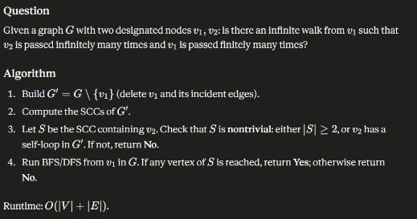
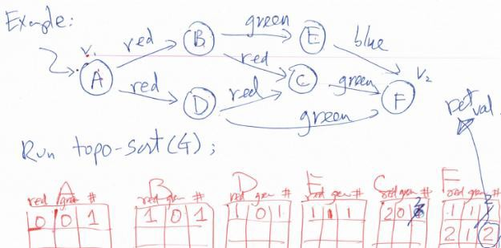
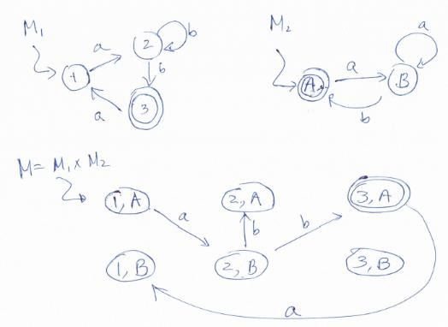
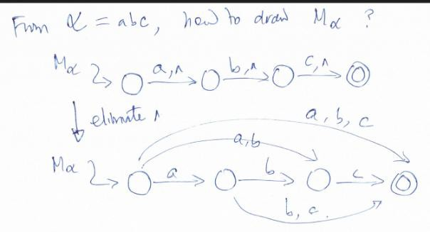
any subset element is final. Worst case 2ⁿ states.

