Mục lục
Contents
1. Thông tin project 2
1.1 Tên dự án 2
1.2 Thông tin tác giả 2
2. Cấu trúc project 2
3. Login page 4
3.1 Source code 4
3.2 UI 5
4. Staff 5
4.1 Manage Room information 6
4.1.1 View 6
4.1.2 Create 6
4.1.3 Edit 7
4.1.2 Delete 7
4.2 Manage customer information 8
4.3 Manage booking 9
4.3.1 View 9
4.3.2 Confirm booking 9
5. Customer 9
5.1 Register 10
5.1.1 Code 10
5.1.2 UI 11
5.2 Create an online booking reservation 12
5.2.1 View 12
5.2.2 Create 12
6. Manage his/her the profile 13
6.1 View 13
6.2 Update 14
7. View booking history 14
7.1 View 15
7.2 View detail 15
7.3 Dashboard 15

Thông tin project

Tên dự án
Assignment 03 SBA301 - Securing REST Services with Spring Boot

Thông tin tác giả
Nguyễn Công Toàn DE180895

Cấu trúc project
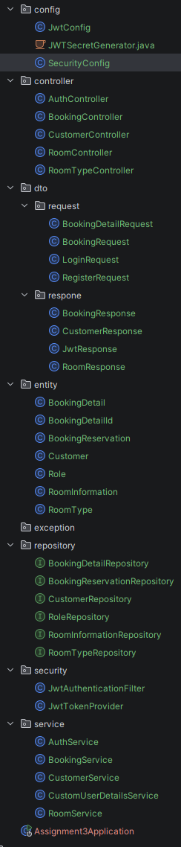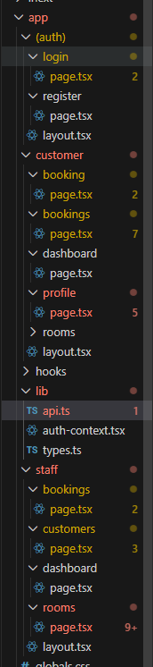

Login page

Source code
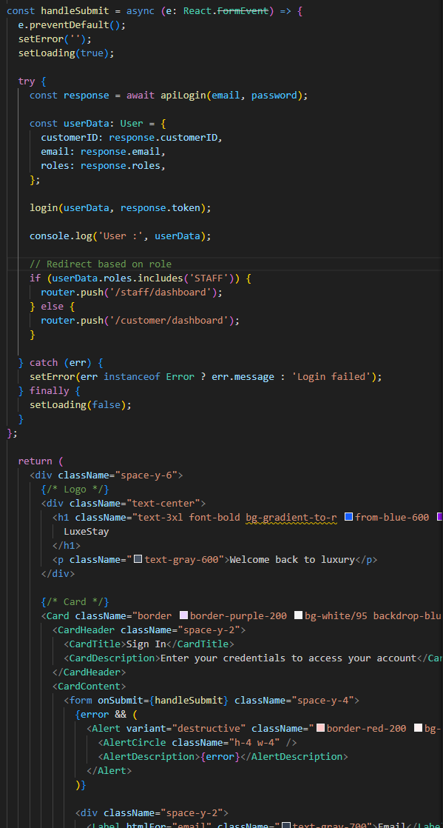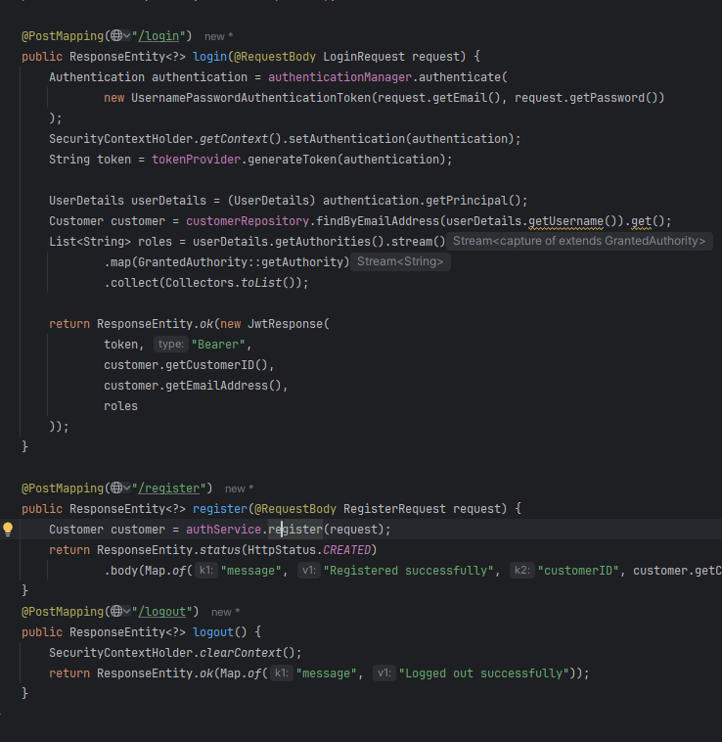

UI
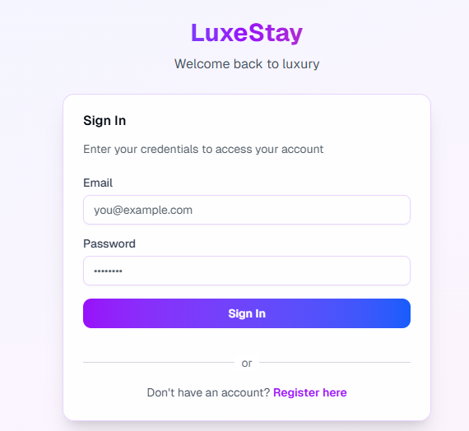

Staff

Manage Room information

4.1.1 View
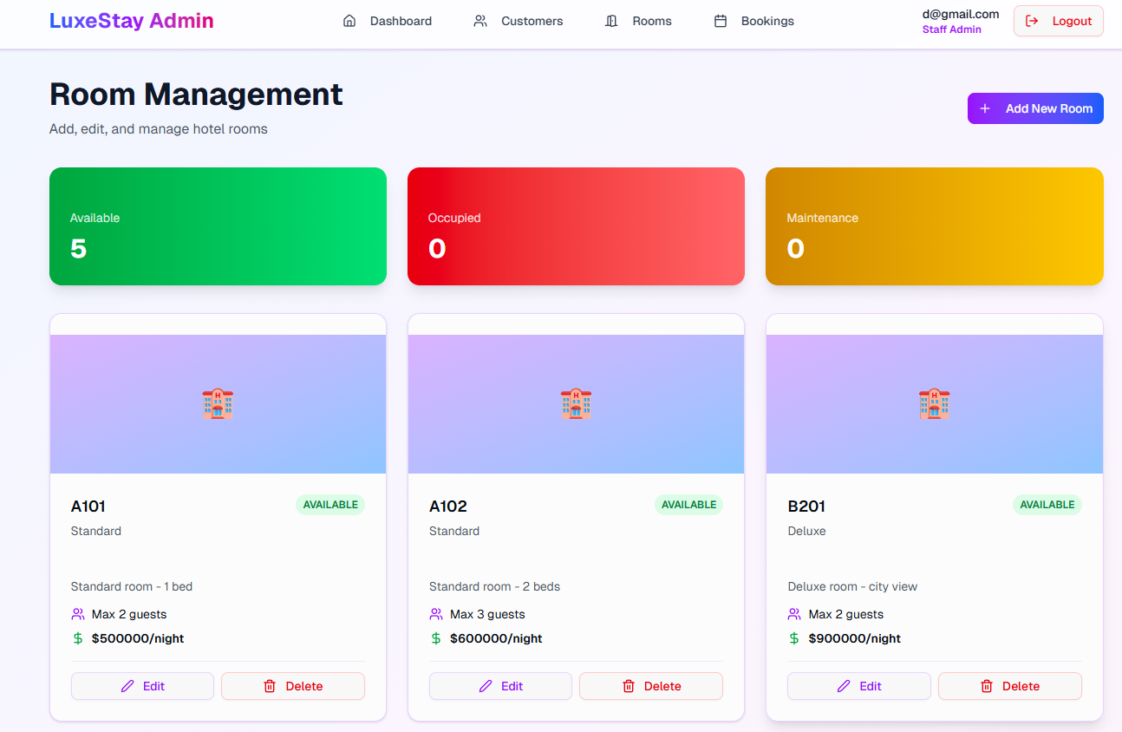

4.1.2 Create
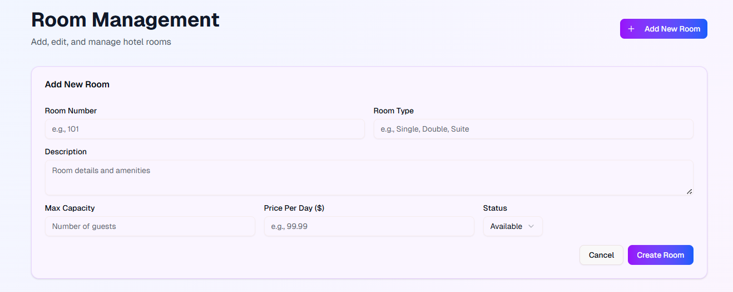

4.1.3 Edit
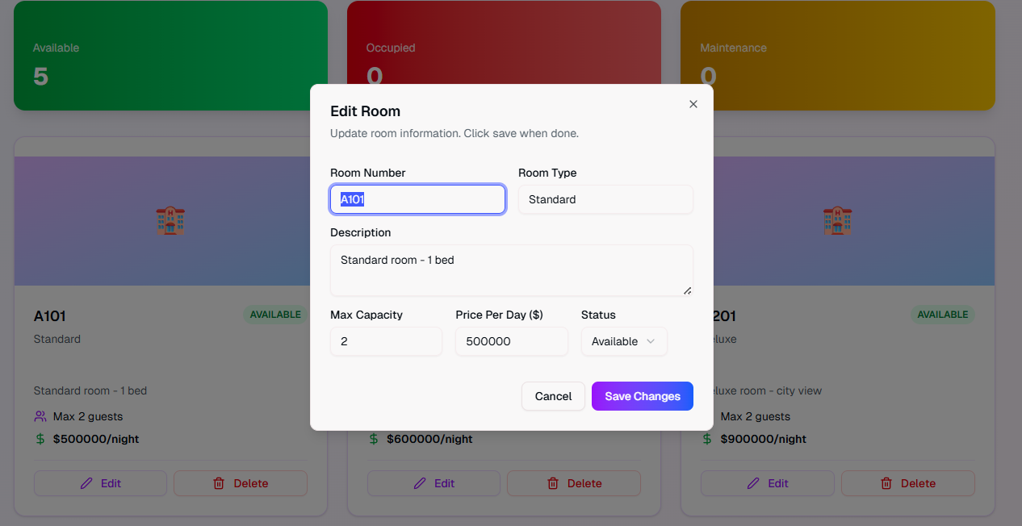

4.1.2 Delete
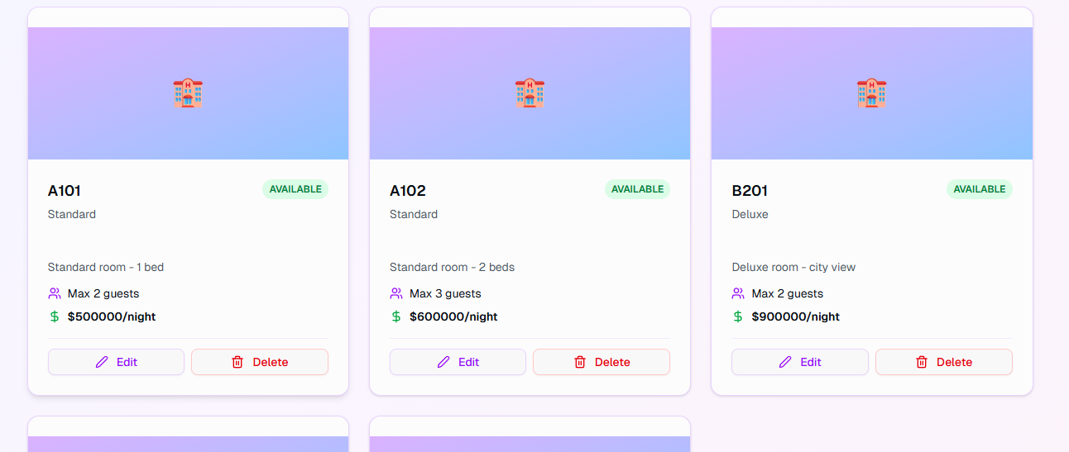

Manage customer information
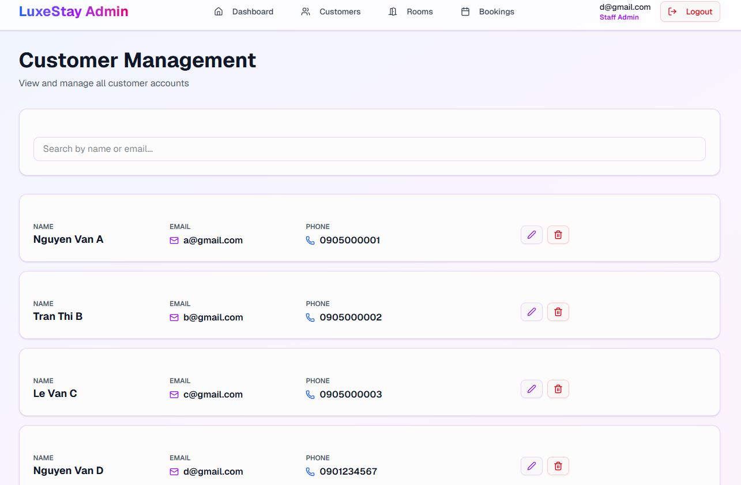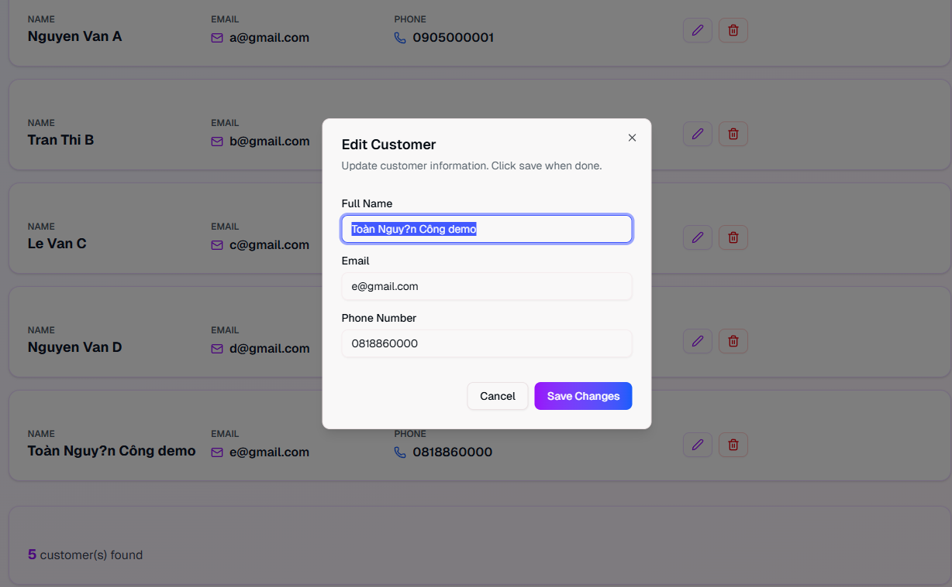

Manage booking

View
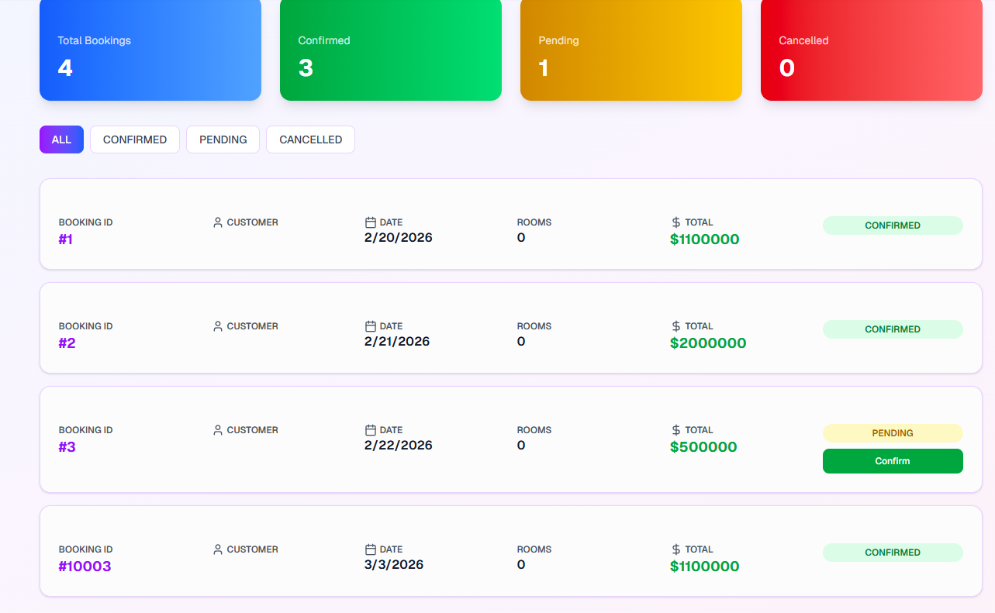

Confirm booking
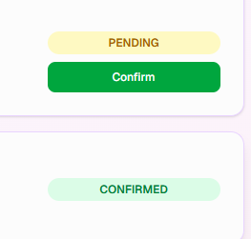

Customer

Register

Code
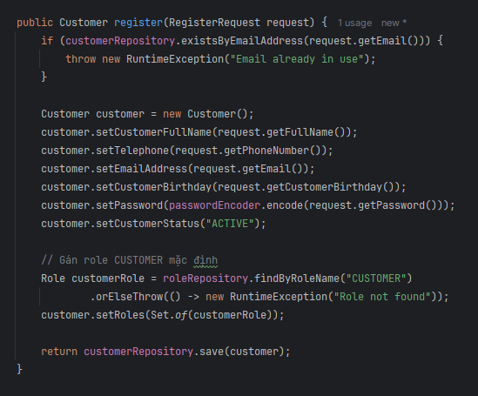

UI
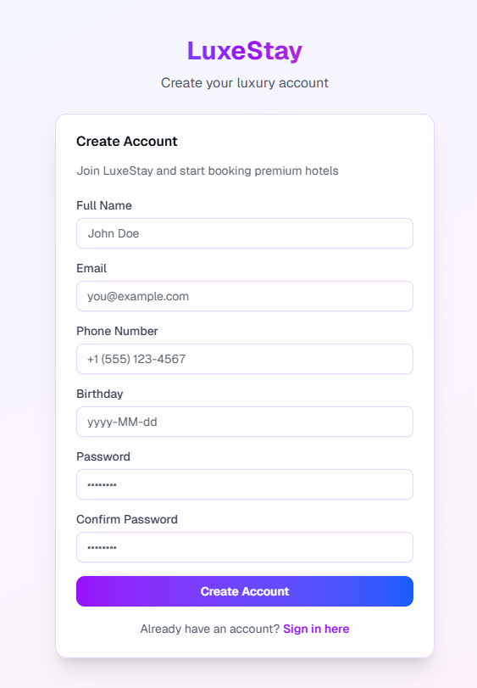

Create an online booking reservation

View
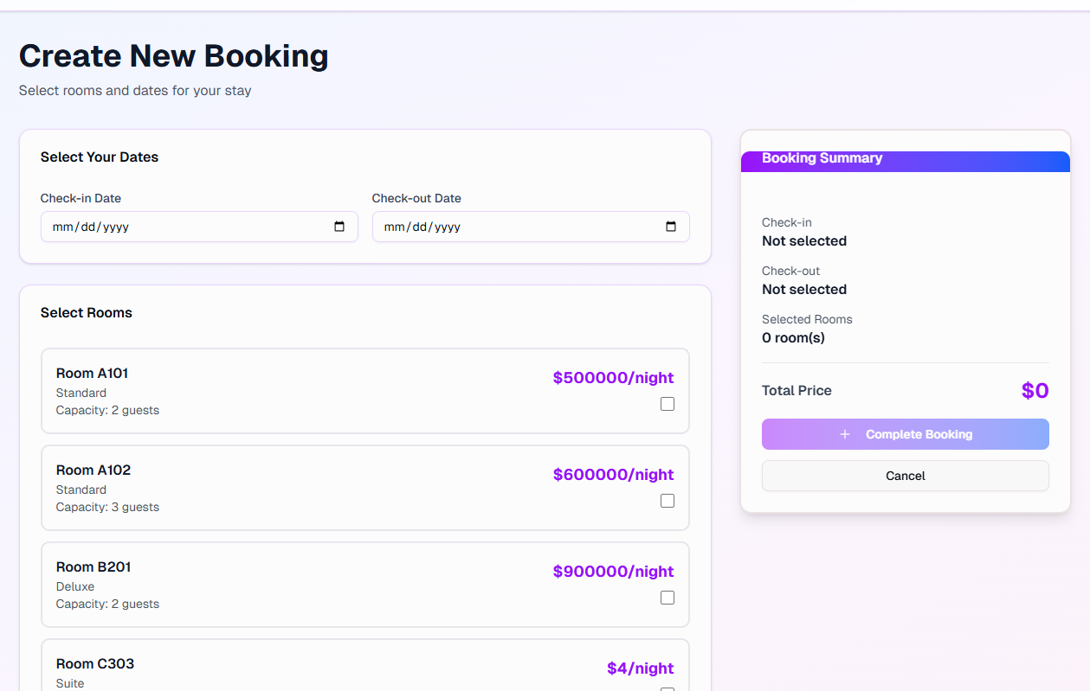

5.2.2 Create

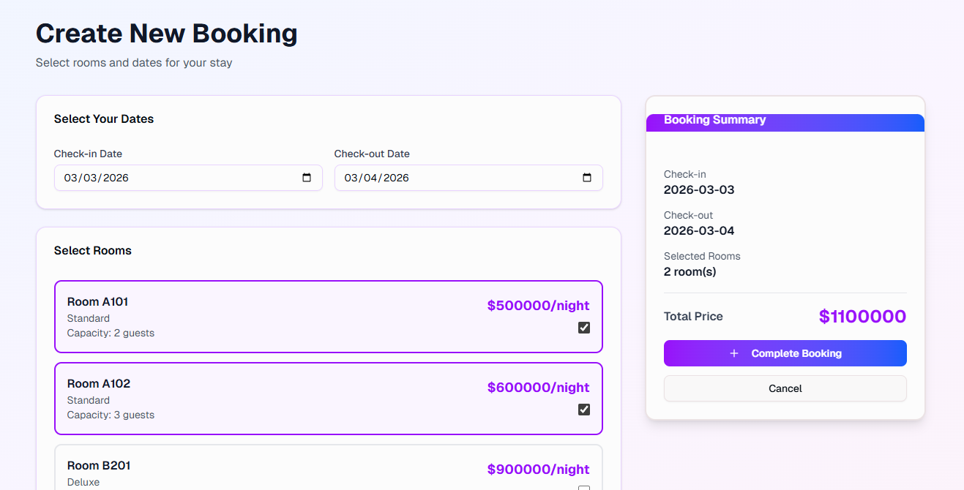

Manage his/her the profile

View
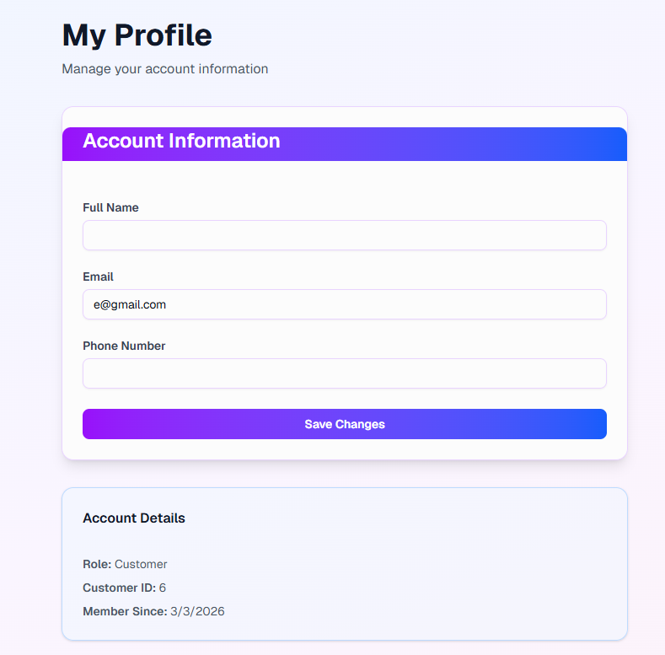

Update
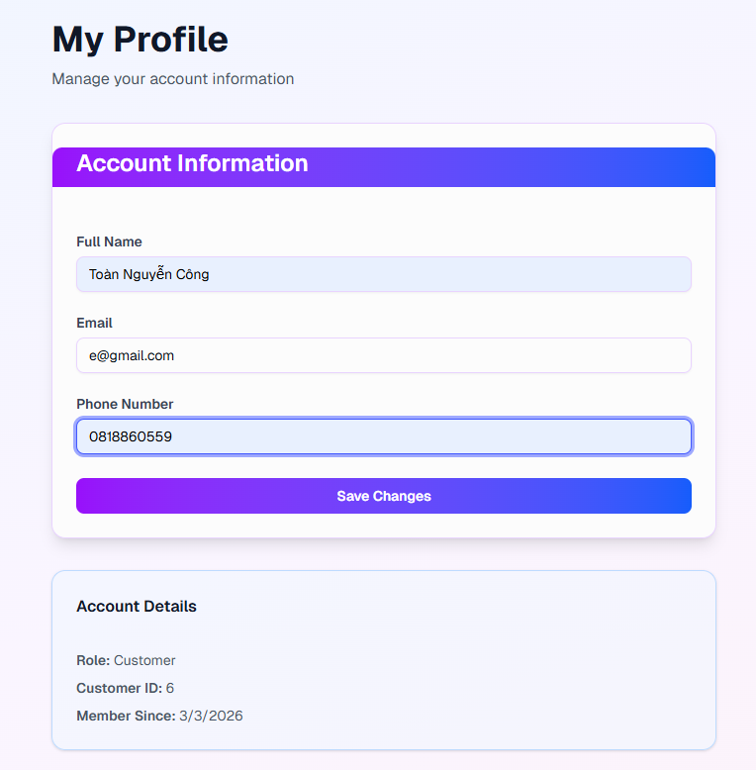

View booking history

View
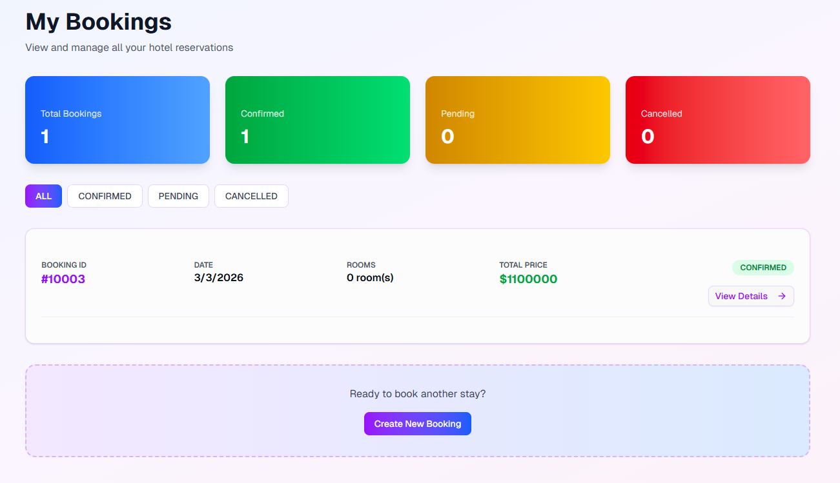

View detail
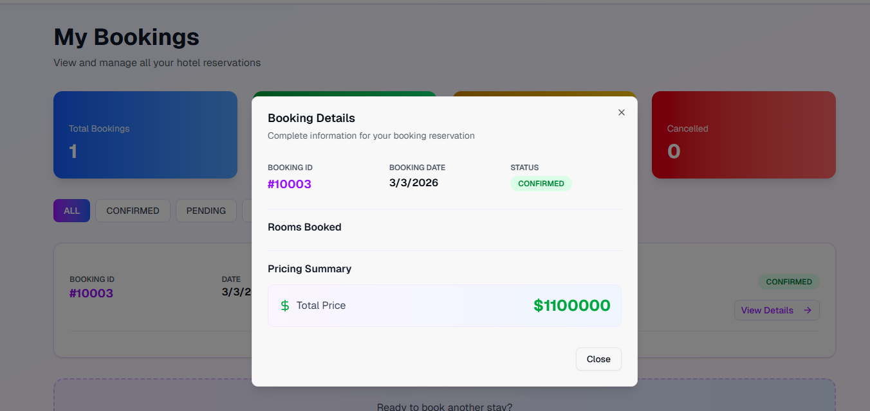

7.3 Dashboard

