**PRACTICAL EXAMINATION**Subject code: FER201m – FA 2023   
Duration: 85 minutes

A simple quiz is an interactive application designed to test users' knowledge on a particular topic or subject. It typically consists of a series of questions with multiple-choice options. Users select their answers and at the end of the quiz, the app displays the user's score (each right question adds 1 score) and often offers a review of the questions and their correct answers.

The student should put the code of the app in a zip file named "**Quiz_code.zip**"   
(please avoid using the student's name or ID).

The student can write the code based on the specific tasks (if using Redux architecture and Redux Thunk, student will get full 10 marks, otherwise 9 marks):

1. Create the component **Quiz** to render the information of Questions (id, text, options, correctAnswerIndex, selectedOption). (3 marks)

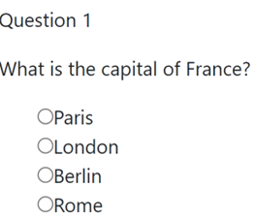

1. Display correct answer of questions (1 marks)
2. Fetching data from json-server (1 marks)

Hint: Create a file named db.json to perform the initialization of a virtual server using json-server, with the sample data below

1. Create the component **ContactForm** to send and display message (2 marks)

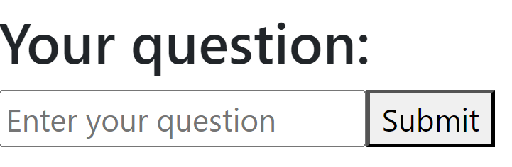

1. Use the React Router to configure and set up navigation among two pages (Contact and Quiz) in a Quiz application (2 marks)
2. Create a beautiful interface using Bootstrap. (1 marks)

The materials that the student must submit to the lsmdn system for marking include: Quiz_code.zip

**Note:**

* The questions.js file are located in the provided folder, which students can use for test.
* During the file compression for submission, please exclude the node_modules folder.
* The interface should be able to be responsive on different device platforms, such as mobile.

**question.js**

export const Question = [

    {

      id: 1,

      text: 'What is the capital of France?',

      options: ['Paris', 'London', 'Berlin', 'Rome'],

      correctAnswer: 'Paris',

      selectedOption: null

    },

    {

      id: 2,

      text: "Who developed the theory of relativity?",

      options: ["Albert Einstein", "Isaac Newton", "Galileo Galilei", "Nikola Tesla"],

      correctAnswerIndex: 'Albert Einstein',

      selectedOption: null

    },

    {

      id: 3,

      text: "What is the symbol for iron on the periodic table?",

      options: ["Fe", "I", "Au", "Ag"],

      correctAnswerIndex: 'Fe',

      selectedOption: null

    }

    // Add more questions here...

  ]