**PRACTICAL EXAMINATION**Subject code: FER202m – SP 2024   
Duration: 85 minutes

**Notice for students:**

+ Using NodeJS version 18

+ Only using Internet in order to download packages/modules

+ Student put the code of the app on 1 zip file, named the file with the meaningful words: **Video_code**.zip (please avoid using the student’s name or student ID and do not compress node-modules folder)

**Questions:**

A video app is an application that allows users to browse, search, and watch videos. It provides a platform for users to access a wide range of videos, such as movies, TV shows, documentaries, music videos, and user-generated content.

The student should put the code of the app in a zip file named "**Video_code.zip**"   
(please avoid using the student's name or ID).

The student can write the code based on the specific tasks (if using Redux architecture and Redux Thunk, student will get full 10 marks, otherwise 9 marks):

1. Create the component **Home** to render the information of Home page. (1 marks)

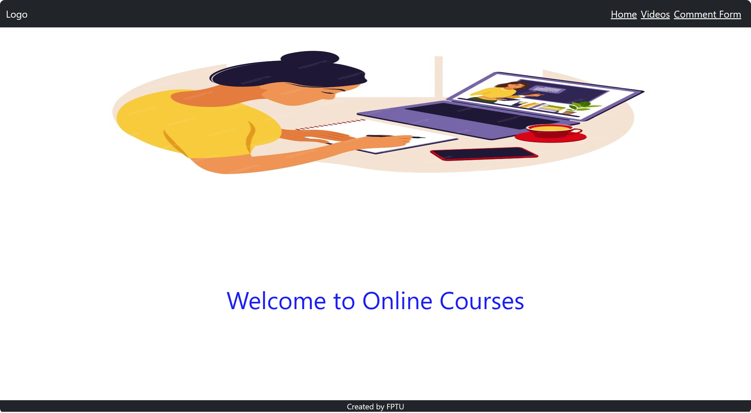

1. Create the component **Video** to render the information of Videos. (3 marks)

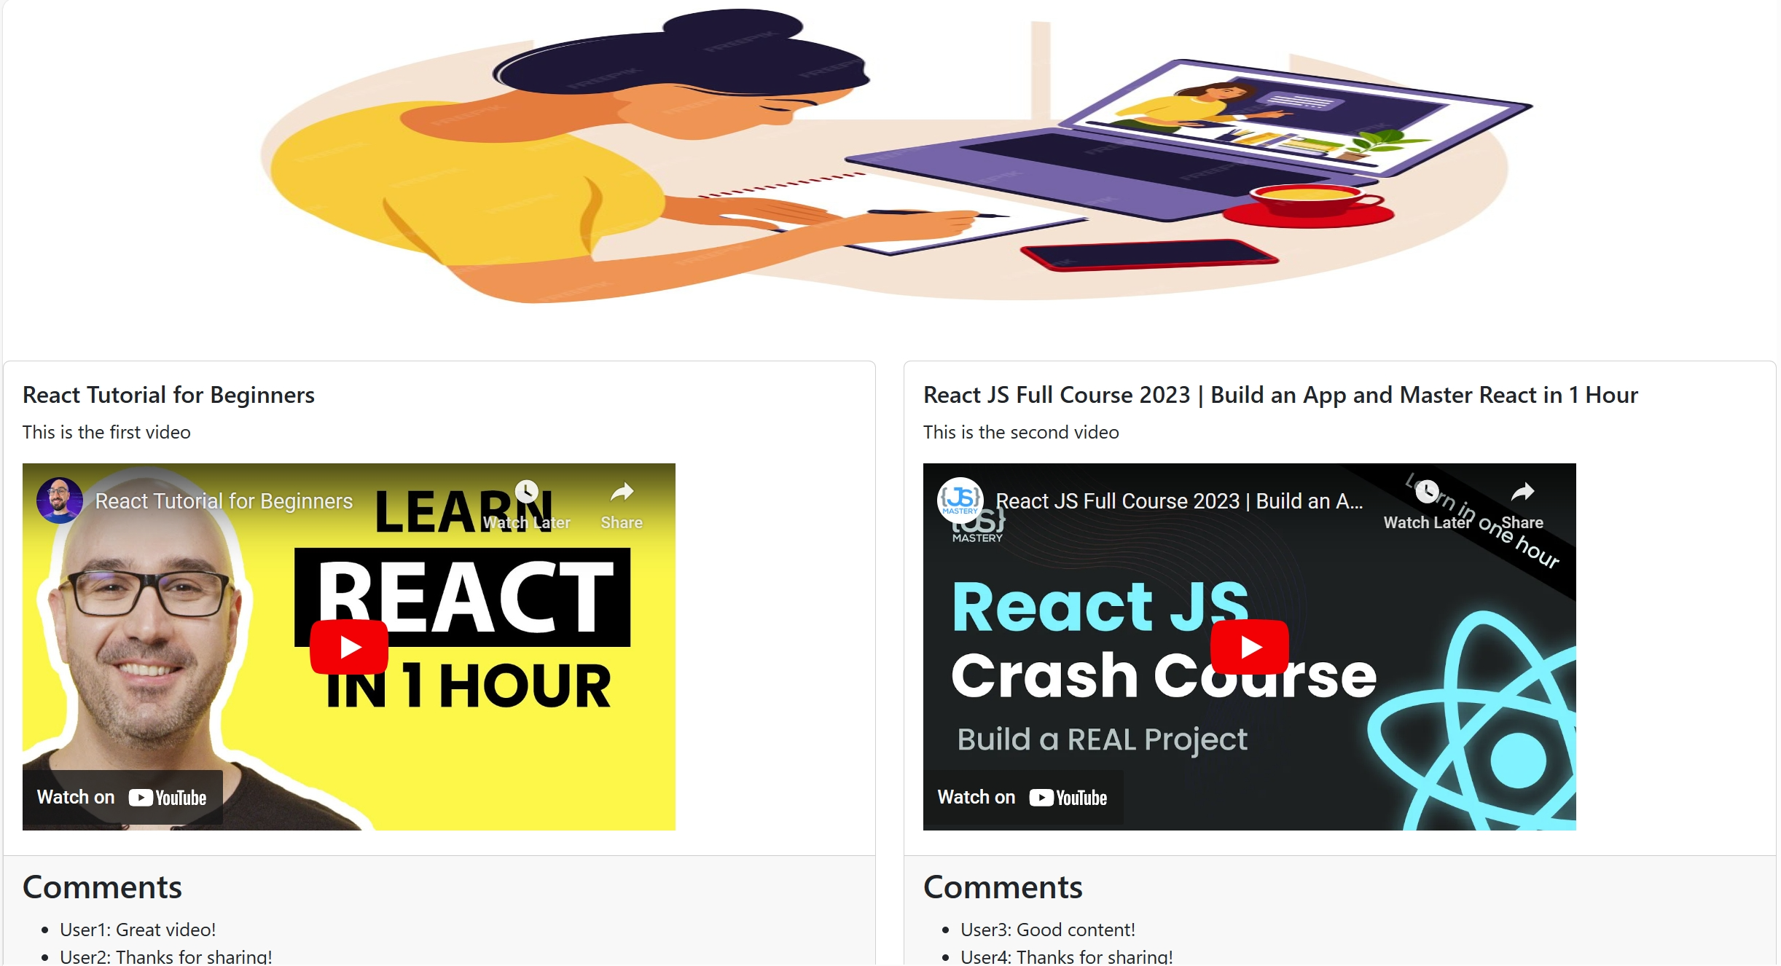

Hint: embed video

 <iframe width="560" height="315" src={video.url} title="YouTube video player" frameborder="0" allow="accelerometer; autoplay; clipboard-write; encrypted-media; gyroscope; picture-in-picture; web-share" allowfullscreen></iframe>

1. Add PropTypes for the video prop in the Video component. The video prop is expected to be an object with the following properties: title, description, url and comments. The title, description and url properties are expected to be strings and are marked as required using isRequired. The comments property is expected to be an array of objects, where each object has user and text properties, both of which are marked as required strings. (2 marks)
2. Fetching data from json-server (1 mark)

Hint: Create a file named db.json to perform the initialization of a virtual server using json-server, with the sample data below

1. Use the React Router to configure and set up navigation among two pages (**Home** and **Videos**) in a Video application (1 mark)
2. Create a beautiful interface using Bootstrap. (1 marks)

The materials that the student must submit to the lsmdn system for marking include: Video_code.zip

**Note:**

* The videos.js file are located in the paper, which students can use for test.
* During the file compression for submission, please exclude the node_modules folder.
* The interface should be able to be responsive on different device platforms, such as laptop, mobile.

**videos.js**

export const Videos =

[

{

"id": 1,

"title": "React Tutorial for Beginners",

"description": "This is the first video",

"url": " https://www.youtube.com/embed/SqcY0GlETPk?si=Uh6d9BmNwizQ7lh-",

"duration": "5:30",

"image": "https://example.com/video1.jpg",

"comments": [

{

"id": 1,

"text": "Great video!",

"user": "User1"

},

{

"id": 2,

"text": "Thanks for sharing!",

"user": "User2"

}

]

},

{

"id": 2,

"title": "React JS Full Course 2023 | Build an App and Master React in 1 Hour",

"description": "This is the second video",

"url": " https://www.youtube.com/embed/b9eMGE7QtTk?si=u6DOYlRIMf3XW-3j",

"duration": "3:45",

"image": "https://example.com/video2.jpg",

"comments": [

{

"id": 3,

"text": "Good content!",

"user": "User3"

},

{

"id": 4,

"text": "Thanks for sharing!",

"user": "User4"

}

]

},

{

"id": 3,

"title": "React JS Full Course for Beginners | Complete All-in-One Tutorial | 9 Hours",

"description": "This is the third video",

"url": " https://www.youtube.com/embed/RVFAyFWO4go?si=4c63xf2lgNdoEN9p",

"duration": "8:12",

"image": "https://example.com/video3.jpg",

"comments": []

}

// Add more questions here...

]