Q1.

import pytest
a = [2,5,7,8]
def nguyento(A):
T = True
F = False
prime = True
C = 0
B = len(A)

for i in range(B):
if (A[i] == 2 ):
C = C + 1
elif (A[i] < 2):
prime = False
elif (A[i] % 2 == 0):
prime = False
else :
for n in range(2,A[i]):

if (A[i] % n == 0 ):
prime = False
else :
C = C + 1
if (C >= 2):
return T
if (C < 2 ):
return F
print(nguyento(a))
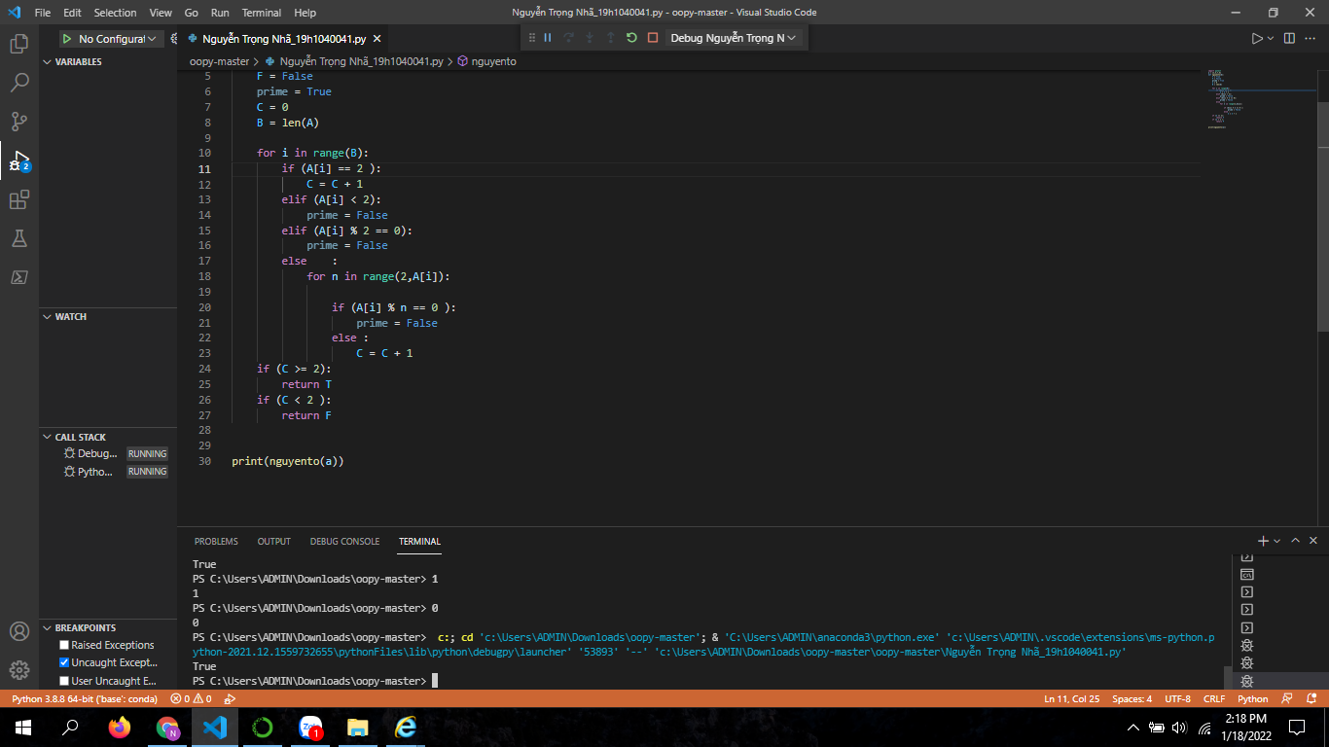

Q3:3.1
SELECT a.cust_name AS "city",
a.city, b.commission
FROM customer a
INNER JOIN salesman b
ON a.salesman_id=b.salesman_id
WHERE b.commission>.10;
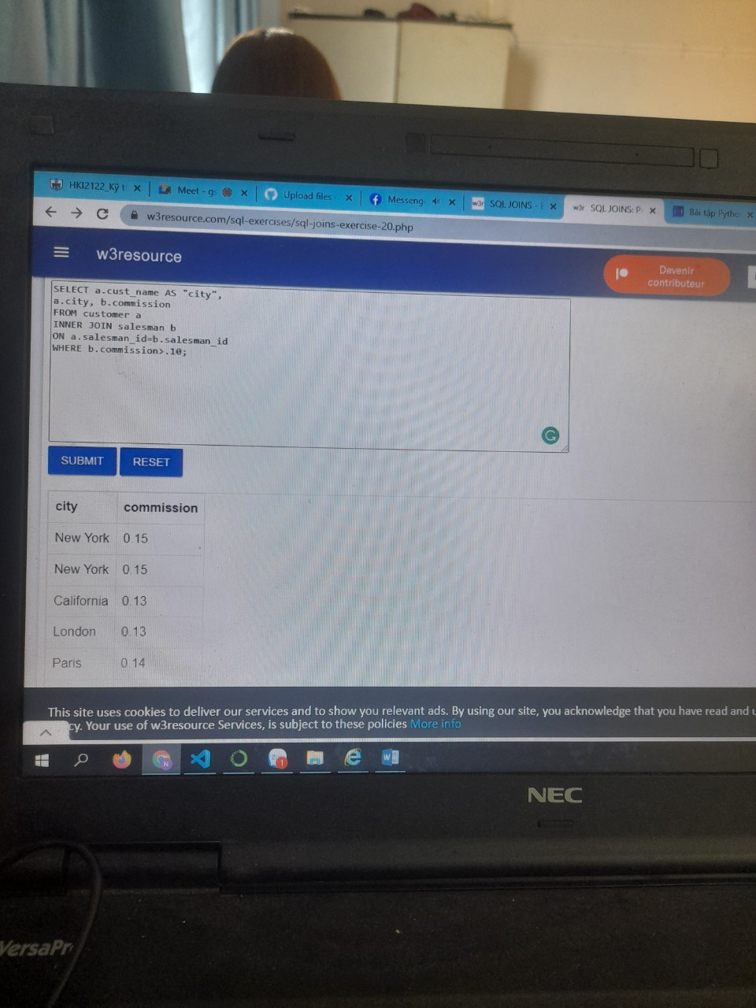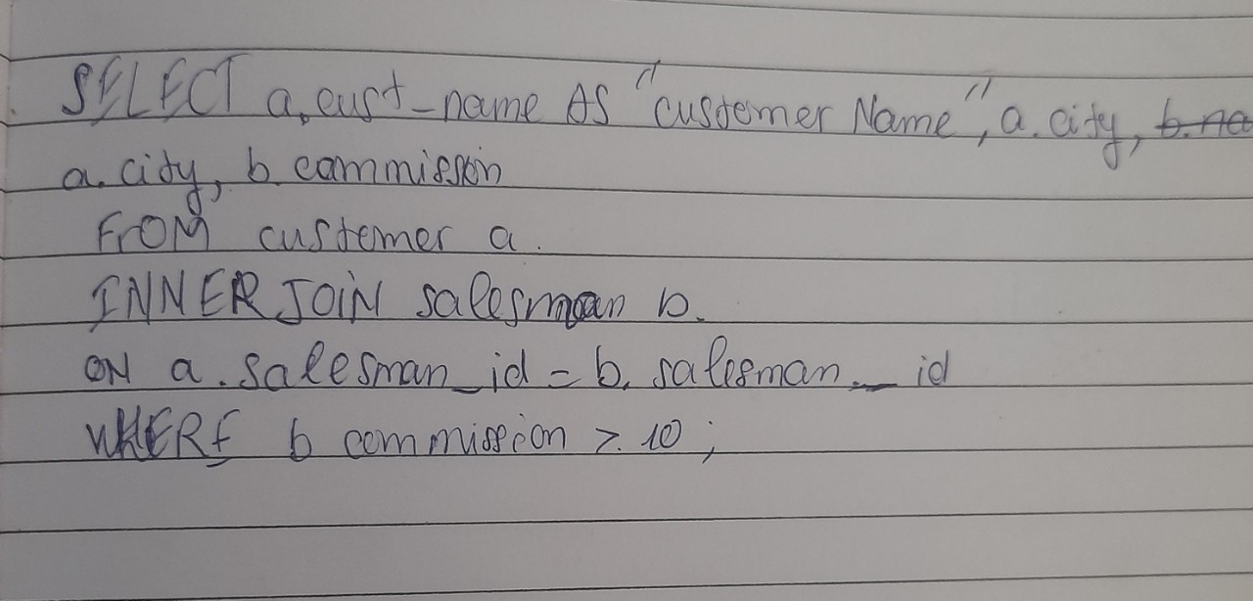

3.2
SELECT a.cust_name AS "Customer Name",
a.city, b.name AS "Salesman", b.commission
FROM customer a
INNER JOIN salesman b
ON a.salesman_id=b.salesman_id
WHERE b.commission>.12
