**Colorful Boardgame Shop**

*SWP391-SE1737-Team 1*

Nguyen Truong Khang Thuan

Huynh Nguyen Thai Duong

**Software Requirements Specification**

**Document**

**Version: (1.0)** **Date: (22 Jul, 2023)**

**Table of Contents**

**1. Introduction** **5**

1.1 Purpose 5

1.2 Scope 5

1.3 Definitions, Acronyms, and Abbreviations. 5

1.3.1 Definitions 5

1.3.2 Acronyms 6

1.4 References 6

1.5 Overview 6

**2. The Overall Description** **7**

2.1 Product Perspective 7

2.1.1 System Interfaces 7

2.2 Product Functions 8

2.3 User Characteristics 8

2.3.1 Users 8

2.3.2 Publishers 8

2.3.3 Administrator 8

2.5 Assumptions and Dependencies 8

**3. Specific Requirements** **9**

3.1 Functions 9

Function 1: Login 9

Function 2: Register 9

Function 3: Search Game Package 9

Function 4: View Details of Game Package 10

Function 5: Add Game Packages to Cart 10

Function 6: Remove Game Packages from Cart 11

Function 7: Proceed to Checkout 11

Function 8: View Profile 11

Function 9: Update Profile 12

Function 10: View Order History 12

Function 11: Add new Game Packages 13

Function 12: Update current Game Packages 13

Function 13: Remove Game Packages from the stock 13

Function 14: View Users 14

Function 15: View Publishers 14

Function 16: Add Publishers 14

Function 17: Ban Publishers 14

Function 18: View Boardgames 15

Function 19: Add Based Boardgames 15

Function 20: Remove Based Boardgames 15

Function 21: View Transactions 15

# 1. Introduction

*The following sections will briefly introduce about the idea behind the project, as well as some definitions included in the project*

## 1.1 Purpose

Boardgames have become a favorite among every teenagers in Vietnam nowadays, but with only few original boardgames to play, many publishers have figured out a way of creating more aesthetic rendition of beloved classics in order to increase the variety in the boardgames collection. With this in mind, our projects aims to open an e-commerce shop so everyone can buy all kinds of boardgames and its visual-enhanced edition for more fun and more colorful.

## 1.2 Scope

With the purpose behind the idea of developing the product, this Colorful Boardgame Shop aims to:

- Create a platform for publishers to showcase their variety of different boardgames extensions through their creative work by selling their products in our shop.

- Allow users to explore and purchase their favorite boardgames collections

## 1.3 Definitions, Acronyms, and Abbreviations.

## 1.3.1 Definitions

| **Term** | **Definition** |
| --- | --- |
| Boardgame | Any game played on a board, especially one that involves the movement of pieces on the board |
| Gamepacks (or Game Packages) | Refer to a full collection or/and extension of any Boardgame. |
| Publishers | Companies or Individuals who publish their product |
| Customers | Users who visits the shop and purchase products from the shop. |
| Administrators | Users who oversee the entire system. |
| Stock | Refers to a place where publishers can store their products |

## 1.3.2 Acronyms

| **Acronyms/Abbreviation** | **Full Form** |
| --- | --- |
| SRS | Software Requirements Specification |
| UI | User Interface |
| UX | User Experience |
| API | Application Programming Interface |
| BG(s) | Boardgame(s) |
| CTA | Call To Action |

## 1.4 References

- Boardgame VN: <https://boardgame.vn>

## 1.5 Overview

*In the upcoming parts of the documents, we will go through*

1. *Project Overall*
2. *Project Specific Requirements*

# 2. The Overall Description

*This section will go through the overall of the Colorful Boardgame Shop.*

## 2.1 Product Perspective

### 2.1.1 System Interfaces

### 

**2.1.2 Use Case Diagram**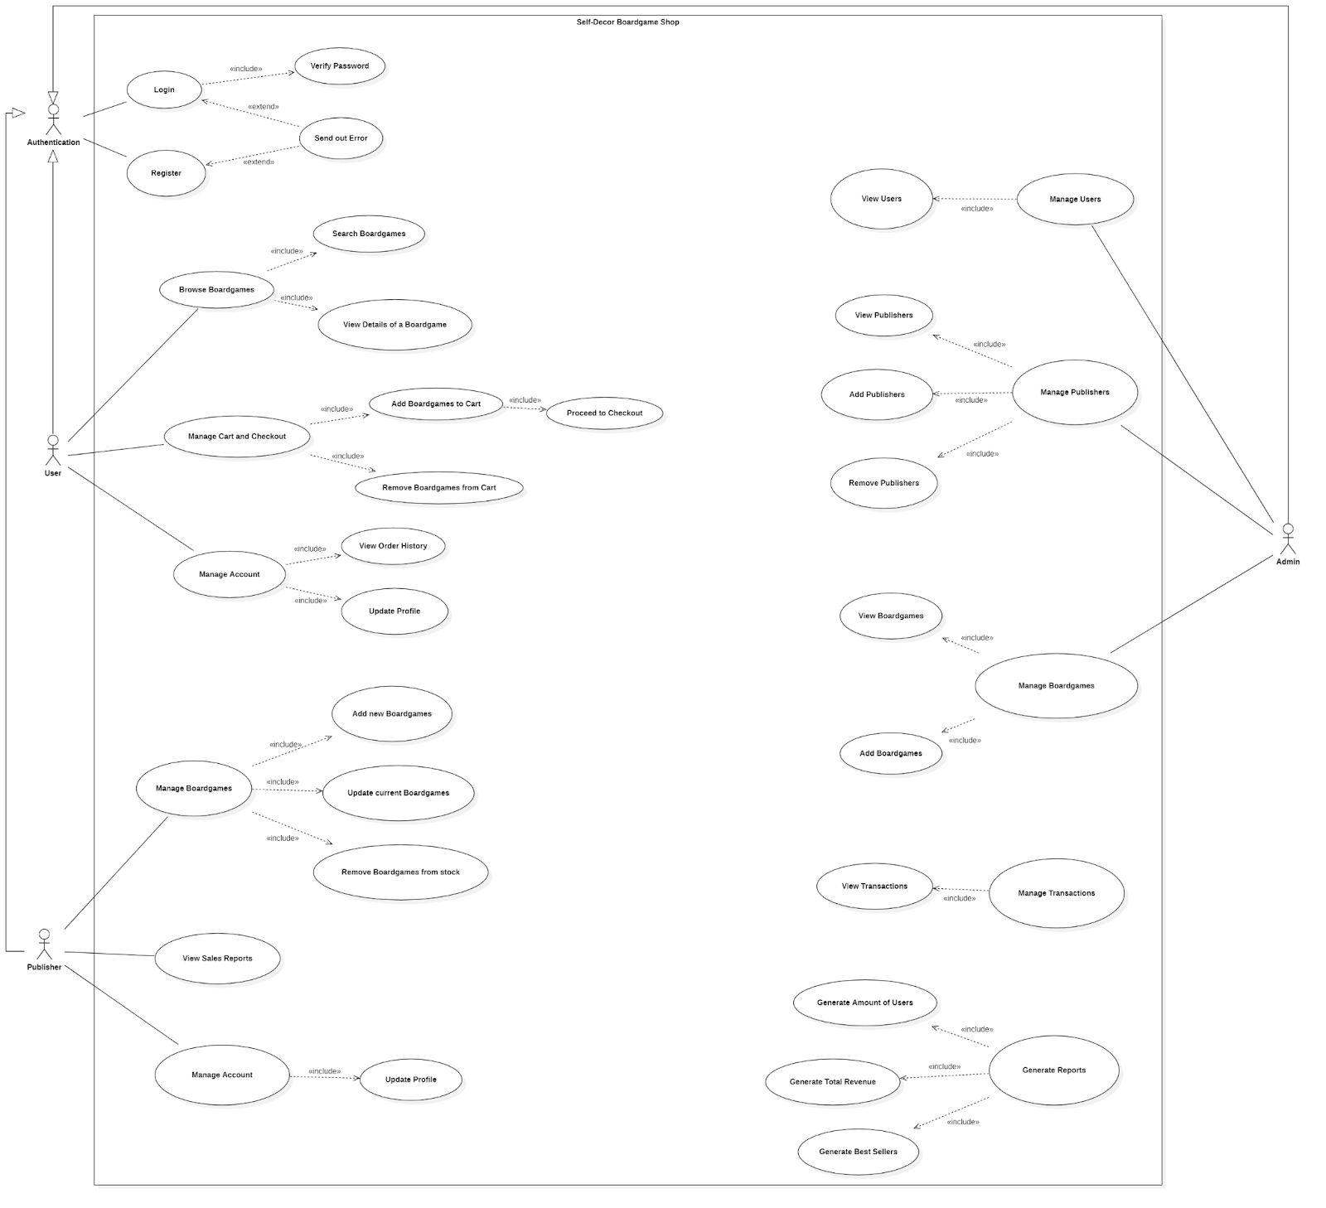

## 2.2 Product Functions

Some notable functions that are available in the system are:

1. Authentication: For further actions, each Users, Publishers and Administrators need to have an account in order to enter into the system.
2. Add and Update Gamepacks: For publishers, they must be able to add or update certain gamepacks.
3. Manage Data: For Administrators, they must be able to manage certain data in the system such as Users Account Information, Publishers Information and some gamepacks and based boardgames already in the system.

## 2.3 User Characteristics

### 2.3.1 Users

Users are customers who will visit and purchase the boardgame from our shop.

They must have some certain knowledge towards Boardgames, in addition to being a person who will be able to make payment as well.

### 2.3.2 Publishers

Publishers typically are companies that are publishing boardgames or artists who want to export their artistic creations related to boardgame, into our system.

In addition to the requirements in terms of knowledge related to boardgames and publishing games as physical products, Publishers also need to cooperate well with the Administrator as the permission to access into the system relies heavily on the Administrators agreement.

### 2.3.3 Administrator

Administrators will need to understand the system in order to manage the entire system.

## 2.5 Assumptions and Dependencies

* Each users already have their Momo installed and has activate permission for payment
* After making the payment, products will be sent to the post office of the city the user is living in currently. If the address of the user is available, products will be sent to the post office near their locations.

# 3. Specific Requirements

## 3.1 Functions

#### Function 1: *Login*

* **Actors**: Users, Publishers, Administrators
* **Description**: This function allows users, publishers and administrators to log into the website as their corresponding roles.
* **Pre-condition**: Users, Publishers, Administrators’ account has already been registered in the system.
* **Post-condition (Results)**:
  + Success: The authorisation will direct users to the Shop page, Publishers to their Publish Boardgame Page, and Administrators to the Admin Page.
  + Fail: Display an error message “Incorrect Username or Password”

#### Function 2: *Register*

* **Actors**: Users, Publishers, Administrators
* **Description**: This function allows users and publishers to create an account for the system.
* **Pre-condition**: For Publishers and Administrators, they need to have the permission from the Admin Team in order to create an account.
* **Post-condition (Results)**: The authorisation will direct users to the Shop page, Publishers to their Publish Boardgame Page, and Administrators to the Admin Page.

#### Function 3: *Search Game Package*

* **Actor**: Users
* **Description**: This function allows users to search items available in the website through keywords and Tags
* **Pre-condition**: Users must successfully login to the website.
* **Post-condition (Results)**:
  + Success: Display a list of Game Packages that match with the keyword and, or Tags.
  + Fail: Display “There are no items that match your searching criteria”

#### Function 4: *View Details of Game Package*

* **Actor**: Users
* **Description**: This function allows users to view details of a game package in the shop.
* **Pre-condition**:
  + Users must successfully login to the website.
  + The Game Package remains available for sale in the shop.
* **Post-condition (Results)**: Display details of the Game Package including information about Publishers of the package, components inside the package, ruleset or other additional information related to the package itself.

#### Function 5: *Add Game Packages to Cart*

* **Actor**: Users
* **Description**: This function allows users to add the selected Game Packages to their Cart
* **Pre-condition**:
  + Users must successfully login to the website.
  + The Game Package remains available for sale in the shop.
* **Post-condition (Results)**:
  + Success:
    - Displays the message “Item is successfully added to your cart, please check your cart for more details”.
    - Inside the cart, display details of the Game Packages, quantity which can be modified through a number input, the total price of each of the Game Packages and the grand total price for all items in the cart.
  + Fail:
    - Displays the message “Your order quantity exceeds item’s remaining quantity”

#### Function 6: *Remove Game Packages from Cart*

* **Actor**: Users
* **Description**: This function allows users to remove the selected Game Packages to their Cart
* **Pre-condition**:
  + Users must successfully login to the website.
  + The cart must contain at least 1 item inside.
* **Post-condition (Results)**:
  + The item will be removed from the cart, and a message will be displayed “Item(s) successfully removed”

#### Function 7: *Proceed to Checkout*

* **Actor**: Users
* **Description**: This function allows users to checkout after viewing all items in their cart.
* **Pre-condition**:
  + Users must successfully login to the website.
  + The cart must contain at least 1 item inside.
* **Post-condition (Results)**:
  + Success: Display message “Order Complete! Here’s the result”, along with the result of the cart.
  + Fail:
    - Display message “Fail to make purchase due to your balance in the account” if the account does not have enough balance to pay for the order

#### Function 8: *View Profile*

* **Actor**: Users
* **Description**: This function allows users to view all of their profile, including their username, email, password and additional information such as phone number, address,...
* **Pre-condition**:
  + Users must successfully login to the website.
* **Post-condition (Results)**:
  + A User Details page will open and display all information of the user.

#### Function 9: *Update Profile*

* **Actor**: Users
* **Description**: This function allows users to modify all of their profile, including their username, email, password and additional information such as phone number, address,...
* **Pre-condition**:
  + Users must successfully login to the website.
  + Users already open the User Details page.
* **Post-condition (Results)**:
  + All information will become text boxes allowing users to update their information. After clicking on “Save”, display the message “Profile updated successfully” and return to the User Details page.

#### Function 10: *View Order History*

* **Actor**: Users
* **Description**: This function allows users to view all of their history of order in the shop. This information includes: the date and time user orders, items in the order, total price for each of the items and the grand total price of the orders.
* **Pre-condition**:
  + Users must successfully login to the website.
* **Post-condition (Results)**:
  + A list of Orders will be displayed in a table, with a View Details allowing users to view all details of the specific order.
  + If no orders are made in the account, nothing will be displayed in the Order list. In addition, “There are no orders created” message will be displayed.

#### Function 11: *Add new Game Packages*

* **Actor**: Publishers
* **Description**: This function allows publishers to add their new Game Packages to the stock for selling.
* **Pre-condition**: Publishers must successfully login to the website.
* **Post-condition (Results)**: A screen will appear, allowing Publishers to add information to the new Game Packages. Once the publishers fill the information in the form, the Game Packages will be added to their stock along with a message displaying “Game Package added successfully”.

#### Function 12: *Update current Game Packages*

* **Actor**: Publishers
* **Description**: This function allows publishers to update their current game packages in their stock
* **Pre-condition**:
  + Publishers must successfully login to the website.
  + Their stock must have at least a Game Package
* **Post-condition (Results)**:
  + A screen will appear, allowing the publisher to modify the information of the Game Package and save them.
  + After saving the information, message “Game Package update successfully” will be displayed

#### Function 13: *Remove Game Packages from the stock*

* **Actor**: Publishers
* **Description**: This function allows publishers to remove Game Packages from their stock
* **Pre-condition**:
  + Publishers must successfully login to the website.
  + Their stock must have at least a Game Package
* **Post-condition (Results)**:
  + Success: The item will be removed from the stock, and the message “Game Package(s) Removed Successfully” will be displayed.
  + Fail: Display “Unable to Remove Game Package(s)”

#### Function 14: *View Users*

* **Actor**: Administrators
* **Description**: This function allows admins to view and manage a list of current users that have registered into the system
* **Pre-condition**: ADMINs must log into the system
* **Post-condition (Results)**: A Table of Users Account will be displayed. Here ADMINs can have an option of viewing details of the User in the table.

#### Function 15: *View Publishers*

* **Actor**: Administrator
* **Description**: This function allows admins to view and manage a list of current publishers that have registered into the system
* **Pre-condition**: ADMINs must log into the system
* **Post-condition (Results)**: A Table of Publishers Account will be displayed. Here ADMINs can have an option of viewing details of the Publisher in the table.

#### Function 16: *Add Publishers*

* **Actor**: Administrator
* **Description**: This function allows administrator to add new publishers into the system
* **Pre-condition**:
  + ADMINs must log into the system
  + ADMINs have clicked on the Add button inside the View Publishers Table.
* **Post-condition (Results)**: A form will be created for ADMIN to add Publisher in. After entering the form and clicking on “Add”, the new Publisher will be created.

#### Function 17: *Ban Publishers*

* **Actor**: Administrator
* **Description**: This function allows administrator to ban a publisher from entering into the system
* **Pre-condition**:
  + ADMINs must log into the system
  + ADMINs have navigated to the View Publishers page and clicked on “Banned” for the selected Publisher.
* **Post-condition (Results)**: The Publisher will be switching to state “Banned”.

#### Function 18: *View Boardgames*

* **Actor**: Administrator
* **Description**: This function allows Administrators to view certain type of based boardgames.
* **Pre-condition**: ADMINs must login to the system.
* **Post-condition (Results)**: A Table of based boardgames will be displayed.

#### Function 19: *Add Based Boardgames*

* **Actor**: Administrator
* **Description**: This function will allow Administrators to add certain based boardgames into the list.
* **Pre-condition**:
  + ADMINs must login to the system.
  + ADMINs have clicked on the Add button inside the View Boardgames Table.
* **Post-condition (Results)**: A form will be created for ADMIN to add Boardgame in. After entering the form and clicking on “Add”, the new Boardgame will be created.

#### Function 20: *Remove Based Boardgames*

* **Actor**: Administrator
* **Description**: This function allow administrator to remove any based boardgames out of the list
* **Pre-condition**:
  + ADMINs must log into the system
  + ADMINs have navigated to the View Boardgames page and clicked on “Delete” for the selected Boardgame.
* **Post-condition (Results)**: The selected Boardgame will be removed from the list

#### Function 21: *View Transactions*

* **Actor**: Administrator
* **Description**: This function allows administrators to view all transactions in the shop
* **Pre-condition**: ADMINs must login to the system
* **Post-condition (Results)**: A list of Transactions will be displayed.