Tên: Nguyễn Hữu Tuấn

MSV: 23115053122247

Lớp HP:125LTTD03

Bài Tập Ôn Tập Java

# Bài 1)

## Hình ảnh code

## Hình ảnh kết quả chạy

## Link git: https://github.com/NguyenTuan180505/JavaBaiOnTap/tree/BaiTap1

# Bài 2)

## Hình ảnh code

## Hình ảnh chạy

## Link git: https://github.com/NguyenTuan180505/JavaBaiOnTap/tree/BaiTap2

# Bài 3)

## Hình ảnh code

## Hình ảnh chạy

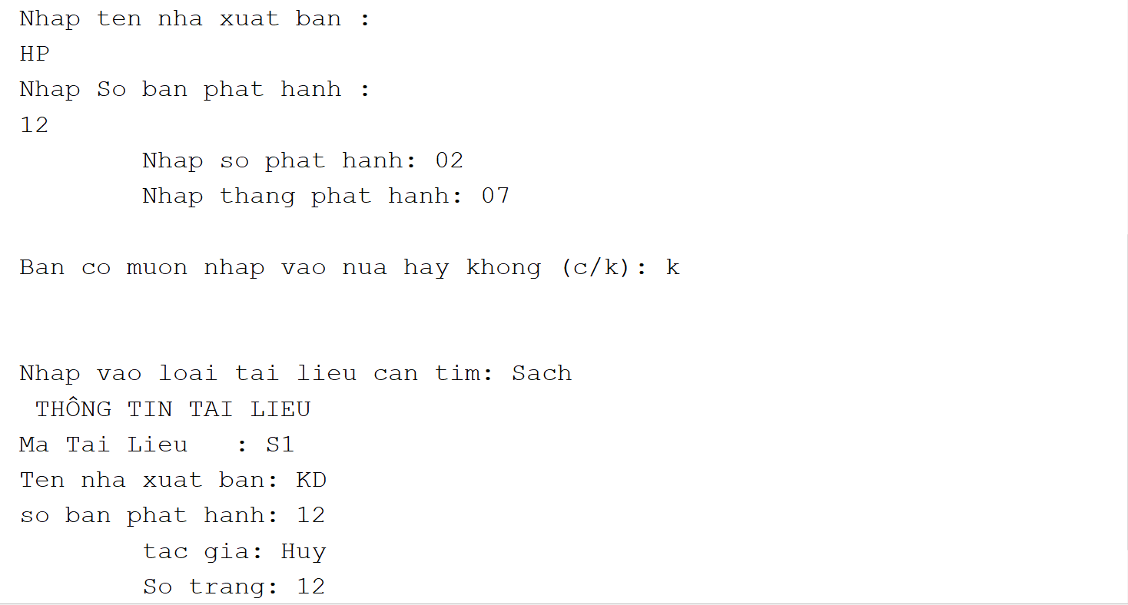

## Link 3: <https://github.com/NguyenTuan180505/JavaBaiOnTap/tree/BaiTap3>

# Bài 4)

## Hình ảnh code

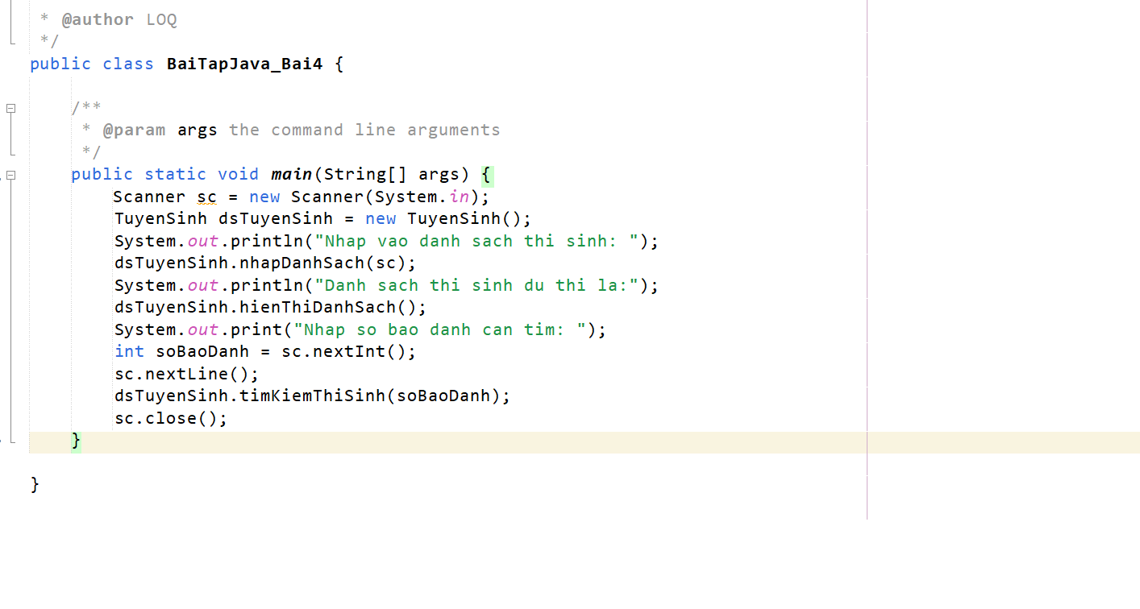

## Hình ảnh chạy



## Link git: https://github.com/NguyenTuan180505/JavaBaiOnTap/tree/BaiTap4

# Bài 5)

## Hình ảnh code

## Hình ảnh chạy

## Link git: https://github.com/NguyenTuan180505/JavaBaiOnTap/tree/BaiTap5

# Bai 6)

## Hình ảnh code

## Hình ảnh chạy

## Link git: https://github.com/NguyenTuan180505/JavaBaiOnTap/tree/BaiTap6

# Bài 7)

## Link git: <https://github.com/NguyenTuan180505/JavaBaiOnTap/tree/BaiTap7>

# Bài 8)

## Hình ảnh code

## Hình ảnh chạy

## Link git: https://github.com/NguyenTuan180505/JavaBaiOnTap/tree/BaiTap8

# Bài 9)

## Hình ảnh code

## Hình ảnh chạy

## Link git: https://github.com/NguyenTuan180505/JavaBaiOnTap/tree/BaiTap9

# Bài 10)

## Hình ảnh chạy

## Link git: https://github.com/NguyenTuan180505/JavaBaiOnTap/tree/BaiTap10