

**FPT ACADEMY INTERNATIONAL FPT – APTECH COMPUTER EDUCATION**

**PROJECT: Online Insurance**

**Semester: 03 Batch No: T1-1908E0**

# A.Hardware / Software Requirements

1. **Server Requirement**

* Hardware

|  |  |
| --- | --- |
| **Component** | **Requirement** |
| **CPU** | Processor type:  Pentium IV-compatible processor or faster  Processor speed:  Recommended: 2.0 GHz or faster |
| **OS** | Microsoft Windows Server 2012 with IIS |
| **Memory (RAM)** | RAM:  Minimum: 1 GB  Recommended: 2 GB or more |
| **Hard Drive** | Free space:  Minimum: 512 MB  Recommended: 50 GB or more  Maximum: Operating system maximum |

* Software

|  |  |
| --- | --- |
| **Component** | **Requirement** |
| **Microsoft .NET Framework** | Version 4.6 or higher |
| **RDBMS** | Microsoft SQL Server 2017 |

1. **Client Requirement**

* Hardware

|  |  |
| --- | --- |
| **Component** | **Requirement** |
| **CPU** | Processor type:  Pentium III-compatible processor or faster  Processor speed:  Recommended: 1.0 GHz or faster |
| **OS** | All OS (Window, Linux, Android, Mac OS …) |
| **Memory (RAM)** | RAM:  Minimum: 1 GB  Recommended: 2 GB or more  Maximum: Operating system maximum |
| **Hard Drive** | Free space:  Minimum: 10 MB |

* Software

|  |  |
| --- | --- |
| **Component** | **Requirement** |
| **Web Browser** | Chrome (up to date). |

**B. Cài đặt chương trình**

Step 1: Extract file

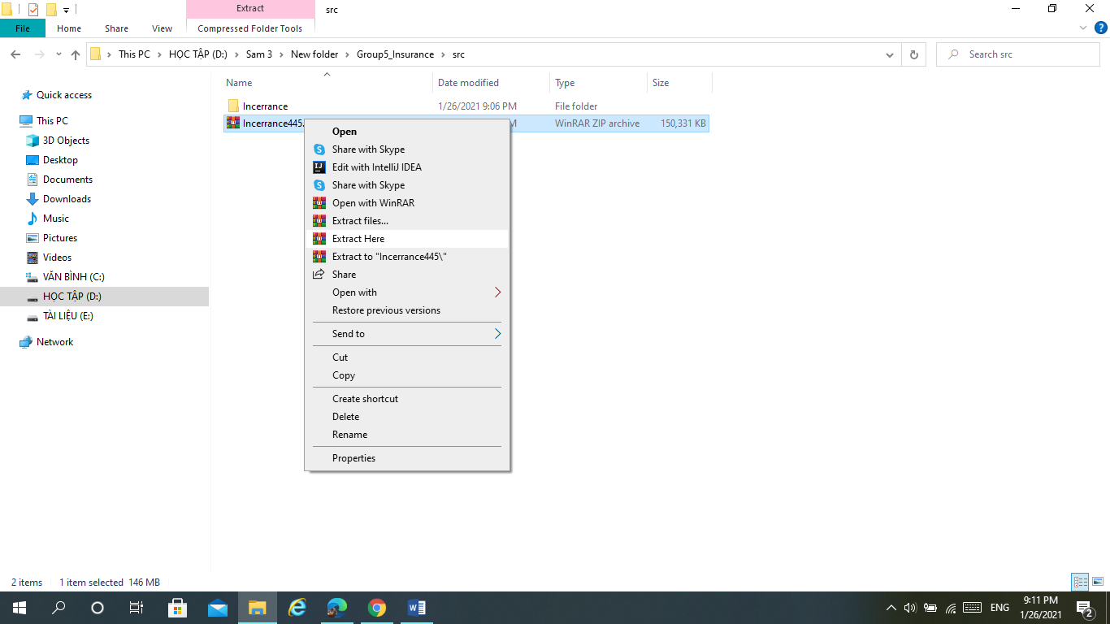

Step 2: Open Folder Insurance445.

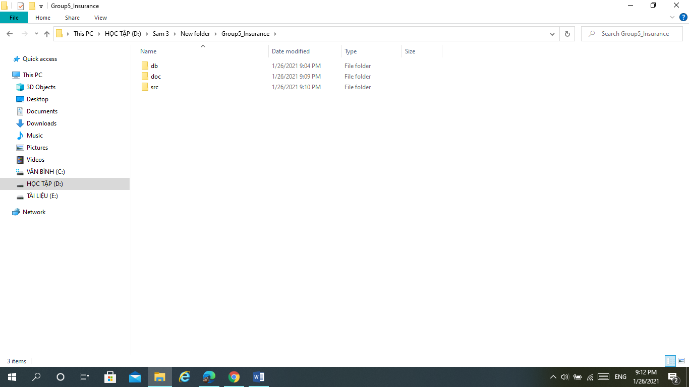

Step 3:Open Folder src

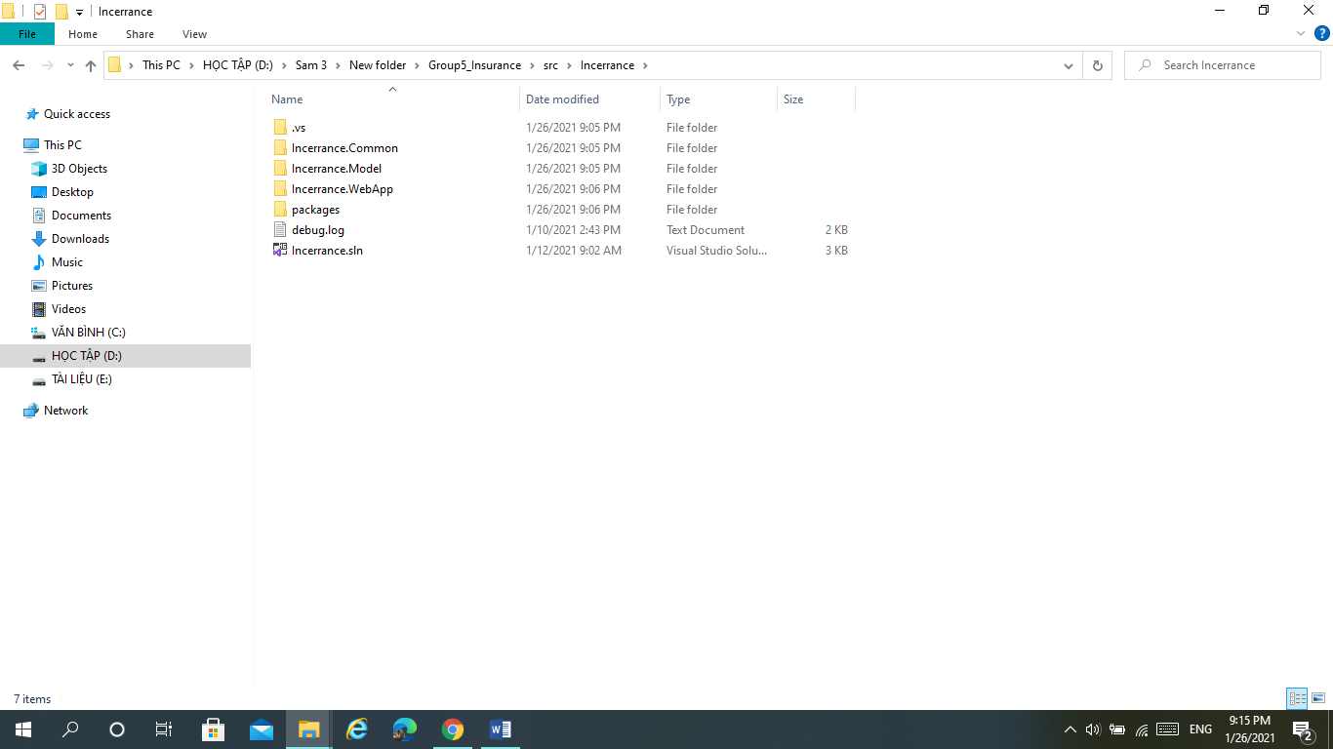

Step 4: Open File Visual Insurance.sln

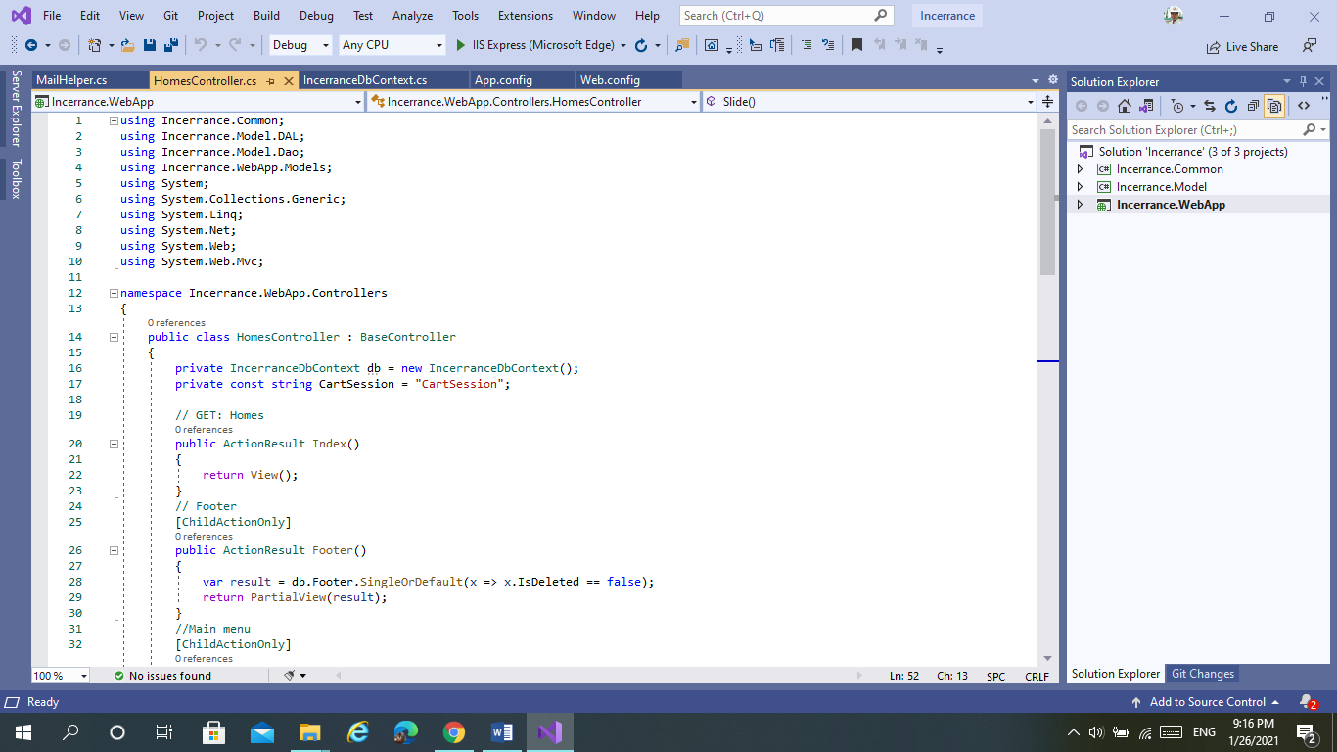

Step 5: Click Open Web.config

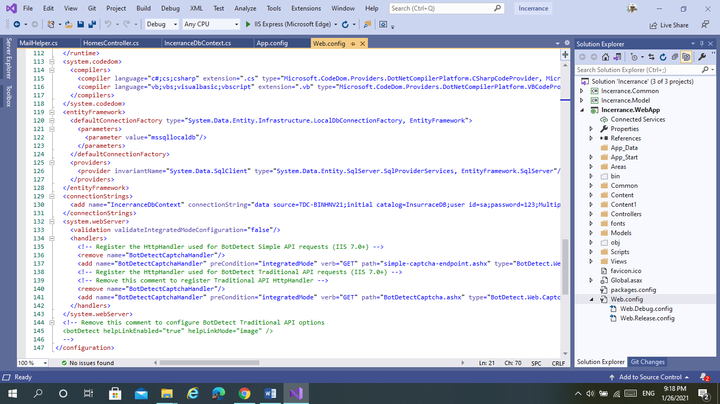

Step 6: Connect Database in project:

Find line <connectionStrings>... </connectionStrings>, Edit

datasource=...; id=...;password=...

Connect to server SQL Server



Step 7: Open Microsoft SQL Server Management Studio 18

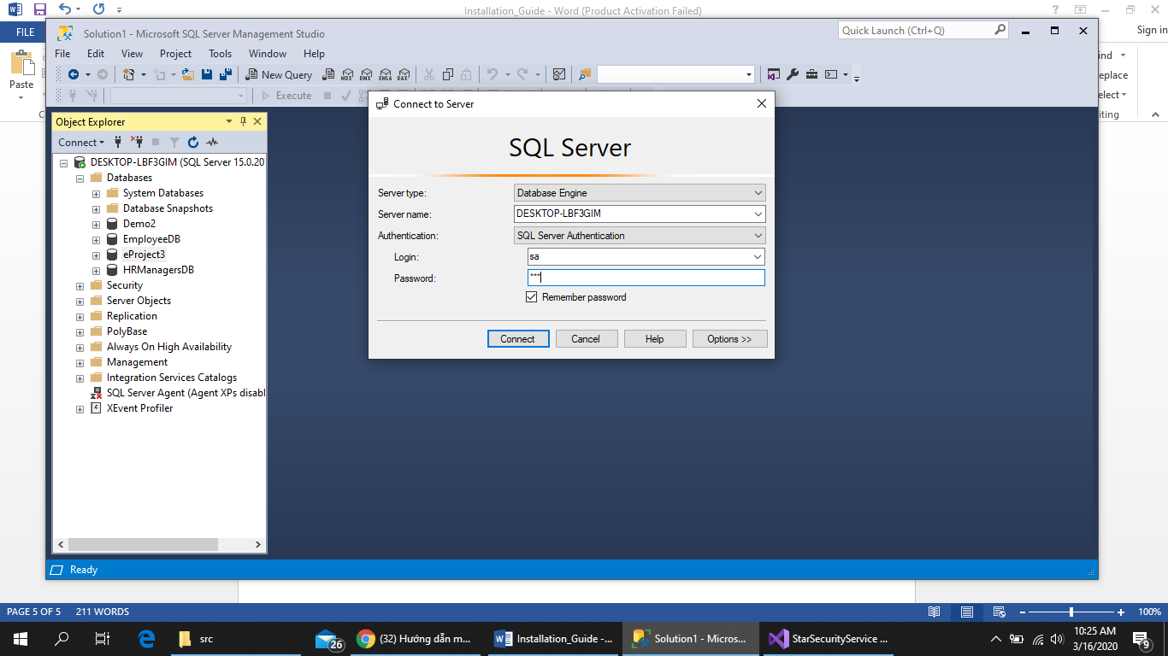

Step 8: Open file

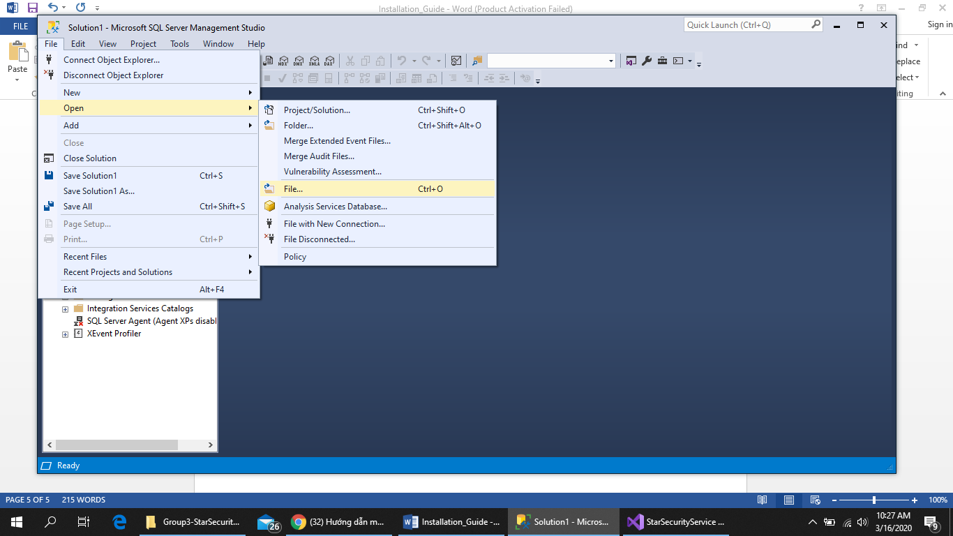

Step 9: Open Group5-Insurance\db\db445

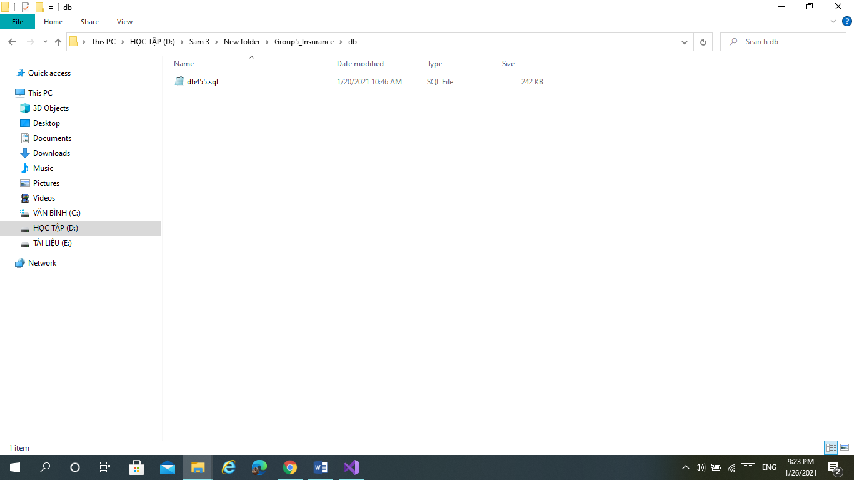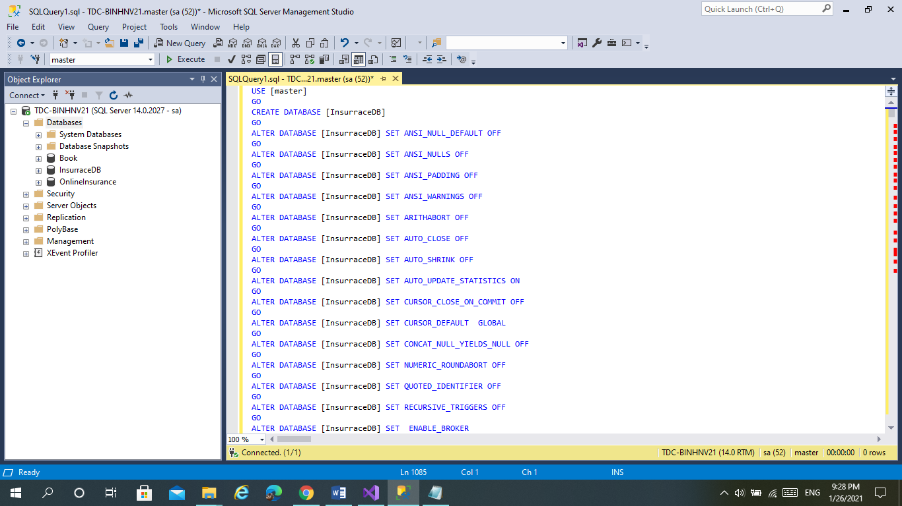

Step 10: Click Execute(F5), Complete

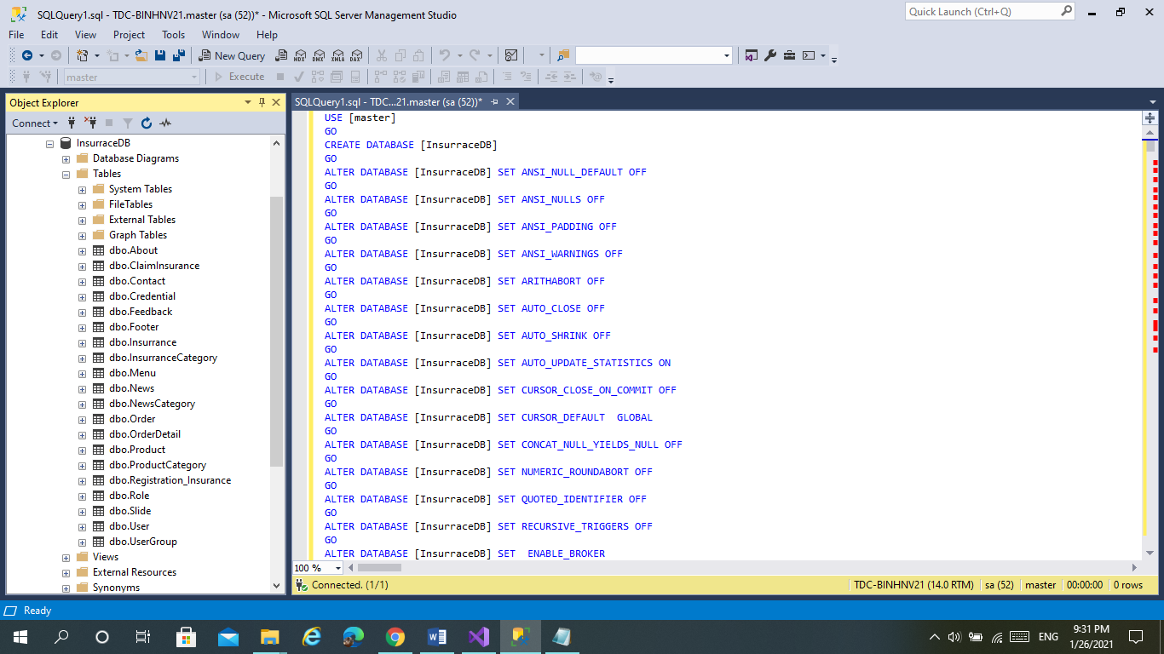

Complete

Step 11: Open Visual. Click Run IIS Express(Google Chrome).

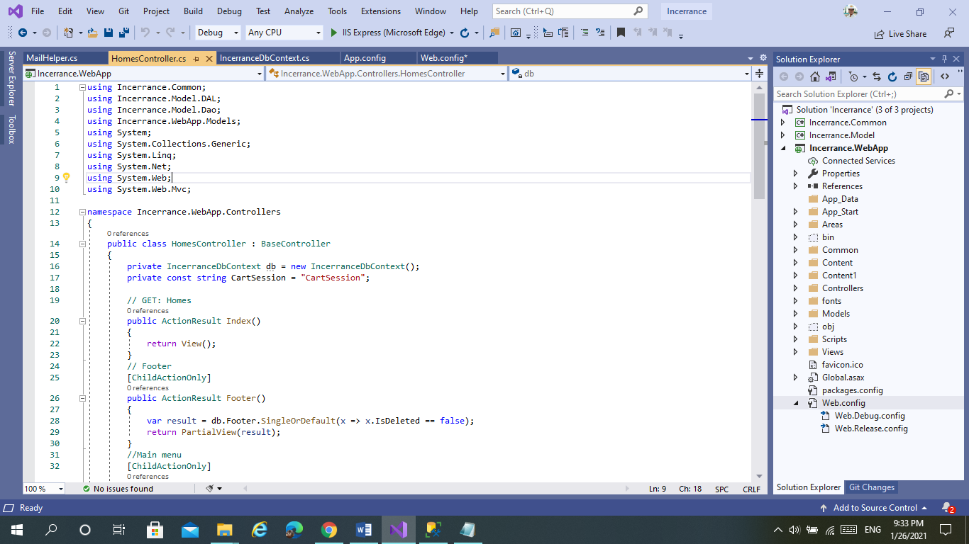

After Run

