**REPORT WEEK 12**

Họ và tên: Nguyễn Văn Hưng

MSSV: 20225634

Lớp: Thực hành kiến trúc máy tính – Mã lớp: 147799

1. **Assignment 1:**

# Running the Data Cache Simulator tool

1. Close any MIPS programs you are currently using.

1. Open the program **row-major.asm** from the Examples folder. This program will traverse a 16 by 16 element integer matrix in row-major order, assigning elements the values 0 through 255 in order. It performs the following algorithm:

for (row = 0; row < 16; row++) for (col = 0; col < 16; col++)

data[row][col] = value++;

Code:

#############################################################################

# Row-major order traversal of 16 x 16 array of words.

# Pete Sanderson

# 31 March 2007

#

# To easily observe the row-oriented order, run the Memory Reference

# Visualization tool with its default settings over this program.

# You may, at the same time or separately, run the Data Cache Simulator

# over this program to observe caching performance. Compare the results

# with those of the column-major order traversal algorithm.

#

# The C/C++/Java-like equivalent of this MIPS program is:

# int size = 16;

# int[size][size] data;

# int value = 0;

# for (int row = 0; row < size; row++) {

# for (int col = 0; col < size; col++) }

# data[row][col] = value;

# value++;

# }

# }

#

# Note: Program is hard-wired for 16 x 16 matrix. If you want to change this,

# three statements need to be changed.

# 1. The array storage size declaration at "data:" needs to be changed from

# 256 (which is 16 * 16) to #columns * #rows.

# 2. The "li" to initialize $t0 needs to be changed to new #rows.

# 3. The "li" to initialize $t1 needs to be changed to new #columns.

#

.data

data: .word 0 : 256 # storage for 16x16 matrix of words

.text

li $t0, 16 # $t0 = number of rows

li $t1, 16 # $t1 = number of columns

move $s0, $zero # $s0 = row counter

move $s1, $zero # $s1 = column counter

move $t2, $zero # $t2 = the value to be stored

# Each loop iteration will store incremented $t1 value into next element of matrix.

# Offset is calculated at each iteration. offset = 4 * (row*#cols+col)

# Note: no attempt is made to optimize runtime performance!

loop: mult $s0, $t1 # $s2 = row * #cols (two-instruction sequence)

mflo $s2 # move multiply result from lo register to $s2

add $s2, $s2, $s1 # $s2 += column counter

sll $s2, $s2, 2 # $s2 *= 4 (shift left 2 bits) for byte offset

sw $t2, data($s2) # store the value in matrix element

addi $t2, $t2, 1 # increment value to be stored

# Loop control: If we increment past last column, reset column counter and increment row counter

# If we increment past last row, we're finished.

addi $s1, $s1, 1 # increment column counter

bne $s1, $t1, loop # not at end of row so loop back

move $s1, $zero # reset column counter

addi $s0, $s0, 1 # increment row counter

bne $s0, $t0, loop # not at end of matrix so loop back

# We're finished traversing the matrix.

li $v0, 10 # system service 10 is exit

syscall # we are outta here.

1. Assemble the program.

1. From the **Tools** menu, select **Data Cache Simulator**. A new frame will appear in the middle of the screen.

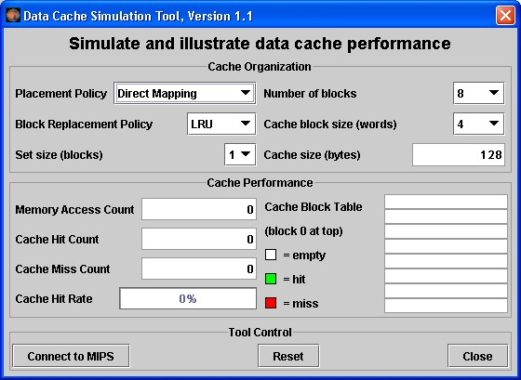

This is a MARS Tool that will simulate the use and performance of cache memory when the underlying MIPS program executes. Notice its three major sections:

* + *Cache Organization:* You can use the combo boxes to specify how the cache will be configured for this run. Feel free to explore the different settings, but the default is fine for now.
  + *Cache Performance:* With each memory access during program execution, the simulator will determine whether or not that access can be satisfied from cache and update the performance display accordingly.
  + *Tool Control:* These buttons perform generic control functions as described by their labels.

1. Click the tool's **Connect to MIPS** button. This causes the tool to register as an observer of MIPS memory and thus respond during program execution.

1. Back in MARS, adjust the **Run Speed slider** to 30 instructions per second. It is located at the right side of the toolbar. This slows execution so you can watch the Cache Performance animation.



1. In MARS, run the program using the **Run** toolbar button  , the menu item or keyboard shortcut. Watch the Cache Performance animate as it is updated with every access to MIPS memory.

1. *What was the final cache hit rate?* **75%** . With each miss, a block of 4 words are written into the cache. In a row-major traversal, matrix elements are accessed in the same order they are stored in memory. Thus each cache miss is followed by 3 hits as the next 3 elements are found in the same cache block. This is followed by another miss when Direct Mapping maps to the next cache block, and the patterns repeats itself. So 3 of every 4 memory accesses will be resolved in cache.

1. Given that explanation, *what do you predict the hit rate will be if the block size is increased from 4 words to 8 words?* **88%.**

*Decreased from 4 words to 2 words?* **50%.**

1. Verify your predictions by modifying the block size and re-running the program from step 7.

*NOTE:* when you modify the Cache Organization, the performance values are automatically reset (you can always use the tool's **Reset** button).

*NOTE:* You have to **reset**  the MIPS program before you can re-run it. *NOTE:* Feel free to adjust the **Run Speed slider** to maximum speed anytime you want.

1. Repeat steps 2 through 10 for program **column-major.asm** from the Examples folder. This program will traverse a 16 by 16 element integer matrix in column-major order, assigning elements the values 0 through 255 in order. It performs the following algorithm:

for (col = 0; col < 16; col++) for (row = 0; row < 16; row++) data[row][col] = value++;

*NOTE:* You can leave the Cache Simulator in place, move it out of the way, or close it. It will not interfere with the actions needed to open, assemble, or run this new program and will remain connected to MIPS memory. If you do not close the tool, then skip steps 4 and 5.

Code:

################################################################

#

# Column-major order traversal of 16 x 16 array of words.

# Pete Sanderson

# 31 March 2007

#

# To easily observe the column-oriented order, run the Memory Reference

# Visualization tool with its default settings over this program.

# You may, at the same time or separately, run the Data Cache Simulator

# over this program to observe caching performance. Compare the results

# with those of the row-major order traversal algorithm.

#

# The C/C++/Java-like equivalent of this MIPS program is:

# int size = 16;

# int[size][size] data;

# int value = 0;

# for (int col = 0; col < size; col++) {

# for (int row = 0; row < size; row++) }

# data[row][col] = value;

# value++;

# }

# }

#

# Note: Program is hard-wired for 16 x 16 matrix. If you want to change this,

# three statements need to be changed.

# 1. The array storage size declaration at "data:" needs to be changed from

# 256 (which is 16 * 16) to #columns * #rows.

# 2. The "li" to initialize $t0 needs to be changed to the new #rows.

# 3. The "li" to initialize $t1 needs to be changed to the new #columns.

#

.data

data: .word 0 : 256 # 16x16 matrix of words

.text

li $t0, 16 # $t0 = number of rows

li $t1, 16 # $t1 = number of columns

move $s0, $zero # $s0 = row counter

move $s1, $zero # $s1 = column counter

move $t2, $zero # $t2 = the value to be stored

# Each loop iteration will store incremented $t1 value into next element of matrix.

# Offset is calculated at each iteration. offset = 4 * (row*#cols+col)

# Note: no attempt is made to optimize runtime performance!

loop: mult $s0, $t1 # $s2 = row * #cols (two-instruction sequence)

mflo $s2 # move multiply result from lo register to $s2

add $s2, $s2, $s1 # $s2 += col counter

sll $s2, $s2, 2 # $s2 *= 4 (shift left 2 bits) for byte offset

sw $t2, data($s2) # store the value in matrix element

addi $t2, $t2, 1 # increment value to be stored

# Loop control: If we increment past bottom of column, reset row and increment column

# If we increment past the last column, we're finished.

addi $s0, $s0, 1 # increment row counter

bne $s0, $t0, loop # not at bottom of column so loop back

move $s0, $zero # reset row counter

addi $s1, $s1, 1 # increment column counter

bne $s1, $t1, loop # loop back if not at end of matrix (past the last column)

# We're finished traversing the matrix.

li $v0, 10 # system service 10 is exit

syscall # we are outta here.

1. *What was the cache performance for this program?* **0%**. The problem is the memory locations are now accessed not sequentially as before, but each access is 16 words beyond the previous one (circularly). With the settings we've used, no two consecutive memory accesses occur in the same block so every access is a miss. A screenshot of a computer

   Description automatically generated

1. Change the block size to 16. Note this will reset the tool.

1. Create a second instance of the Cache Simulator by once again selecting **Data Cache Simulator** from the **Tools** menu. Adjust the two frames so you can view both at the same time. Connect the new tool instance to MIPS, change its block size to 16 and change its number of blocks to 16.

1. Re-run the program. *What is the cache performance of the original tool instance?* **0%.**Block size 16 didn't help because there was still only one access to each block, the initial miss, before that block was replaced with a new one. *What is the cache performance of the second tool instance?* **94%** . At this point, the entire matrix will fit into cache and so once a block is read in it is never replaced. Only the first access to a block results in a miss.

1. **Assignment 2:**

# The Memory Reference Visualization tool

1. Open the program **row-major.asm** from the Examples folder if it is not already open.

1. Assemble the program.

1. From the **Tools** menu, select **Memory Reference Visualization**. A new frame will appear in the middle of the screen.

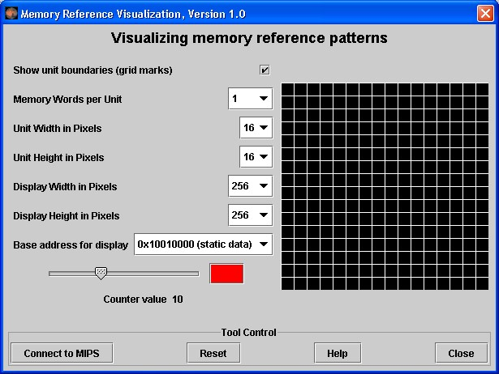

This tool will paint a grid unit each time the corresponding MIPS memory word is referenced. The base address, the first static data segment (.data directive) word, corresponds to the upper-left grid unit. Address correspondence continues in rowmajor order (left to right, then next row down).

The color depends on the number of times the word has been referenced. Black is 0, blue is 1, green is 2, yellow is 3 and 4, orange is 5 through 9, red is 10 or higher.

View the scale using the tool’s slider control. You can change the color (but not the reference count) by clicking on the color patch.

1. Click the tool's **Connect to MIPS** button. This causes the tool to register as an observer of MIPS memory and thus respond during program execution.

1. Back in MARS, adjust the **Run Speed slider** to 30 instructions per second.
2. Run the program. Watch the tool animate as it is updated with every access to MIPS memory. *Feel free to stop the program at any time.*

1. Hopefully you observed that the animation sequence corresponded to the expected memory access sequence of the row-major.asm program. *If you have trouble seeing the blue,* reset the tool, move the slider to position 1, change the color to something brighter, and re-run.

1. Repeat steps 2 through 7, for **column-major.asm**. You should observe that the animation sequence corresponded to the expected memory access sequence of this program.

1. Repeat again for **fibonacci.asm** to observe the animated pattern of memory references. Adjust the run speed and re-run if necessary.

1. *(Optional)* Create a new instance of the Data Cache Simulator. Move the two frames around so you can see both. Connect the cache simulator to MIPS and reset the Memory Reference Visualization. Re-run the program. This exercise illustrates that two different tools can be used simultaneously.

The Memory Reference Visualization tool could be useful in an operating systems course to illustrate spatial and temporal locality and memory reference patterns in general.