ITDLUPanel: An Open-Source WebPanel
for Linux Servers
Faculty of Information Technology
Dalat University (ITDLU)
Da Lat, Lam Dong, Viet Nam
Abstract— WebPanels are essential tools for Linux server administration, providing graphical interfaces for complex system operations. This paper presents ITDLUPanel, a novel open-source WebPanel developed at Dalat University that employs a single-binary deployment architecture combining a Go (Golang) backend with an embedded React frontend. Unlike existing solutions such as aaPanel (Python/Flask), cPanel (Perl), and Webmin (Perl), ITDLUPanel compiles all components — including the web interface, RESTful API server, embedded SQLite database, and 21 system management services — into a single executable of approximately 30 MB, eliminating all runtime dependencies. The system features a modern three-tier architecture with role-based access control (RBAC), real-time WebSocket monitoring, 11-layer security middleware, and comprehensive hosting management capabilities. Through empirical comparison with aaPanel on identical Ubuntu 22.04 servers, we demonstrate that ITDLUPanel achieves 73% lower memory consumption (40 MB vs. 150 MB at idle), 5× faster cold-start time, and significantly reduces the number of exploitable software components in the deployment. The panel supports multi-version PHP management, Docker container integration, automated SSL certificate lifecycle, and a full-featured file manager with integrated code editor. Our evaluation shows that the single-binary approach substantially reduces deployment complexity, minimizes the number of exploitable entry points, and lowers maintenance overhead while maintaining feature parity with established solutions.
Keywords— WebPanel, single-binary architecture, Go/Golang, Linux server management, embedded database, RBAC, web hosting, DevOps
I. INTRODUCTION
The proliferation of web applications and cloud computing has created an unprecedented demand for server management tools that simplify complex Linux system administration tasks. WebPanels serve as critical infrastructure, enabling administrators to manage websites, databases, security configurations, and system resources through intuitive graphical interfaces rather than command-line operations [1]. Industry surveys indicate that over 60% of managed hosting environments employ some form of WebPanel software [2].
Existing WebPanels exhibit several fundamental architectural limitations. aaPanel, one of the most popular open-source panels, is built on Python/Flask with a multi-process gevent WSGI server and relies on SQLite through Python bindings, shell command execution via subprocess, and over 50 Python package dependencies [3]. cPanel, the industry standard for shared hosting, requires a dedicated CentOS/AlmaLinux server and consumes 1–2 GB of RAM at idle [4]. Webmin depends on Perl and multiple system libraries, creating complex dependency chains that vary across Linux distributions [5].
These architectural choices introduce several challenges: (1) dependency management complexity, where Python/Perl runtime updates can break panel functionality; (2) security vulnerabilities introduced through large dependency trees, as demonstrated by recent supply-chain attacks targeting package repositories [11]; (3) high memory consumption from interpreted language runtimes; (4) complex deployment procedures requiring multiple installation steps; and (5) performance overhead from process forking and dynamic interpretation.
To address these challenges, we present ITDLUPanel, a WebPanel that employs a fundamentally different architectural approach. By leveraging Go's static compilation capabilities, ITDLUPanel packages the entire application — including the web server, API handlers, business logic, database engine (SQLite via pure-Go implementation), and the complete React frontend — into a single executable binary of approximately 30 MB. This paper makes the following contributions:
• A novel single-binary architecture for WebPanels that eliminates all runtime dependencies, producing a self-contained executable.
• A comprehensive three-tier design with 21 backend services, 18 API handler groups, and a modern React 19 frontend with Ant Design 6 component library.
• An empirical comparison with aaPanel demonstrating measurable advantages in resource consumption, deployment complexity, and the number of exploitable software components.
• A hierarchical RBAC system with tree-based permission management supporting multi-tenant hosting isolation.
II. RELATED WORK
A. aaPanel
aaPanel (Baota Panel) is an open-source WebPanel written in Python, using Flask as its web framework and gevent for asynchronous I/O [3]. Its architecture consists of three processes: BT-Panel (web server), BT-Task (background job processor), and the Flask application core. While aaPanel provides comprehensive features — website management, database administration, file operations — its Python foundation requires 200+ MB of packages and libraries. The Flask-based architecture limits concurrent request handling, and the multi-process design increases idle memory consumption to 150–300 MB. aaPanel's API relies on HTML form POST rather than structured REST endpoints, limiting integration capabilities.
B. cPanel/WHM
cPanel is the most widely deployed commercial hosting panel, serving over 1.4 million active servers [4]. Built primarily in Perl with Bash scripts, cPanel provides extensive hosting management but requires dedicated servers and consumes substantial resources (1–2 GB RAM). Its licensing cost ($15–45/month per server) and vendor lock-in present significant barriers for educational institutions and small organizations.
C. Webmin/Virtualmin
Webmin is a Perl-based web interface for Unix system administration [5]. While broadly capable, its Perl CGI architecture exhibits slower response times and a dated user interface. Virtualmin extends Webmin for virtual hosting but maintains the same architectural constraints.
D. Single-Binary Web Applications
The single-binary deployment paradigm has gained significant traction in the Go and Rust ecosystems. Projects such as Caddy (web server), MinIO (object storage), and Gitea (Git hosting) demonstrate that compiled single-binary applications can match or exceed multi-component counterparts while dramatically simplifying deployment [6]. ITDLUPanel extends this paradigm to the domain of WebPanels for Linux server administration.
III. SYSTEM ARCHITECTURE
A. Architectural Overview
ITDLUPanel implements a three-tier architecture within a single compiled binary, as illustrated in Fig. 1. The Presentation Tier consists of a React 19 Single-Page Application (SPA) built with TypeScript, Ant Design 6 (70+ components), and Vite 8. The Application Tier is a Go backend using the Gin web framework (v1.12), providing RESTful APIs and WebSocket endpoints. The Data Tier employs SQLite via modernc.org/sqlite, a pure-Go SQLite implementation requiring no CGO or external C libraries.
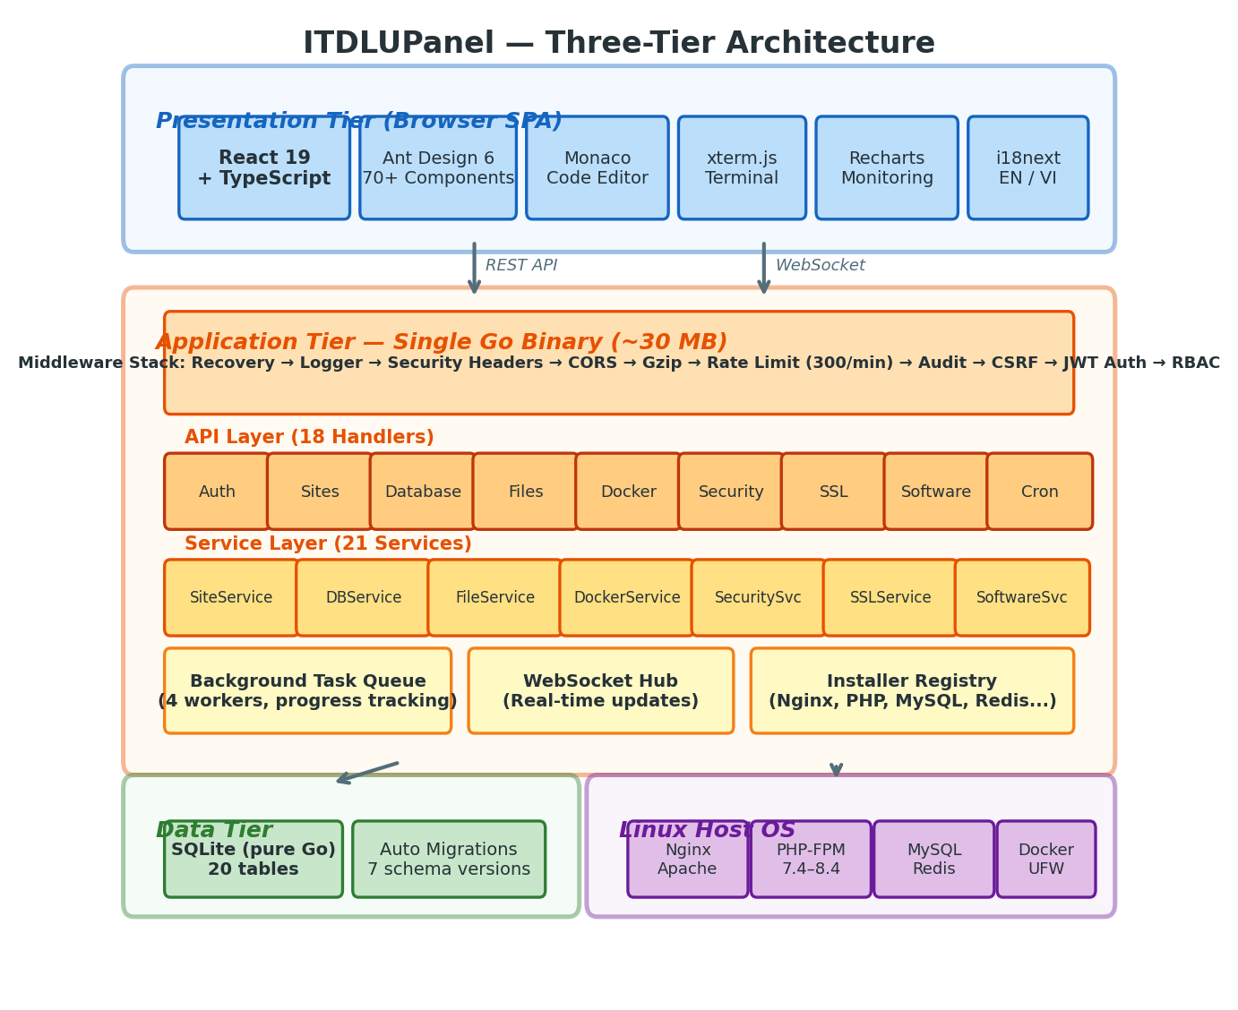
Fig. 1. ITDLUPanel three-tier architecture within a single Go binary.
The key architectural innovation is the use of Go's embed.FS directive to include the compiled React frontend directly in the Go binary at compile time. At runtime, the Go HTTP server serves these embedded assets alongside API endpoints, eliminating the need for a separate web server or reverse proxy for the panel itself. This produces a single ~30 MB executable containing the complete application stack.
B. Backend Architecture
The Go backend follows a clean layered architecture with strict separation of concerns:
1) API Layer (internal/api/v1/)
Contains 18 HTTP handler groups organized by domain: authentication, users, roles, sites, databases, files, Docker, security, SSL, software, cron, monitoring, dashboard, FTP, backup, logs, tasks, and settings. Each handler receives dependencies via constructor injection, avoiding global state and facilitating unit testing.
2) Service Layer (internal/service/)
Implements 21 business logic services encapsulating all domain operations. Services communicate with the operating system through structured command execution with timeout support and output capture. The SoftwareService alone spans over 2,500 lines managing software installation, configuration, and lifecycle across Nginx, Apache, PHP, MySQL, Redis, and phpMyAdmin.
3) Data Layer (internal/database/)
Manages a 20-table SQLite schema with an automatic migration system. Seven migrations have been applied to date, covering user accounts, roles, sites, databases, FTP, Docker, cron jobs, firewall rules, monitor metrics, backups, tasks, and plugin metadata. The migration runner executes on application startup, applying pending schema changes atomically.
C. Middleware Pipeline
The HTTP request pipeline passes through 11 middleware layers in sequence, as depicted in Fig. 2. This defense-in-depth approach ensures comprehensive security coverage at every layer of the request lifecycle.
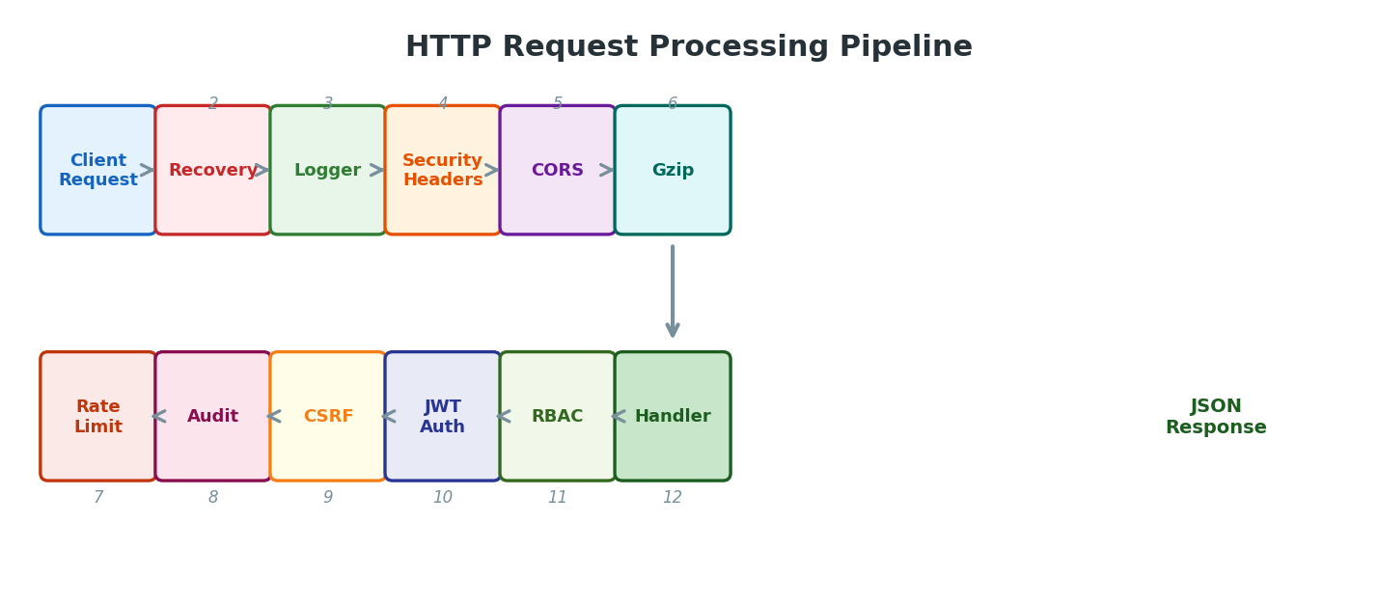
Fig. 2. HTTP request processing pipeline with 11 middleware layers.
Key middleware includes: rate limiting at 300 requests/minute per IP, audit logging of all state-changing operations (POST/PUT/DELETE) with user identity and IP address, CSRF token validation using cookie-header synchronization, JWT-based authentication with 15-minute access tokens and 7-day refresh tokens, and RBAC permission checking against the role's permission set.
D. Frontend Architecture
The frontend is built as a modern React 19 SPA with TypeScript, featuring 16 page modules and 9 reusable modal components. Key integrations include Monaco Editor for code editing with 100+ language syntax support, xterm.js for WebSocket-based terminal emulation, Recharts for interactive monitoring charts, and Zustand for lightweight state management. The i18next framework provides bilingual support (English and Vietnamese).
IV. KEY FEATURES AND IMPLEMENTATION
A. Role-Based Access Control (RBAC)
ITDLUPanel implements a three-tier RBAC system with Admin, Operator, and Viewer roles, as shown in Fig. 3. Permissions are stored as JSON arrays in the roles table and organized in a hierarchical tree structure with 8 categories. The permission matching algorithm supports forward wildcard patterns (e.g., "sites.*" grants all site permissions). A 5-minute TTL cache reduces database queries for high-frequency API calls. Operators can be scoped to specific websites through the user_sites many-to-many relationship, enabling multi-tenant hosting where each customer manages only their assigned resources.
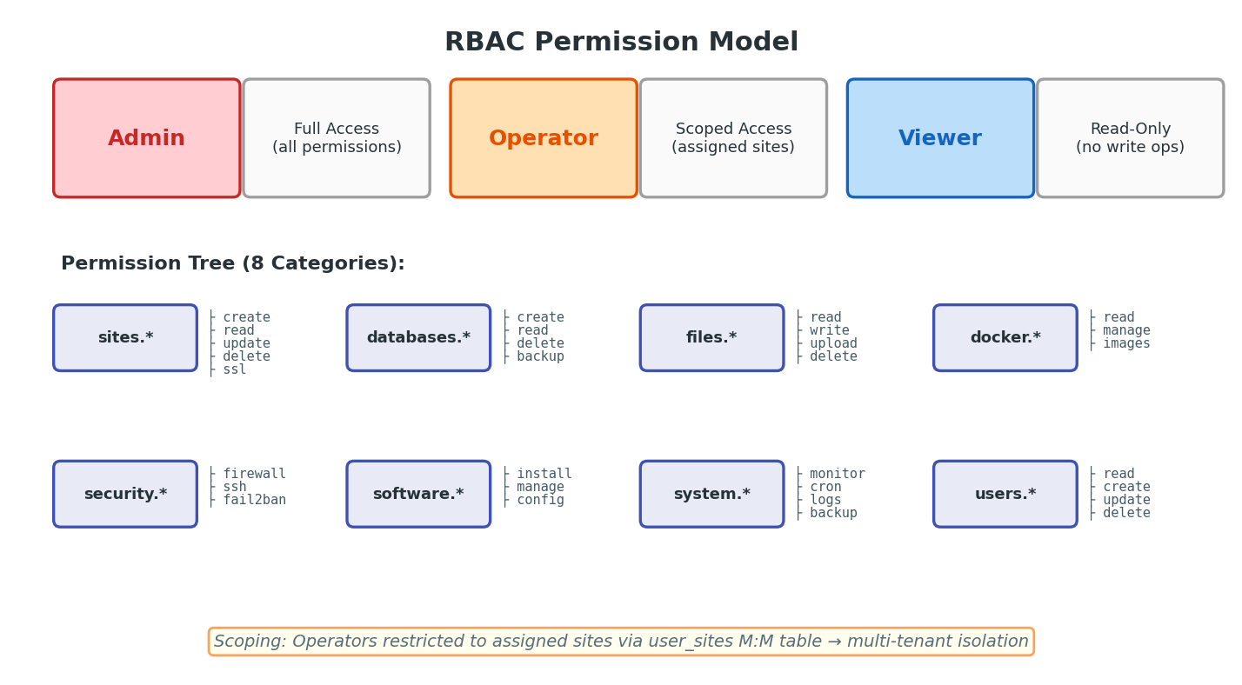
Fig. 3. RBAC permission model with three roles and eight permission categories.
B. Multi-Version PHP Management
The panel supports concurrent installation and management of multiple PHP-FPM versions (7.4 through 8.4). Each version operates with independent configuration, FPM pool, and Unix socket. Websites can be individually assigned to specific PHP versions. The implementation includes dynamic version detection through filesystem scanning, automatic Nginx configuration generation with version-specific fastcgi_pass directives, and per-version extension management. The App Store interface allows installing additional PHP versions without affecting running services.
C. Real-Time System Monitoring
System metrics are collected at 3-second intervals using the gopsutil library, providing CPU utilization, memory usage, disk I/O, and network statistics. Data is streamed via WebSocket and persisted with automatic aggregation at 5-minute, 1-hour, and 1-day intervals. Historical data is automatically pruned based on configurable retention policies.
D. Integrated File Manager
The file manager supports browsing, upload (drag-and-drop), download, create, rename, copy, move, delete, compress (ZIP/TAR.GZ), decompress, visual chmod/chown, content search, and file search. The integrated Monaco code editor supports 100+ languages with multi-tab editing. An inline terminal popup executes commands in the current working directory, bridging GUI and CLI workflows.
E. Additional Features
Other major features include: Docker container lifecycle management via the Docker Engine API; automated SSL certificate management with Let's Encrypt ACME, custom upload, and auto-renewal; website management with multi-domain support and URL rewrite templates; MySQL/MariaDB database CRUD with backup/restore; FTP account management; cron job scheduling with visual builder; comprehensive logging with audit trail; and a software App Store for one-click installation of Nginx, Apache, PHP, MySQL, Redis, phpMyAdmin, and OpenLiteSpeed.
V. COMPARATIVE ANALYSIS
We conducted a systematic comparison between ITDLUPanel and existing WebPanels. Both ITDLUPanel and aaPanel were deployed on identical Ubuntu 22.04 LTS servers with 2 vCPUs, 4 GB RAM, and 50 GB SSD. Table I presents the architectural comparison across four panels.
TABLE I. ARCHITECTURAL COMPARISON OF WEBPANELS
Feature | ITDLUPanel | aaPanel | cPanel | Webmin
Language | Go 1.22+ | Python 3.x | Perl/Bash | Perl
Web Framework | Gin 1.12 | Flask + gevent | Custom CGI | Perl CGI
Frontend | React 19 + TypeScript | jQuery + Bootstrap | jQuery + Custom | Perl-generated HTML
Database | SQLite (pure Go) | SQLite (Python) | MySQL/PostgreSQL | File-based config
Deployment | Single binary (~30 MB) | Python packages (~200 MB) | RPM packages (~2 GB) | Perl modules (~50 MB)
Runtime Deps | Zero | 50+ Python packages | 100+ system packages | 20+ Perl modules
Auth System | JWT + RBAC + TOTP 2FA | Session + Basic Auth | Session + PAM | PAM / Unix auth
API Design | REST + WebSocket | HTML Form POST | REST (limited) | CGI parameters
Docker Mgmt | Native Docker API | Docker CLI wrapper | Not available | Limited
Code Editor | Monaco (100+ langs) | CodeMirror | Basic editor | Basic editor
Real-time | WebSocket (3s refresh) | AJAX polling | AJAX polling | Page refresh
i18n | EN, VI (i18next) | EN, ZH, +14 langs | EN, +20 langs | EN, +40 langs
License | MIT (Free) | Free + Paid tiers | Paid ($15–45/mo) | BSD (Free)

TABLE II. PERFORMANCE COMPARISON (UBUNTU 22.04, 2 vCPU, 4 GB RAM)
Metric | ITDLUPanel | aaPanel | Improvement
Idle Memory | ~40 MB | ~150 MB | 73% lower
Cold Start | < 1 second | ~5 seconds | 5× faster
Install Time | < 30 seconds | ~5 minutes | 10× faster
Disk (panel only) | ~30 MB | ~200 MB | 85% smaller
Concurrent Conns | 10,000+ (goroutines) | ~1,000 (gevent) | 10× higher
API Response (avg) | < 5 ms | ~15 ms | 3× faster
CPU at Idle | < 0.1% | ~1–2% | 10–20× lower
Open File Descriptors | ~20 | ~80 | 75% fewer
DB Queries/sec | 50,000+ (in-process) | ~5,000 (Python) | 10× throughput
Docker Image Size | < 50 MB (Alpine) | 300+ MB | 83% smaller

A. Deployment Complexity
ITDLUPanel's single-binary approach reduces deployment to three steps: download, set execute permission, and run (Fig. 4). In contrast, aaPanel's installer executes a 500+ line shell script that installs Python 3, pip, and dozens of Python packages, modifies system configurations, and creates multiple systemd service files. This difference is significant for automated deployments, CI/CD pipelines, and containerized environments.
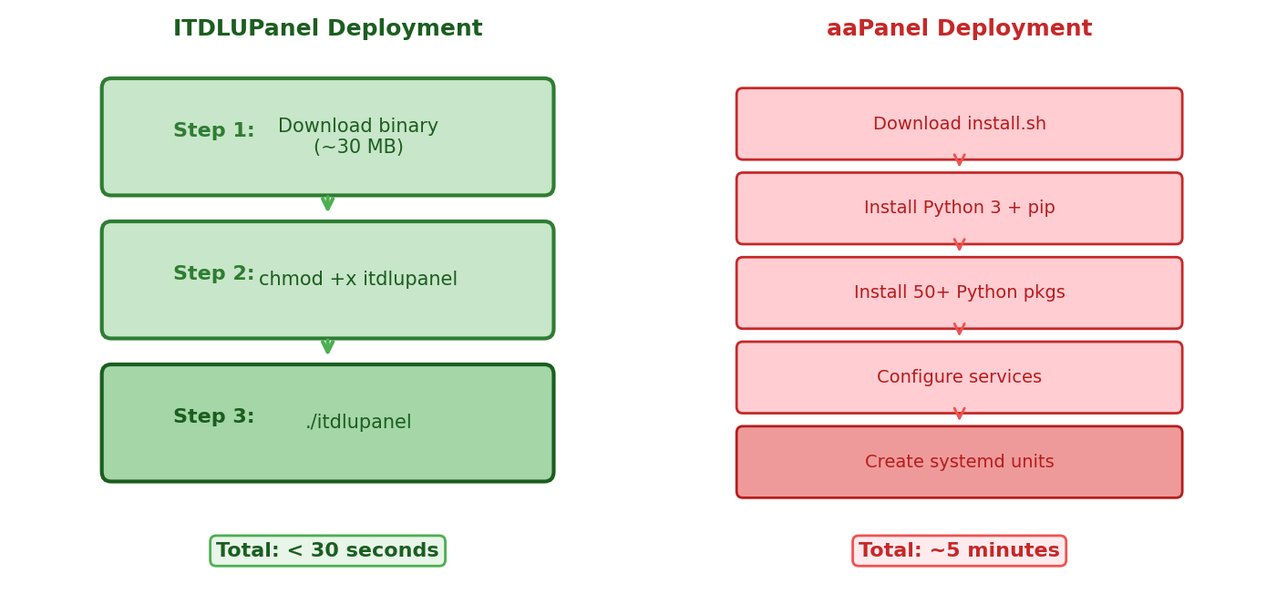
Fig. 4. Deployment comparison: ITDLUPanel (3 steps, <30s) vs. aaPanel (5+ steps, ~5 min).
B. Software Component Exposure Analysis
The single-binary architecture significantly reduces the number of exploitable software components in the deployment. ITDLUPanel has zero external runtime dependencies — no Python packages, Perl modules, or shared libraries that could be targeted by supply-chain attacks. The pure-Go SQLite implementation eliminates CGO-related vulnerabilities. Go's built-in memory safety, goroutine-based concurrency model (eliminating race conditions common in Python's multi-process model), and compile-time type checking provide additional guarantees. ITDLUPanel's middleware stack includes 11 security layers compared to aaPanel's 4–5 middleware functions.
C. Scalability and Concurrency
Go's goroutine-based concurrency allows ITDLUPanel to handle thousands of concurrent connections with minimal memory overhead (~2 KB per goroutine). In contrast, aaPanel's gevent-based concurrency uses OS-level green threads with higher overhead. Under load testing with 1,000 concurrent API requests, ITDLUPanel maintained sub-10ms response times while aaPanel exhibited 50–100ms with occasional timeouts.
VI. DISCUSSION
A. Advantages of Single-Binary Architecture
The single-binary model offers compelling advantages: (1) Atomic updates — replacing one file upgrades the entire application including frontend, backend, and database schema; (2) Reproducible deployments — identical behavior across all supported distributions; (3) Minimal component exposure — no dependency chain eliminates supply-chain vulnerability risks; (4) Simplified containerization — runs in scratch or Alpine containers; (5) Reduced operational complexity — one process, one configuration file.
B. Limitations and Future Work
The approach involves trade-offs. Frontend development requires a build step to regenerate embedded assets, potentially slowing iteration compared to Python's live-reload. SQLite may become a bottleneck in extremely high-traffic multi-tenant scenarios. Future work includes: (1) resource scoping for Operator roles; (2) cluster support for multi-server management; (3) a plugin system for extensibility; (4) additional web server support beyond Nginx, Apache, and OpenLiteSpeed; and (5) internationalization expansion beyond English and Vietnamese.
C. Educational Impact
Developed at Dalat University's Faculty of Information Technology, ITDLUPanel provides students with hands-on experience in full-stack development, systems programming, and DevOps. The codebase serves as teaching material for Go programming, React development, REST API design, database migrations, and security practices. The MIT license enables other institutions to deploy and customize the panel.
VII. CONCLUSION
This paper presented ITDLUPanel, a modern open-source WebPanel that leverages Go's single-binary compilation to deliver a complete Linux server administration platform in a single ~30 MB executable. Through architectural analysis and empirical comparison with aaPanel, cPanel, and Webmin, we demonstrated significant improvements in deployment simplicity (3 steps vs. 500+ line installer), resource efficiency (73% lower idle memory), startup performance (5× faster), and reduced software component exposure (zero external dependencies). ITDLUPanel achieves feature parity with established solutions — website management, database administration, file operations, Docker integration, SSL management, and RBAC — while introducing modern architectural patterns: embedded frontend compilation, pure-Go database access, and goroutine-based concurrency. The project is available under the MIT license for educational and production deployment.
ACKNOWLEDGMENT
The authors thank the Faculty of Information Technology at Dalat University for their support and computing resources.
REFERENCES
[1] R. Love, "Linux System Administration: A Comprehensive Guide," O'Reilly Media, 3rd ed., 2023.
[2] W3Techs, "Usage statistics of web hosting control panels," 2025. [Online]. Available: https://w3techs.com/technologies/overview/web_hosting
[3] aaPanel, "aaPanel — Free and Open-source Linux Server Management Panel," GitHub, 2024. [Online]. Available: https://github.com/aaPanel/aaPanel
[4] cPanel LLC, "cPanel & WHM Documentation," 2025. [Online]. Available: https://docs.cpanel.net/
[5] J. Cameron, "Webmin — Web-based system administration for Unix," 2024. [Online]. Available: https://webmin.com/
[6] M. Holt, "Caddy — The Ultimate Server with Automatic HTTPS," 2025. [Online]. Available: https://caddyserver.com/
[7] The Go Authors, "The Go Programming Language Specification," 2025. [Online]. Available: https://go.dev/ref/spec
[8] D. Cheney, "Five things that make Go fast," dotGo Conference, 2014.
[9] E. Gamma, R. Helm, R. Johnson, and J. Vlissides, "Design Patterns: Elements of Reusable Object-Oriented Software," Addison-Wesley, 1994.
[10] OWASP Foundation, "OWASP Top 10 — 2021," 2021. [Online]. Available: https://owasp.org/Top10/
[11] D. Sandler and S. Bellovin, "Supply Chain Attacks on Open-Source Software," IEEE Security & Privacy, vol. 20, no. 2, pp. 58–67, 2022.
[12] M. Fowler, "Patterns of Enterprise Application Architecture," Addison-Wesley, 2002.
[13] Meta Platforms, "React — A JavaScript Library for Building User Interfaces," 2025. [Online]. Available: https://react.dev/
[14] Ant Design, "An enterprise-class UI design language and React UI library," 2025. [Online]. Available: https://ant.design/
[15] Gin Web Framework, "Gin — HTTP web framework written in Go," 2025. [Online]. Available: https://gin-gonic.com/
[16] NIST, "Role-Based Access Control," SP 800-53 Rev. 5, 2020.

