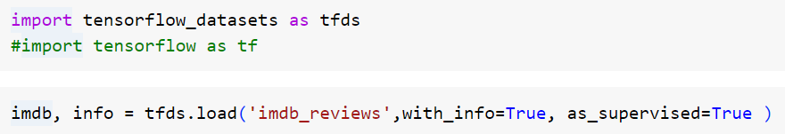

import tensorflow_datasets as tfds #import tensorflow as tf

imdb, info = tfds.load('imdb_reviews',with_info=True, as_supervised=True)