Lecture 1: Introduction
Simple introduction how deep learning had changed computer vision from hand-crafted feature to end-to-end training pipeline.
Why being invented for long time, deep learning only exploded recently?
- Data: Even neural network (NN) can approximate any function but to get good approximation, you need a lot of data. Old approach requires expert’s knowledge
- Compute: GPU appear to be usable for NN
- Some new ideas
This course focuses on how to ship project.
- How to generate ideas
- How to deploy things that easy testable and maintainable
- How to easy to improve upon when we have new data

Lecture 2: Setting Up Machine Learning Projects
Goal:
- Introduce to framework for understanding ML projects
- Describe best practices for planning and setting up ML projects
Lifecycle of a ML Project

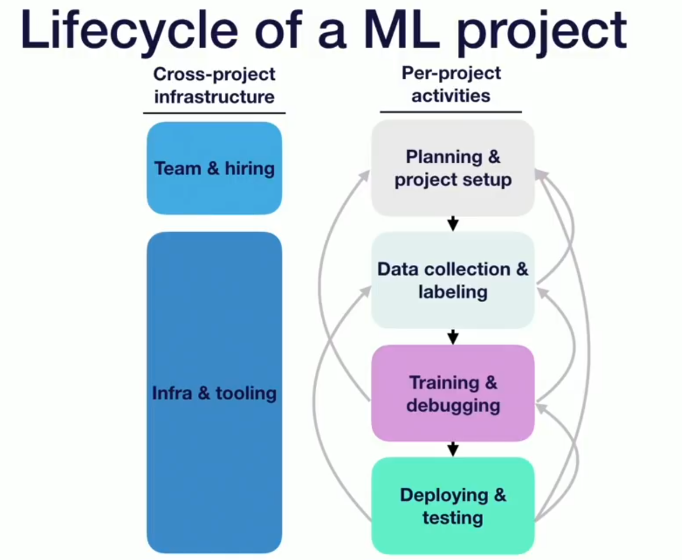
- Planning and project setup
- Determine requirements and goals
- Allocate resources
- Data collection and labelling
- Collect training object
- Capture image of objects
- Annotate with ground truth
Sometimes we face some problem that we might need to revisit our goal/approach:
- Too hard to get data
- Easier to label different task
- Hard to annotate
- Training and debugging
- Implement baseline in OpenCV
- Find SOTA model and reproduce
- We need to know what is the limits
- What can we do next
- Future research
- Debug our implementation
- Improve model for our task
Sometimes, we loopback to training phase to data collection phase because:
- Need to collect more data(overfitting)
- Data labelling is unreliable
Even, we might get back to planning phase:
- The task is too hard
- Have to compromise some critical requirement
- Deploying and testing
- Pilot in grasping system in the lab
- Rolling in product
We might come back to previous phase
- Data collection
- Fix data mismatch between training data and data seen in deployment
- Collect more data
- Mine hard case
- Planning:
- Metric to evaluate is not suitable
- Performance doesn’t meet with end user’s requirement

More detail version:
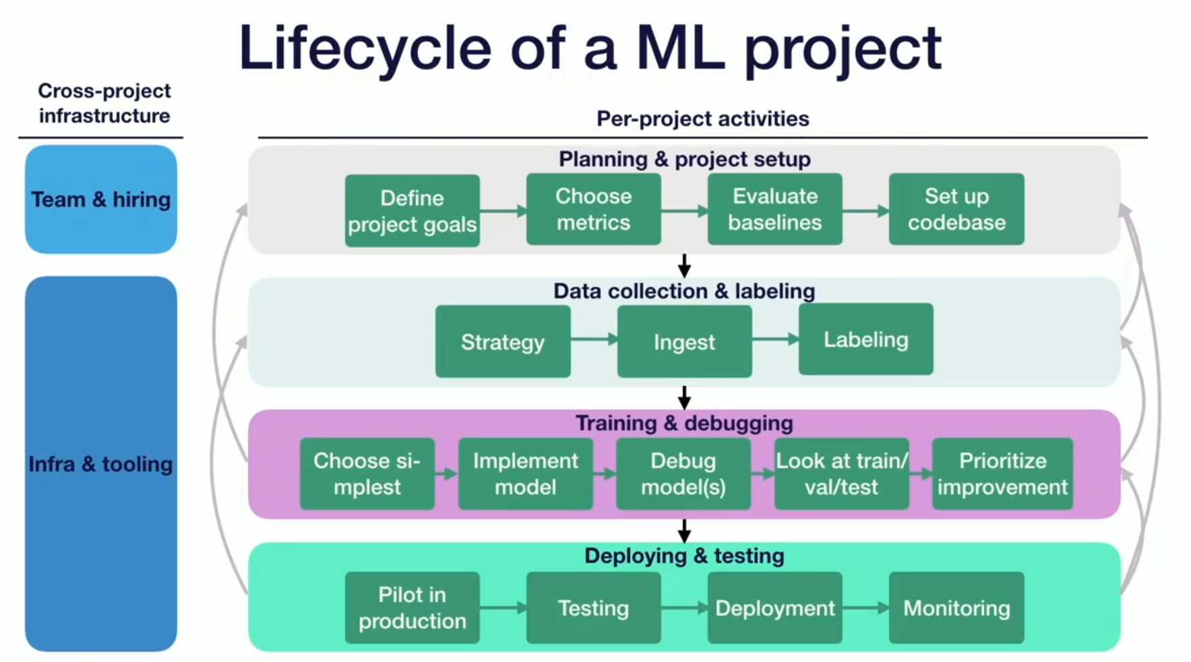
Some question:
Q: We usually divide training set to training set and validation set. So what is the difference between testing in deploying and testing with validation set?
A: Will be answered more detail by Sergey

- Prioritizing projects and choosing goal
- High-impact ML problems
- Complex parts of your pipeline
- Places where cheap prediction is valuable
- Cost of ML projects is driven by data availability + accuracy requirement
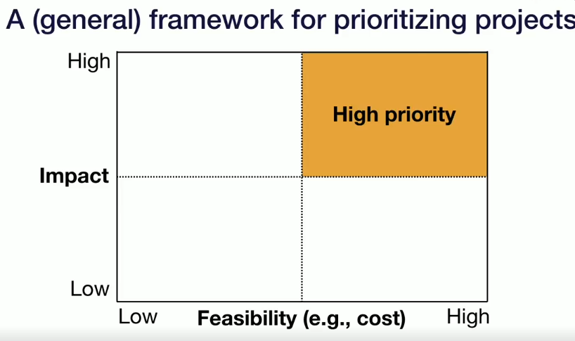
- Mental models for high-impact ML projects
- Where can you take advantage of cheap prediction?
- Where can you automate complicated manual software pipeplines?
- Assessing feasibility for ML project
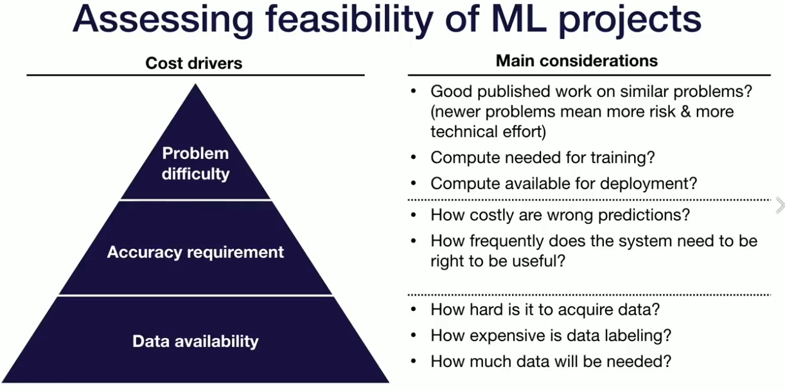
Project cost can grow exponentially with accuracy, so we can redesign product to reduce need for accuracy

- Choosing metrics
- The real world is messy. We need to consider about lots of metrics
- Common ML systems work best when optimizing a single number
- We need to pick a formula for combining metrics
- Simple average metrics
- Threshold n-1 metrics evaluate the n-th
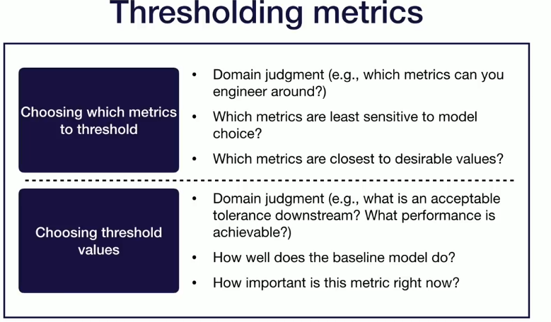
- More complex metrics

- Choosing baselines
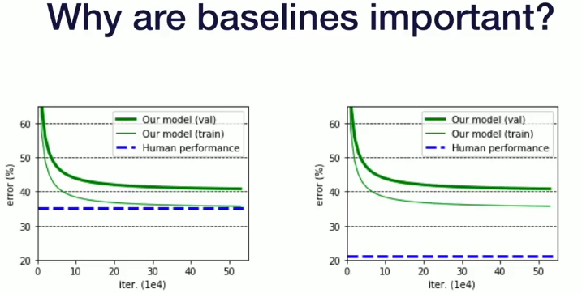
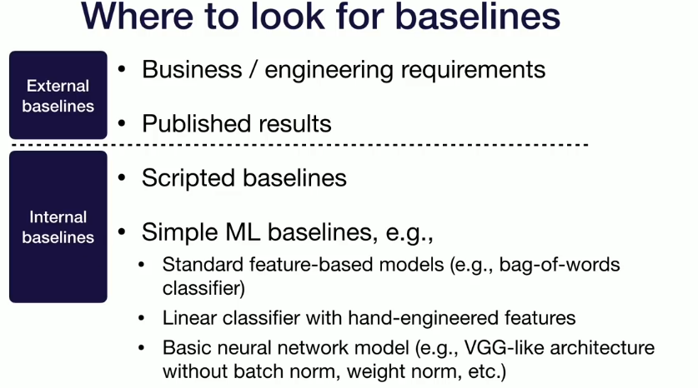

Lecture3: Introduction to Text recognizer Project
