CSS430

Prof. Yang Peng

Proj1a

Nguyen Vi Cao

The following three images are the screenshot for the output of my assignment and the illustration of all processes and their pipe connections involved in processes.cpp. My username is cnv3103 and I was using Linux lab machine 7.

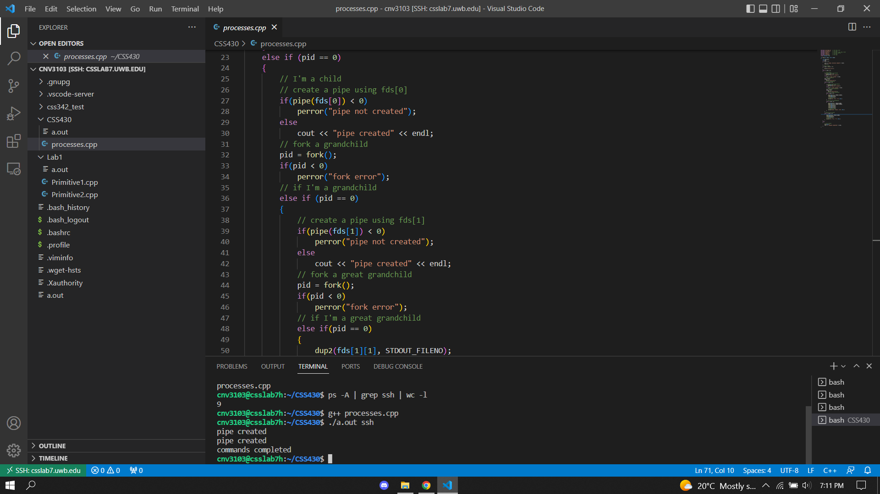

Picture

* Note: for the same code, (I was only doing some minor changes to the comment from “pipe created” to “child pipe” none of the code was changed) but I was having two different output. Picture 1 was taken Saturday July 2nd, the output was 9 and the Picture 2 was taken on Sunday July 3rd, output was 5.

Picture

