The following two screenshots are the output of program 1b

1. PingPong abc 100 ; PingPong xyz 100 ; PingPong 123 100 ;

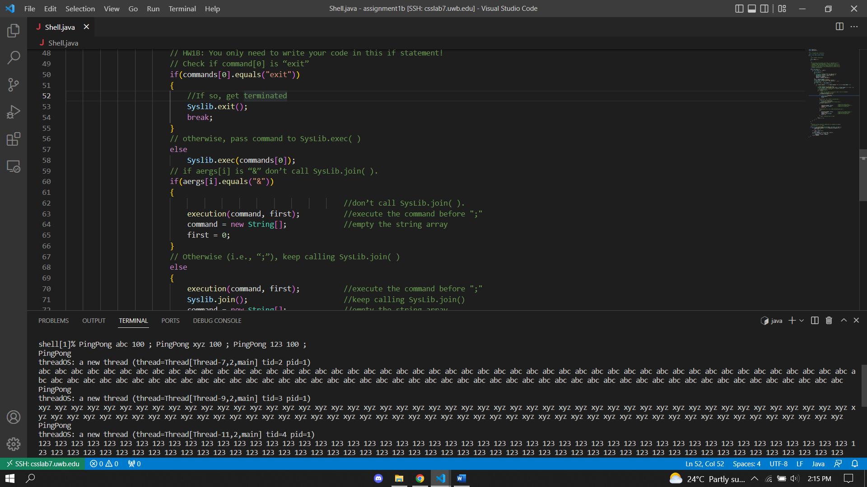

1. PingPong abc 100 & PingPong xyz 100 & PingPong 123 100 &

