Screenshots attached below are the output of my program assignment and the illustration of stack layers.

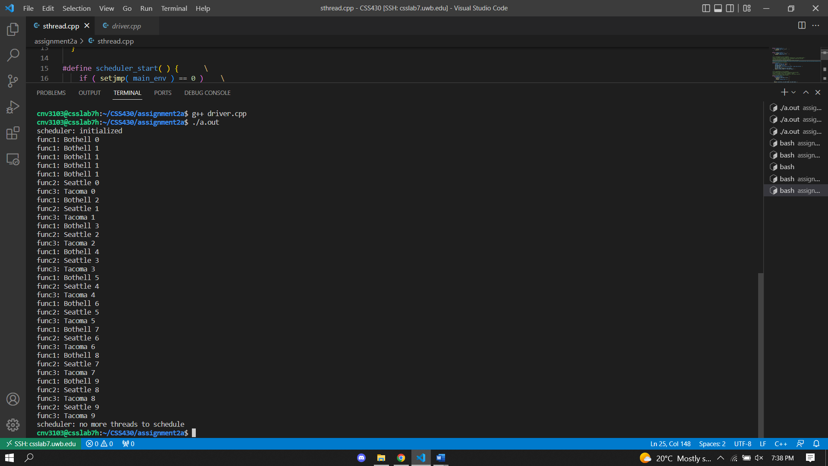

* I got to the point where I had the segmentation fault error and then based on professor’s Yang Peng’s hint, I figured out that the stack is default to be NULL, that’s why its address is invalid.
* Hence, I tried to point the stack (a temporary space to maintain the latest stack contents) to the destination and I was able to avoid the segmentation error.
* I also think of pushing the cur_tcb into the current active thread queue thr_queue and execute them.

Above was the process of thinking while I was doing the coding part.

Below is the illustration of how I understand the stack layers and the RR algorithm.



* We can clearly see the pattern that repeats which represent the quantum for the RR algorithm.
* Capture() will save the process to a temporary space while the next func in queue get to run.
* After all three functions arrive then they will run when it gets to their turn
* Each func will need to be called 10 times (0-9) and it is represented by the number after Bothell, Seattle, Tacoma.