CSS 430

Prof: Yang Peng

Assignment 4a

Coder: Nguyen Vi Cao

Assignment 4a Purpose:

This assignment implements malloc( ) and free( ) using the “sbrk” system function: change data segment size. Your implementation is based on the first-fit and the best-fit strategies. Since the original malloc/free functions in Linux use “brk” (an even more legacy function than sbrk), you can compare your own and the Linux-original implementations in terms of # brk system function calls.

Below are the screenshots and the challenges that I have faces during the assignment.

Output for $ strace ./a.out l 2>&1 | grep brk

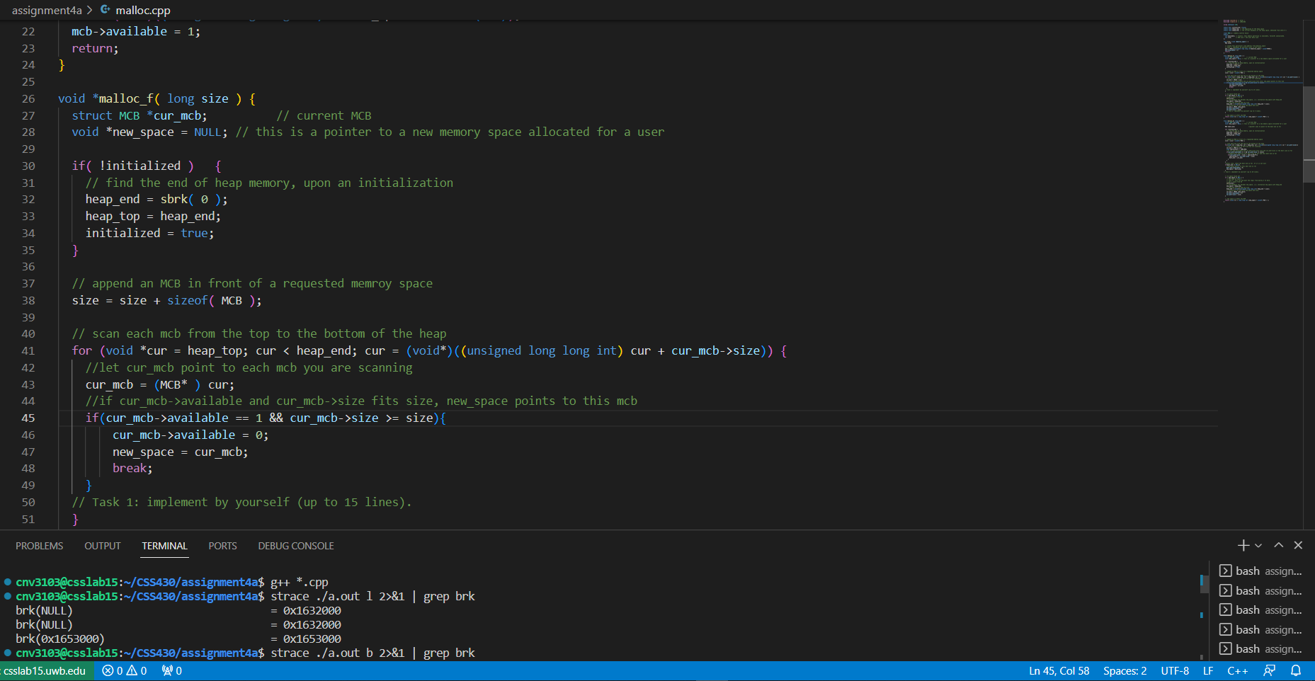

Output for $ strace ./a.out b 2>&1 | grep brk

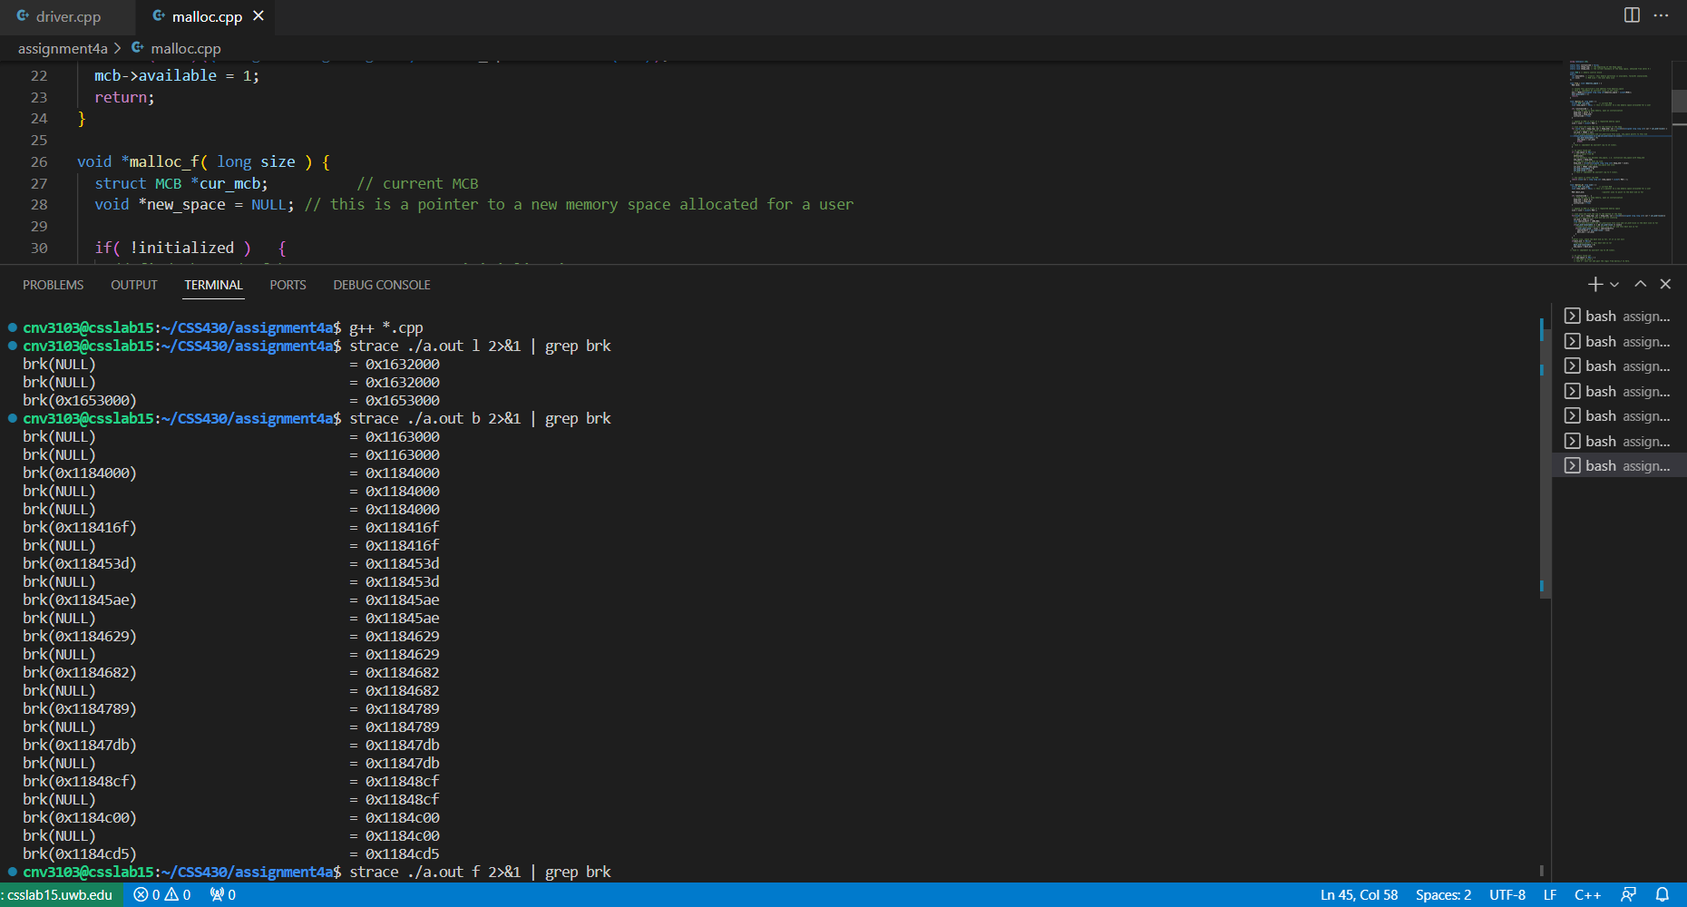

Output for $ strace ./a.out f 2>&1 | grep brk

