Breadth First Search
BFS stands for Breadth First Search is a vertex based technique for finding a shortest path in graph. It uses a Queue data structure which follows first in first out. In BFS, one vertex is selected at a time when it is visited and marked then its adjacent are visited and stored in the queue. It is slower than DFS.
Ex-
A
/ \
B C
/ / \
D E F

Output is:
A, B, C, D, E, F

Depth First Search
DFS stands for Depth First Search is a edge based technique. It uses the Stack data structure, performs two stages, first visited vertices are pushed into stack and second if there is no vertices then visited vertices are popped.
Ex-
A
/ \
B C
/ / \
D E F

Output is:A, B, D, C, E, F

Depth-first search
38 languages
- Article
- Talk
- Read
- Edit
- View history
From Wikipedia, the free encyclopedia
 | This article needs additional citations for verification. Please help improve this article by adding citations to reliable sources. Unsourced material may be challenged and removed.  Find sources: "Depth-first search" – news · newspapers · books · scholar · JSTOR (July 2010) (Learn how and when to remove this template message)

Depth-first search
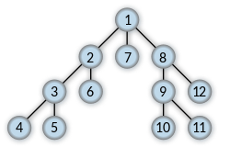
Order in which the nodes are visited
Class | Search algorithm
Data structure | Graph
Worst-case performance | for explicit graphs traversed without repetition, for implicit graphs with branching factor b searched to depth d
Worst-case space complexity | if entire graph is traversed without repetition, O(longest path length searched) = for implicit graphs without elimination of duplicate nodes

Graph and tree
search algorithms
- α–β pruning
- Backtracking
- Beam search
- Best-first search
- Branch & bound
- Breadth-First Search (BFS)
- British Museum
- Depth-First Search (DFS)
- Hill climbing
- Iterative Deepening DFS (IDDFS)
- Lexicographic BFS
Shortest path
- A*
- B*
- Bellman–Ford
- Bidirectional search
- D*
- Dijkstra's
- Floyd–Warshall
- Fringe search
- Iterative Deepening (IDA*)
- Johnson's
- Jump point search
- Kruskal's
- Lifelong Planning A* (LPA*)
- Pathfinding
- SMA*
Lists
- Graph algorithms
- Search algorithms
- List of graph algorithms
Related topics
- Dynamic programming
- Graph coloring
- Graph traversal
- Minimum spanning tree
- Search games
- Threaded binary tree
- Tree traversal
- v
- t
- e
Depth-first search (DFS) is an algorithm for traversing or searching tree or graph data structures. The algorithm starts at the root node (selecting some arbitrary node as the root node in the case of a graph) and explores as far as possible along each branch before backtracking. Extra memory, usually a stack, is needed to keep track of the nodes discovered so far along a specified branch which helps in backtracking of the graph.
A version of depth-first search was investigated in the 19th century by French mathematician Charles Pierre Trémaux^{[1]} as a strategy for solving mazes.^{[2][3]}

Properties[edit]
The time and space analysis of DFS differs according to its application area. In theoretical computer science, DFS is typically used to traverse an entire graph, and takes time ,^{[4]} where is the number of vertices and the number of edges. This is linear in the size of the graph. In these applications it also uses space in the worst case to store the stack of vertices on the current search path as well as the set of already-visited vertices. Thus, in this setting, the time and space bounds are the same as for breadth-first search and the choice of which of these two algorithms to use depends less on their complexity and more on the different properties of the vertex orderings the two algorithms produce.
For applications of DFS in relation to specific domains, such as searching for solutions in artificial intelligence or web-crawling, the graph to be traversed is often either too large to visit in its entirety or infinite (DFS may suffer from non-termination). In such cases, search is only performed to a limited depth; due to limited resources, such as memory or disk space, one typically does not use data structures to keep track of the set of all previously visited vertices. When search is performed to a limited depth, the time is still linear in terms of the number of expanded vertices and edges (although this number is not the same as the size of the entire graph because some vertices may be searched more than once and others not at all) but the space complexity of this variant of DFS is only proportional to the depth limit, and as a result, is much smaller than the space needed for searching to the same depth using breadth-first search. For such applications, DFS also lends itself much better to heuristic methods for choosing a likely-looking branch. When an appropriate depth limit is not known a priori, iterative deepening depth-first search applies DFS repeatedly with a sequence of increasing limits. In the artificial intelligence mode of analysis, with a branching factor greater than one, iterative deepening increases the running time by only a constant factor over the case in which the correct depth limit is known due to the geometric growth of the number of nodes per level.
DFS may also be used to collect a sample of graph nodes. However, incomplete DFS, similarly to incomplete BFS, is biased towards nodes of high degree.

Example[edit]
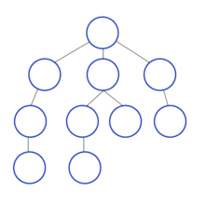
Animated example of a depth-first search
For the following graph:
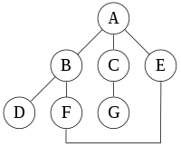
a depth-first search starting at the node A, assuming that the left edges in the shown graph are chosen before right edges, and assuming the search remembers previously visited nodes and will not repeat them (since this is a small graph), will visit the nodes in the following order: A, B, D, F, E, C, G. The edges traversed in this search form a Trémaux tree, a structure with important applications in graph theory. Performing the same search without remembering previously visited nodes results in visiting the nodes in the order A, B, D, F, E, A, B, D, F, E, etc. forever, caught in the A, B, D, F, E cycle and never reaching C or G.
Iterative deepening is one technique to avoid this infinite loop and would reach all nodes.

Output of a depth-first search[edit]
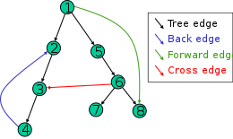
The four types of edges defined by a spanning tree
The result of a depth-first search of a graph can be conveniently described in terms of a spanning tree of the vertices reached during the search. Based on this spanning tree, the edges of the original graph can be divided into three classes: forward edges, which point from a node of the tree to one of its descendants, back edges, which point from a node to one of its ancestors, and cross edges, which do neither. Sometimes tree edges, edges which belong to the spanning tree itself, are classified separately from forward edges. If the original graph is undirected then all of its edges are tree edges or back edges.

Vertex orderings[edit]
It is also possible to use depth-first search to linearly order the vertices of a graph or tree. There are four possible ways of doing this:
- A preordering is a list of the vertices in the order that they were first visited by the depth-first search algorithm. This is a compact and natural way of describing the progress of the search, as was done earlier in this article. A preordering of an expression tree is the expression in Polish notation.
- A postordering is a list of the vertices in the order that they were last visited by the algorithm. A postordering of an expression tree is the expression in reverse Polish notation.
- A reverse preordering is the reverse of a preordering, i.e. a list of the vertices in the opposite order of their first visit. Reverse preordering is not the same as postordering.
- A reverse postordering is the reverse of a postordering, i.e. a list of the vertices in the opposite order of their last visit. Reverse postordering is not the same as preordering.
For binary trees there is additionally in-ordering and reverse in-ordering.
For example, when searching the directed graph below beginning at node A, the sequence of traversals is either A B D B A C A or A C D C A B A (choosing to first visit B or C from A is up to the algorithm). Note that repeat visits in the form of backtracking to a node, to check if it has still unvisited neighbors, are included here (even if it is found to have none). Thus the possible preorderings are A B D C and A C D B, while the possible postorderings are D B C A and D C B A, and the possible reverse postorderings are A C B D and A B C D.
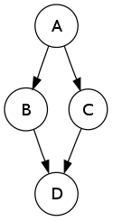
Reverse postordering produces a topological sorting of any directed acyclic graph. This ordering is also useful in control-flow analysis as it often represents a natural linearization of the control flows. The graph above might represent the flow of control in the code fragment below, and it is natural to consider this code in the order A B C D or A C B D but not natural to use the order A B D C or A C D B.
if (A) then {
B
} else {
C
}
D

Pseudocode[edit]
Input: Output: A recursive implementation of DFS:^{[5]}
procedure DFS(G, v) is
label v as discovered
for all directed edges from v to w that are in G.adjacentEdges(v) do
if vertex w is not labeled as discovered then
recursively call DFS(G, w)
A non-recursive implementation of DFS with worst-case space complexity , with the possibility of duplicate vertices on the stack:^{[6]}
procedure DFS_iterative(G, v) is
let S be a stack
S.push(v)
while S is not empty do
v = S.pop()
if v is not labeled as discovered then
label v as discovered
for all edges from v to w in G.adjacentEdges(v) do
S.push(w)
These two variations of DFS visit the neighbors of each vertex in the opposite order from each other: the first neighbor of v visited by the recursive variation is the first one in the list of adjacent edges, while in the iterative variation the first visited neighbor is the last one in the list of adjacent edges. The recursive implementation will visit the nodes from the example graph in the following order: A, B, D, F, E, C, G. The non-recursive implementation will visit the nodes as: A, E, F, B, D, C, G.
The non-recursive implementation is similar to breadth-first search but differs from it in two ways:
- it uses a stack instead of a queue, and
- it delays checking whether a vertex has been discovered until the vertex is popped from the stack rather than making this check before adding the vertex.
If G is a tree, replacing the queue of the breadth-first search algorithm with a stack will yield a depth-first search algorithm. For general graphs, replacing the stack of the iterative depth-first search implementation with a queue would also produce a breadth-first search algorithm, although a somewhat nonstandard one.^{[7]}
Another possible implementation of iterative depth-first search uses a stack of iterators of the list of neighbors of a node, instead of a stack of nodes. This yields the same traversal as recursive DFS.^{[8]}
procedure DFS_iterative(G, v) is
let S be a stack
label v as discovered
S.push(iterator of G.adjacentEdges(v))
while S is not empty do
if S.peek().hasNext() then
w = S.peek().next()
if w is not labeled as discovered then
label w as discovered
S.push(iterator of G.adjacentEdges(w))
else
S.pop()

Breadth-first search
39 languages
- Article
- Talk
- Read
- Edit
- View history
From Wikipedia, the free encyclopedia
This article needs additional citations for verification. Please help improve this article by adding citations to reliable sources. Unsourced material may be challenged and removed.
Find sources: "Breadth-first search" – news · newspapers · books · scholar · JSTOR (April 2012) (Learn how and when to remove this template message)

Breadth-first search
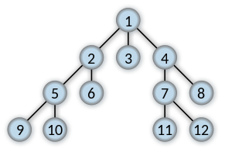
Order in which the nodes are expanded
Class | Search algorithm
Data structure | Graph
Worst-case performance
Worst-case space complexity

Graph and tree
search algorithms
- α–β pruning
- Backtracking
- Beam search
- Best-first search
- Branch & bound
- Breadth-First Search (BFS)
- British Museum
- Depth-First Search (DFS)
- Hill climbing
- Iterative Deepening DFS (IDDFS)
- Lexicographic BFS
Shortest path
- A*
- B*
- Bellman–Ford
- Bidirectional search
- D*
- Dijkstra's
- Floyd–Warshall
- Fringe search
- Iterative Deepening (IDA*)
- Johnson's
- Jump point search
- Kruskal's
- Lifelong Planning A* (LPA*)
- Pathfinding
- SMA*
Lists
- Graph algorithms
- Search algorithms
- List of graph algorithms
Related topics
- Dynamic programming
- Graph coloring
- Graph traversal
- Minimum spanning tree
- Search games
- Threaded binary tree
- Tree traversal
- v
- t
- e
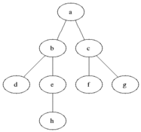
Animated example of a breadth-first search. Black: explored, grey: queued to be explored later on

BFS on Maze-solving algorithm
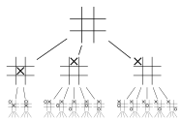
Top part of Tic-tac-toe game tree
Breadth-first search (BFS) is an algorithm for searching a tree data structure for a node that satisfies a given property. It starts at the tree root and explores all nodes at the present depth prior to moving on to the nodes at the next depth level. Extra memory, usually a queue, is needed to keep track of the child nodes that were encountered but not yet explored.
For example, in a chess endgame a chess engine may build the game tree from the current position by applying all possible moves, and use breadth-first search to find a win position for white. Implicit trees (such as game trees or other problem-solving trees) may be of infinite size; breadth-first search is guaranteed to find a solution node^{[1]} if one exists.
In contrast, (plain) depth-first search, which explores the node branch as far as possible before backtracking and expanding other nodes,^{[2]} may get lost in an infinite branch and never make it to the solution node. Iterative deepening depth-first search avoids the latter drawback at the price of exploring the tree's top parts over and over again. On the other hand, both depth-first algorithms get along without extra memory.
Breadth-first search can be generalized to graphs, when the start node (sometimes referred to as a 'search key')^{[3]} is explicitly given, and precautions are taken against following a vertex twice.
BFS and its application in finding connected components of graphs were invented in 1945 by Konrad Zuse, in his (rejected) Ph.D. thesis on the Plankalkül programming language, but this was not published until 1972.^{[4]} It was reinvented in 1959 by Edward F. Moore, who used it to find the shortest path out of a maze,^{[5][6]} and later developed by C. Y. Lee into a wire routing algorithm (published 1961).^{[7]}

Pseudocode[edit]
Input: A graph G and a starting vertex root of G
Output: Goal state. The parent links trace the shortest path back to root^{[8]}
1 procedure BFS(G, root) is
2 let Q be a queue
3 label root as explored
4 Q.enqueue(root)
5 while Q is not empty do
6 v := Q.dequeue()
7 if v is the goal then
8 return v
9 for all edges from v to w in G.adjacentEdges(v) do
10 if w is not labeled as explored then
11 label w as explored
12 w.parent := v
13 Q.enqueue(w)

More details[edit]
This non-recursive implementation is similar to the non-recursive implementation of depth-first search, but differs from it in two ways:
- it uses a queue (First In First Out) instead of a stack and
- it checks whether a vertex has been explored before enqueueing the vertex rather than delaying this check until the vertex is dequeued from the queue.
If G is a tree, replacing the queue of this breadth-first search algorithm with a stack will yield a depth-first search algorithm. For general graphs, replacing the stack of the iterative depth-first search implementation with a queue would also produce a breadth-first search algorithm, although a somewhat nonstandard one.^{[9]}
The Q queue contains the frontier along which the algorithm is currently searching.
Nodes can be labelled as explored by storing them in a set, or by an attribute on each node, depending on the implementation.
Note that the word node is usually interchangeable with the word vertex.
The parent attribute of each node is useful for accessing the nodes in a shortest path, for example by backtracking from the destination node up to the starting node, once the BFS has been run, and the predecessors nodes have been set.
Breadth-first search produces a so-called breadth first tree. You can see how a breadth first tree looks in the following example.

Example[edit]
The following is an example of the breadth-first tree obtained by running a BFS on German cities starting from Frankfurt:
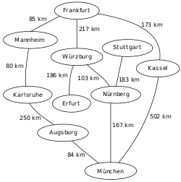
An example map of Southern Germany with some connections between cities
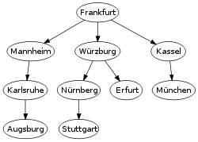
The breadth-first tree obtained when running BFS on the given map and starting in Frankfurt

Analysis[edit]

Time and space complexity[edit]
The time complexity can be expressed as , since every vertex and every edge will be explored in the worst case. is the number of vertices and is the number of edges in the graph. Note that may vary between and , depending on how sparse the input graph is.^{[10]}
When the number of vertices in the graph is known ahead of time, and additional data structures are used to determine which vertices have already been added to the queue, the space complexity can be expressed as , where is the number of vertices. This is in addition to the space required for the graph itself, which may vary depending on the graph representation used by an implementation of the algorithm.
When working with graphs that are too large to store explicitly (or infinite), it is more practical to describe the complexity of breadth-first search in different terms: to find the nodes that are at distance d from the start node (measured in number of edge traversals), BFS takes O(b^{d + 1}) time and memory, where b is the "branching factor" of the graph (the average out-degree).^{[11]: 81}

Completeness[edit]
In the analysis of algorithms, the input to breadth-first search is assumed to be a finite graph, represented as an adjacency list, adjacency matrix, or similar representation. However, in the application of graph traversal methods in artificial intelligence the input may be an implicit representation of an infinite graph. In this context, a search method is described as being complete if it is guaranteed to find a goal state if one exists. Breadth-first search is complete, but depth-first search is not. When applied to infinite graphs represented implicitly, breadth-first search will eventually find the goal state, but depth first search may get lost in parts of the graph that have no goal state and never return.^{[12]}

BFS ordering[edit]
An enumeration of the vertices of a graph is said to be a BFS ordering if it is the possible output of the application of BFS to this graph.
Let be a graph with vertices. Recall that is the set of neighbors of . Let be a list of distinct elements of , for , let be the least such that is a neighbor of , if such a exists, and be otherwise.
Let be an enumeration of the vertices of . The enumeration is said to be a BFS ordering (with source ) if, for all , is the vertex such that is minimal. Equivalently, is a BFS ordering if, for all with , there exists a neighbor of such that .

BackTracking algorithms

Sinh mọi tổ hợp dùng đệ qui

- Hàm bổ trợ giải bài toán với kích thước xác định

- Nhiều lời gọi đệ qui đến hàm bổ trợ

- Bài toán ban đầu gọi hàm bổ trợ với trường hợp cơ sở

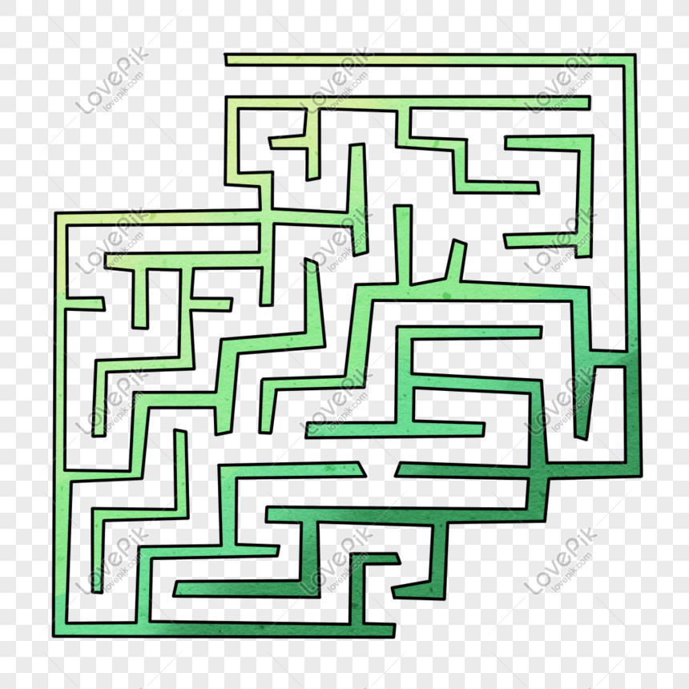
- Tổ hợp nhị phân

Cho trước n, sinh mọi xâu nhị phân độ dài n

- Tổ hợp từ các số thập phân

- Tổ hợp các ký tự từ một tập hợp

Đệ qui và tổ hợp

- Đệ qui cung cấp một cách để sinh ra mọi xâu độ dài n từ tập hợp các ký tự S
- Ví dụ S = {U, S, C} sinh ra các xâu:
{UU, US, UC, SU, SS, SC, CU, CS, CC}
Phương pháp Backtracking
- Dùng các xâu để lưu kết quả trung gian đang được xây dựng
- Mỗi lời gọi đệ qui chỉ dành cho một trong n chỗ (chằng hạn ở ký tự thứ i)
- Một hàm quay vòng bên trong sẽ lựa chọn một ký tự trong S đặt vào vị trí i cho phương án hiện thời và sau đó đệ qui để xử lý mọi ví trí còn lại từ i+1 đến n.
- Khi trả về, thử một lựa chọn khác và lại đệ qui.
- Trường hợp cơ sở: có thể dừng khi tất cả n vị trí đã được chọn
- Trường hợp đệ qui trả về sau khi thử mọi phương án

class GFG {

// The method that prints all
// possible strings of length k.
// It is mainly a wrapper over
// recursive function printAllKLengthRec()
static void printAllKLength(char[] set, int k)
{
int n = set.length;
printAllKLengthRec(set, "", n, k);
}

// The main recursive method
// to print all possible
// strings of length k
static void printAllKLengthRec(char[] set,
String prefix,
int n, int k)
{

// Base case: k is 0,
// print prefix
if (k == 0)
{
System.out.println(prefix);
return;
}

// One by one add all characters
// from set and recursively
// call for k equals to k-1
for (int i = 0; i < n; ++i)
{

// Next character of input added
String newPrefix = prefix + set[i];

// k is decreased, because
// we have added a new character
printAllKLengthRec(set, newPrefix,
n, k - 1);
}
}
// Driver Code
public static void main(String[] args)
{
System.out.println("First Test");
char[] set1 = {'a', 'b'};
int k = 3;
printAllKLength(set1, k);

System.out.println("\nSecond Test");
char[] set2 = {'a', 'b', 'c', 'd'};
k = 1;
printAllKLength(set2, k);
}
}

- Bài toán N-Queens

Backtracking Algorithm
Ý tưởng là đặt các quân hậu lần lượt từng quân ở các cột khác nhau, bắt đầu từ cột bên trái nhất. Khi chúng ta đã đặt một quân hậu ở một cột, chúng ta kiểm tra xung đột với các quân hậu đã được đặt. Trong cột hiện tại, nếu chúng ta tìm được hàng mà không có xung đột, chúng ta đánh dấu hàng và cột này như một phần của lời giải đang tìm. Nếu chúng ta không tìm thấy hàng vì có các xung đột, thì chúng ta phải quay lại và trả về false.

- Bắt đầu cột trái nhất
- Nếu mọi hậu đã được đặt, trả về true
- Thử mọi hàng trong cột hiện tại
Thực hiện điều sau cho mỗi hàng đang thử
  - Nếu hậu có thể đặt an toàn ở hàng đó, thì đánh dấu [hàng, cột] như một phần của lời giải và đệ qui kiểm tra nếu đặt hậu ở đây có dẫn đến một lời giải không.
  - Nếu đặt hậu ở [hàng, cột] dẫn đến một lời giải thì trả về true
  - Nếu đặt hậu ở đó không dẫn đến một lời giải thì không đánh dấu [hàng, cột] này (quay lui) và trở về bước a. để thử hàng khác.
- Nếu mọi hàng đã được thử và không có gì tiến triển tiếp, trả về false để kích hoạt quay lui.

Đặt được Hạu thứ 4, nhưng không thể đặt tiếp Hậu thứ 5, nên phải quay lui!

Implementation of Backtracking solution

Một lời giải của bài toán NQueens

/* Java program to solve N Queen Problem using
backtracking */

public class OneSolNQueens {
final int N = 8;

/* A utility function to print solution */
void printSolution(int board[][])
{
for (int i = 0; i < N; i++) {
for (int j = 0; j < N; j++)
System.out.print(" " + board[i][j]
+ " ");
System.out.println();
}
}

/* A utility function to check if a queen can
be placed on board[row][col]. Note that this
function is called when "col" queens are already
placeed in columns from 0 to col -1. So we need
to check only left side for attacking queens */

boolean isSafe(int board[][], int row, int col)
{
int i, j;

/* Check this row on left side */
for (i = 0; i < col; i++)
if (board[row][i] == 1)
return false;

/* Check upper diagonal on left side */
for (i = row, j = col; i >= 0 && j >= 0; i--, j--)
if (board[i][j] == 1)
return false;

/* Check lower diagonal on left side */
for (i = row, j = col; j >= 0 && i < N; i++, j--)
if (board[i][j] == 1)
return false;

return true;
}

/* A recursive utility function to solve N
Queen problem */
boolean solveNQUtil(int board[][], int col)
{
/* base case: If all queens are placed
then return true */
if (col >= N)
return true;

/* Consider this column and try placing
this queen in all rows one by one */
for (int i = 0; i < N; i++) {
/* Check if the queen can be placed on
board[i][col] */
if (isSafe(board, i, col)) {
/* Place this queen in board[i][col] */
board[i][col] = 1;

/* recur to place rest of the queens */
if (solveNQUtil(board, col + 1) == true)
return true;

/* If placing queen in board[i][col]
doesn't lead to a solution then
remove queen from board[i][col] */
board[i][col] = 0; // BACKTRACK
}
}

/* If the queen can not be placed in any row in
this colum col, then return false */
return false;
}

/* This function solves the N Queen problem using
Backtracking. It mainly uses solveNQUtil () to
solve the problem. It returns false if queens
cannot be placed, otherwise, return true and
prints placement of queens in the form of 1s.
Please note that there may be more than one
solutions, this function prints one of the
feasible solutions.*/
boolean solveNQ()
{
int board[][] = { { 0, 0, 0, 0, 0, 0, 0, 0},
{ 0, 0, 0, 0, 0, 0, 0, 0},
{ 0, 0, 0, 0, 0, 0, 0, 0},
{ 0, 0, 0, 0, 0, 0, 0, 0},
{ 0, 0, 0, 0, 0, 0, 0, 0},
{ 0, 0, 0, 0, 0, 0, 0, 0},
{ 0, 0, 0, 0, 0, 0, 0, 0},
{ 0, 0, 0, 0, 0, 0, 0, 0} };

if (solveNQUtil(board, 0) == false) {
System.out.print("Solution does not exist");
return false;
}

printSolution(board);
return true;
}

// driver program to test above function
public static void main(String args[])
{
NQueenProblem Queen = new NQueenProblem();
Queen.solveNQ();
}
}
// This code is contributed by Abhishek Shankhadhar

Mọi lời giải của bài toán NQueens

Backtracking Algorithm
/* Java program to solve N Queen
Problem using backtracking */

class AllSolNQueens
{

static int N = 8;
static int k = 1; /*lời giải thứ k */

/* A utility function to print solution */
static void printSolution(int board[][])
{
System.out.printf("%d-\n", k++);
for (int i = 0; i < N; i++)
{
for (int j = 0; j < N; j++)
System.out.printf(" %d ", board[i][j]);
System.out.printf("\n");
}
System.out.printf("\n");
}

/* A utility function to check if a queen can
be placed on board[row][col]. Note that this
function is called when "col" queens are
already placed in columns from 0 to col -1.
So we need to check only left side for
attacking queens */
static boolean isSafe(int board[][], int row, int col)
{
int i, j;

/* Check this row on left side */
for (i = 0; i < col; i++)
if (board[row][i] == 1)
return false;

/* Check upper diagonal on left side */
for (i = row, j = col; i >= 0 && j >= 0; i--, j--)
if (board[i][j] == 1)
return false;

/* Check lower diagonal on left side */
for (i = row, j = col; j >= 0 && i < N; i++, j--)
if (board[i][j] == 1)
return false;

return true;
}

/* A recursive utility function
to solve N Queen problem */
static boolean solveNQUtil(int board[][], int col)
{
/* base case: If all queens are placed
then return true */
if (col == N)
{
printSolution(board);
return true;
}

/* Consider this column and try placing
this queen in all rows one by one */
boolean res = false;
for (int i = 0; i < N; i++)
{
/* Check if queen can be placed on
board[i][col] */
if ( isSafe(board, i, col) )
{
/* Place this queen in board[i][col] */
board[i][col] = 1;

// Make result true if any placement
// is possible
res = solveNQUtil(board, col + 1) || res;

/* If placing queen in board[i][col]
doesn't lead to a solution, then
remove queen from board[i][col] */
board[i][col] = 0; // BACKTRACK
}
}

/* If queen can not be place in any row in
this column col then return false */
return res;
}

/* This function solves the N Queen problem using
Backtracking. It mainly uses solveNQUtil() to
solve the problem. It returns false if queens
cannot be placed, otherwise return true and
prints placement of queens in the form of 1s.
Please note that there may be more than one
solutions, this function prints one of the
feasible solutions.*/
static void solveNQ()
{
int board[][] = new int[N][N];

if (solveNQUtil(board, 0) == false)
{
System.out.printf("Solution does not exist");
return ;
}

return ;
}

// Driver code
public static void main(String[] args)
{
solveNQ();
}
}

// This code has been contributed
// by 29AjayKumar

Tối ưu trong hàm is_safe ()

Ý tưởng là không kiểm tra mỗi phần tử ở đường chéo bên phải và bên trái thay vì sử dụng tính chất của đường chéo
- Tổng i và j là hằng số và là duy nhất cho mỗi đường chéo bên phải ở đó i là hàng và j là cột của phần tử
- Hiệu i và j là hằng số và là duy nhất cho mỗi đường chéo bên trái ở đó i là hàng và j là cột của phần tử tương ứng

Implementation of Backtracking solution(with optimization)

/* Java program to solve N Queen Problem
using backtracking */
import java.util.*;

class OptNQueens
{
static int N = 8;

/* ld is an array where its indices indicate row-col+N-1
(N-1) is for shifting the difference to store negative
indices */
static int []ld = new int[30];

/* rd is an array where its indices indicate row+col
and used to check whether a queen can be placed on
right diagonal or not*/
static int []rd = new int[30];

/*column array where its indices indicates column and
used to check whether a queen can be placed in that
row or not*/
static int []cl = new int[30];

/* A utility function to print solution */
static void printSolution(int board[][])
{
for (int i = 0; i < N; i++)
{
for (int j = 0; j < N; j++)
System.out.printf(" %d ", board[i][j]);
System.out.printf("\n");
}
}

/* A recursive utility function to solve N
Queen problem */
static boolean solveNQUtil(int board[][], int col)
{
/* base case: If all queens are placed
then return true */
if (col >= N)
return true;

/* Consider this column and try placing
this queen in all rows one by one */

for (int i = 0; i < N; i++)
{

/* Check if the queen can be placed on
board[i][col] */
/* A check if a queen can be placed on
board[row][col].We just need to check
ld[row-col+n-1] and rd[row+coln] where
ld and rd are for left and right
diagonal respectively*/
if ((ld[i - col + N - 1] != 1 &&
rd[i + col] != 1) && cl[i] != 1)
{
/* Place this queen in board[i][col] */
board[i][col] = 1;
ld[i - col + N - 1] =
rd[i + col] = cl[i] = 1;

/* recur to place rest of the queens */
if (solveNQUtil(board, col + 1))
return true;

/* If placing queen in board[i][col]
doesn't lead to a solution, then
remove queen from board[i][col] */
board[i][col] = 0; // BACKTRACK
ld[i - col + N - 1] =
rd[i + col] = cl[i] = 0;
}
}

/* If the queen cannot be placed in any row in
this colum col then return false */
return false;
}
/* This function solves the N Queen problem using
Backtracking. It mainly uses solveNQUtil() to
solve the problem. It returns false if queens
cannot be placed, otherwise, return true and
prints placement of queens in the form of 1s.
Please note that there may be more than one
solutions, this function prints one of the
feasible solutions.*/

static boolean solveNQ()
{
int board[][] = {{ 0, 0, 0, 0, 0, 0, 0, 0},
{ 0, 0, 0, 0, 0, 0, 0, 0},
{ 0, 0, 0, 0, 0, 0, 0, 0},
{ 0, 0, 0, 0, 0, 0, 0, 0},
{ 0, 0, 0, 0, 0, 0, 0, 0},
{ 0, 0, 0, 0, 0, 0, 0, 0},
{ 0, 0, 0, 0, 0, 0, 0, 0},
{ 0, 0, 0, 0, 0, 0, 0, 0}};

if (solveNQUtil(board, 0) == false)
{
System.out.printf("Solution does not exist");
return false;
}

printSolution(board);
return true;
}

// Driver Code
public static void main(String[] args)
{
solveNQ();
}
}

// This code is contributed by Princi Singh

