<https://paiza.io/projects/jwbNz0TL10zeX2FXQFr_Xw>

Bài 1:

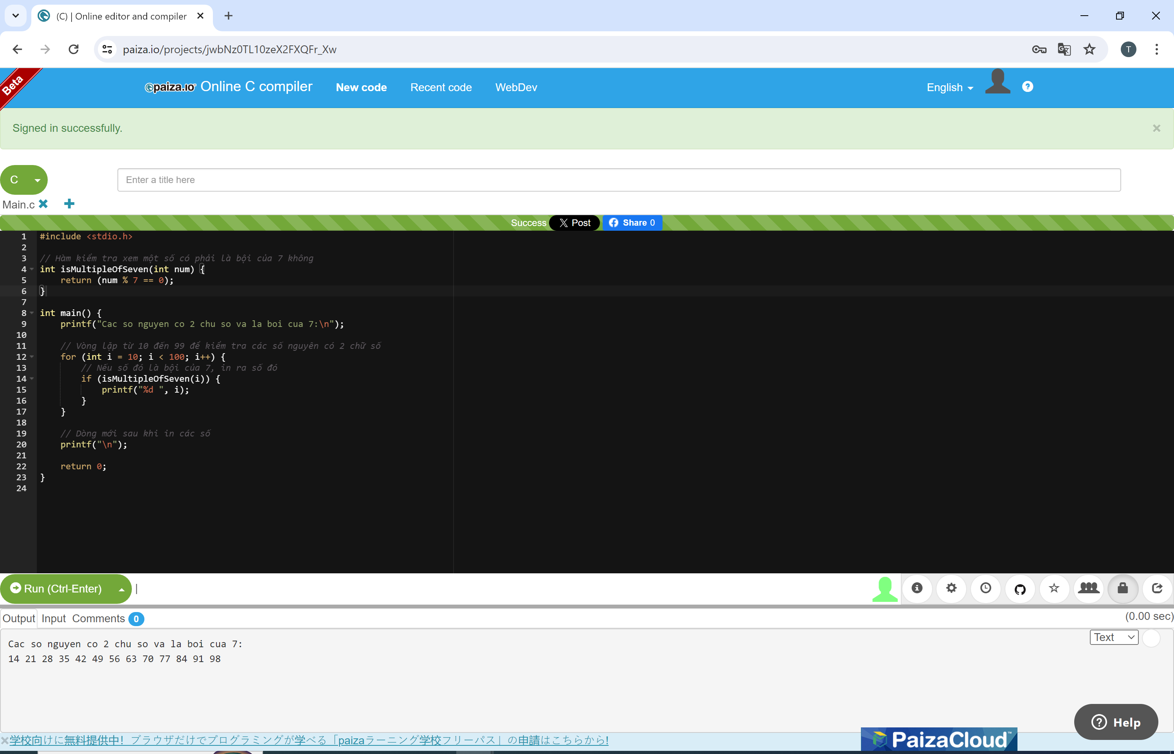

Bài 2:

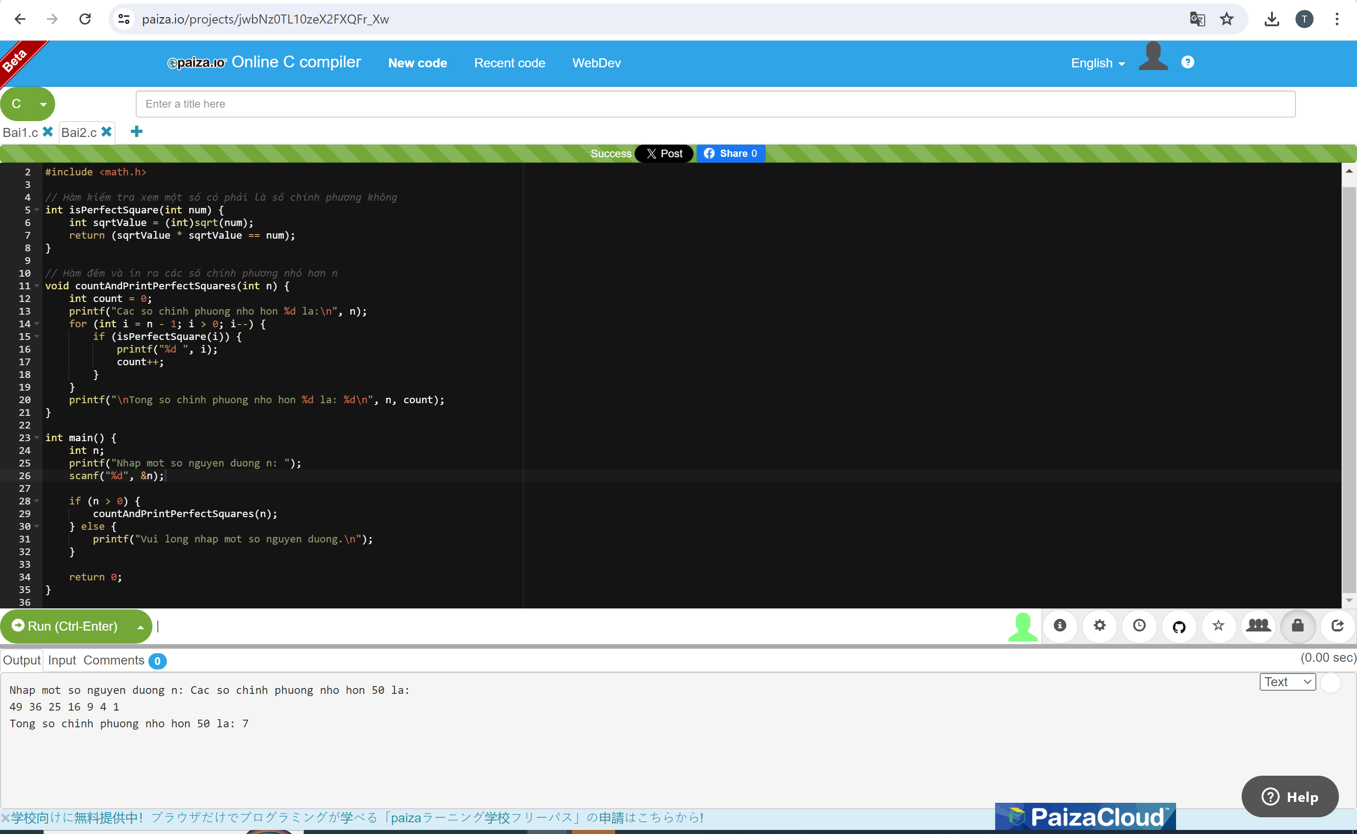

Bai 3:

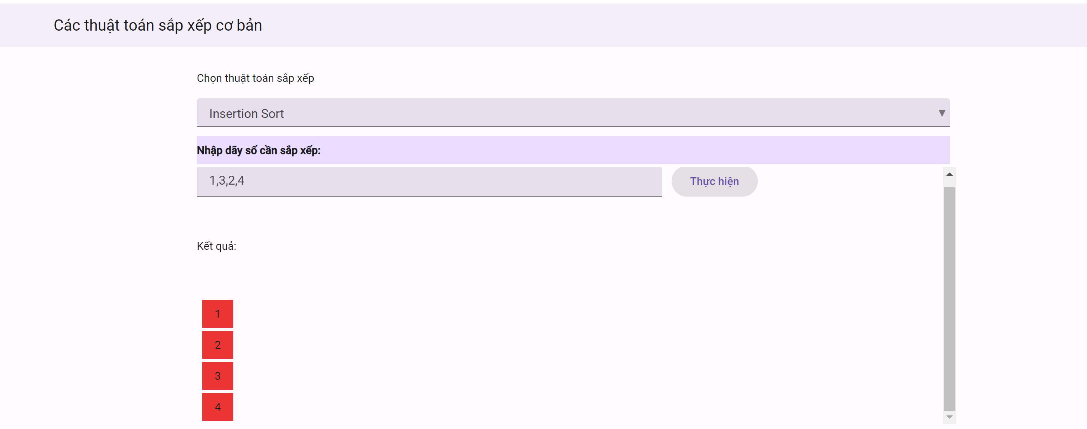

<https://thiendao.anvil.app>

<https://github.com/NguyenVincy/Bai3>