ISYS2120 Sem2, 2024

Assignment 1 (Relational schema)

530604594

SID:

PART A

Your relational schema diagram here (add additional pages as necessary)

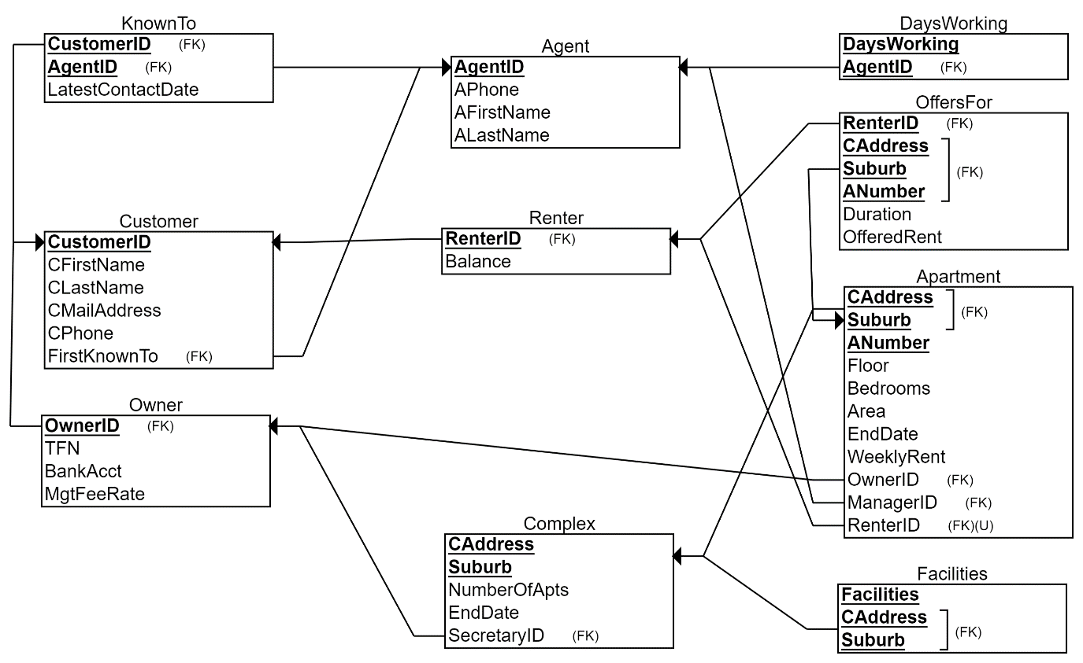

PART B

Your SQL DDL here (exactly as in the .sql text file)

-- Entities

-- Agent

CREATE TABLE Agent(

  AgentID INT,

  APhone VARCHAR(15),

  AFirstName VARCHAR(150),

  ALastName VARCHAR(150),

  PRIMARY KEY(AgentID)

);

-- DaysWorking multi-values attribute of Agent

CREATE TABLE DaysWorking(

  DaysWorking VARCHAR(50),

  AgentID INT,

  PRIMARY KEY(DaysWorking, AgentID),

  FOREIGN KEY(AgentID) REFERENCES Agent(AgentID)

);

-- Customer

-- Difficulty in ensuring participation constraint, uses FirstKnownTo NOT NULL in Customer to ensure this but not compatible with INSERT and DELETE

CREATE TABLE Customer(

  CustomerID INT,

  CFirstName VARCHAR(150),

  CLastName VARCHAR(150),

  CMailAddress VARCHAR(150),

  CPhone VARCHAR(15),

  FirstKnownTo INT NOT NULL,

  PRIMARY KEY(CustomerID),

  FOREIGN KEY(FirstKnownTo) REFERENCES Agent(AgentID)

);

--Overlapping partial ISA relationship

-- Owner

CREATE TABLE Owner(

  OwnerID INT,

  TFN VARCHAR(10),

  BankAcct VARCHAR(10),

  MgtFeeRate FLOAT,

  PRIMARY KEY(OwnerID),

  FOREIGN KEY(OwnerID) REFERENCES Customer(CustomerID)

);

-- Renter

CREATE TABLE Renter(

  RenterID INT,

  Balance FLOAT,

  PRIMARY KEY(RenterID),

  FOREIGN KEY(RenterID) REFERENCES Customer(CustomerID)

);

-- Complex

-- SecretaryID NOT NULL, EndDate for isSecretary relationship

CREATE TABLE Complex(

  CAddress VARCHAR(150),

  Suburb VARCHAR(150),

  NumberOfApts INT,

  EndDate DATE,

  SecretaryID INT NOT NULL,

  PRIMARY KEY(CAddress, Suburb),

  FOREIGN KEY(SecretaryID) REFERENCES Owner(OwnerID)

);

-- Apartment

-- OwnerID NOT NULL for Owns relationship, one owner to many apartments

-- ManagerID NOT NULL for Manages relationship, one manager to many apartments

-- Floor, CAddress and Suburb attributes for LocatedIn relationship, Caddress and Suburb being part of the primary key for weak entity

-- EndDate, WeeklyRent and RenterID UNIQUE for one to one Rents relationship without participation constraint

CREATE TABLE Apartment(

  CAddress VARCHAR(150),

  Suburb VARCHAR(150),

  ANumber VARCHAR(10),

  Floor VARCHAR(10),

  Bedrooms INT,

  Area FLOAT,

  EndDate DATE,

  WeeklyRent FLOAT,

  OwnerID INT NOT NULL,

  ManagerID INT NOT NULL,

  RenterID INT UNIQUE,

  PRIMARY KEY(CAddress, Suburb, ANumber),

  FOREIGN KEY(CAddress, Suburb) REFERENCES Complex(CAddress, Suburb),

  FOREIGN KEY(OwnerID) REFERENCES Owner(OwnerID),

  FOREIGN KEY(ManagerID) REFERENCES Agent(AgentID),

  FOREIGN KEY(RenterID) REFERENCES Renter(RenterID)

);

-- Facilities multi-values attribute of Apartment

CREATE TABLE Facilities(

  Facilities VARCHAR(50),

  CAddress VARCHAR(150),

  Suburb VARCHAR(150),

  PRIMARY KEY(Facilities, CAddress, Suburb),

  FOREIGN KEY(CAddress, Suburb) REFERENCES Complex(CAddress, Suburb)

);

-- Relationships

-- KnownTo

-- Difficulty in ensuring participation constraint, uses FirstKnownTo NOT NULL in Customer to ensure this but not compatible with INSERT and DELETE

CREATE TABLE KnownTo(

  CustomerID INT,

  AgentID INT,

  LatestContactDate DATE,

  PRIMARY KEY(CustomerID, AgentID),

  FOREIGN KEY(CustomerID) REFERENCES Customer(CustomerID),

  FOREIGN KEY(AgentID) REFERENCES Agent(AgentID)

);

-- OffersFor

-- RenterID, CAddress, Suburb, ANumber as primary key for many to many relationship

CREATE TABLE OffersFor(

  RenterID INT,

  CAddress VARCHAR(150),

  Suburb VARCHAR(150),

  ANumber VARCHAR(10),

  Duration INTERVAL,

  OfferedRent FLOAT,

  PRIMARY KEY(RenterID, CAddress, Suburb, ANumber),

  FOREIGN KEY(RenterID) REFERENCES Renter(RenterID),

  FOREIGN KEY(CAddress, Suburb, ANumber) REFERENCES Apartment(CAddress, Suburb, ANumber)

);