**Hip-Hop Music Festival**

Setup Document



Course: Project P-phase

Date: 18 February 2018

Students: Marc Owen Dañe – 3318605

David van Rijthoven – 3376540

Nguyen Vu Nhan – 3420981

Youssef Belganche – 3203379

Contents

Functional Requirements 3

Website Design 5

Home page 5

Register Page 6

Account Page 7

Schedule Page 8

Application Design 10

Event Store GUI 10

Manager Application 12

Check in/out 13

Loan Application GUI 14

Add-Visitor Application GUI 15

Database 16

# Functional Requirements

* A functioning website will be provided
  + Must: It will allow for user registration
    - Users must buy a ticket when they register
  + Must: Users can make reservations of camping spots on it
  + Must: Users can join their friend’s camping spots by entering their code
  + Should: Users can leave a review of the event on the website
  + Should: The website should feature an up to date schedule
  + Could: The website has a full-featured search function
  + Won’t: The website won’t have a full list of everything that’s sold in the event
* Several Applications will be provided
  + A Manager Application
    - Must: The manager must be able to find the status of the event
    - Must: The manager can access the schedule
    - Must: The manager can look at specific customer information
    - Must: The manager can create a login for other managers or employees
    - Should: The manager can use several functions to access various data from the database
    - Could: It will not feature any way to change any data in the database (such as schedule, etc.)
    - Won’t: Feature a messaging system with other managers/employees
  + Check in/out Application (for camping spot and for event)
    - Must: Scans Ticket/ID-card/other
    - Should: Used with login from employees
  + Store application
    - Must: Feature a full list of relevant sold products and the possibility to sell multiple of any product
    - Should: Used by employees with login
* A functioning database will be provided so data from the other programs can be saved
  + Must: It must store information about customers, their purchases/spending/reservations and employee information such as login
  + Won’t: It won’t store information about every employee of the company, only employees working on the event

# Website Design

## Home page

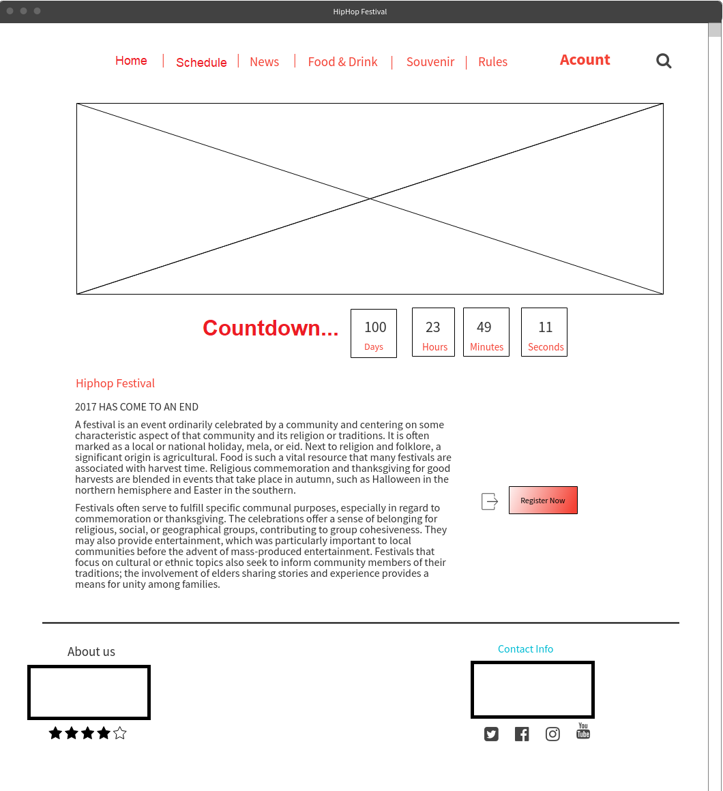

## Register Page

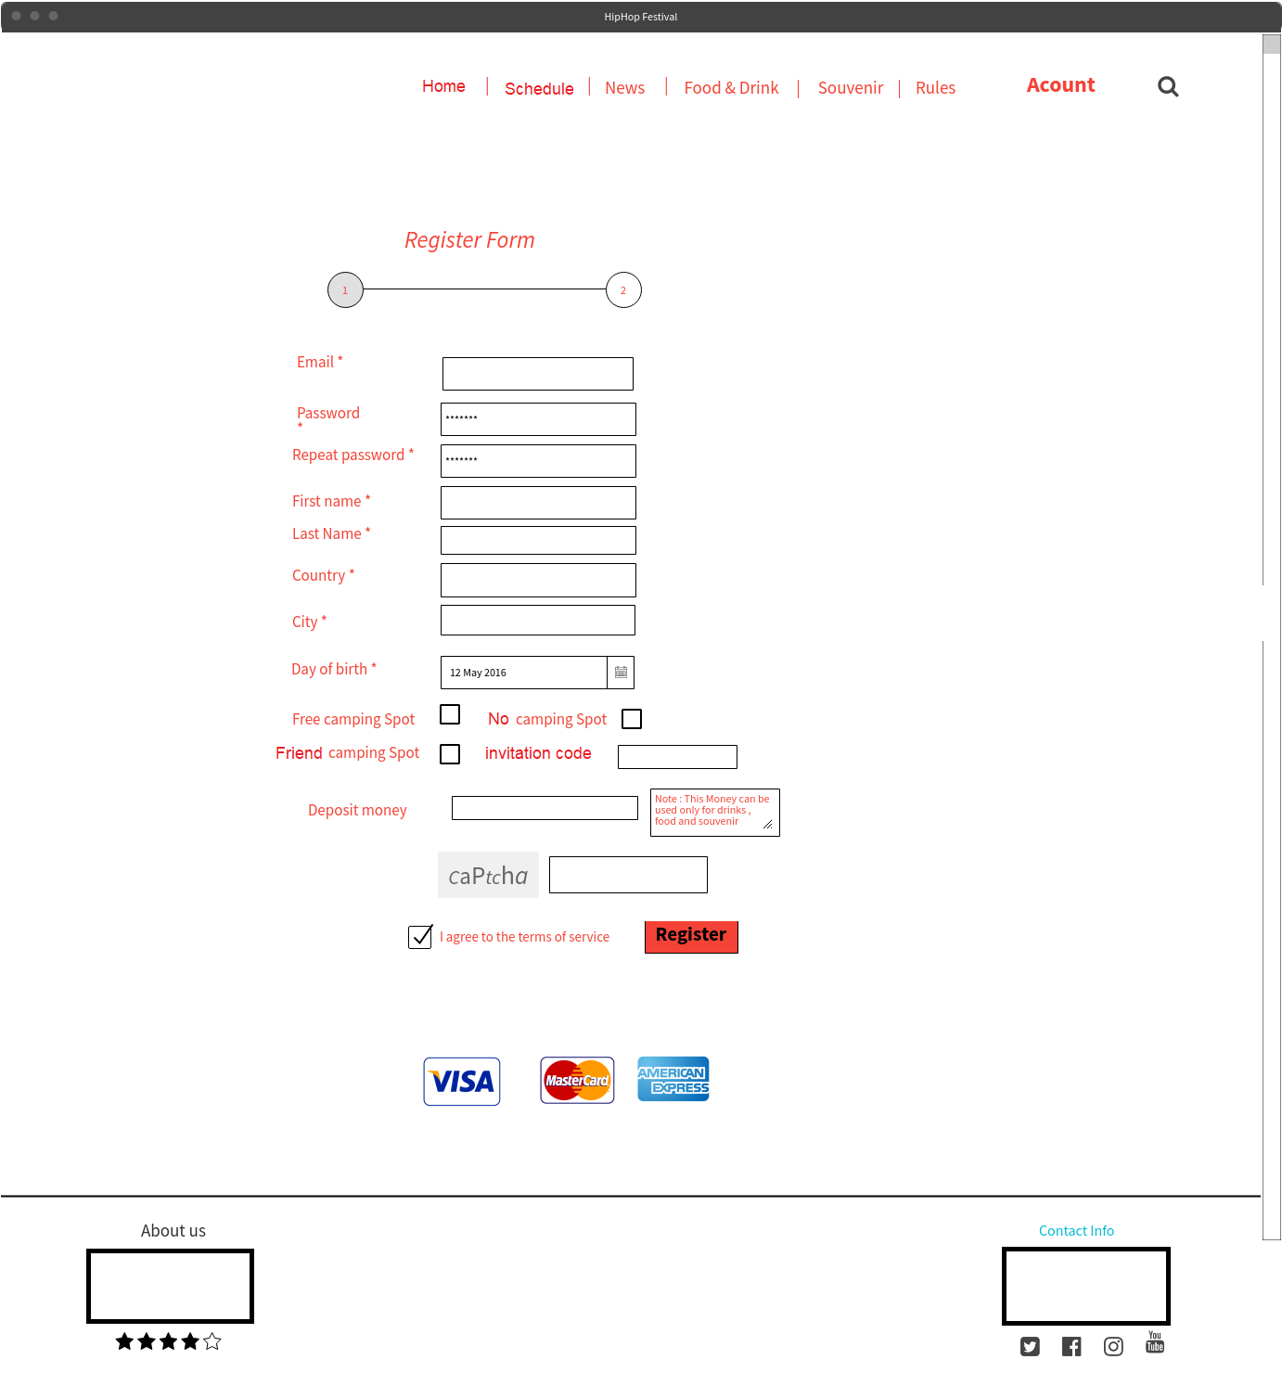

## Account Page

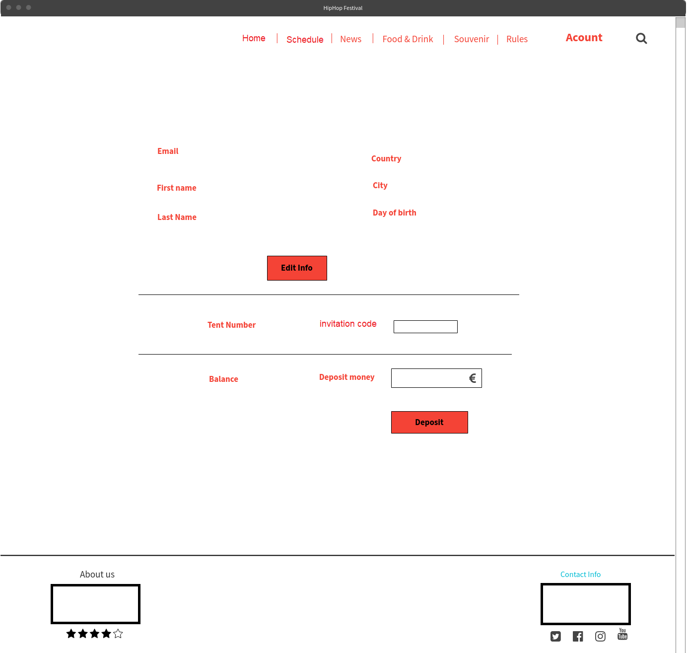

## Schedule Page

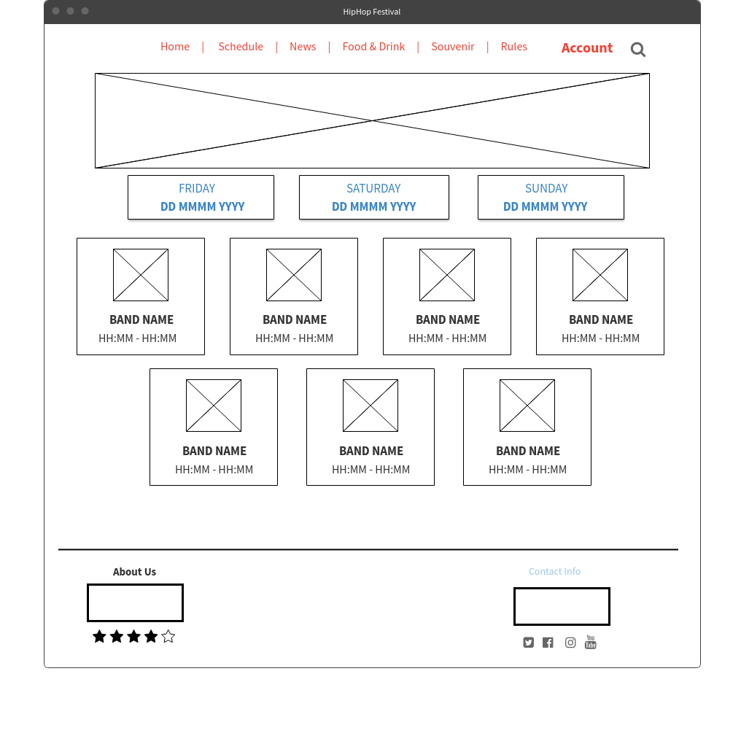Website use cases

1. The website Give a chance to visitor to register in the event Provided that visitor filled he’s/she’s information (Email , First name , last name , date of birth , country city and set a password to his an account ) and agreed with condition .
2. The website gives a look to visitor to what he/she will expect in the event ( Drinks , food and souvenirs available in the event )
3. The website give’s update of the event in News
4. The website contains rules of the event what’s allowed and what’s not .

**Use case of a subsystem with actor**

|  |
| --- |
| Use case name: register in the event |
| Brief description: this use case is allowed the visitor to register in the event trough the website |
| Actor: visitor |
| Actor Action | System Response |
| 1 : The visitor clicks the register button | 2 : The system displays a page with form to fill |
| 3 : the visitor fills information and Checks the radio Button and clicks on Register | 4 : the system refer the visitor to a page to process the payment |
| 5 : If the payment process finished successfully | 6 : the system takes visitor automatically to his/her account |

# Application Design

## Event Store GUI

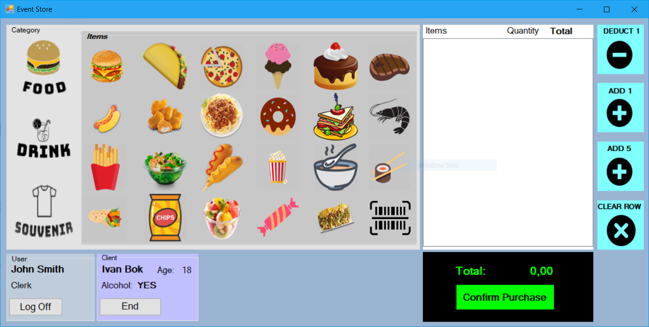

|  |  |
| --- | --- |
| **Name** | Buy food/drinks/souvenirs |
| **Description** | During the event, visitor should be able to buy food/drinks/souvenirs at event-shops. |
| **Actors** | Staff members (store-clerks) |
| **Trigger** | Scanning the visitor’s event bracelets |
| **Pre-Condition** | Visitor is at the counter to have his/her order taken. |
| **Post-Condition** | Update bought-items in system based on what is bought. The system should also update the currency left on the visitors account. |
| **Main Course** | 1. The system displays on the screen the details about the visitor. 2. The staff member will add items to the receipt based on what the visitor wants. 3. The system will check if the visitor can have his selected items on the receipt. (Ex1) 4. The system will display if there is enough currency on the account for the items on the receipt. (Ex2) 5. If there is no exception, the system will prompt to confirm the purchase. 6. Event-bracelet will be scanned to confirm the purchase. 7. After confirmation, the system will update the visitors account-balance and update what is bought. 8. App will be cleared for the next visitor in line. |
| **Exception** | *Ex1:*  If the visitor is under the age of 18 and has items (18+) on his receipt, the application will prompt to have those items removed.  The store-clerk will have to remove the items from the receipt.  The application will continue with the Main Course (4).  *Ex2:*  If the visitor does not have enough event-currency for the items on his receipt, the application will prompt to have items removed.  If the visitor has enough event-currency left on his account for the items, the application will resume with the Main Course (5). |

## Manager Application

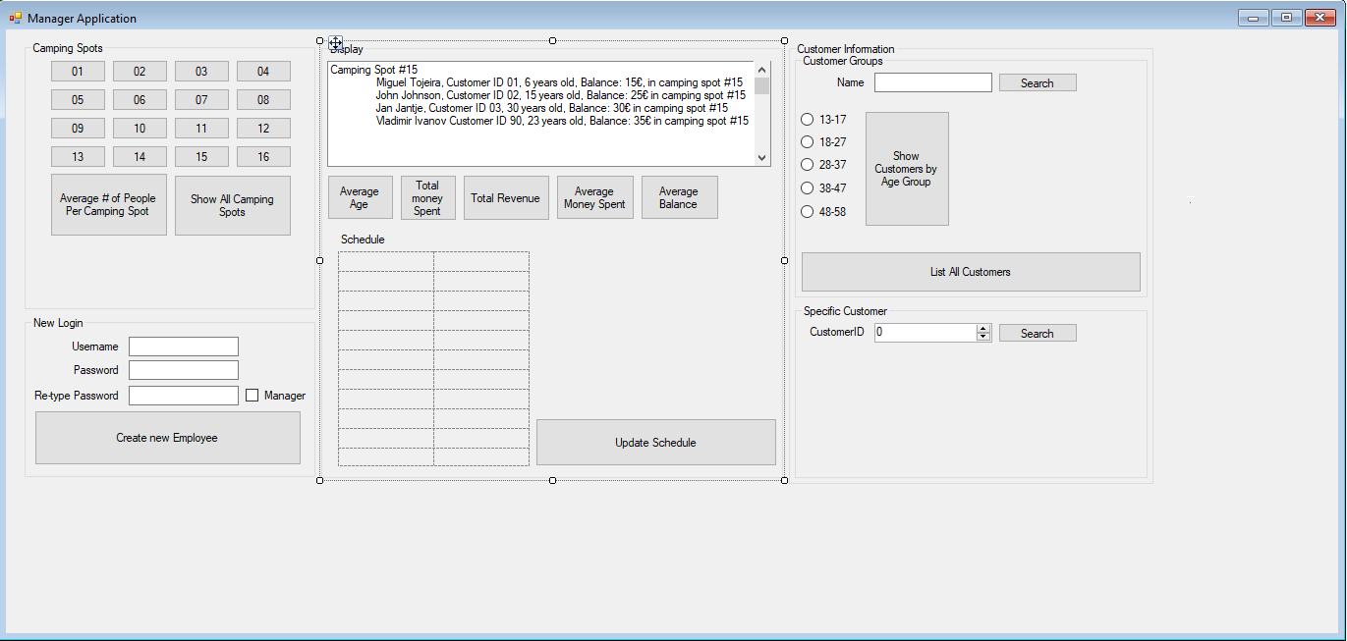

|  |
| --- |
| Use case name: Various Management Use Cases |
| Brief description: The event managers will have many options to display information with the management app |
| Actor: Manager |
| Actor Action | System Response |
| 1: The manager searches for a Customer by name | 2: The system displays all information of customers whose names contain the specified name on the right |
| 1: The manager searches for a Customer by customerID | 2: If it exists the system displays the Customer with the specified ID, otherwise a message is shown saying it was not found |
| 1: The manager clicks on any Camping spot | 2: The information of that camping spot and the people it’s been reserved for is displayed on the right by the system |
| 1: The manager creates a new login for an employee by filling out his new credentials | 2: If the username does not already exist, it is added to the system and a message is shown saying the new employee can use his login. |
| 1: The manager updates the schedule | 2: The complete updated schedule is shown in the table |
| 1: The manager checks the current status | 2: The event status application is opened |
| 1:The manager searches for customers in a certain age group | 2: The information of all customers in that age group are shown in the box to the right |

## Check in/out

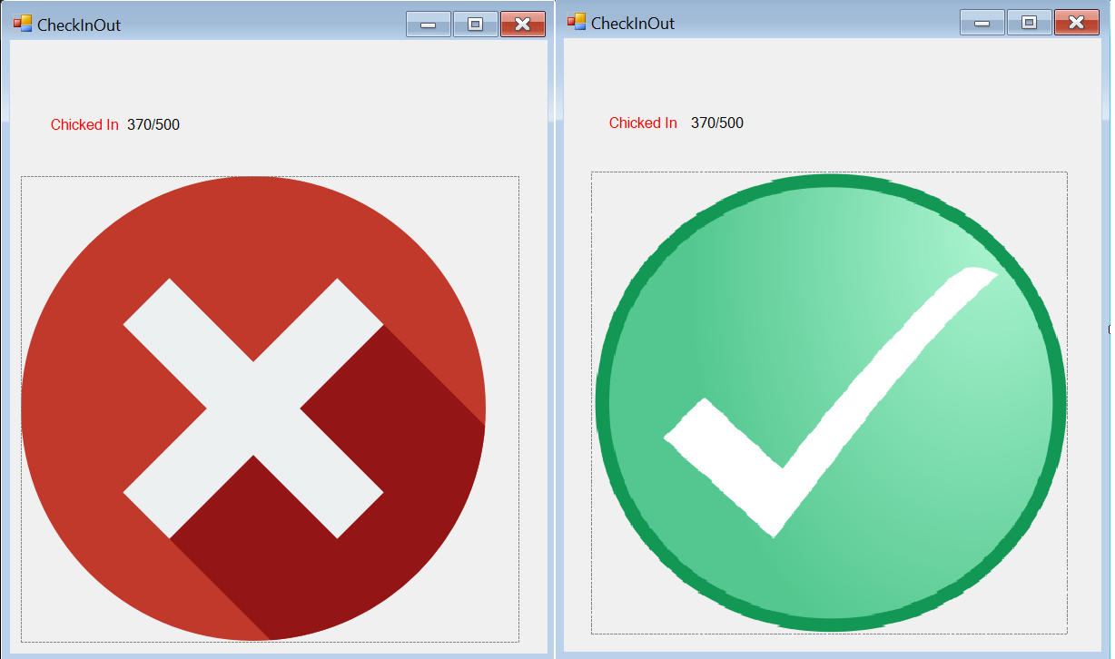

|  |  |
| --- | --- |
| **Name** | Checking Visitors In & Out |
| **Description** | During the event visitors needs to be checked in and out at the gates by the staff. This is to check if indeed visitors are allowed enter or leave the event. |
| **Actors** | Staff members (Check-In/-Out staff) |
| **Trigger** | Scanning the visitor’s event bracelets |
| **Pre-Condition** | Visitor is waiting at the gate to have his/her bracelet scanned. |
| **Post-Condition** | Show that visitor has successfully been checked in/out the event or that this was unsuccessful. |
| **Main Course** | *Check In:*   1. System checks if the visitor is allowed onto the event. (Ex1) 2. If no exceptions are raised, the visitors checked-in status in the database will be changed to “Checked In”. 3. Application will display that the visitor has successfully been checked in to the staff member.   *Check Out:*   1. System checks if there are any loaned items still in possession by the visitors. 2. Based on the results, system checks if the visitor can leave the event. (Ex2) 3. If no exceptions are raised, the visitors checked-in status in the database will be changed to “Checked Out”. 4. Application will display that the visitor has successfully been checked out to the staff member. |
| **Exception** | *Ex1:*  If the bracelet is deemed unauthentic by the system and/or the visitor is denied access to the event by the system, the application will display a message to the staff member.  *Ex2:*  If the visitor still has loaned items in his/her possession, the visitor will be denied access to leave the event. The application will display a message to the staff member. |

## Loan Application GUI

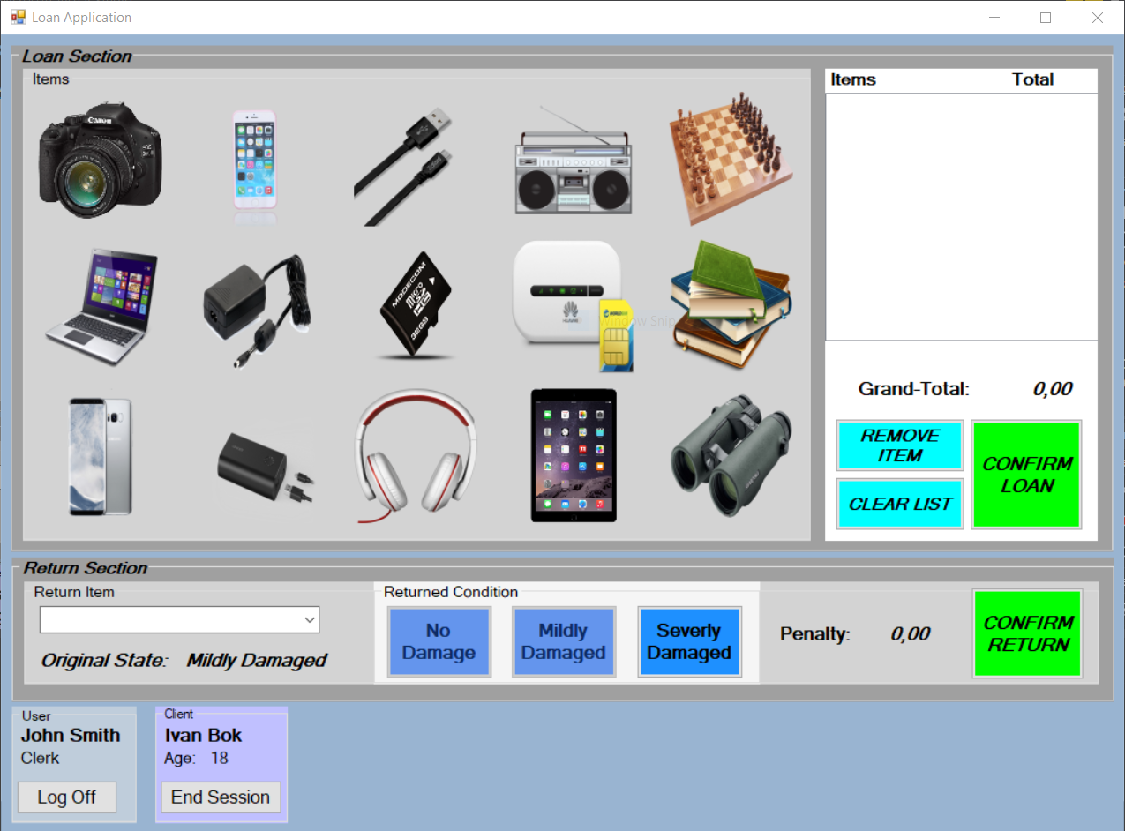

## Add-Visitor Application GUI

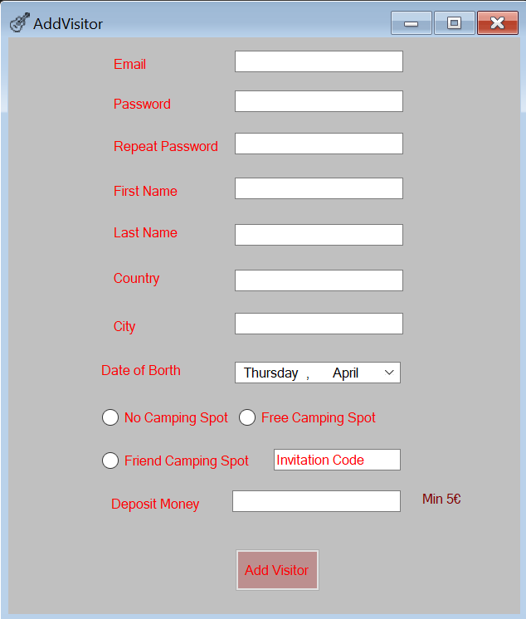

# Database

