Jenkin war has embedded server in its war file => java -jar <war name>

* No need to run on tomcat server

Start at another port: java -jar <war name> --httpPort = 8181

1. Jenkin credential:

Scope:

* System credential: used by admin to config genkin => job has no access
* Global: git credential for job to get code (for exp) => used anywhere

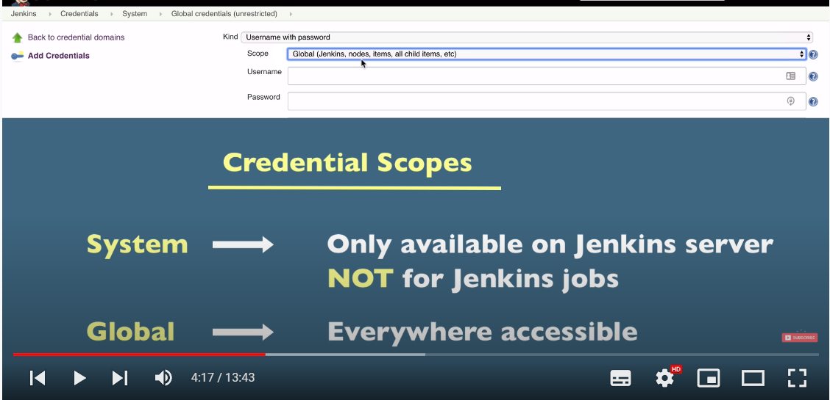

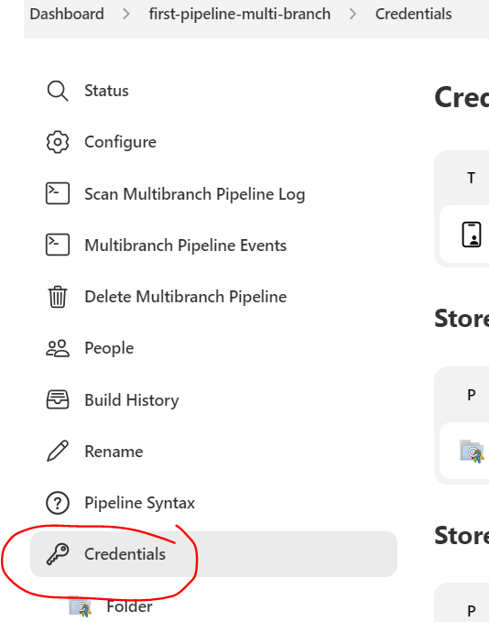

* Pipeline credential, other pipeline cannot access this credential

Filter name of branch to deploy:

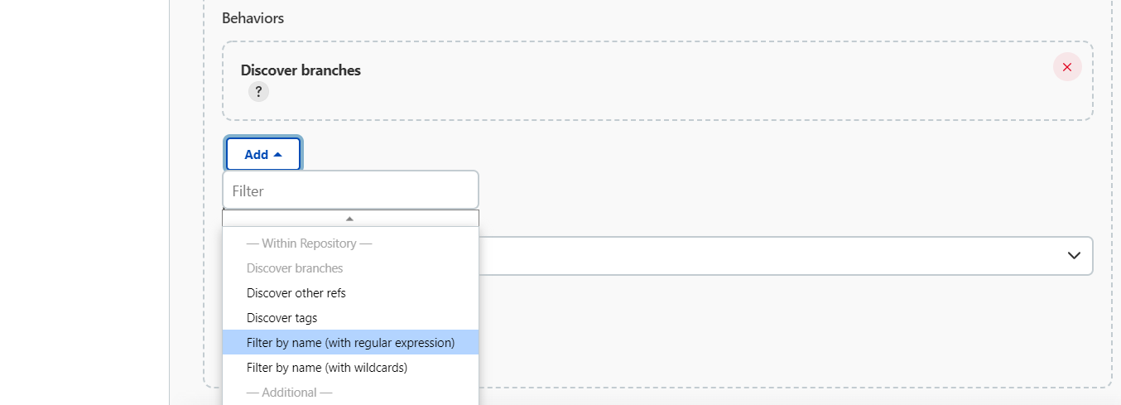

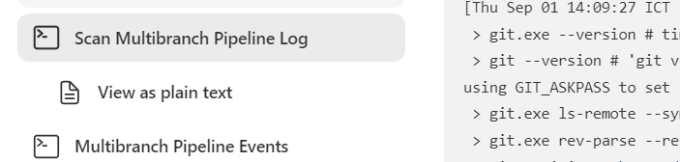

Check this to know which branch is being scanned

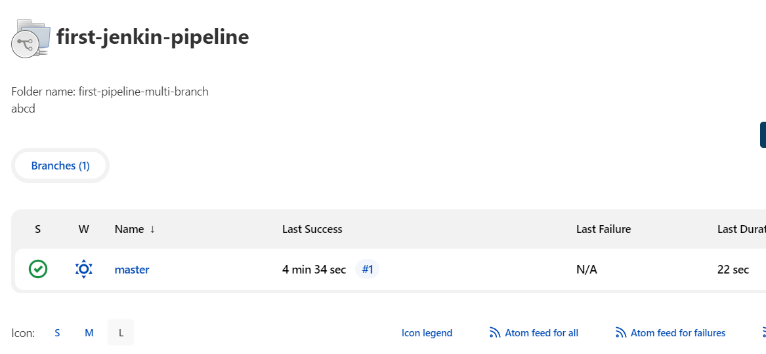

Pipeline = jobs => repo => many branches

Restart from stage:

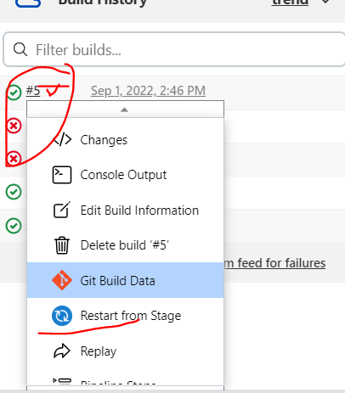

File JenkinsFile not found: skip the root foldr

