MAVEN

<https://www.youtube.com/watch?v=jJcOr0-2VjM&list=PLzS3AYzXBoj8E3NjjWNjrrFjyexXIyZbL&index=28&ab_channel=KKJavaTutorials>

1. Proxy server (VPN is a proxy server but it encrypted data in request)

User requests are forwarded to proxy and proxy will retrieve data and send back to user

Proxy is a server so it has url, port, …

Go to setting.xml config proxy for maven

1. Profile:

ProfilesDemoProject-master

Run with command: cmd clean install -P <ip of profile>

1. Repositories

First maven found in local (m2) repo, next: central repo(maven repo) final find in remote repo(compony repo => using <repositories> in pom)

For central repo => no need any comfig => super pom already have

1. Maven compiler

Mvn compile required jdk to compile => nothing related to jdk of project => specified

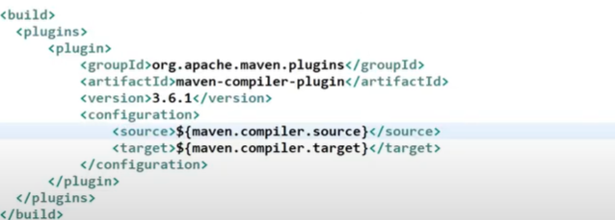

1. Scope in maven pom

* 3 class path: compile, test, run classpath, complile time using compile classPath, test using testClassPath, runTime using runClassPath
* Depen scope default is compile => available on all classPath
* Test => testClassPath+ run
* Provided => compile + test: this one is important when using javax-servlet => should not include during run time because imbedded server already have
* Import: using in child pom to refer to parent pom

