* First step: Start minikube: minikube start

1. Get nodes, pods, services:

Kubectl get nodes(pods, services)

1. Create deployment:

* kubectl create deployment nginx-deployment --image=nginx
* get replicaset => manage replica of pods:

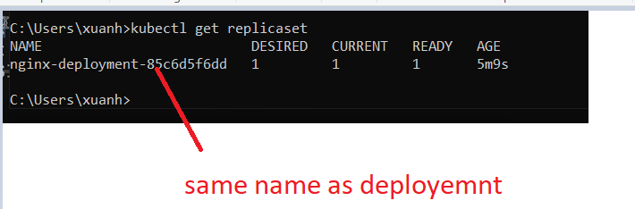

* Edit delete deployment <pod, replicaset>:

kubectl edit (delete) deployment <deployment-name>

* Edit this file, old pods replicasets dies,
* Get logs of pod <container>, describe pods

Kubectl logs <pod id>

kubectl describe pod mongo-depl-{pod-name}

* Enter pods : kubectl exec -it <pod name> bin/bash
* Alias : alias k =”kubectl”
* Deploy local images:
* Open **powershell (not cmd)** in the folder containing docker file

Point docker env to kube env: minikube docker-env | Invoke-Expression

* Build image in this shell
* Create deployment in this shell by this image
* Edit deployment file Always => Never

This set up is only applied for current powershell

<https://stackoverflow.com/questions/42564058/how-to-use-local-docker-images-with-minikube>

* Deployment using file:

Kubectl apply -f <name of yaml file>

* Master nodes: all kubectl command goto masternode
* Get id of pods: kubectl get pods -o wide
* Label of component:

Deployment and service both have their own selector => point to the same label of pods => connect pods to service and deployment

Label of deployment does not related to service or pods

* Get status of current deployment => yaml file

kubectl get deployment <deployment name> -o yaml