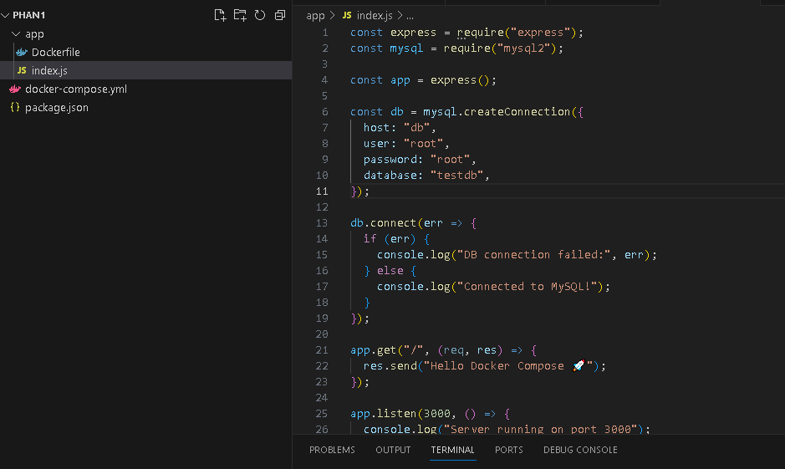
- docker compose version
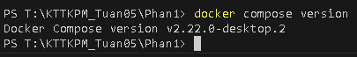
- docker compose up
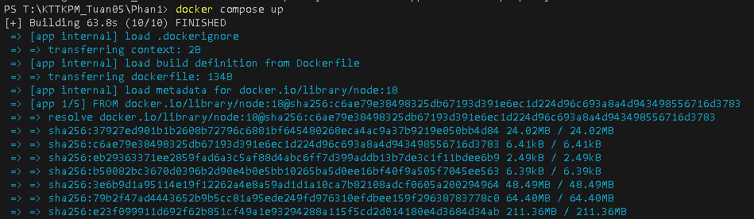
- docker compose up –d
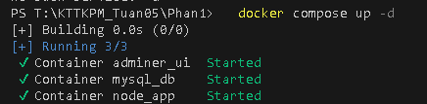
- docker compose ps
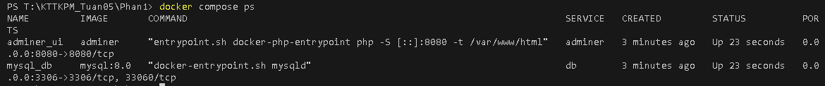
- docker compose down
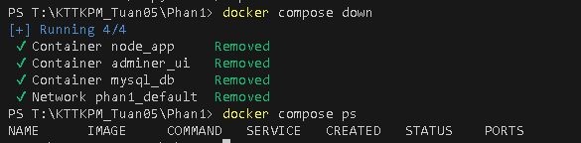
- docker compose restart
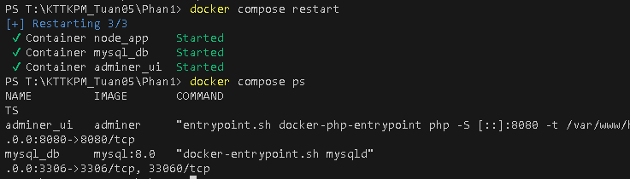
- docker compose logs –f
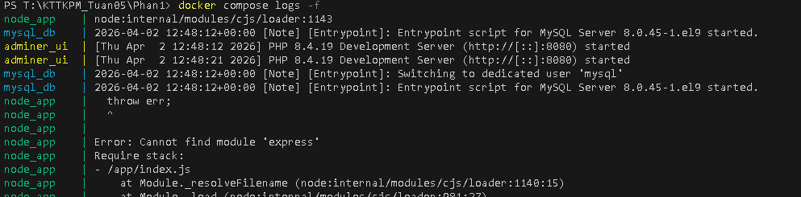
- docker compose build
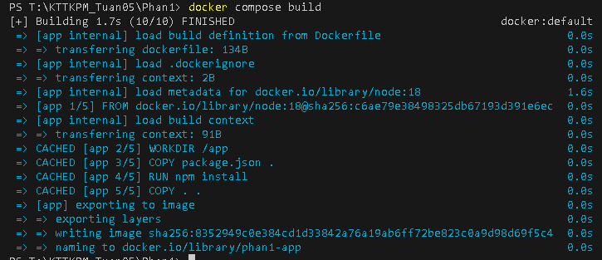
- docker compose exec <service_name> <command>
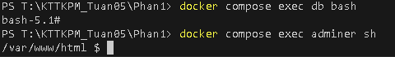
- docker compose down –v
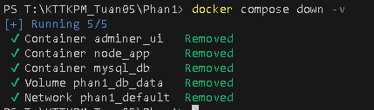
- docker compose run <service_name> <command>
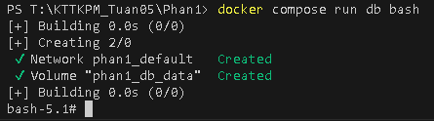
- docker compose stop <service_name>
- docker compose rm <service_name>
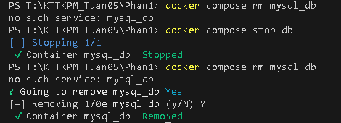
- docker compose config
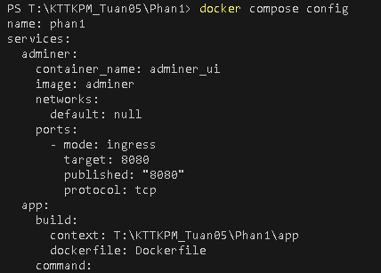
- docker compose up -d --build

