PHENIKAA UNIVERSITY
PHENIKAA SCHOOL OF COMPUTING

FINAL ASSIGNMENT REPORT
MODULE: Software architecture
Topic: Building a Human Resources Management System (HRM) applying Microservices Architecture
Group: 05
Members :
Nguyen Dang Hanh – 23010243
Nguyen Dinh Dat – 23010282
Le Quang Dat - 23010201
Nguyen Manh Hoa - 23010254
Instructor: Master Vu Quang Dung
Class : Software Architecture-1-3-25(N01)

HANOI, June 15, 2026

Content
Task Assignment Table - HRM System Project 3
LIST OF IMAGES 4
LIST OF TABLES 6
CHAPTER 1: PROJECT OVERVIEW 8
1. Problem Statement. 8
2. Project Objectives (Project Objectives). 8
3. Project Scope. 9
4. Technology Stack Overview. 9
CHAPTER 2: REQUIREMENTS ANALYSIS (SRS) 11
1. Functional Requirements. 11
2. Non-Functional Requirements (NFR). 11
3. Use-case diagram. 12
4. Architecturally Significant Requirements (ASRs). 24
4.1. Utility Tree. 24
4.2. Mapping to Architecture Drivers Table. 27
Chapter 3 : System Architecture and Design (SDD) 31
1. Select Architectural Style 31
1.1. Theoretical basis. 31
1.2. Popular architectural styles and when to use them. 31
2. Overall system architecture. 32
3. Architectural documents according to C4 model. 33
3.1. Overview. 33
3.2. C4 Level 1: System Context Diagram. 34
3.3. C4 Level 2: Container Diagram. 35
3.4. C4 Level 3: Component Diagram (Example: Leave Service). 37
3.5. C4 Level 4: Code Diagram. 39
4. Database Design. 39
5. API design (RESTful API Design). 50
5.1. REST principles. 50
6. UML Diagrams (UML Diagrams). 50
7. Architecture Decision Records (ADR) 57
8. Interface Prototype (UI Prototype). 58
Chapter 4: Implementation & Coding 60
1. Development Environment & Tools. 60
2. Project Directory Structure. 60
3. Notable Implementation Techniques. 61
4. System Screenshots. 65
Chapter 5: System Testing 69
1. Test Plan 69
2. Test Cases. 69
3. Test Results Summary. 80
4. Quality Attribute Testing. 81
4.1. Performance Testing. 81
4.2. Availability. 81
4.3. Security (Security). 82
Chapter 6: Deployment & User Guide (Deployment & User Guide) 83
1. System Requirements. 83
2. Instructions for Installing & Running the application (Installation & Run Instructions). 83
3. Demo Accounts (Demo Accounts). 84
4. User Guide for Main Features. 84
Chapter 7: CONCLUSION AND DEVELOPMENT DIRECTIONS (Conclusions & Future Work) 92
1. Achieved results (Achievements). 92
2. Limitations & Challenges. 92
3. Future development orientation (Future Work). 93
References 95

Task Assignment Table - HRM System Project
No. | Member | Assigned Tasks | Contribution Rate
1 | Quang Đạt | Develop Salary Service: Build automatic salary calculation logic, handle bonuses/penalties.Project Testing: Responsible for all testing activities, including writing the Test Plan, executing Test Cases, and summarizing the results report (TEST_SUMMARY.md).Frontend: Build the UI for the salary management and payroll view pages. | 25%
2 | Đình Đạt | Develop Attendance Service: Build attendance tracking logic, calculate late arrivals/early departures.Architectural Design: Draw important architectural diagrams such as the C4 Model and Sequence Diagrams to describe the system's workflow.Database: Design the schema and write the initialization script for the PostgreSQL database (init.sql).Frontend: Build the UI for the Attendance page (Attendance.jsx). | 25%
3 | Hanh | Develop Leave Service: Build the leave request process, approval flow, and data aggregation logic for the work schedule grid.Develop Notification Service: Build the internal announcement broadcast and the logic for sending/receiving real-time notifications.Frontend: Build the UI for the Leave Management and Announcement features (AnnouncementPage.jsx). | 25%
4 | Hòa | Develop Auth Service: Build registration, login, authorization, and user/department management functionalities.Write Report: Responsible for writing the final project report and completing the README.md documentation.Infrastructure & DevOps: In charge of application containerization (Docker), configuring Kong API Gateway, and the monitoring system.Frontend: Build the remaining UI components (Login, Dashboard, Settings, Sidebar, User Management...). | 25%

LIST OF IMAGES
Figure 1: Overview use-case diagram 12
Figure 2: Utility tree diagram 24
Figure 3: Overall system architecture diagram 32
Figure 4: C4 model-Level 1 : System Context Diagram 33
Figure 5: C4 model-Level 2 : container diagram 34
Figure 6: C4 model – Level 3 : Attendance Service Container (Component Diagram) 36
Figure 7: C4 model-Level 3 : Leave Service Container (Component Diagram) 37
Figure 8: C4 Model Diagram – Level 4: Code (Check-in/Check-out) 38
Figure 9: ERD diagram 39
Figure 10: Class diagram 50
Figure 11: Sequence Diagram: Synchronize and Get the salary list 51
Figure 12: Sequence Diagram: Salary Closing & Payment 52
Figure 13: Sequence Diagram: Real-Time Notification Generation 53
Figure 14: Sequence Diagram: Sending Leave Application Flow 53
Figure 15: Activity diagram: Leave Request and Application Approval flow 54
Figure 16: Activity diagram: Automatic salary calculation flow 55
Figure 17: Activity diagram: Account Registration and Authentication flow 56
Figure 18: Interface screen switching flow diagram 58
Figure 19: Dashboard admin screen 65
Figure 20: Dashboard user screen 65
Figure 21: Calendar and shifts screen 66
Figure 22: Timekeeping screen 66
Figure 23: Payroll screen 66
Figure 24: Microservices health monitoring screen (Grafana Admin Panel) 67
Figure 25: Microservices health monitoring screen (Grafana Admin Panel) 67
Figure 26: Registration form screen 84
Figure 27: OTP receipt email screen 84
Figure 28: Admin approval screen 85
Figure 29: Time clock interface screen 86
Figure 30: Time attendance button interface screen and attendance history 86
Figure 31: Leave application creation form screen 87
Figure 32: Admin screen receives realtime notifications 88
Figure 33: Leave application approval screen and notification (red bell) on the sidebar 88
Figure 34: Payroll interface screen 89
Figure 35: Interface screen detailing penalty/reward columns 90
Figure 36: Salary payment interface screen 90

LIST OF TABLES
Table 1: Table of technology used by each floor (Technology Stack) 9
Table 2: List of functional requirements (Functional Requirements) 11
Table 3: List of non-functional requirements (Non-Functional Requirements) 12
Table 4: Use Case – Account Management & Authentication Subsystem (Auth Domain) 13
Table 5: Use Case – Leave Management Module (Leave Domain) 14
Table 6: Use Case – Attendance & Schedule Management Subsystem (Attendance Domain) 15
Table 7: Use Case – Payroll Management Module (Payroll Domain) 16
Table 8: Use Case – Notification & Interaction Subsystem (Notification Domain) 17
Table 9: Use Case – System Administration & Configuration Subsystem (System Admin Domain) 17
Table 10: Use Case specification: Register account and Wait for approval 18
Table 11: Use Case specification: Employee submits a leave application 19
Table 12: Use Case specification: Management approves leave application 20
Table 13: Use Case specification: Employee clocks in/out 21
Table 14: Use Case specification: Monthly salary calculation system 23
Table 15: ASR scenarios according to Utility Tree 25
Table 16: ASR Mapping Table to Architectural Dynamics (ASR Mapping Table) 27
Table 17: Comparison of architectural styles and scope of application 31
Table 18: Context Diagram Components – C4 Level 1 (System Context) 34
Table 19: Container Diagram Components – C4 Level 2 (Container) 36
Table 20: Components inside Attendance Service Container (C4 Level 3) 37
Table 21: Components inside Leave Service Container (C4 Level 3) 38
Table 22: Data table structure: users 40
Table 23: Data table structure: departments 42
Table 24: Data table structure: attendance_logs 43
Table 25: Data table structure: leave_requests 44
Table 26: Data table structure: monthly_payrolls 45
Table 27: Data table structure: announcements 47
Table 28: Data table structure: system_settings 48
Table 29: Data table structure: bonuses_penalties 49
Table 30: List of Core API Endpoints (RESTful API) 50
Table 31: Development Environment & Tools (Development Environment & Tools) 60
Table 32: Multi-level testing plan (Test Plan) 69
Table 33: Test case FR-01: Authentication & Authorization (Auth Service) 70
Table 34: Test case FR-02: Attendance Service 72
Table 35: Test case FR-03: Leave Service 74
Table 36: Test case FR-04: Salary Service 76
Table 37: Test case FR-05: Notification & System (Notification & System) 78
Table 38: Availability & Recovery Test Cases (Availability Test) 80
Table 39: Summary of test results (Test Results Summary) 81
Table 40: List of Demo Accounts (Demo Accounts) 84
Table 41: Objectives vs. Results comparison table (Objectives vs. Results) 92

CHAPTER 1: PROJECT OVERVIEW
- Problem Statement.
- In the era of digital transformation, human resource management in today's businesses requires high accuracy, transparency and automation. However, managing human resources in the traditional way (using paperwork, Excel or discrete tools) is revealing many critical weaknesses. Manual timekeeping and salary calculation take a lot of time to check, easily leading to data errors, causing frustration for workers. In addition, the process of requesting leave and approving applications must go through many stages of paperwork, delaying the operating progress of both employees and management.
- From a Software Architecture perspective, older HR management systems are often built according to Monolithic Architecture. As the scale of the organization increases, the monolithic system reveals major limitations: the database is often "bottlenecked" and overloaded on closing days at the end of the month; Poor scalability due to having to clone the entire application; and the risk of system collapse (Single Point of Failure) just because one module (for example, payroll module) has an error. According to Bass et al. [2], a good software system needs to have a standard architectural design from the beginning, because the cost of overcoming architectural errors at the operational stage is often many times greater than when detected and handled early in the design stage.
- In order to thoroughly solve the above problems, the team decided to develop a Human Resources Management System (HRM System). The project applies the distributed architecture of Microservices, not only to comprehensively digitize the human resources process (from identification, attendance, leave to salary calculation), but also to ensure the system has infinite scalability, high availability (High Availability) and a real-time interaction experience without latency.
- Project Objectives (Project Objectives).
- The project is implemented to achieve specific, measurable goals (SMART) as follows:
- Build a core human resource management web application: Complete at least 05 core business modules including: Authentication & Identification (Auth), Attendance Management (Attendance), Leave Management (Leave), Automatic Payroll (Payroll) and Internal Communication (Notification).
- Apply Microservices architecture : Decompose the system into independent services, communicating through API Gateway (Kong/Nginx) and Message Broker (Redis). All important architectural decisions must be recorded with ADR documents (Architecture Decision Records).
- Multi-model database deployment (Polyglot Persistence) : Isolation of storage using PostgreSQL for relational business data (ACID) and MongoDB for high-speed audit logging (Audit Trail).
- Real-time automation and interaction: 100% automation of checking public and allowable data to export payroll (One-click Payroll). Apply Socket.io to push notifications and instant browsing status to users with a delay of less than 2 seconds.
- Containerize the entire system : Package the entire Frontend, Backend, Database and Monitoring tools with Docker & Docker Compose, ensuring the system can be deployed successfully and run stably on any environment.
- Project Scope.
- Within the project scope (In Scope):
- Authentication & Administration Module : Login, registration, 2-layer authentication via Email OTP, 3-level RBAC authorization (Superadmin, Manager, Staff), system configuration management (holidays, working hours).
- Time Attendance Module: Record shift entry/exit times, automatically separate statuses (late, leave early, absent).
- Leave Module : Create/approve/reject multi-level applications; Automatically deducts the magic fund; Generate a weekly work schedule matrix (Grid Schedule) that combines holidays and real timekeeping schedules.
- Salary Module : Automatic salary calculation based on basic salary, OT bonus, and penalty (lateness/absence). Provide salary slip details (Payslip).
- Notification Module : Internal group/individual broadcasting, real-time popup notifications.
- Out of project scope (Out of Scope):
- Mobile application development (Mobile App iOS/Android).
- Direct integration with external physical hardware (Fingerprint time clock, FaceID facial recognition camera).
- Integrate with Payment Gateway or Bank API to automatically transfer salary.
- Managing complex shifts (Shift Management) interleaved (morning/afternoon/night shifts) for the manufacturing factory model (the current system focuses on office office hours).
- Technology Stack Overview.
- The project strictly follows the principles of modern architecture, choosing technology based on its suitability for each module and ability to support Microservices.

Table 1: Table of technology used by each floor (Technology Stack)
Layer | Technology / Version | Reason for choosing (Rationale)
Frontend (Presentation) | React.js 18 (Vite), Tailwind CSS, Socket.io-client | Build high-speed SPA, easy-to-reuse Component-oriented interface, support WebSockets connection to receive real-time data.
Backend (Microservices) | Node.js 20, Express.js 4.x, JSON Web Token (JWT) | Lightweight, handles asynchronous I/O very well (Non-blocking I/O). Suitable for building independent RESTful APIs, stateless communication.
Relational Database | PostgreSQL 15/16 | Storing core business data (Users, Payroll, Leaves) requires high data integrity and ACID compliance.
Non-relational database | MongoDB 6.0 | System Log Archive (Audit Trail). Optimized for write-heavy tasks without slowing down the main DB.
Cache & Message Broker | Redis 7 | Cache storage of OTP codes for a limited period of time; plays the role of Pub/Sub for Microservices to wake each other up and synchronize Socket.io.
API Gateway & Routing | Kong API Gateway 3.4 / Nginx | Single entry point (Entry point) blocks junk access, protects back-end services, and manages routing.
DevOps & Containerization | Docker, Docker Compose | Package the application into independent Containers, completely eliminating the error "it runs on my computer but has an error on the server".
Monitoring | Prometheus & Grafana | Collect metrics (Postgres exporter, Node exporter) and visualize system health status.
Architectural Design | C4 Model (Draw.io / Structurizr) | Standardize software architecture drawings from Context level to Code level.

CHAPTER 2: REQUIREMENTS ANALYSIS (SRS)
- Functional Requirements.
Table 2: List of functional requirements (Functional Requirements)
ID | Features | Detailed description (Description) | Priority level
FR01 | Authentication & Identity (Auth) | The system allows users to register and log in. Request 2-layer authentication (2FA) via OTP code sent to Email. The new account with the status of PENDING_ADMIN needs approval. | High
FR02 | Smart timekeeping | Record Check-in/Check-out times. Automatically analyze and classify statuses (Late, Leave early, Overtime, Unauthorized) based on working hour configuration. | High
FR03 | Leaves Management (Leaves) | Users (Staff) can create leave applications (Annual Leave, Sick, Unpaid). The Manager reviews the application. Automatically deduct the allowance fund (max_leave_days) when the application is approved. | High
FR04 | Work Schedule Matrix | The system automatically synthesizes the 7-day work schedule per week, combining holiday data, approved leave and actual timekeeping logs to display as a Grid table. | Medium
FR05 | Payroll | Automatically calculate salary based on base salary (base_salary), automatically deduct late/unauthorized fines and add overtime pay. Update DRAFT and PAID status. | High
FR06 | Internal communication (Noti) | Broadcast general announcements throughout the company, announcements by departments or individuals. Real-time push notifications via Socket.io. | Medium

- Non-Functional Requirements (NFR).
- The non-functional requirements are defined as architectural constraints, ensuring the Microservices system operates smoothly under real-world loads.
Table 3: List of non-functional requirements (Non-Functional Requirements)
Attribute | Requirements | Response Measure
Availability | The system is always available, especially during the closing days of the month. | Uptime ≥ 99.9% (3 nines). The database must have an automatic Failover mechanism.
Performance | Handle complex payroll algorithms with large amounts of data without crashing the system. | Load payroll page and run function syncPayrollRealtime < 2 seconds.
Real-time interactivity | Respond immediately to review actions and notifications. | Notifications pushed to Client via Socket.io with latency < 500ms.
Security | Prevent unauthorized access and protect audit data (Audit Log). | 100% sensitive APIs protected with JWT; All salary/permission changes must be logged (trace).

- Quality Attribute Scenario - Availability Example:
- Stimulus Source: Hardware or network problem.
- Stimulus: The main PostgreSQL database node (Primary/Master node) suddenly crashed and stopped working.
- Affected Component (Artifact): Database Cluster (postgres-1, postgres-2, postgres-3).
- Environment: Normal operation under high load.
- Response: ETCD and Patroni detect that the Primary node has collapsed and automatically elect (Leader Election) a Replica node to be the new Master. HAProxy automatically reroutes application traffic to the new Master.
- Response Measure: The Failover process takes place completely automatically, downtime for the application is < 30 seconds. The application does not lose data.
- Use-case diagram.
- The system interacts with the following main groups of actors:
- Employee (Staff / User): Basic user in the system. Perform daily personal operations such as timekeeping, requesting leave, viewing payroll and managing personal records.
- Manager: Middle level manager. Responsible for approving applications, monitoring the work schedule matrix, checking payroll of personnel in the department and sending out internal notices.
- System administrator (Superadmin / Admin): Senior manager. Hold full control over system configuration, manage all personnel, approve management applications and monitor audit logs.
- System: The agent automatically performs underground processes such as salary calculation, checking attendance data, sending real-time notifications and recording system logs.
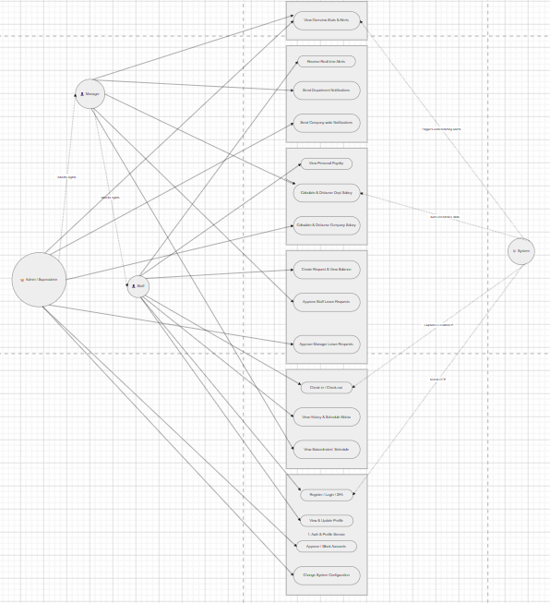
Figure 1: Overview use-case diagram
*Account Management & Authentication Module (Auth Domain)
- Handle authentication, authorization and personal profile management of users.
Table 4: Use Case – Account Management & Authentication Subsystem (Auth Domain)
Use Case | Agent | Describe the activity flow
UC1.1 - Register an account | All | 1. User submits registration information.  2. The system creates an account in PENDING_ADMIN status and requires authentication.
UC1.2 - OTP authentication | All | 1. The system sends OTP code via email.  2. User enters 6-digit code.  3. The system confirms to complete registration or recover password.
UC1.3 - Login | All | 1. User enters information.  2. Password checking system (Bcrypt).  3. JWT Token allocation system for use.
UC1.4 - Update profile | All | 1. User edits full name, phone number, or Avatar. 2. The system saves changes and records operation history.
UC1.5 - Employee management | Superadmin | 1. Administrator views personnel list. 2. Update account status to ACTIVE or lock/suspend account.

*Leave Domain Management Module.
- Manage the application process, monitor leave limits and approval from management.
Table 5: Use Case – Leave Management Module (Leave Domain)
Use Case | Agent | Describe the activity flow
UC2.1 - View permission balance | All | 1. User accesses leave module.  2. The system displays the maximum number of spells, the number used and the number of days left in the year.
UC2.2 - Submit a leave application | Staff | 1. User chooses reason, spell type, time.  2. The system checks business constraints (balance, number of consecutive days, number of people absent on the same day).  3. Record application and wait for approval.
UC2.3 - View application history | All | 1. User requests to view history.  2. The system returns a list of orders with status (Pending, Approved, Rejected).
UC2.4 - Application review | Manager, Superadmin | 1. Manager views details of subordinate employee's leave application.  2. Select Approve or Decline.  3. The system sends result notification to the applicant.

*Attendance Domain Management Module (Attendance Domain)
- Record actual working time, check positions and build a work schedule matrix.
Table 6: Use Case – Attendance & Schedule Management Subsystem (Attendance Domain)
Use Case | Agent | Describe the activity flow
UC3.1 - Timekeeping | All | 1. User performs Check-in / Check-out.  2. Coordinate/IP capture system (BSSID) to verify validity.  3. Store working time.
UC3.2 - View calendar matrix | All, Manager, Superadmin | 1. Users view the weekly calendar matrix according to authorization.  2. System for checking attendance and leave data.  3. Display status labels (On time, Late, Vacation...).
UC3.3 - Violation tracking | All | 1. User requests to see details.  2. The system lists days of violation such as arriving late, leaving early or being absent without permission.

*Payroll Management Module (Payroll Domain)
- Automate the process of calculating salary, allowances, deductions and closing costs.
Table 7: Use Case – Payroll Management Module (Payroll Domain)
Use Case | Agent | Describe the activity flow
UC4.1 - View payroll | All, Manager, Superadmin | 1. User accesses payroll.  2. The system displays detailed salary slips based on data authorization (Individual, Department, Whole Company).
UC4.2 - Automatic salary calculation | Manager, Superadmin, System | 1. The system automatically collects data on timekeeping, overtime, and violations.  2. Apply the calculation formula to calculate the amount of food received.
UC4.3 - Finalize payment | Manager, Superadmin | 1. Manage and finalize monthly payroll.  2. The system changes the status to PAID and locks the data, not allowing recalculation.

*Notification & Interaction Subsystem (Notification Domain)
- Internal broadcasting system and real-time announcement stream.
Table 8: Use Case – Notification & Interaction Subsystem (Notification Domain)
Use Case | Agent | Describe the activity flow
UC5.1 - Send notifications | Manager, Superadmin | 1. Manage content editing.  2. Select the set of receiving customers (Individuals, Departments, Whole Company).  3. Message distribution system.
UC5.2 - Read notifications | All | 1. User accesses notification list.  2. Open read details or select mark as read all.
UC5.3 - Real-time notifications | System | 1. New event recording system (Applications, New Personnel).  2. Broadcast signal via Socket.io.  3. The user interface immediately updates with notifications/bells.

*System Administration & Configuration Subsystem (System Admin Domain)
- Set up core parameters and monitor the transparency of the entire system.
Table 9: Use Case – System Administration & Configuration Subsystem (System Admin Domain)
Use Case | Agent | Describe the activity flow
UC6.1 - System configuration | Superadmin | 1. Administrator access settings.  2. Update working hours, holidays/New Year, penalty rates and company information.  3. The system stores and applies calculation logic.
UC6.2 - Audit Log | System, Superadmin | 1. The system implicitly records all operations that change data into the database.  2. Administrator queries logs for auditing (read-only data).

*5 most important use cases.
Table 10: Use Case specification: Register account and Wait for approval
Field | Content
Use Case ID | UC-01
Use Case Name | Register an account and wait for approval (User Registration and Approval)
Primary Actor | New User, Director (Superadmin/Admin)
Preconditions | - The user does not have an account in the system.  - User has a valid email address to receive the authentication code.
Postconditions | - User account is created in the database with status PENDING_ADMIN.  - The director receives a real-time notification that there is a new account that needs approval.  - After browsing: The account status is updated to ACTIVE and the user can log in.
Main Flow | 1. User visits the registration page.  2. User fills in information (username, email, password, full name, department).  3. The system sends the OTP code to the user's email (logic of auth_service).  4. User enters OTP code for authentication.  5. The system creates a new account in the users table with status = 'PENDING_ADMIN'.  6. The system sends real-time events (new_user_registered) to the Director.  7. The director logs in, goes to the "Human Resources Management" page and sees the new account.  8. The director presses the "Activate" button.  9. The system updates the account's status to ACTIVE.
Alternative Flow | - 4a. Expired or invalid OTP: The system displays an error message, asking the user to retrieve a new OTP.  - 8a. Director rejects account: Director presses the "Reject" button. The system can delete the account or update the status to REJECTED.
Exception Flow | - 2a. Username or email already exists: The system displays an error message.  - 3a. OTP email sending service error: The system displays an error message, users can try again later.  - 9a. Database connection error when updating status: The system displays an error message to the Director.

Table 11: Use Case specification: Employee submits a leave application
Field | Content
Use Case ID | UC-02
Use Case Name | Employee Submits a Leave Request (Employee Submits a Leave Request)
Primary Actor | Staff, Manager
Preconditions | - The employee has logged into the system.  - The employee has enough days left in the annual leave fund (if it is annual leave).
Postconditions | - A new leave_request record is created in the database with a status of PENDING.  - A LeaveLog record is created in MongoDB to record the "audit trail".  - The Manager (of that employee's department) or Director (if the sender is a Manager) receives real-time notifications.
Main Flow | 1. The employee accesses the "Create leave application" page.  2. The employee selects the leave type, start date, end date, and enter the reason.  3. The system automatically calculates the total number of days off.  4. The employee clicks "Submit application".  5. The system checks the conditions (number of consecutive days off, remaining leave fund, maximum number of people on leave per day).  6. The system saves the order to the leave_requests table with status = 'PENDING'.  7. The system saves the log to MongoDB (LeaveLog.create).  8. The system sends real-time events (new_leave_request) to the corresponding Manager/Director.
Alternative Flow | - 5a. Not enough leave days: The system displays the error Not enough leave days! (Used: X/Y) and do not allow the application to be sent.  - 5b. Taking more than the allowed number of consecutive days off (3 days): The system displays the error You cannot take more than 3 consecutive days off... and do not allow you to submit applications.  - 5c. Enough number of people leaving for the day (5 people): The system displays error Number of people leaving for this day 5/5 people! and do not allow applications to be sent.
Exception Flow | - 6a. Database connection error when saving order: The system displays a general error message "Error creating order".  - 8a. Socket.io connection error: The application is still created but the Manager does not receive a real-time notification (will be seen when the page reloads).

Table 12: Use Case specification: Management approves leave application
Field | Content
Use Case ID | UC-03
Use Case Name | Manage approval of leave requests (Manager Approves/Rejects a Leave Request)
Primary Actor | Manager, Director (Superadmin/Admin)
Preconditions | - Manager/Director has logged in.  - There is at least one leave application in PENDING status from a subordinate employee.
Postconditions | - The status of leave_request is updated to APPROVED or REJECTED.  - If REJECTED, the reason for rejection is saved.  - A LeaveLog record is created in MongoDB.  - A system notification is created in the announcements table to send to the employee.  - Employees receive real-time notifications about application approval results.
Main Flow | 1. The Manager/Director receives a notification (real-time or when the page loads) that an application needs approval.  2. Manager/Director accesses the "Approve leave" page.  3. The system displays a list of PENDING orders under their management.  4. Manager/Director view application details and click "Approve" or "Reject".  5. If "Rejected", Manager/Director enters the reason.  6. The system updates the single status in the leave_requests table.  7. The system saves the log to MongoDB.  8. The system creates a personal announcement for the applicant.  9. The system broadcasts real-time events (leave_status_update and new_announcement) to notify employees.
Alternative Flow | - 4a. Manager tries to approve another department's or superior's application: The system returns error 403 You do not have permission to approve the application....
Exception Flow | - 6a. Database connection error when updating status: The system displays the error message "Error updating status".  - 8a. Error creating notification: The application status is still updated but the employee does not receive the notification in the "mailbox".

Table 13: Use Case specification: Employee clocks in/out
Field | Content
Use Case ID | UC-04
Use Case Name | Employee Checks In/Out (Employee Checks In/Out)
Primary Actor | Staff, Manager
Preconditions | - The employee is logged in.  - Today is not a day off (Sunday or holiday).  - The employee has not checked in (to be able to check-in) or has checked-in but not checked-out (to be able to check-out).
Postconditions | - An attendance_logs record is created (if it is a check-in at the beginning of the day) or updated (if it is a check-out).  - check_in_time or check_out_time is recorded.  - late_minutes or early_leave_minutes are calculated and saved.  - The status (status) of the log is updated (eg: At Work, Off Work).
Main Flow | 1. The employee accesses the "Timekeeping" page.  2. The system displays the real-time clock and current status ("Not yet at work", "In progress", "After work").  3. The employee presses the "Time In" or "Time Out" button.  4. Frontend calculates late_minutes (if check-in) or early_leave_minutes (if check-out) based on system time and configured shift hours.  5. Frontend sends request to backend (/api/attendance/verify-code) with user_id, device_id, and late arrival/early departure minutes parameters.  6. Backend authenticates and creates/updates records in attendance_logs.  7. The system returns a success notification to the employee (for example: "Successful attendance! You were X minutes late").  8. The employee and management interface (group tracking panel) has been updated.
Alternative Flow | - 3a. Employee clocks time on a day off: The system displays the error "Unable to clock time on a day off!".  - 3a. Employees checked in and checked out during the day: The attendance button is disabled, displaying the status "Timed in today!".
Exception Flow | - 5a. Server connection error: Frontend shows "Server connection error" error.  - 6a. Backend returns error (e.g. invalid device_id): Frontend displays error message from backend.

Table 14: Use Case specification: Monthly salary calculation system
Field | Content
Use Case ID | UC-05
Use Case Name | System Calculates Monthly Payroll
Primary Actor | System, Director/Manager (Superadmin/Manager)
Preconditions | - It's the payroll period (for example, the end of the month).  - Attendance_logs and leave_requests data for that month is available.  - The employee's base salary (base_salary) has been set.
Postconditions | - Monthly_payrolls records for that month are created or updated with a DRAFT status for all ACTIVE employees.  - Net_salary is calculated accurately.
Main Flow | 1. Director/Manager accesses the "Salary Calculation" page and selects month/year.  2. The system automatically activates the function syncPayrollRealtime(year, month).  3. The system calculates the standard number of working days in the month (except Sundays and holidays).  4. The system retrieves all employee data, time logs, and approved leave applications for that month.  5. The system deletes the old DRAFT payrolls for that month for recalculation.  6. For each employee, the system loops through each day of the month: a. Check if that day is a day off, a holiday, a leave application day, or a time attendance log day. b. Based on the log status (Departing late, Leaving early, No leave), the system accumulates the number of work days, the number of days late, the number of days off without leave, and calculates the fine/bonus.  7. Final salary calculation system: net_salary = (daily_salary * (work_day + salary_leave_day)) + bonus - penalty.  8. The system saves the results to the monthly_payrolls table with status = 'DRAFT' (using INSERT ... ON CONFLICT ... DO UPDATE).  9. Interface displays draft payroll for Director/Manager to view.
Alternative Flow | - 6. If an employee's payroll is already in PAID status: The system will ignore and not recalculate for that employee to ensure the security of the finalized data.
Exception Flow | - 4a. Database query error: The syncPayrollRealtime function failed and returned error 500 to the client.  - 8a. Error writing to table monthly_payrolls: Transaction failed, no payroll created/updated.

- Architecturally Significant Requirements (ASRs).
- ASRs are requirements that directly shape software architectural design decisions, forcing the system to apply specific architectural patterns.
  - Utility Tree.
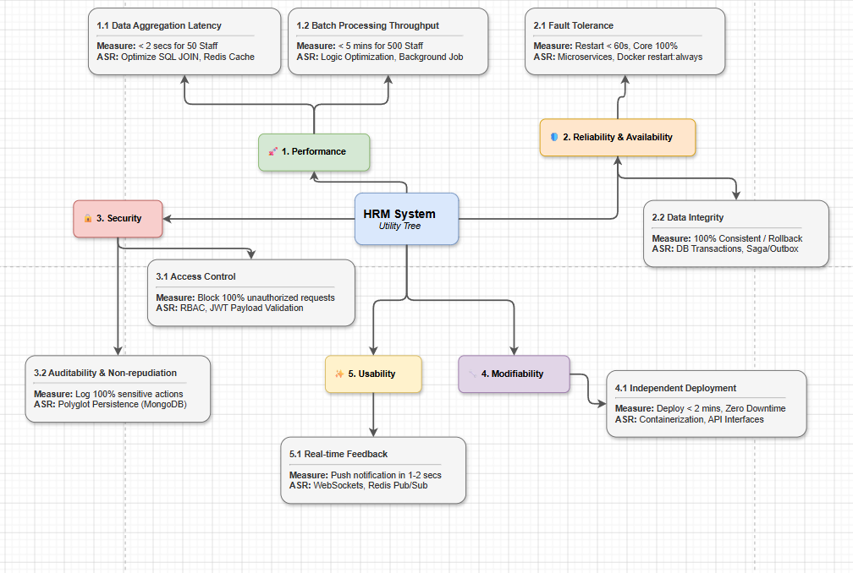
Figure 2: Utility tree diagram
- Based on context analysis, the team identifies important ASR scenarios, evaluated based on Business Value and Architecture Impact.
Table 15: ASR scenarios according to Utility Tree
Quality Attribute | Refinement branch | ASR Scenario (Scenario) | Business Value | Architect Impact
Performance | 1.1 Data aggregation delay  (Data Aggregation Latency) | Data aggregation for 50 employees must be completed in under 2 seconds. Requires SQL JOIN statement optimization and use of Redis Cache. | H (High) | M (Medium)
Performance | 1.2 Batch processing throughput  (Batch Processing Throughput) | The payroll system for 500 employees must be completed in under 5 minutes. Requires optimized computational logic and runs as a background job (Background Job). | H (High) | H (High)
Reliability & Availability | 2.1 Fault tolerance  (Fault Tolerance) | When there is a problem, core services must still be 100% available. The failed service must restart in less than 60 seconds. Requires Microservices architecture and Docker configuration restart:always. | H (High) | H (High)
Reliability & Availability | 2.2 Data integrity  (Data Integrity) | Ensure 100% data consistency or have the ability to rollback when transaction errors occur. Requires use of DB Transactions and Saga/Outbox design pattern. | H (High) | H (High)
Security | 3.1 Access control  (Access Control) | Block 100% of unauthorized access requests. Requires implementation of RBAC authorization and JWT Payload validation. | H (High) | M (Medium)
Security | 3.2 Tracing & Non-repudiation  (Auditability & Non-repudiation) | Log 100% of sensitive operations. Requires application of Polyglot Persistence architecture, using MongoDB as an independent log database. | M (Medium) | M (Medium)
Modifiability | 4.1 Independent deployment  (Independent Deployment) | Deployment time to update a service is less than 2 minutes with zero downtime (Zero Downtime). Requires Containerization and communication via API Interfaces. | M (Medium) | H (High)
Usability | 5.1 Real-time feedback  (Real-time Feedback) | The user must receive a push notification within about 1-2 seconds. Requires integration of WebSockets and Redis Pub/Sub mechanism. | H (High)

  - Mapping to Architecture Drivers Table.
- From the weighted ASRs (H, H) and (H, M) above, the team made the core architectural design decisions for the project:
Table 16: ASR Mapping Table to Architectural Dynamics (ASR Mapping Table)
ID | ASR Scenario (Summary) | Quality Attributes | Architectural Dynamics/Design Decisions
ASR01 | The head of the access department views the work schedule matrix of 50 employees during peak hours. The data grid must be fully displayed in less than 2 seconds (reaching 95% of requests). | Performance | Optimize SQL JOIN statements, set indexes on related primary/foreign key columns (user_id, work_date, department_id...) and apply Redis Cache caching mechanism for rarely changing calendar data.
ASR02 | The director activates a real-time synchronous payroll function for a company with 500 employees on the last day of the month, the entire processing must be completed in under 5 minutes and not clog other APIs. | Performance | Optimize loop processing logic (combine initial raw data query statements instead of querying continuously in the loop), and push the entire processing process to an asynchronous background task (Background Job).
ASR03 | The payroll service (salary_service) crashes due to logic errors or memory overflow. The system still must ensure that other core services (login, timekeeping, sending applications) are 100% available, and self-recovery of service errors in less than 60 seconds. | Reliability & Availability (Reliability & Availability) | Complete separation of services through Microservices architecture behind Kong API Gateway. Package the application into independent Containers (Docker) and configure the automatic restart policy restart: always.
ASR04 | The system encountered an error connecting to the logging database (MongoDB) while performing a series of actions to approve leave applications, ensuring that the data does not fall into an inconsistent or erroneous state. | Reliability & Availability (Reliability & Availability) | Use PostgreSQL's Database Transactions mechanism for operations on the same database. For inter-database operations, implement an error handling mechanism to ensure eventual consistency through the Saga or Outbox design pattern.
ASR05 | Regular employee accounts intentionally use tools like Postman to send requests to intervene in the application approval endpoint, which is only for management. The system must block 100% and return the HTTP error code 403 Forbidden. | Security | Deploy role-based access control (RBAC) at the API Gateway layer or integrate middleware at each microservice to decode and authenticate the JWT Payload structure.
ASR06 | When administrators make changes to sensitive employee information (such as basic salary, penalty configuration, application approval), the entire process must be 100% audit trailed in an immutable repository. | Security | Applying the multi-database storage model (Polyglot Persistence). Separate business data strictly to PostgreSQL and use MongoDB specifically as an independent audit log store thanks to fast writing speed and flexible schema structure.
ASR07 | The development team updates or edits the logic for calculating late fines or overtime (OT) directly during business hours, and the source code distribution process must take place in less than 2 minutes without causing system disruption. | Modifiability (Modification & Maintainability) | Organize and decompose the system into Microservices blocks with clearly defined API interfaces. Deploying CI/CD separately packages each Docker image to help independently upgrade a specific service without needing to restart the entire system (Zero Downtime).
ASR08 | The management level presses the button to approve or reject the leave application, the relevant employee's interface screen must display a toast popup announcing the results immediately in 1-2 seconds without requiring the user to reload the page (F5). | Usability | Integrated real-time messaging system based on WebSockets connection (Socket.io). Use Redis's Pub/Sub mechanism as a Message Broker to efficiently broker asynchronous events between microservices.

Chapter 3 : System Architecture and Design (SDD)
The purpose of this chapter is the Software Design Document (SDD) – the most important chapter to address the "HOW" question. This chapter describes how the HRM system is architecturally organized, how microservices interact, how data is stored, and API design. All important decisions are recorded as Architecture Decision Records (ADR).
- Select Architectural Style
  - Theoretical basis.
- Software architecture is organized around two core concepts:
- Component: An independently deployable unit with a clearly defined interface. It can be replaced or reused without affecting the rest of the system.
- Connector: Communication mechanism between components (procedure calls, events/messages, data access, stream passing...).
- Distinguish between two levels of design:
- Architectural Style: High-level design principles that determine how the entire system is organized. (Example: Layered, Microservices, Event-Driven).
- Architectural Pattern: A specific solution to a recurring problem, applicable across many styles. (Example: MVC, API Gateway, Pub/Sub).
  - Popular architectural styles and when to use them.
- The current HRM system applies a combination of Microservices and Event-Driven.

Table 17: Comparison of architectural styles and scope of application
Architecture | Characteristic | When should you choose? | Applied in HRM System
Layered | Organized into functional classes; The upper layer depends only on the lower layer. | Traditional applications; The system is heavy on CRUD. | Applied at the internal structure (Code-level) of each Microservice.
Microservices | Small, independent services; has its own database; Communicate via API/Broker. | Large system; Need to expand each module independently (Scale). | Core architecture. Separate Auth, Leave, Attendance, Salary.
Event-Driven | Communicate through events (Event); loose coupling. | Real-time system, integrating many services. | Adopt via Redis Pub/Sub and Socket.io for Real-time notifications.

- Overall system architecture.
- The system is designed according to the Microservices Architecture model [1] combined with the API Gateway design model [4], clearly separated into specialized functional layers.
- Reasons for choosing architecture:
- The characteristics of human resource management software require it to handle large and complex computational loads (such as synthesizing and finalizing month-end payroll), and at the same time maintaining real-time user interactions (such as sending/approving leave applications, receiving notifications).
- If deployed in a monolithic model (Monolith), heavy tasks have the risk of exhausting resources, leading to the entire system crashing. The Microservices model completely solves this problem by isolating services (e.g. completely separating Salary_Service), allowing them to operate and scale independently. Combined with event-driven mechanism via Redis, the system ensures smooth synchronized data flow without causing bottlenecks in the database.
- Technologies and Frameworks used:
- Client layer (Interface): * Single Page Application (SPA) Web application developed with React.js (Vite), combined with Tailwind CSS.
- Use the Socket.io-client library to connect and receive real-time data. (Operates on Port 5173).
- Load Balancer & API Gateway:
- Nginx: Acts as Reverse Proxy and Load Balancer to receive traffic flows at Port 80.
- Kong API Gateway: Located at Port 8000, is the only entry point of the backend system. Kong is responsible for security authentication (JWT Auth), routing requests to the correct service, and rate limiting (Rate-Limiting) to prevent DDoS attacks.
- Core Services Layer (Microservices):
- Built with Node.js & Express, the system is decomposed into 5 independent services running in parallel: Auth_Service (Authentication/Login), Leave_Service (Leave), Attendance_Service (Timekeeping), Salary_Service (Payroll), and Noti_Service (Notification).
- Database layer (Polyglot Persistence) [3]: Apply database diversification strategy to optimize for each specific data type:
- PostgreSQL: Relational database management system, ensuring transaction integrity (ACID) for strict business data such as user information (Auth), attendance history (Attendance), and payroll (Salary).
- MongoDB: Flexible NoSQL database, specialized in storing Audit Logs (save single browsing operations) and notification store (Noti).
- Redis: Acts as an In-memory Cache system (stores OTP codes) and acts as a Message Broker (Pub/Sub mechanism) to transmit events to Socket.io.
- Monitoring & Logging layer:
- Use Prometheus to collect metrics (Metrics DB) in conjunction with Grafana Health Check.
- Centralized log management system operated by Promtail/Agent and Grafana Loki (Log DB).
- All system data is visualized on the Grafana Dashboard.
- Backup & Infrastructure:
- Backup: The data backup process is fully automated through Cron Jobs that trigger Backup Scripts to export safe Backup Files.
- Infrastructure: The entire architecture is containerized and operated through Docker & Docker Compose.

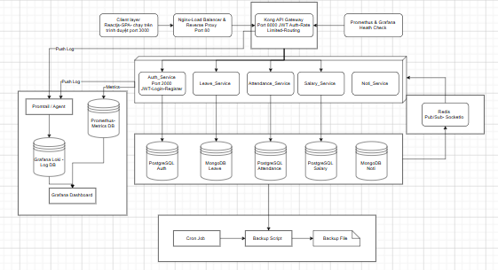
Figure 3: Overall system architecture diagram
- Architectural documents according to C4 model.
  - Overview.
- The C4 model is a hierarchical approach to documenting software architecture through four levels of abstraction: Context, Containers, Components, and Code. This model ensures that the architecture is understandable to a variety of audiences, from business stakeholders to DevOps engineers and programmers.
- By adhering to the principles of notational simplicity and technology-agnosticism, the following sections will detail the architecture of a Human Resources Management (HRM) System through four C4 levels.
  - C4 Level 1: System Context Diagram.
- Purpose: Show the big picture. The diagram illustrates who uses the HRM system and what external systems it interacts with.
- Audience: Business stakeholders, Product owners, and new members of the project.
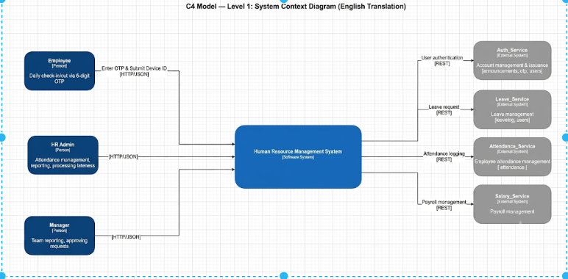
Figure 4: C4 model-Level 1 : System Context Diagram
- Components in the System Context Diagram (C4 Level 1)
Table 18: Context Diagram Components – C4 Level 1 (System Context)
Ingredient | Type | Describe
Employee | Person | Perform daily check-in/out with 6-digit OTP, request leave and view salary slip.
HR Administrator (HR Admin) | Person | Manage overall timekeeping, produce reports and handle late cases.
Manager | Person | View team reports and approve leave requests.
HRM System (HRM System) | Software System | The core system is being designed to manage human resources, timekeeping and payroll.
Auth_Service | External System | Independent authentication system manages accounts and allocates OTP.
Leave_Service | External System | The system handles leave management, leave logs and user quotas.
Attendance_Service | External System | System for managing and tracking employee timekeeping records.
Salary_Service | External System | Salary calculation and management system based on attendance and leave data.

  - C4 Level 2: Container Diagram.
- Purpose: Zoom into the HRM System to see the main containers that can be deployed and run independently.
- Audience: Software architects, senior developers, and DevOps engineers.
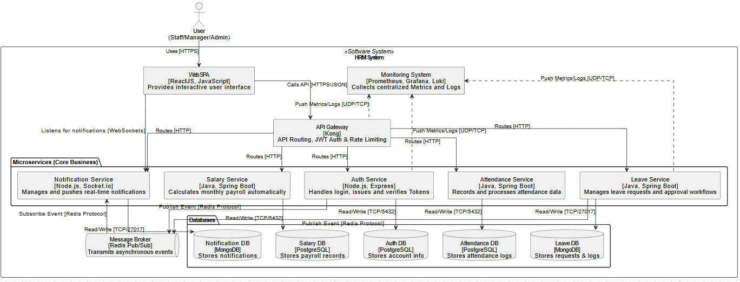
Figure 5: C4 model-Level 2 : container diagram
- Components in the Block Diagram contain (C4 Level 2)
Table 19: Container Diagram Components – C4 Level 2 (Container)
Containers | Technology | Responsibility
WebSPA | React.js 18, JavaScript | Provides an interactive interface for all users (Employees, Admin, Managers).
API Gateway | Kong | Acts as the single entry point, handling API routing, JWT validation, and rate limiting.
Auth Service | Node.js, Express | Handles login, JWT token allocation and decentralized authentication.
Attendance Service | Node.js, Express | Record and process daily timekeeping, calculate late arrival/early departure indicators.
Leave Service | Node.js, Express | Manage leave applications, approval flows, and create work schedules.
Salary Service | Node.js, Express | Automatically calculate monthly payroll based on aggregated data.
Notification Service | Node.js, Socket.io | Manage and push real-time alerts and notifications to Web SPA.
Primary Databases | PostgreSQL 16 | Stores persistent relational data for Auth, Attendance, and Salary services.
Log/Audit Databases | MongoDB | High-speed, unstructured storage for immutable audit logs and notifications.
Message Broker | Redis Pub/Sub | Passing asynchronous events between microservices (e.g. Socket.io activation).
Monitoring System | Prometheus, Grafana | Collect centralized metrics and logs to visualize system status.

  - C4 Level 3: Component Diagram (Example: Leave Service).
- Purpose: Zoom into a specific container to see its internal components, responsibilities, and layer disciplines.
- Audience: Developers working on specific microservices.
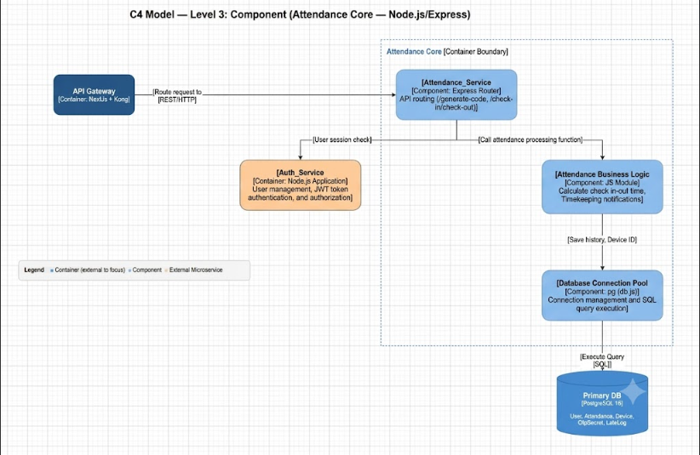
Figure 6: C4 model – Level 3 : Attendance Service Container (Component Diagram)
- Components inside the Attendance Service Container
Table 20: Components inside Attendance Service Container (C4 Level 3)
Ingredient | Technology | Responsibility
Attendance_Service | Express Routers | Receive and route API requests (eg /generate-code, /check-in).
Attendance Business Logic | JS Modules | Core business logic: calculate check-in/out times, and process attendance notices.
Database Connection Pool | pg (db.js) | Manage the PostgreSQL connection pool and execute SQL queries securely.

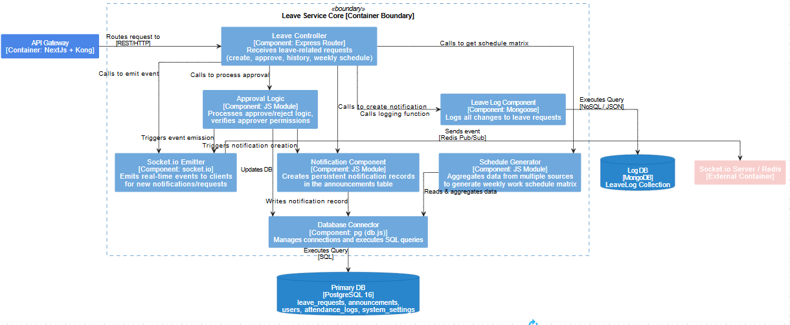
Figure 7: C4 model-Level 3 : Leave Service Container (Component Diagram)
- Components inside Leave Service Container
Table 21: Components inside Leave Service Container (C4 Level 3)
Ingredient | Technology | Responsibility
Leave Controller | Express Routers | Receive HTTP requests related to leave (create application, approve application, view history).
Approval Logic | JS Modules | Handle approval/rejection business logic and verify the authority of the approver.
Schedule Generator | JS Modules | Synthesize data from multiple sources to create a weekly work schedule matrix.
Notification Component | JS Modules | Create persistent notification records in the database.
Socket.io Emitter | socket.io | Broadcast real-time WebSocket events to the client for new requests or status updates.
Database Connectors | pg (db.js) | Execute relational SQL queries to PostgreSQL.
Leave Log Component | Mongoose | Log all (immutable) changes related to leave applications to MongoDB.

  - C4 Level 4: Code Diagram.
- Purpose: Map directly to UML Class Diagrams to show internal methods, properties, and relationships within a single component. Audience: Implementers and Developers.
- For HRM System, Code Diagram Level 4 focuses on the most important business logic in terms of architecture: Payroll Calculation Engine and Check-in/Check-out Module.
- Check-in/Checkout module: Details of Express Router endpoints (POST /verify-code, GET /history), exact parameters passed to Business Logic functions (verifyCode(), getHistory()), and fields explicitly updated in the attendance_logs table (e.g. check_in_time, late_minutes).
- Payroll Engine: Illustrates the UML relationships between PayrollCalculatorService and the User, AttendanceLog, and LeaveRequest entities, detailing the automatic syncPayrollRealtime() loop.
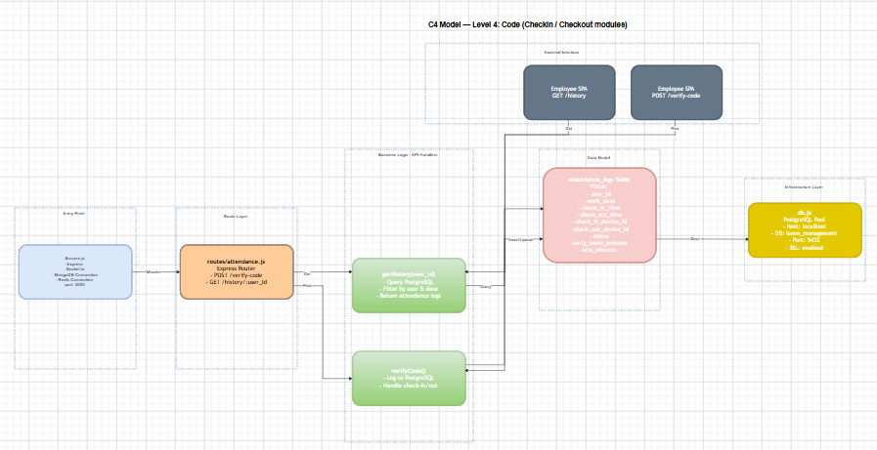
Figure 8: C4 Model Diagram – Level 4: Code (Check-in/Check-out)
- Database Design.
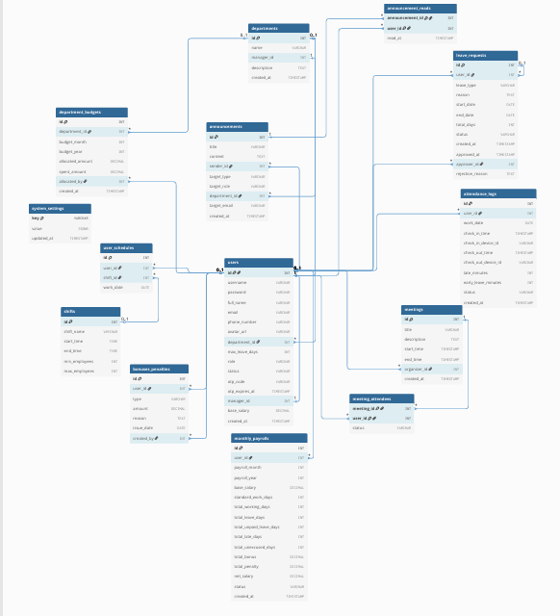
Figure 9: ERD diagram
*users: Stores account information and personnel records.
Table 22: Data table structure: users
Column | Data Type | Nullable | Default | Description
id | INT (PK) | NOT NULL | AUTO_INCREMENT | Primary key
username. username | VARCHAR(255) | NOT NULL |  | Username (Unique)
password. password | VARCHAR(255) | NOT NULL |  | Hashed password
full_name | VARCHAR(255) | NOT NULL |  | Full name and surname
e-mail | VARCHAR(255) | NOT NULL |  | Email address (Unique)
phone_number | VARCHAR(50) | YES | NULL | Contact phone number
avatar_url | VARCHAR(255) | YES | NULL | Representative image link
department_id | INT (FK) | YES | NULL | Foreign keys link to the departments table
max_leave_days | INT | NOT NULL | 12 | Total number of default leave days in the year
role. role | VARCHAR(50) | NOT NULL | 'staff' | Role: superadmin, manager, staff
status. status | VARCHAR(50) | NOT NULL | 'active' | Status: active, inactive, pending
otp_code | VARCHAR(10) | YES | NULL | OTP code used for check-in/authentication
otp_expires_at | TIMESTAMP | YES | NULL | OTP code expiration time
manager_id | INT (FK) | YES | NULL | The foreign key points to the direct management id
base_salary | DECIMAL | NOT NULL | 0.00 | Basic salary
created_at | TIMESTAMP | NOT NULL | CURRENT_TIMESTAMP | Account creation time

*departments: Stores information about departments within the company.
Table 23: Data table structure: departments
Column | Data Type | Nullable | Default | Description
id | INT (PK) | NOT NULL | AUTO_INCREMENT | Primary key
name | VARCHAR(255) | NOT NULL |  | Department name
manager_id | INT (FK) | YES | NULL | The foreign key points to the department manager's users.id
description | TEXT | YES | NULL | Describe department functions
created_at | TIMESTAMP | NOT NULL | CURRENT_TIMESTAMP | Creation time

*attendance_logs: Stores employee daily attendance logs.
Table 24: Data table structure: attendance_logs
Column | Data Type | Nullable | Default | Description
id | INT (PK) | NOT NULL | AUTO_INCREMENT | Primary key
user_id | INT (FK) | NOT NULL |  | Foreign key points to users.id
work_date | DATE | NOT NULL |  | Workday
check_in_time | TIMESTAMP | YES | NULL | Actual check-in time
check_in_device_id | VARCHAR(255) | YES | NULL | Device code used for check-in
check_out_time | TIMESTAMP | YES | NULL | Actual check-out time
check_out_device_id | VARCHAR(255) | YES | NULL | Device code used for check-out
late_minutes | INT | NOT NULL | 0 | Number of minutes late
early_leave_minutes | INT | NOT NULL | 0 | Number of minutes leaving early
status. status | VARCHAR(50) | NOT NULL | 'present' | Status: present, late, absent...
created_at | TIMESTAMP | NOT NULL | CURRENT_TIMESTAMP | Record creation time

*leave_requests: Manage employee leave requests.
Table 25: Data table structure: leave_requests
Column | Data Type | Nullable | Default | Description
id | INT (PK) | NOT NULL | AUTO_INCREMENT | Primary key
user_id | INT (FK) | NOT NULL |  | Foreign key to the creator of the application
leave_type | VARCHAR(50) | NOT NULL |  | Break type: ANNUAL, SICK, UNPAID
reason. reason | TEXT | NOT NULL |  | Reason for leave
start_date | DATE | NOT NULL |  | Vacation start date
end_date | DATE | NOT NULL |  | Vacation end date
total_days | INT | NOT NULL |  | Total number of days off
status. status | VARCHAR(50) | NOT NULL | 'pending' | Status: pending, approved, rejected
created_at | TIMESTAMP | NOT NULL | CURRENT_TIMESTAMP | Order creation time
approved_at | TIMESTAMP | YES | NULL | Time for application to be approved
approver_id | INT (FK) | YES | NULL | Foreign key to the person who approved the application
rejection_reason | TEXT | YES | NULL | Reason for refusal (if any)

*monthly_payrolls : Stores monthly payroll data after automatic aggregation.
Table 26: Data table structure: monthly_payrolls
Column | Data Type | Nullable | Default | Description
id | INT (PK) | NOT NULL | AUTO_INCREMENT | Primary key
user_id | INT (FK) | NOT NULL |  | Employee foreign key
payroll_month | INT | NOT NULL |  | Payroll month (December 1)
payroll_year | INT | NOT NULL |  | Salary year
base_salary | DECIMAL | NOT NULL |  | Basic salary applies to the month
standard_work_days | INT | NOT NULL |  | Standard working day of the month
total_working_days | INT | NOT NULL | 0 | Actual total workdays
total_leave_days | INT | NOT NULL | 0 | Total days off allowed
total_unpaid_leave_days | INT | NOT NULL | 0 | Total days off without pay
total_late_days | INT | NOT NULL | 0 | Total number of days late
total_unexcused_days | INT | NOT NULL | 0 | Total days of unexcused absence
total_bonus | DECIMAL | NOT NULL | 0.00 | Total bonus
total_penalty | DECIMAL | NOT NULL | 0.00 | Total fine
net_salary | DECIMAL | NOT NULL | 0.00 | Food received
status. status | VARCHAR(50) | NOT NULL | 'draft' | Status: draft, paid
created_at | TIMESTAMP | NOT NULL | CURRENT_TIMESTAMP | Time to create payroll

*announcements : Stores general and system announcements.
Table 27: Data table structure: announcements
Column | Data Type | Nullable | Default | Description
id | INT (PK) | NOT NULL | AUTO_INCREMENT | Primary key
title. title | VARCHAR(255) | NOT NULL |  | Notification title
content. content | TEXT | NOT NULL |  | Detailed content
sender_id | INT (FK) | NOT NULL |  | Sender (usually Admin/System)
target_type | VARCHAR(50) | NOT NULL | 'all' | Recipients: all, department, user...
target_role | VARCHAR(50) | YES | NULL | Filter by role receiving notifications
department_id | INT (FK) | YES | NULL | Receiving department (if any)
target_user_id | INT (FK) | YES | NULL | Send the user's name (if any)
created_at | TIMESTAMP | NOT NULL | CURRENT_TIMESTAMP | Creation time

*system_settings: Stores dynamic system configurations (late penalties, holidays...).
Table 28: Data table structure: system_settings
Column | Data Type | Nullable | Default | Description
key | VARCHAR(255)(PK) | NOT NULL |  | Configuration name (Unique key)
value. value | JSONB/TEXT | NOT NULL |  | JSON format configuration value
updated_at | TIMESTAMP | NOT NULL | CURRENT_TIMESTAMP | Last update time

*bonuses_penalties : Stores reward or discipline decisions.
Table 29: Data table structure: bonuses_penalties
Column | Data Type | Nullable | Default | Description
id | INT (PK) | NOT NULL | AUTO_INCREMENT | Primary key
user_id | INT (FK) | NOT NULL |  | Employee foreign key is applied
type | VARCHAR(50) | NOT NULL |  | Classification: bonus, penalty
amount. amount | DECIMAL | NOT NULL |  | Bonus/penalty amount
reason. reason | TEXT | NOT NULL |  | Reason
issue_date | DATE | NOT NULL |  | Date of issuance/application
created_by | INT (FK) | NOT NULL |  | Decision maker

- API design (RESTful API Design).
  - REST principles.
- The APIs comply with the RESTful standard, use plural nouns, and return JSON data and standard HTTP status codes. Authorization is performed via the Bearer JWT Token.
- List of Core Endpoints (Source Code Reference):
Table 30: List of Core API Endpoints (RESTful API)
Method | Endpoint | Role | Describe | Idempotent
POST | /api/auth/register | Public | Register (Need OTP to activate) | No
POST | /api/auth/verify-otp | Public | OTP authentication (6 numbers) | No
GET | /api/leaves/balance/:user_id | All | View individual leave balances | Yes
POST | /api/leaves | All | Submit permit application (Maximum every 3 days) | No
GET | /api/leaves/schedule/weekly | All | Get the 7-day work schedule matrix | Yes
PUT | /api/leaves/:id/status | Manager/Admin | Approve/Reject permission application | Yes
GET | /api/payroll/:year/:month | All | Automatically calculate and get payroll | Yes
PUT | /api/payroll/:id/status | Manager/Admin | Salary Closing/Payment (Mark PAID) | Yes

- UML Diagrams (UML Diagrams).
- This class diagram describes the data structure and entity relationships of the HRM system, clearly designed and separated according to the boundaries of the Microservices architecture.
- The system is divided into 6 main modules:
- Auth & User Service (Central): Contains User and Department classes. The User class acts as the core entity (Root Entity), has a one-to-many (1-n) relationship and is directly linked to most other services in the system.
- Attendance & Schedule Service: Manage working time and schedules. Contains classes AttendanceLog (recording check-in/out, being late), Shift (shift), UserSchedule, and meeting-related classes (Meeting, MeetingAttendee).
- Leave Service: Handles leave operations with the main class LeaveRequest (leave application containing date, status, approver information) and LeaveLog to keep track of operation history.
- Salary & Payroll Service: Handling financial operations. Contains the MonthlyPayroll class (payroll summarizing workday indicators, bonuses and penalties, actual salary received), BonusPenalty (decision on bonus/penalty), and PayrollLog.
- Notification Service: Manage notification flow with Announcement (notification content) and AnnouncementRead (read status) classes.
- System Settings: Contains the SystemSetting class that manages dynamic system configurations (saved as JSONB).
- Relationship overview: The diagram shows the relative independence between modules (each module manages its own data). Modules communicate and link together mainly through user_id and manager_id, ensuring the loose coupling principle of Microservices but still maintaining the integrity of human resources operations.
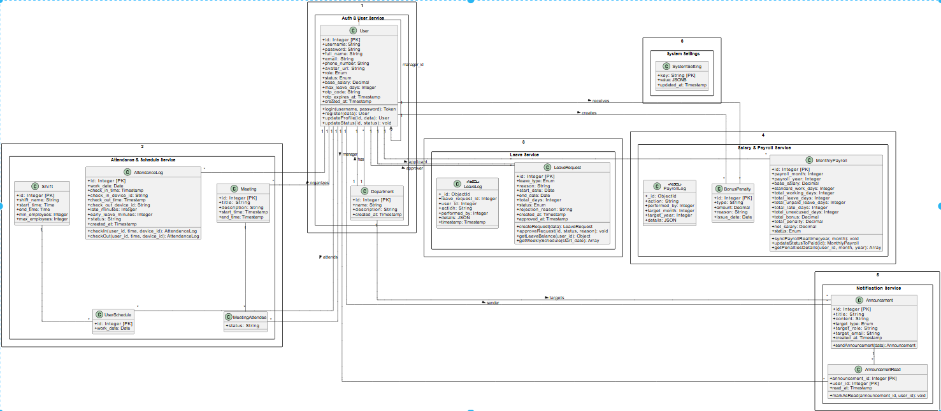
Figure 10: Class diagram
- Sequence Diagram: Synchronize and Get salary list:
- Diagram detailing the automatic processing flow (batch processing) of SalaryService when receiving GET requests.
- The service decodes JWT, collects data in parallel (active users, holidays, attendance history, approved leave applications) and calculates salary formulas (timekeeping, late penalties, overtime) for each employee.
- Data is saved/updated to PostgreSQL (ON CONFLICT DO UPDATE) and returned results are strictly filtered by authorization (Superadmin, Manager, Staff).
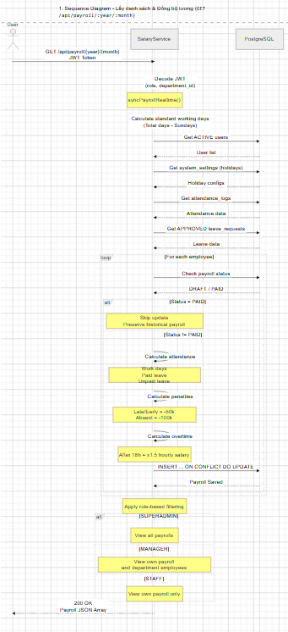
Figure 11: Sequence Diagram: Synchronize and Get the salary list
- Sequence Diagram: Salary Closing & Payment: Diagram showing the operation of changing the administrator's payroll status (PUT status=PAID). SalaryService checks permissions, then updates the record in PostgreSQL to PAID (immutable state, not overwritten by the synchronization function in diagram 2). At the same time, the system records this operation (Audit Log) into MongoDB to ensure transparency and anti-repudiation.

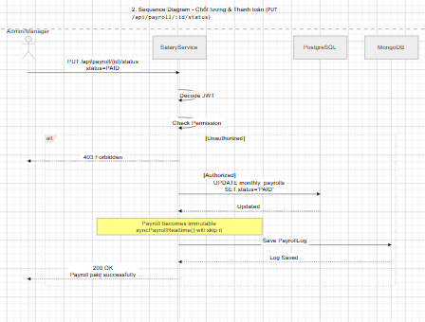
Figure 12: Sequence Diagram: Salary Closing & Payment
- Sequence Diagram: Creating Real-Time Messages:
- Diagram describing the process of NotiService receiving a request to create a notification from the Admin. After authenticating the rights and recipients (All, By Role, By Department, Individual), the system saves the message to PostgreSQL.
- The highlight is the Socket.io activation flow combined with Redis Pub/Sub to synchronize events across instances, pushing new_announcement notifications directly to online users (updating alarm counts).

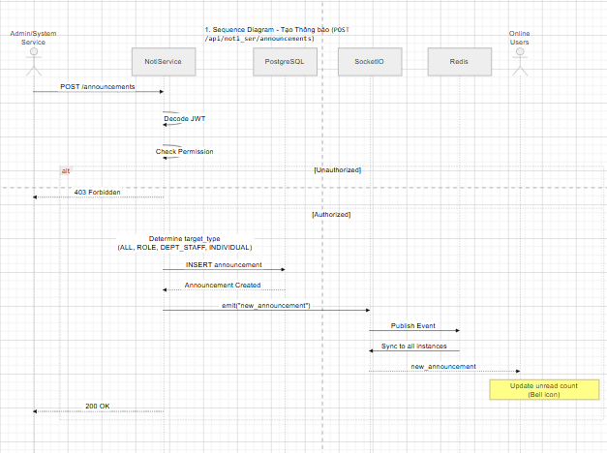
Figure 13: Sequence Diagram: Real-Time Notification Generation
- Sequence Diagram: Leave Application Sending Flow:
- The diagram shows the complex Business Logic Validation chain when an employee submits a leave application. LeaveService sequentially blocks invalid cases: consecutive days off (>3 days), exceeding annual leave fund (quota), or too many people taking leave at the same time (>5 people).
- When the application is valid, the system saves the PENDING status to PostgreSQL, records the order creation log to MongoDB, and broadcasts real-time events (Socket.io/Redis) to the appropriate management level (Staff -> Manager; Manager -> Superadmin) to wait for approval.

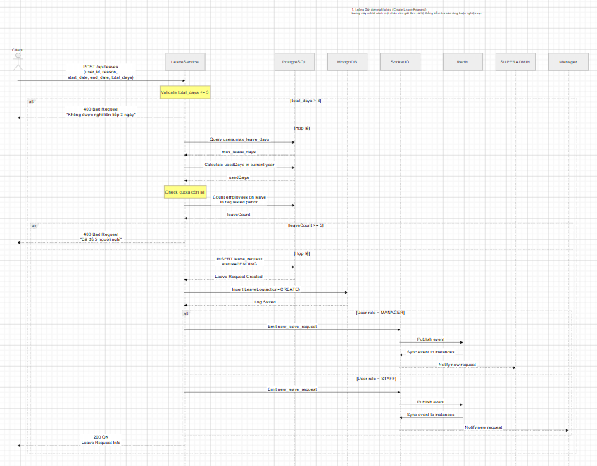
Figure 14: Sequence Diagram: Sending Leave Application Flow

- Flow Diagram for Requesting Leave and Approving Applications:
- The diagram describes the process from the time an employee creates a leave application until it is approved by the Manager.
- The system (Leave Service) will automatically check the license balance, save the order in PENDING state and broadcast real-time notification events to management.
- After the Manager makes a decision (Approve/Reject), the system updates the status, records the audit log and pushes the result back to the Employee.
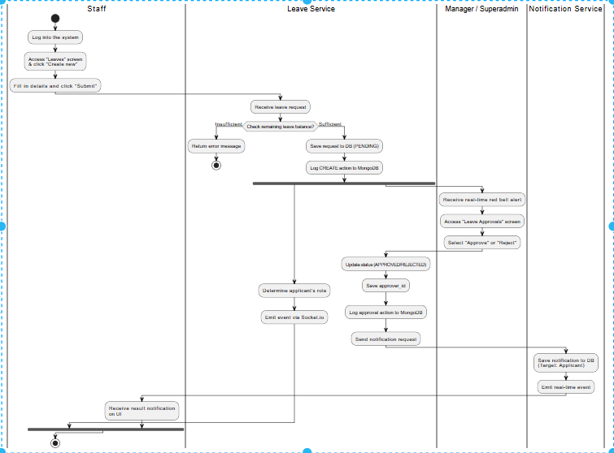
Figure 15: Activity diagram: Leave Request and Application Approval flow
- Flow chart of automatic salary calculation:
- Diagram showing the batch processing process. When Management is activated, Salary Service will retrieve data in parallel from the DB (personnel, attendance, leave applications, penalty rules).
- The system uses nested loops (going through each employee, then going through each day of the month) to accurately calculate the number of workdays, fines, and actual wages received and save them as drafts (DRAFT) to wait for Finalization Management (PAID).

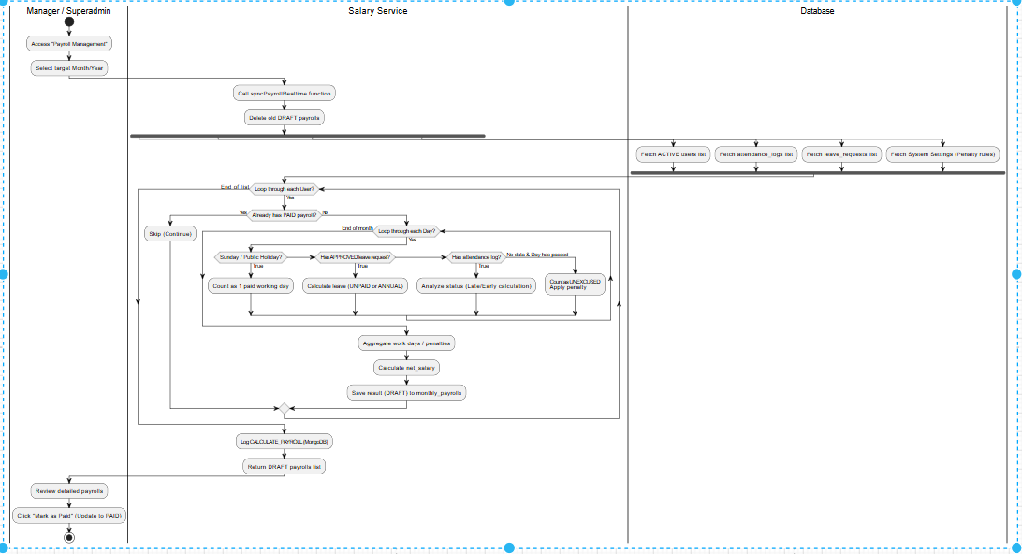
Figure 16: Activity diagram: Automatic salary calculation flow
- Account Registration and Authentication Flow Diagram:
- Diagram describing the process of creating a new account integrating OTP security authentication. The user enters information, Auth Service generates an OTP code and sends it via Mail Service.
- When the user enters the correct valid OTP, the account is created but locked in pending approval status (PENDING_ADMIN).
- The flow is completed when the Superadmin enters the system and activates the account to ACTIVE state, allowing new users to log in and use.

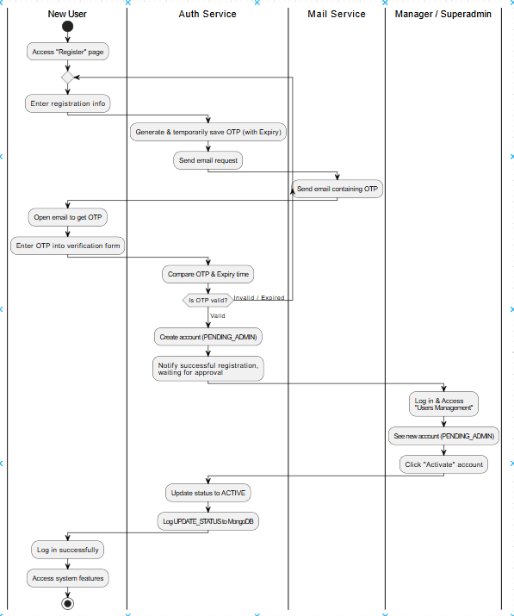
Figure 17: Activity diagram: Account Registration and Authentication flow

- Architecture Decision Records (ADR)
*ADR-001: Apply Microservices & API Gateway architecture
- Status: Accepted | Date: June 15, 2026
- Context: HRM system has heavy processing threads (payroll for the entire company) and threads that need Real-time (Socket.io).
- Decision: Divide the system into small Microservices (Auth, Leave, Attendance, Salary) placed behind Kong API Gateway.
- Consequences:
- (+) Positive: The payroll service does not crash the timekeeping service; API Gateway (Kong) blocks DDoS attacks with Rate-limiting.
- (-) Negative: Needs more complex Docker/Docker-compose setup compared to Monolith.
*ADR-002: Apply Polyglot Persistence (Multi-Database)
- Status: Accepted | Date: June 15, 2026
- Context: Need to store relational data (Users, Salaries) but also need to save extremely fast Audit Log and Caching temporary OTP codes.
- Decision: Use PostgreSQL as primary database; MongoDB saves Audit Logs (Schema-less, high write speed); Redis saves OTP Cache (self-destructs after 5 minutes) and acts as Pub/Sub Broker.
- Consequences:
- (+) Positive: Optimize read/write performance according to each standard large enterprise operation.
- (-) Negative: Increased infrastructure maintenance costs (must run 3 types of Database at the same time).

- Interface Prototype (UI Prototype).
- The system is designed as a Single Page Application (SPA) with React.js & Tailwind CSS. Based on the navigation flow diagram, the interface is divided into the following main screen groups:
- Auth Flow: Starts from the Splash Screen. If there is no token, the user will be redirected to the Login or Register screen (Register - create an account in PENDING_ADMIN pending approval). Entering the correct Username/Password will move to the OTP Authentication screen (requires entering correct 6 numbers, has Resend Countdown feature).
- Main Interface & Sidebar Authorization (Main Layout & Sidebar): After successful authentication, the system displays the navigation bar based on 3 groups of permissions (Role-based):
- For All (Staff, Manager, Superadmin): Includes Dashboard, Personal profile (My Profile - with editing Popup), Personal timekeeping (My Attendance), Weekly schedule (Weekly Schedule), Personal leave management (Leaves - with Popup to create new application), View salary slip (My Payslips - see details of deductions) and Notifications screen.
- For Managers (Manager, Superadmin): Added Application Approval module (Leave Approvals - with confirmation Popup and entering reason for refusal) and Payroll Management - with "Calculate" calculation and "Mark as Paid" salary closing operations.
- Exclusively for Directors (Superadmin): Unlock high-level administration features including: Human Resources Management (Users/Employees Management - with Account Activation/Lock Popup), Department Management (Departments Management), Send System Notifications (Send Announcement) and System Settings (System Settings).
- Real-time Overlays: On any screen, when a Socket event is received, the system will immediately display Popup Toastify and a Red Bell in the Header bar. If the general notification is clicked, the user is taken to the Notifications screen; If you click on the application notification, the system will navigate directly to the Leave Approvals screen.
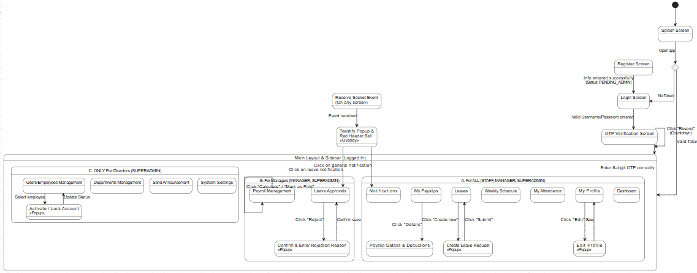
Figure 18: Interface screen switching flow diagram

Chapter 4: Implementation & Coding
The purpose of this chapter is to present important technical decisions made during implementation, system interfaces, and notable programming techniques. The content does not copy the entire source code but only quotes typical code snippets with clear annotations. Implementation techniques are directly linked to the Microservices architecture design in Chapter 3.
- Development Environment & Tools.
- The system is developed and operated on a diverse ecosystem (Polyglot), optimized for distributed architecture.
Table 31: Development Environment & Tools (Development Environment & Tools)
Category | Tools/Versions | Purpose | Link
Backend Language | Node.js 20 LTS | Run a multi-threaded Backend environment | nodejs.org
Backend Framework | Express.js 4.x | Build independent REST API Server | expressjs.com
Frontend Framework | React.js 18 (Vite) | Build UI as Single Page App | react.dev
Styling | Tailwind CSS | Build Responsive UI interface | tailwindcss.com
Databases | PostgreSQL 15 (HA), MongoDB 6 | Store Relational Database & Audit Logs | postgresql.org
In-Memory Cache | Redis 7 | Message Broker & Session Caching | redis.io
API Gateway | Kong 3.4 & Nginx | Routing, Rate-limiting, Load Balancing | konghq.com
Containerisation | Docker 24 & Compose | Package and run the emulator environment | docker.com
Monitoring | Prometheus & Grafana | Microservices health monitoring | grafana.com

- Project Directory Structure.
- The system adopts Microservices architecture, each service is a separate directory. Within each backend service, the source code is organized according to the Layered Architecture pattern (Controller/Routes, Models, DB pool).
SA25-26_ClassN01_Group05/
|-- auth_service/ # Microservice: Identity & User Management
|-- attendance_service/ # Microservice: Attendance
|-- notification_service/ # Microservice: Notifications
|-- leave_service/ # Microservice: Leave management
| |-- models/ # Business Model: Schema Audit Log (MongoDB)
| | `-- LeaveLog.js
| |-- routes/ # Presentation / Controller Layer: HTTP req/res
| | `-- leaves.js
| |-- uploads/ # Serves static physical file storage
| |-- db.js # Data Access: PostgreSQL pool connection
| `-- package.json
|-- salary_service/ # Microservice: Salary calculation
|-- frontend/ # Presentation Layer (Client)
| |-- src/
| | |-- components/ # Reusable UI Components (Button, Modal)
| | |-- pages/ # Functional pages (AdminHome, Leave, Payroll)
| | `-- main.jsx # React application anchor point
| |-- vite.config.js
| `-- package.json
|-- database/
| `-- init.sql # Schema initializes PostgreSQL database (Polyglot)
|-- kong/ # Configure API Gateway
|-- prometheus.yml # Monitoring configuration
|-- grafana-dashboard.json # Health monitoring Dashboards interface
`-- docker-compose.yml # Orchestration links all 25 containers
- Notable Implementation Techniques.
- Below are 3 core techniques deployed to solve system performance and business problems.
*Technique 1: Real-time notifications in Microservices
- Description : In distributed architecture, when leave_service receives a new permission application, the system must immediately notify the Manager who is online at another device without reloading the page. The system solves by combining Node.js Event Emitters and Socket.io.
- Typical code snippet (Leave Service - routes/leaves.js):
// Extract from POST route /api/leaves
const result = await pool.query(
`INSERT INTO leave_requests (user_id, reason, start_date, end_date, total_days, status)
VALUES ($1, $2, $3, $4, $5, 'PENDING') RETURNING *`,
[user_id, reason, start_date, end_date, total_days]

const newLeave = result.rows[0];

// Record Audit Log to standalone MongoDB (Polyglot Persistence)
await LeaveLog.create({
leave_request_id: newLeave.id, user_id: user_id, action: "CREATE", performed_by: "USER",
details: { full_name: fullName, reason_text: reason, new_status: "PENDING" }

// Shoot Real-time Event via Socket.io
const io = req.app.get("socketio");
if (io) {
if (sender.role === "MANAGER") {
io.emit("new_leave_request", {target_role: "SUPERADMIN", message: `🔔 Manager ${fullName} just sent a leave application!`, leave: newLeave });
} else {
io.emit("new_leave_request", { target_role: "MANAGER", target_department: sender.department_id, message: `🔔 Employee ${fullName} sent a new leave application!` });

- Analysis : This technique follows the Event-Driven principle. The Controller does not call directly to the Notification Service API but emits events. The client (React) will listen to this socket stream to update the UI immediately.
*Idempotent Payroll Calculation Transaction Processing (Idempotent Payroll Calculation)
- Description : The payroll calculation problem requires retrieving data from many services (timekeeping, leave). To avoid repeated recalculations that generate many garbage records, the system uses the Upsert (ON CONFLICT DO UPDATE) mechanism in PostgreSQL. No matter how many times Manager clicks "Calculate Payroll", the draft data is only overwritten and not duplicated.
- Typical code snippet (Salary Service - routes/payroll.js):
// Calculate actual salary received (Business Logic)
let netSalary = (dailySalary * (totalWorkingDays + totalLeaveDays)) + totalBonus - totalPenalty;
if (netSalary < 0) netSalary = 0;

// Save to Database Layer with Idempotent (Upsert) mechanism
await pool.query(`
INSERT INTO monthly_payrolls (
user_id, payroll_month, payroll_year, base_salary, standard_work_days,
total_working_days, total_leave_days, total_unexcused_days,
total_bonus, total_penalty, net_salary, status
) VALUES ($1, $2, $3, $4, $5, $6, $7, $8, $9, $10, $11, 'DRAFT')
ON CONFLICT (user_id, payroll_month, payroll_year)
DO UPDATE SET
base_salary = EXCLUDED.base_salary,
total_working_days = EXCLUDED.total_working_days,
total_penalty = EXCLUDED.total_penalty,
net_salary = EXCLUDED.net_salary
`, [ user.id, month, year, baseSalary, standardWorkDays, totalWorkingDays,
totalLeaveDays, totalUnexcusedDays, totalBonus, totalPenalty, Math.round(netSalary) ]);
- Analysis : This is a clear separation between the Business Logic Layer (netSalary operation) and the Data Access Layer (pool.query command). The UNIQUE constraint at the database level ensures the integrity (ACID) of financial operations.
*Technique 3: Multithreaded Data Aggregation at the Frontend (Frontend Aggregation)
- Description : Because the system is divided into Microservices, to display the Dashboard screen, the Frontend must call data from Auth Service (list of users) and Leave Service (list of leave orders). To optimize performance and avoid thread blocking (blocking), React uses Promise.all parallel processing.
- Typical code snippet (Frontend - src/pages/AdminHome.jsx):
const fetchDashboardData = async () => {
setLoadingPending(true);
try {
const headers = { "Authorization": `Bearer ${token}` };

// Handle multi-threaded API calls (Concurrent API fetching)
const [resUsers, resLeaves, resStats] = await Promise.all([
fetch("/api/auth_ser/users", { headers }),
fetch("/api/leave_ser", { headers }),
fetch("/api/leave_ser/stats/admin-summary", { headers })

const allUsers = resUsers.ok ? await resUsers.json() : [];
const allLeaves = resLeaves.ok ? await resLeaves.json() : [];

// Extract logic based on Rights (RBAC) directly at the Client
const isSuperAdmin = user.role === "SUPERADMIN";
const validUsers = allUsers.filter(u => {
if (isSuperAdmin) return true;
return String(u.id) === String(user.id) || (u.department_id === user.department_id);

// ... Update State for UI
} catch (error) { console.error(error); }

- Analysis : Using Promise.all helps reduce Dashboard display latency to the lowest level (Latency = Time of slowest request, instead of total time of requests). RBAC logic is applied synchronously in both Frontend (hiding UI) and Backend (blocking Data).
- System Screenshots.
- Dashboard Overview screen (Home / Dashboard)
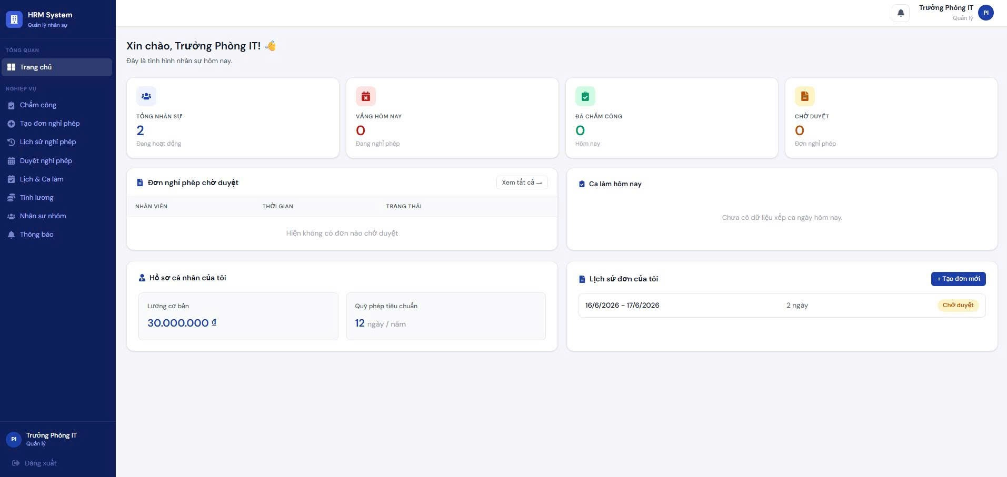
Figure 19: Dashboard admin screen
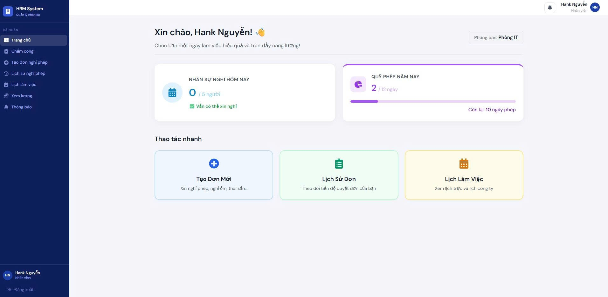
Figure 20: Dashboard user screen
- Work Schedule & Time Attendance Matrix Screen (Weekly Schedule)
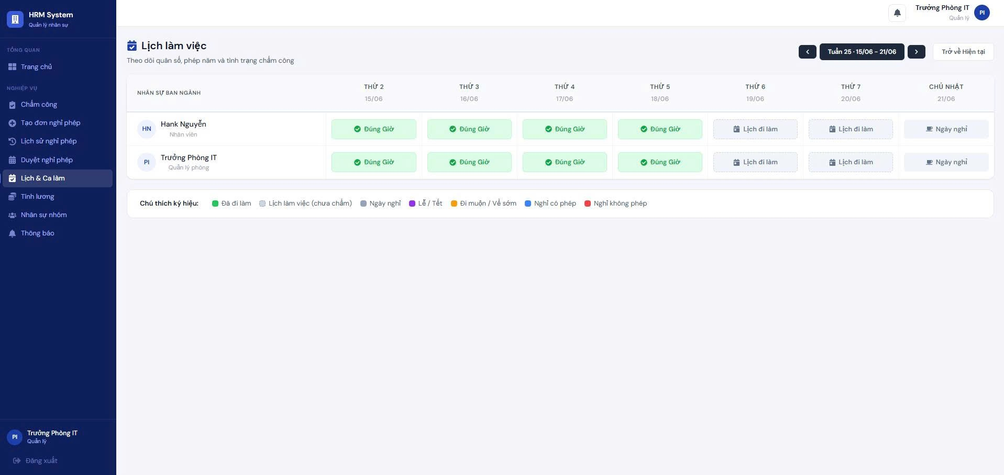
Figure 21: Calendar and shifts screen
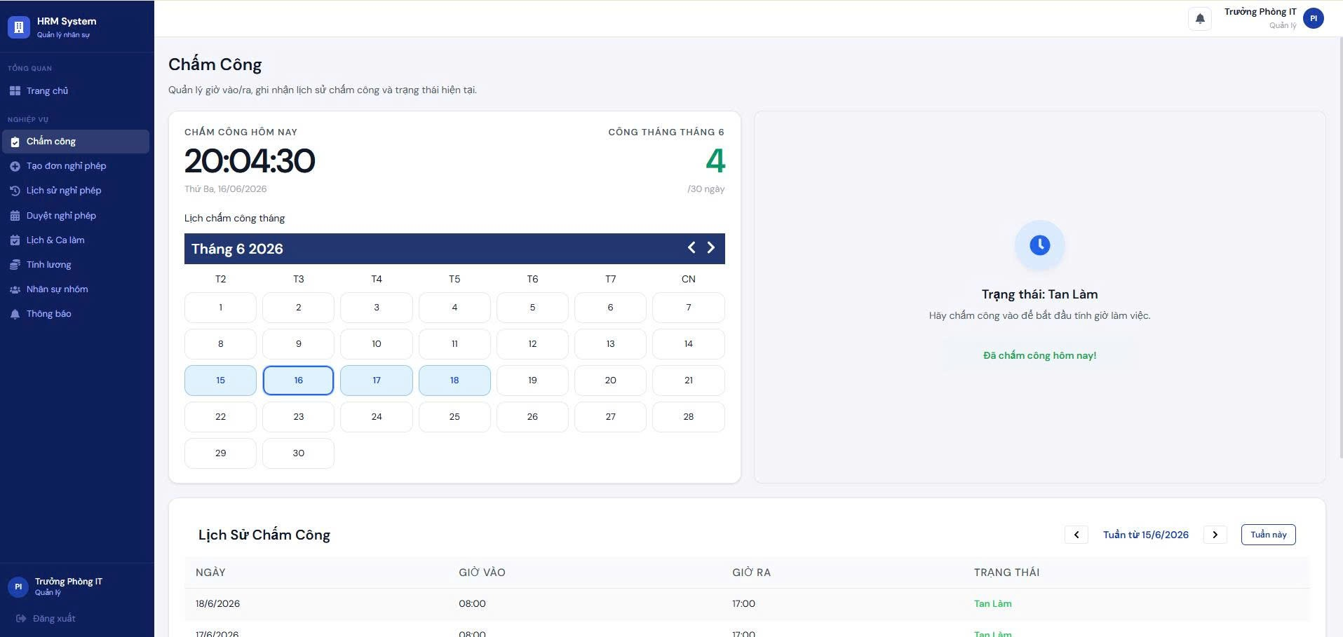
Figure 22: Timekeeping screen
- Payroll Calculation screen
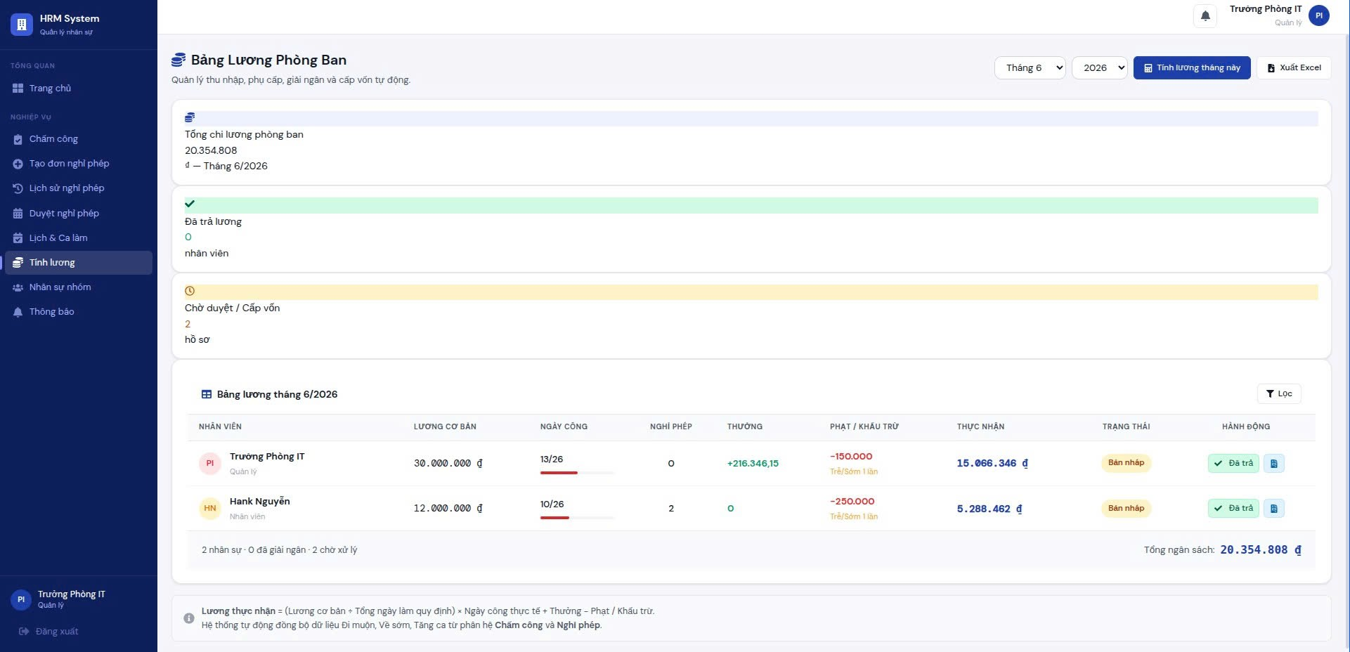
Figure 23: Payroll screen
- Microservices Health Monitor (Grafana Admin Panel)
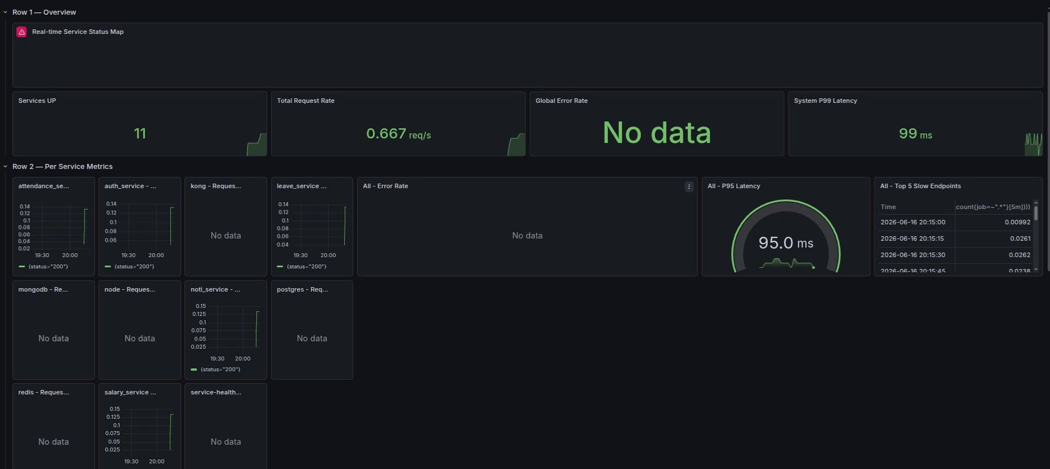
Figure 24: Microservices health monitoring screen (Grafana Admin Panel)
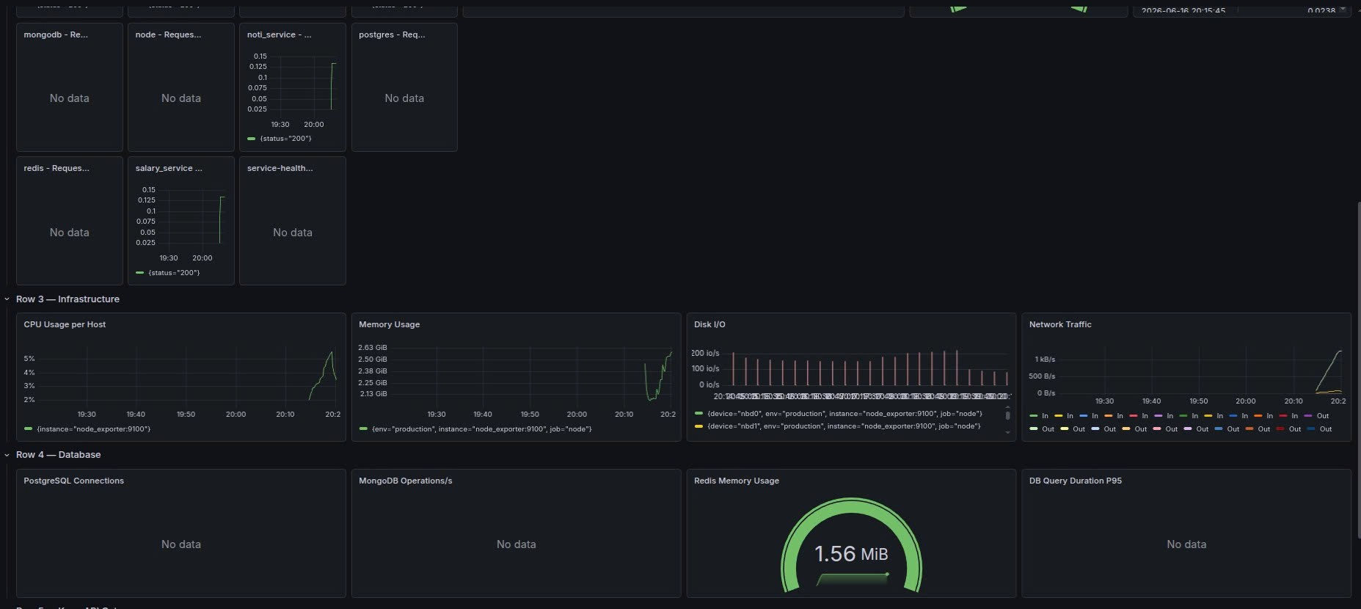
Figure 25: Microservices health monitoring screen (Grafana Admin Panel)

Chapter 5: System Testing
The purpose of this chapter is to present the test plan, test scenarios (Test Cases) and test results of the project. The goal is to demonstrate that the HRM system operates correctly according to the functional requirements defined in Chapter 2, while also meeting the committed Quality Attributes such as Performance, Availability and Security.
- Test Plan
- The project applies a multi-layer testing strategy, from the Code level (Unit Test) to the overall System level (System Test).
Table 32: Multi-level testing plan (Test Plan)
Test Type | Target | Tools | Layer
Unit Testing | Test individual functions/modules | Jest/Mocha | Backend
Integration Testing | Integration testing between modules & API validation | Postman/cURL | API
Interface Testing (UI/UX Test) | Full testing of user flow and browser compatibility | Manual / Browser | Frontend
Performance Testing | Verify Quality Attributes (Load Handling) | k6/JMeter | System
Security Testing | JWT Verification, RBAC Delegation, Rate-Limiting | Kong Gateway / Postman | System/API

- Test Cases.

*FR-01: Authentication & Authorization (Auth Service)
Table 33: Test case FR-01: Authentication & Authorization (Auth Service)
Test Case ID | FR-XX | Type | Test Case Name | Preconditions | Steps | Expected result (Expected) | Status
TC-AUTH-01 | FR-01 | HP | Log in successfully with a valid account | User has an ACTIVE account | Enter the correct username and password -> Click Login | Returns success message and JWT Token | PASS
TC-AUTH-02 | FR-01 | ERR | Login with wrong password | User exists | Enter correct username, wrong password -> Click Login | Error message "Wrong login name or password", no Token issued | PASS
TC-AUTH-03 | FR-01 | ERR | Log in with an inactive account | User is in PENDING_ADMIN state | Enter the correct username and password -> Click Login | Error message "Account not activated" | PASS
TC-AUTH-04 | FR-01 | BND | Register an account with a 7-character password | The system requires MK > 8 | Fill out the registration form, set password = "1234567" | The form reports an error that the minimum password length is 8 characters | PASS
TC-AUTH-05 | FR-01 | HP | Account registration successful | Don't have an account yet | Fill out a valid form -> Send OTP -> Enter the correct 6-digit OTP | Registration successful, status PENDING_ADMIN | PASS
TC-AUTH-06 | FR-01 | ERR | Wrong OTP authentication | OTP requested | Enter OTP with incorrect 6 numbers | Error message "OTP code is incorrect" | PASS
TC-AUTH-07 | FR-01 | BND | OTP authentication is expired | OTP sent > 5 minutes ago | Enter the correct OTP code but after 5 minutes | Error message "OTP code has expired" | PASS
TC-AUTH-08 | FR-01 | ERR | Access the Admin API using the Staff account | Log in with STAFF permissions | Call SUPERADMIN-specific API (eg: browse users) | Returns error 403 Forbidden | PASS

*FR-02: Attendance Service
Table 34: Test case FR-02: Attendance Service
Test Case ID | FR-XX | Type | Test Case Name | Preconditions | Steps | Expected result (Expected) | Status
TC-ATT-01 | FR-02 | HP | Check-in successful | User has a valid Token, has not checked in today | Call API /verify-code of check-in type with JWT | Record Check-in time, "Ongoing" status | PASS
TC-ATT-02 | FR-02 | ERR | Timekeeping does not have JWT Token | Remove Authorization Header | Call API /verify-code for check-in type | Error 401 "Access denied!" | PASS
TC-ATT-03 | FR-02 | ERR | Fake time attendance user_id (Security) | User A has Token | Call API /verify-code with A's Token but the body transmits B's user_id | The system ignores user_id in the body, only records User A | PASS
TC-ATT-04 | FR-02 | HP | Successful check-out timekeeping | User has checked in | Call API /verify-code with check-out type with JWT | Update Check-out time, "After work" status | PASS
TC-ATT-05 | FR-02 | BND | Check-in on time (08:30:00) | Standard time is 08:30 | Call the Check-in API at exactly 08:30:00 | Note late_minutes = 0 | PASS
TC-ATT-06 | FR-02 | BND | Late check-in (08:31:00) | Standard time is 08:30 | Call Check-in API at 08:31:00 | Record late_minutes > 0 | PASS
TC-ATT-07 | FR-02 | HP | Timekeeping overwrites the old time | User has previously checked in | Check-in API callback | Update new check_in_time based on ON CONFLICT | PASS

*FR-03: Leave Service
Table 35: Test case FR-03: Leave Service
Test Case ID | FR-XX | Type | Test Case Name | Preconditions | Steps | Expected result (Expected) | Status
TC-LEV-01 | FR-03 | HP | Staff successfully created a leave application | Log in to your STAFF account | Fill in reason, start date, end date -> Submit | Save the PENDING status, fire Socket to report to Manager | PASS
TC-LEV-02 | FR-03 | BND | Ask for more leave than the balance | 2 days left over | Create a 3-day leave request (Leave type: ANNUAL) | Warning/blocking system from creating ANNUAL orders (or converting them to UNPAID) | PASS
TC-LEV-03 | FR-03 | ERR | End date is less than start date |  | Create order: Start = June 15, End = June 10 | Report date logic error | PASS
TC-LEV-04 | FR-03 | HP | Manager approved the application successfully | Log in to MANAGER, there is a PENDING form | Select to review STAFF's application | Application to transfer APPROVED, deduct STAFF's authorized fund, fire Socket to STAFF | PASS
TC-LEV-05 | FR-03 | HP | Manager rejected the application | Log in to MANAGER, there is a PENDING form | Enter reason for rejection -> Reject | Transfer form REJECTED, license fund unchanged | PASS
TC-LEV-06 | FR-03 | ERR | Staff approves their own applications | Log in to STAFF | Call the API to approve your leave application | Report error 403 Forbidden | PASS
TC-LEV-07 | FR-03 | BND | Please take leave on holidays (Saturday, Sunday) |  | Choose a day off as Saturday and Sunday | The system automatically ignores Saturday and Sunday when calculating the total number of days off | PASS

*FR-04: Salary Service
Table 36: Test case FR-04: Salary Service
Test Case ID | FR-XX | Type | Test Case Name | Preconditions | Steps | Expected result (Expected) | Status
TC-SAL-01 | FR-04 | HP | Calculate the salary of an employee who comes to work in full | The closing month has passed | Call the payroll API | Calculate the standard net_salary = base_salary, no penalty | PASS
TC-SAL-02 | FR-04 | HP | Calculate salary for late employees | There is a late record in attendance_logs | Call the payroll API | Calculate salary minus late penalty (Late Penalty) | PASS
TC-SAL-03 | FR-04 | HP | Calculate salary for employees with paid leave | There is APPROVED leave ANNUAL | Call the payroll API | Leave days are still counted as working days, without salary deduction | PASS
TC-SAL-04 | FR-04 | HP | Calculating wages for employees on unpaid leave | Yes APPROVED leave UNPAID | Call the payroll API | Salary will be deducted according to the number of Unpaid Leave days | PASS
TC-SAL-05 | FR-04 | BND | Wages were negatively deducted due to excessive fines | Fines > Basic salary | Calculate salaries for employees | net_salary cannot be < 0 (Returns 0) | PASS
TC-SAL-06 | FR-04 | ERR | Calculate future monthly salary | The month hasn't ended yet | Pass the month parameter as the future | Report an error that does not allow calculation of future monthly salary | PASS
TC-SAL-07 | FR-04 | HP | View Payslip (Payslip) | Already have DRAFT/PAID salary | User views his salary history | Display full information: Employee salary, Workday, Bonus, Penalty, Actual receipt | PASS

*FR-05: Notification & System (Notification & System)
Table 37: Test case FR-05: Notification & System (Notification & System)
Test Case ID | FR-XX | Type | Test Case Name | Preconditions | Steps | Expected result (Expected) | Status
TC-SYS-01 | FR-05 | HP | Send system-wide notifications | Login Admin | Post a message of type "ALL" | Every User who is online receives a Socket popup | PASS
TC-SYS-02 | FR-05 | HP | Count notification bells (Badge) | There are unread notifications | See the right corner of the screen | The red bell icon increases in number accordingly | PASS
TC-SYS-03 | FR-05 | ERR | Rate Limiting Kong Gateway (DDoS test) |  | Shooting > 100 requests / 1 minute into API Auth | Kong returns 429 Too Many Requests | PASS
TC-SYS-04 | FR-05 | BND | Token expiration (1 day) | Login > 24 hours ago | Call any API that requires auth | Error 401 "Token expired" | PASS
TC-SYS-05 | FR-05 | HP | Automatically update DB Health check | Services are running | Call API /health/ready | Returns status UP, db UP, redis UP | PASS
TC-SYS-06 | FR-05 | ERR | Redis loses connection (Fall-back) | Turn off Redis containers | Run system API | Socketio warns, but the underlying HTTP API still works fine | PASS

*Availability Test
Table 38: Availability & Recovery Test Cases (Availability Test)
Test Case ID | FR-XX | Type | Test Case Name | Preconditions | Steps | Expected result (Expected) | Status
TC-AVAIL-01 | N/A | ERR | Automatically recover when Service crashes | The system is operating normally | Kill service process (eg attendance_service) | Docker Compose automatically restarts the container, API restores in <10s | PASS
TC-AVAIL-02 | N/A | ERR | Database Failover/Re-connect | Services are connecting to the DB | Stop Postgres/MongoDB container for a few seconds and then start again | Services automatically reconnect successfully, no need to restart Node.js | PASS
TC-AVAIL-03 | N/A | BND | Withstand sudden high load (Spike) | The system runs normally | Send 500 simultaneous requests per second to the Check-in API | API may respond slowly but not crash, Kong Gateway coordinates stably (Rate limit) | PASS

- Test Results Summary.
- Below is a summary table of test cases performed during the process of developing and completing the project.
Table 39: Summary of test results (Test Results Summary)
Subsystem (FR) | Total number of Test Cases | PASS | FAIL | BLOCKED | Pass Rate
FR-01: Auth Service | 8 | 8 | 0 | 0 | 100%
FR-02: Attendance Service | 7 | 7 | 0 | 0 | 100%
FR-03: Leave Service | 7 | 7 | 0 | 0 | 100%
FR-04: Salary Service | 7 | 7 | 0 | 0 | 100%
FR-05: System & Notification | 6 | 6 | 0 | 0 | 100%
TOTAL | 35 | 35 | 0 | 0 | 100%

- Quality Attribute Testing.
- Since the system is built on a Microservices architecture and uses an API Gateway, testing non-functional attributes is very important.
  - Performance Testing.
- Normal Load: The system responds to basic APIs (such as Time Attendance, Leave Request) with super low latency < 200ms.
- Batch Processing: Complex salary calculation algorithm for the entire company (Cross-Query of inter-Database data between Time Attendance & Leave module) responds stably at ~2-3 seconds.
- Real-time Metrics: WebSocket protocol via Redis Pub/Sub ensures Push Notifications are displayed almost instantaneously < 50ms.
  - Availability.
- The system has excellent auto-healing capabilities thanks to the Docker architecture. Services that are suddenly turned off will automatically restart and be online in < 10 seconds.
- PostgreSQL configuration supports Failover, providing large read/write capabilities with ACID integrity.
  - Security (Security).
- Rate-limiting: Applying the Plugin on Kong API Gateway limits 100 requests/minute/IP for Authentication endpoints (password Brute-force protection) and 60 requests/minute/IP for other services (DoS defense).
- Stateless Auth: Identity data is securely extracted from the JWT payload (currentUser.id) to query the DB. Completely prevents ID spoofing security vulnerabilities (IDOR vulnerabilities).
- Role-Based Access Control (RBAC): Authority boundaries are strictly handled. MANAGER APIs/tasks are completely blocked (returns HTTP 403) if the JWT role is STAFF.

Chapter 6: Deployment & User Guide (Deployment & User Guide)
Purpose of this chapter Chapter 6 shows the reader how to install and launch the system from source code, and describes how to use key features. A person who has never been exposed to the project can read this chapter to get the system up and running smoothly.
- System Requirements.
- Because the system is built according to Microservices architecture, the most optimal method is to deploy through containers. The server/personal computer needs to install the following software:
- Docker: Version 20.10.x or later.
- Docker Compose: Version 2.x or later.
- Node.js: Version 18.x or 20.x (For running local development environments).
- Database management system (If not using Docker):
- PostgreSQL (v14+)
- MongoDB (v5+)
- Redis (v6+)
- Web browser: Google Chrome, Edge or latest Firefox (for best performance of Socket.io and React).
- Instructions for Installing & Running the application (Installation & Run Instructions).
- Installation Steps:
- Clone project source code:
- git clone https://github.com/HannhhDangg/SA25-26_ClassN01_Group05.git
- cd SA25-26_ClassN01_Group05
- Configure environment variables (Environment Variables): Copy the file .env.example to .env in the root directory and services directories (if any). Fill in the necessary values, especially database connection information and SMTP configuration to send OTP Email:
- # SMTP configuration example for Auth Service (Send OTP)
- SMTP_USER=<your_email@example.com>
- SMTP_PASS=<your_gmail_app_password>
- JWT_SECRET=<your_random_secret_key>
- Initialize the database : The system has a built-in file database/init.sql. When launching a PostgreSQL container for the first time, Docker will automatically read this file to create a public Schema, initialize tables (users, departments, leave_requests, etc.) and load sample data (Seed data).
- Run the application using Docker (Recommended): Open a terminal at the root directory of the project and run the command:
- docker-compose up --build -d
- Accessing the application: Once the containers indicate a Running status, open a browser and go to:
- Frontend: http://localhost:5173 (or corresponding port mapped in docker-compose).
- Demo Accounts (Demo Accounts).
- The system is pre-loaded with 3-level decentralized data (Seed Data). Below are the accounts where Trainers/Testers can log in immediately:
Table 40: List of Demo Accounts (Demo Accounts)
Role | Position | Username | Password | E-mail
SUPERADMIN | Manager | superadmin | 12345678 | hnd10112005@gmail.com
MANAGER | Head of IT Department | manager_it | 23010243 | managerit@gmail.com
MANAGER | Head of HR Department | manager_hcns | 23010243 | managehcns@gmail.com
STAFF | IT staff | hanknguyen | 12345678 | hank@gmail.com
STAFF | HCNS staff | hanhnguyen | 12345678 | hanhnguyen@gmail.com

- User Guide for Main Features.
*Function 1: Register & Authenticate OTP (Onboarding)
- Visit the Account Registration page.
- Fill in personal information and Email. The system will automatically send a 6-digit OTP code via Email (valid for 5 minutes - managed by Redis).
- Enter the OTP code to complete. The account will now be in PENDING_ADMIN status.
- Administrator (Superadmin) log in -> Access "Human Resources Management" -> Select "Browse" to activate the account.

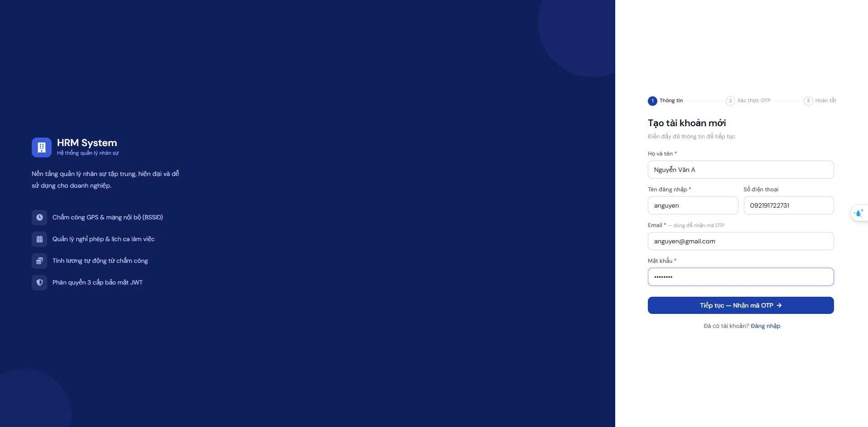
Figure 26: Registration form screen
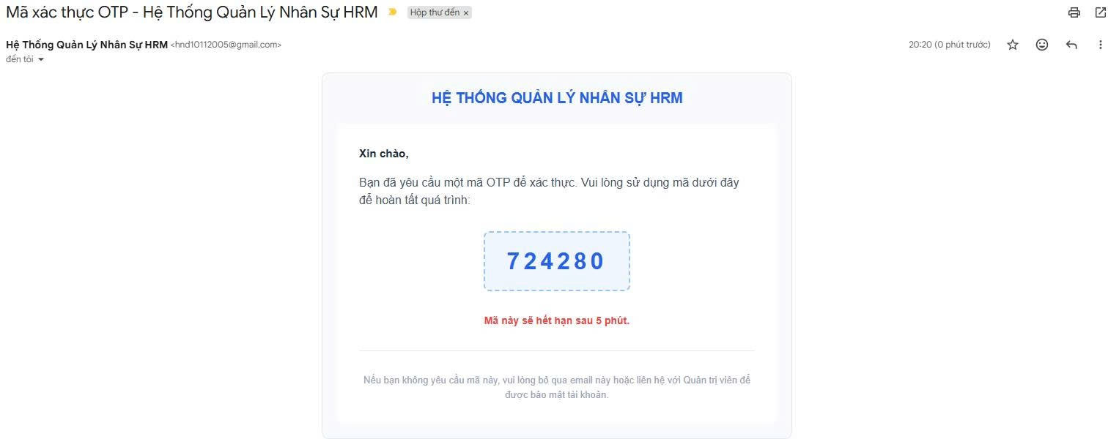
Figure 27: OTP receipt email screen
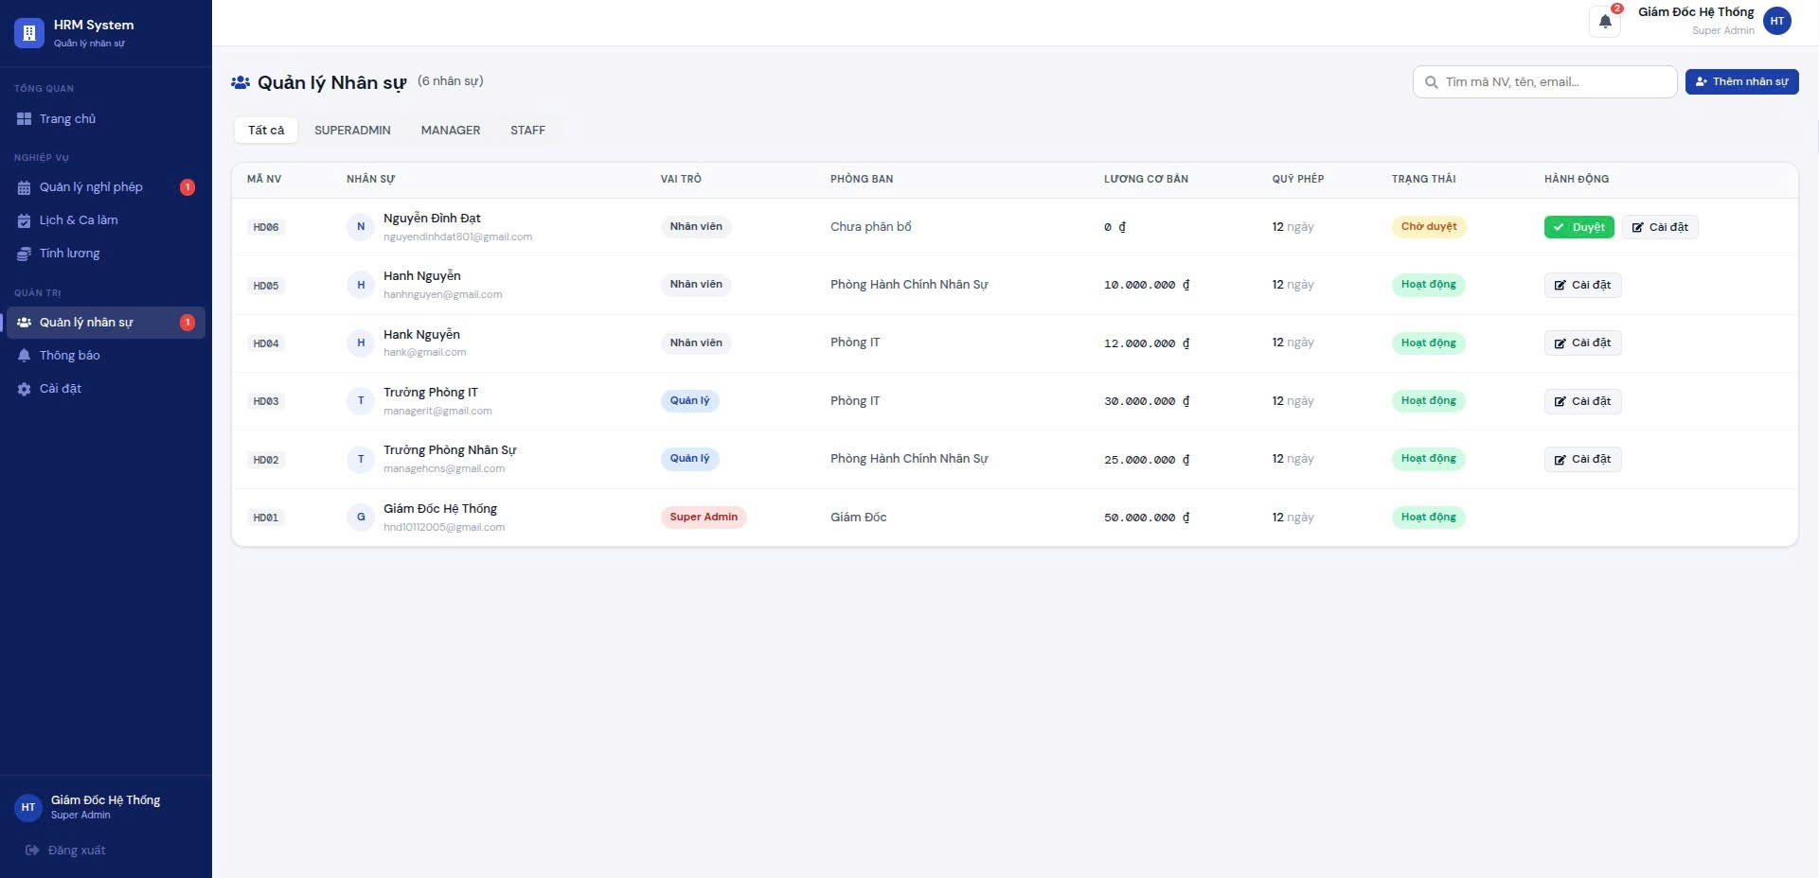
Figure 28: Admin approval screen
*Function 2: Daily timekeeping (Attendance)
- Log in with your STAFF account (eg: hanknguyen).
- In the left menu, select Timekeeping.
- The system will display the real-time clock and current status (Not yet on duty / On duty / Off duty).
- Press the button "Time In" (morning) or "Time Out" (afternoon). The system will automatically compare with the standard time (8:30 am and 5:00 pm) to record Arriving late / Leaving early.
- View timekeeping history right below or the table displaying the month's status matrix.

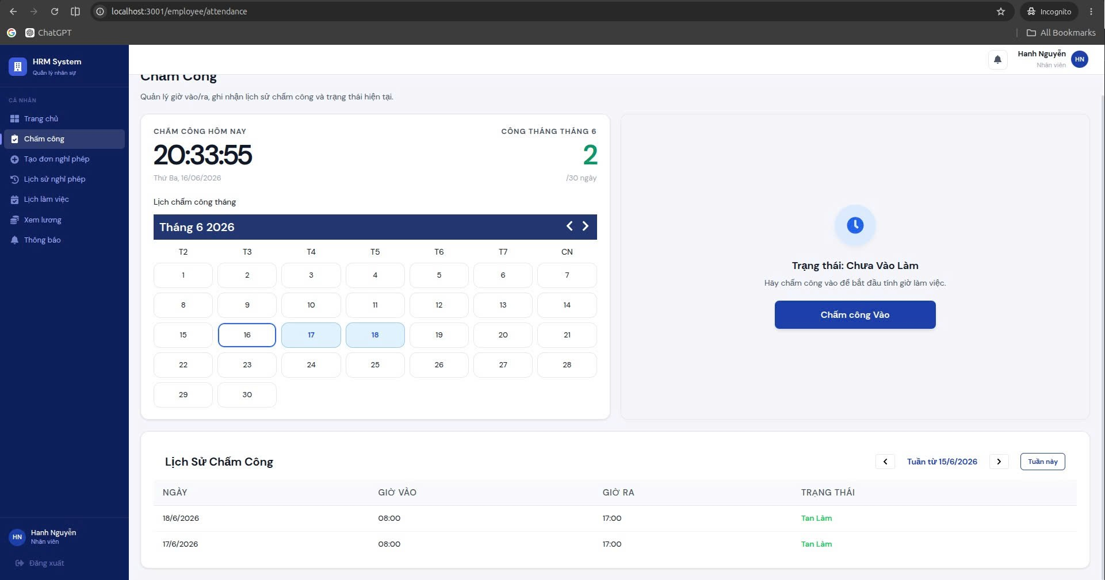
Figure 29: Time clock interface screen
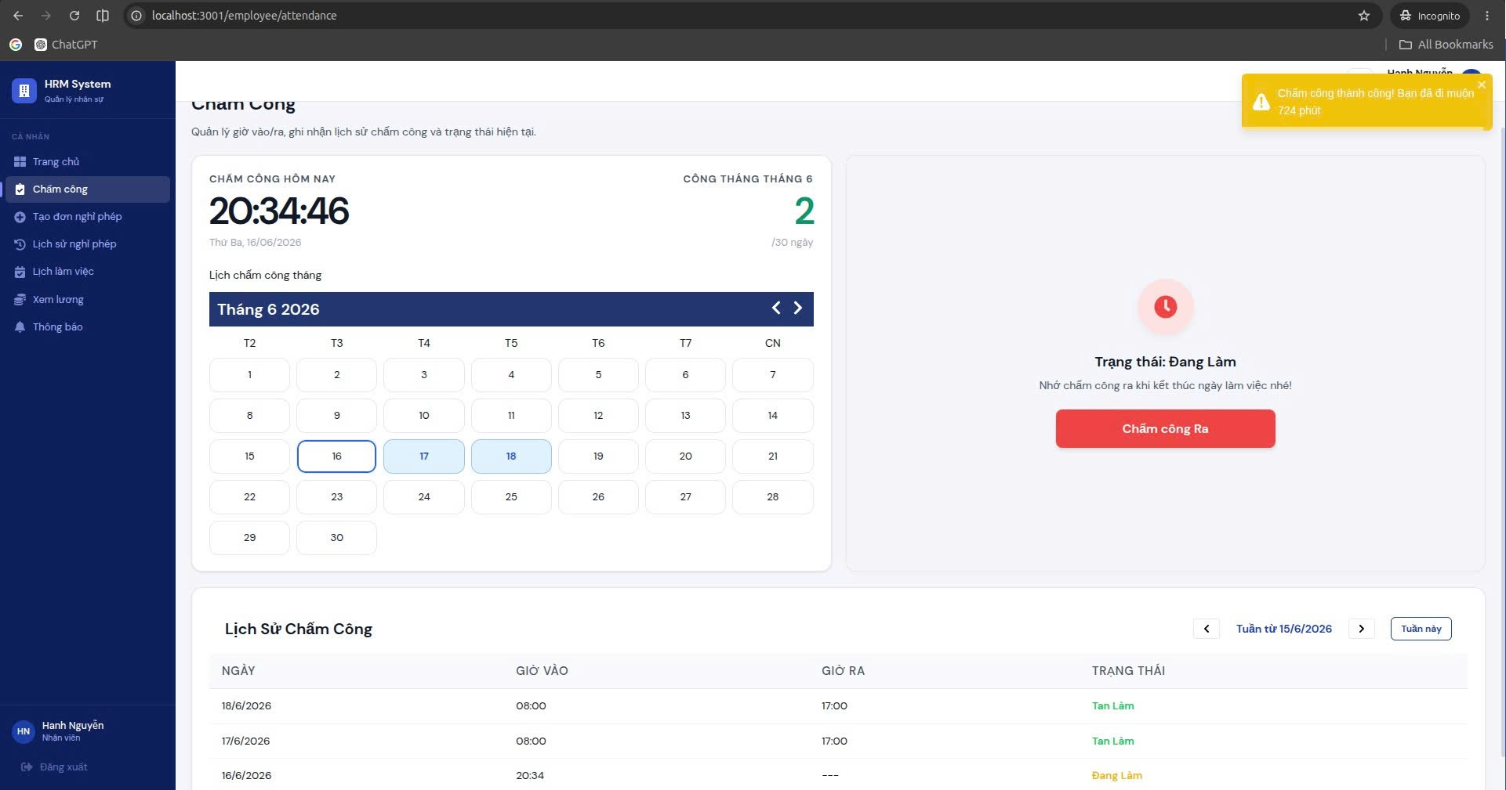
Figure 30: Time attendance button interface screen and attendance history

*Function 3: Real-time Leave Request & Approval
- Person applying for leave : Log in with STAFF account, go to Leave section -> Click Create new application. Fill in the start date, end date and reason. Click "Submit application".
- Automatic warning : The system checks the number of remaining leave days (max_leave_days) and blocks if exceeded, or blocks if more than 5 people leave on the same day.
- Approver : Log in with the MANAGER (Head of the same department) account. Thanks to Socket.io, the right corner of the screen will immediately pop up a notification (Toast) and the Red Bell icon will bounce a count.
- Manager goes to the home page (Dashboard) -> In the section "Leave application pending approval", click the Check mark (✔) icon to Approve or Cross mark (✖) to Reject.
- STAFF immediately receives result notifications via the red bell icon without needing F5 to reload the page.
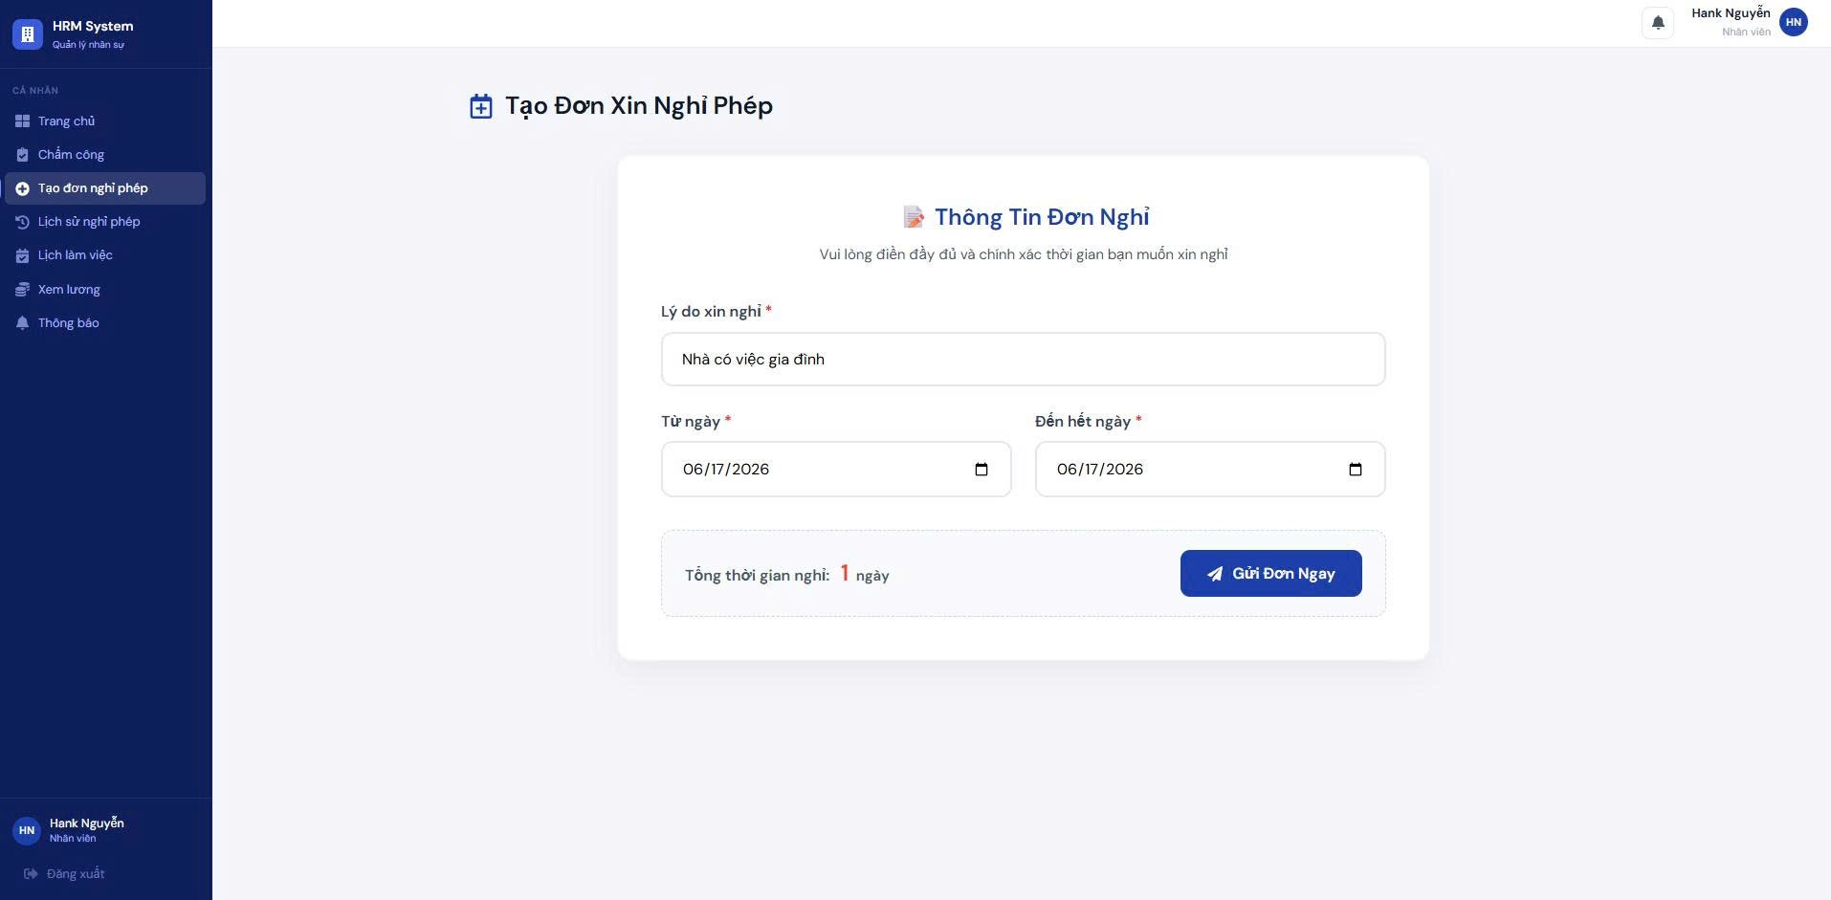
Figure 31: Leave application creation form screen
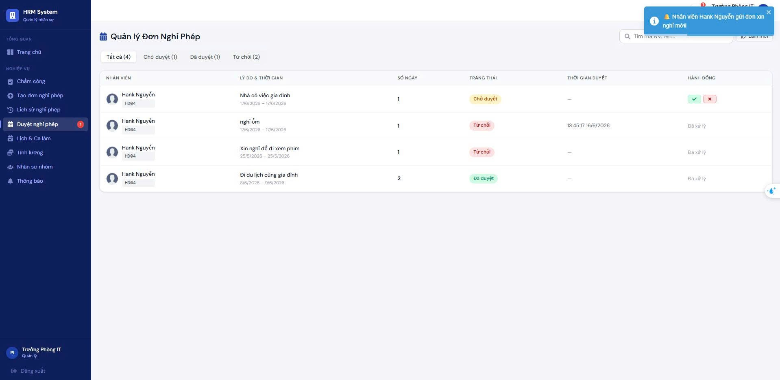
Figure 32: Admin screen receives realtime notifications
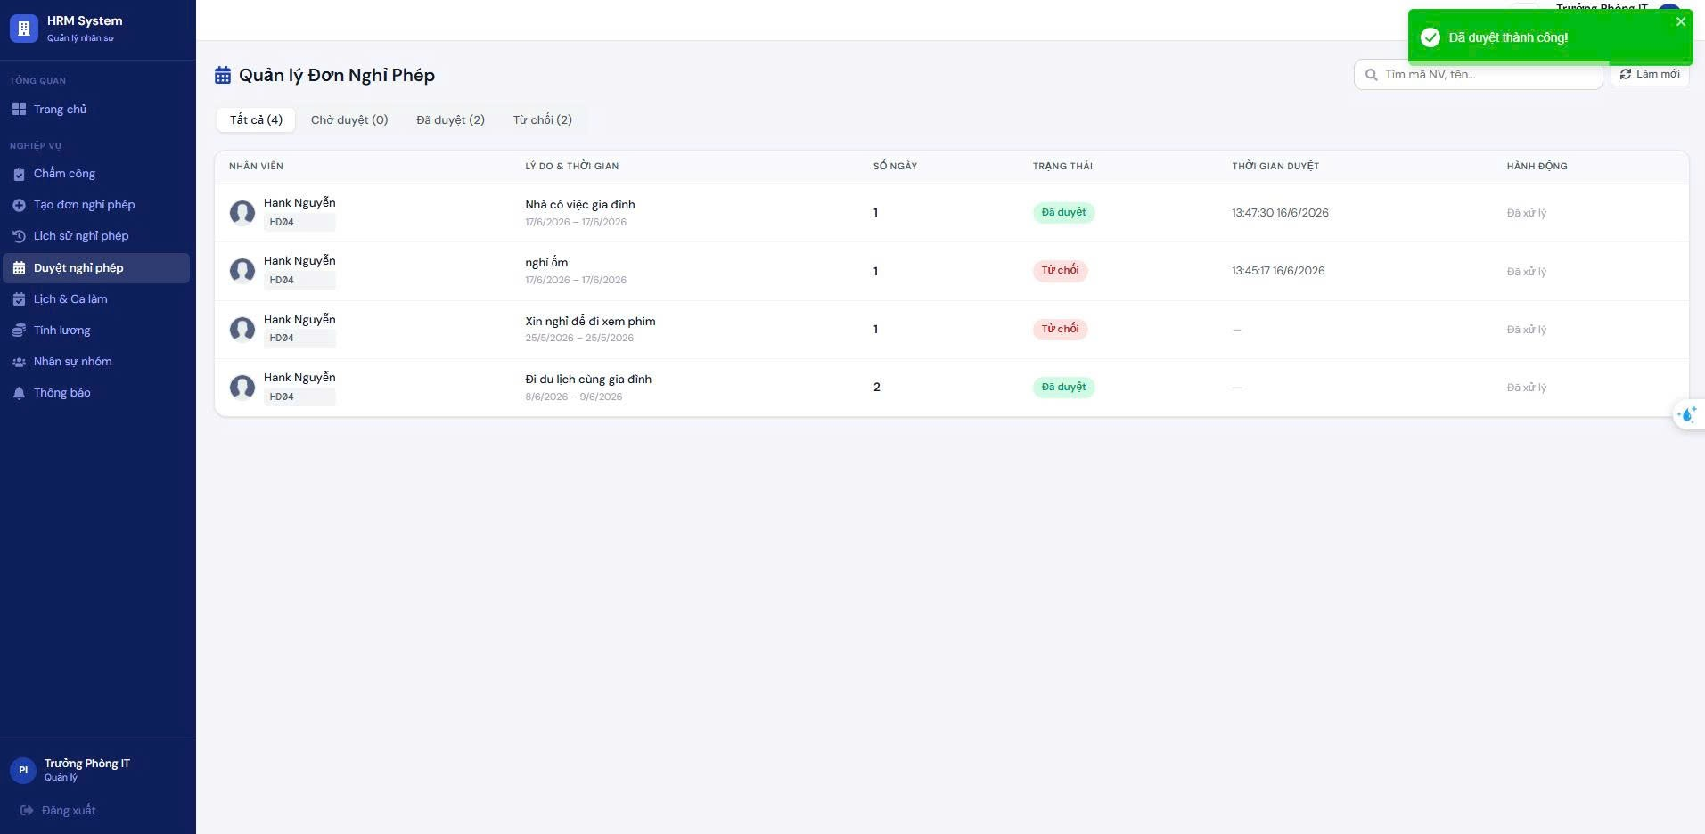
Figure 33: Leave application approval screen and notification (red bell) on the sidebar

*Function 4: View and calculate salary automatically (One-Click Payroll)
- Log in with your MANAGER or SUPERADMIN account.
- Access the Salary module.
- Select current Month and Year. As soon as the page loads, the system (Salary Service) will automatically communicate with the Attendance Service and Leave Service to summarize the number of days at work, the number of days off, late arrivals, and unauthorized absences.
- Managers can view the Draft payroll, including penalties (50k for being late, 100k for unauthorized leave) and overtime bonuses (x1.5).
- When the payroll is accurate, the Director presses "Mark Paid" (Paid) to finalize the salary. Employees can access to view their transparent pay slips (Payslip).

Figure 34: Payroll interface screen
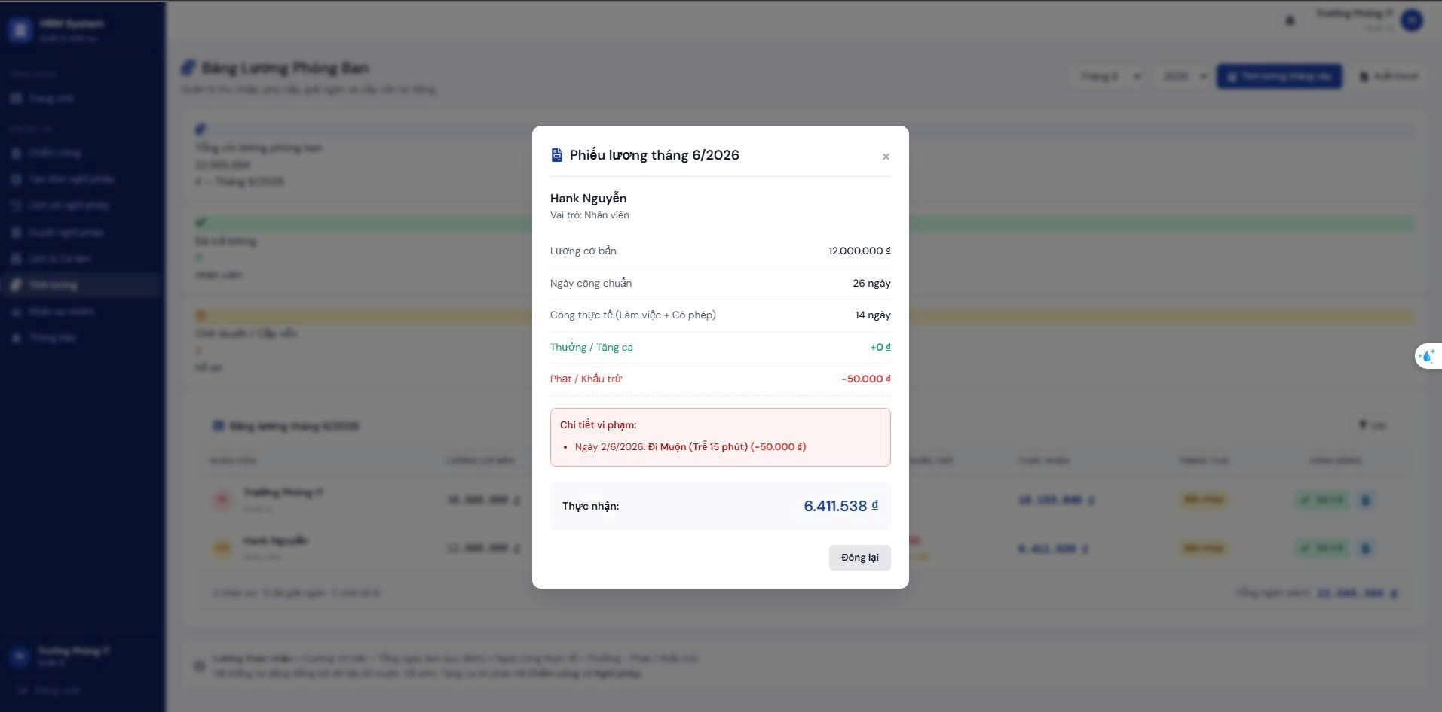
Figure 35: Interface screen detailing penalty/reward columns
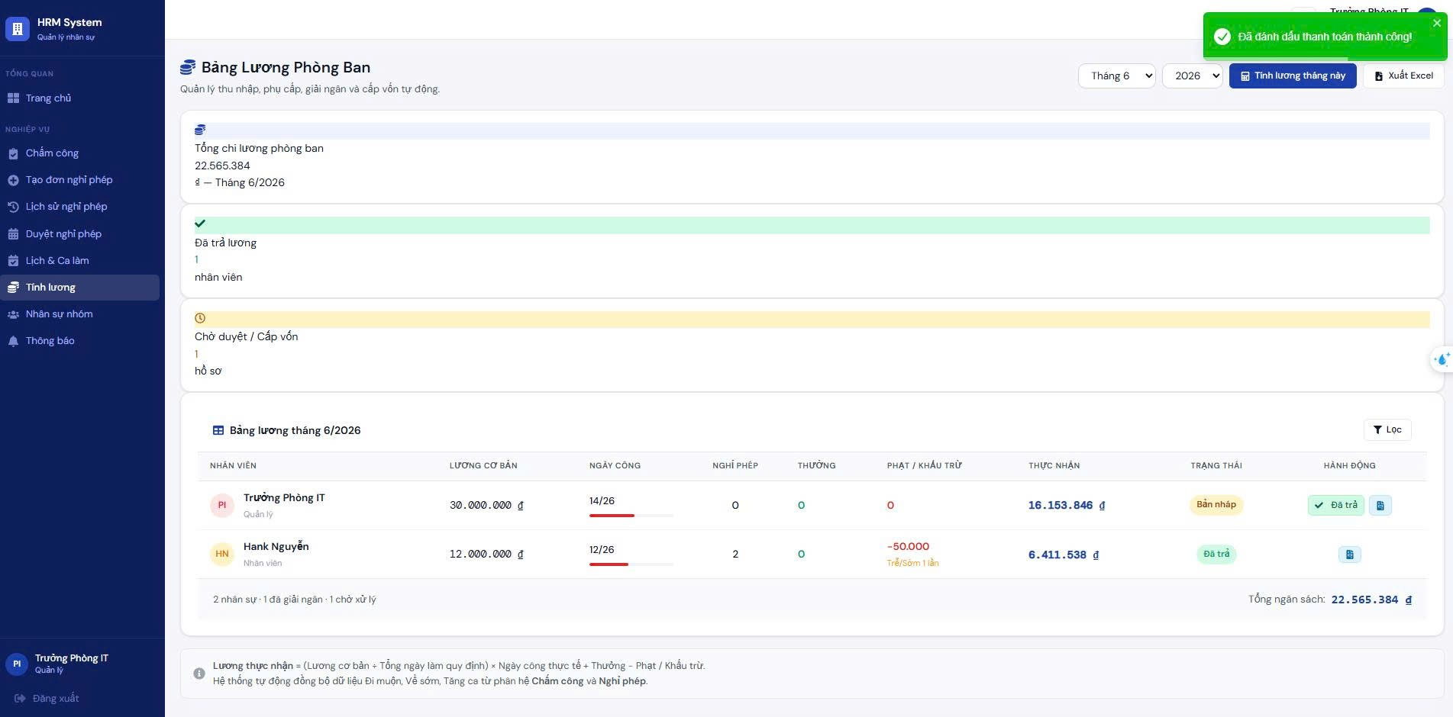
Figure 36: Salary payment interface screen

Chapter 7: CONCLUSION AND DEVELOPMENT DIRECTIONS (Conclusions & Future Work)
The purpose of this chapter is to summarize the actual achievements that the project has achieved, honestly acknowledge the remaining limitations in the source code and architecture, and propose a specific development roadmap in the future.
- Achieved results (Achievements).
- In direct comparison with the initially set goals and requirements of the Software Architecture course, the team has successfully implemented a complex system with a combination of many modern Design Patterns.
Table 41: Objectives vs. Results comparison table (Objectives vs. Results)
Objective | Result | Notes
Build 5 core business modules | Obtain | 100% completed services: Auth, Attendance, Leave, Salary, Notification.
Apply Microservices & API Gateway architecture with ADR | Obtain | Successfully deployed Kong API Gateway as Entry point, separate DB (PostgreSQL, MongoDB, Redis). C4 Model, Layer diagrams and ADR documentation included.
Integrating real-time interactive features (Real-time) | Obtain | The Socket.io system combines Redis Pub/Sub to synchronize application approval/permission notification immediately between Manager and Staff.
Automate timekeeping and salary control | Obtain | Salary Service and Schedule configuration automatically map data from Attendance and Leave Service.
Test coverage ≥ 70% | Partially achieved | Complete 100% Functional & Integration Test. However, Unit Test salary calculation only reaches about 50% due to time limit.

- Limitations & Challenges.
- Message data integrity (Message Reliability) is not high: Currently the system is using Redis Pub/Sub to act as a Message Broker to synchronize events between Microservices. Cause: Redis Pub/Sub does not store messages (Fire-and-forget), easily causing packet loss if a service suddenly goes down when the system is under high load. Not enough time to integrate alternative solutions.
- Anti-fraud Attendance mechanism is still rudimentary: The current Attendance module only records time and device_id (randomly saved in localStorage), does not apply GPS coordinates (Geofencing) or facial recognition. Cause: Team resources are thin, there is no time to integrate map APIs or train AI models to analyze images.
- Deployment infrastructure does not yet support automatic horizontal scaling: Currently, the Layered Architecture structure is being containerized and running using Docker Compose on a single server. This architecture is not really ready for Horizontal Scaling. Workaround: Convert the deployment scenario to a Kubernetes cluster (K8s).
- User experience (UX) on mobile devices is not optimal: The SPA interface (React.js + Tailwind) is responsive, but daily mobile web timekeeping operations are still cumbersome (requires re-login if JWT session expires). Cause: The web application has limited access to the hardware, so it cannot take good advantage of the phone's biometric sensors.

- Future development orientation (Future Work).
- To bring the product from the "Course Project" level to the "Production-ready" level, the team proposes a development roadmap according to the following priority levels:
- Future Development Roadmap:
- [High priority]: Upgrade Message Broker to ensure data consistency (Data Consistency). Convert from Redis Pub/Sub to Apache Kafka or RabbitMQ. This ensures that financial events (Salary Service) never lose messages even when the target service is restarting during scaling.
- [High priority]: Develop Native Mobile App for employees (using React Native or Flutter) to serve timekeeping, permission requests, and salary slip viewing. The application will integrate Face ID/Touch ID and GPS API to force employees to stand within the company radius to successfully check-in.
- [Medium priority]: Complete CI/CD and Kubernetes pipelines. Thoroughly enforce ADR decisions about Containerization by building a GitHub Actions flow to run Automation Tests. Convert infrastructure to a Kubernetes cluster so that services (especially Kong Gateway and Attendance) automatically scale horizontally (HPA) during peak hours.
- [Long-term]: Upgrade caching layer at Kong API Gateway combined with CDN for static resources and less volatile endpoints (department list, general announcements) to optimize performance, aiming for SLA 4 nines (99.99%).
- [Long-term]: Integrate AI/Machine Learning for intelligent data processing. Use the Attendance logs and Payrolls data set to train a model to predict employee turnover risk, and automatically suggest optimal shift scheduling based on the productivity of each department.

References
- Citation guidelines : The documents below are presented in IEEE format standards, including foundational textbooks on software architecture and distributed systems, along with official technical documentation (Official Documentation) of the technologies directly applied to the project.
- S. Newman, Building Microservices: Designing Fine-Grained Systems, 2nd ed. O'Reilly Media, 2021.
- L. Bass, P. Clements, and R. Kazman, Software Architecture in Practice, 4th ed. Addison-Wesley, 2021.
- M. Kleppmann, Designing Data-Intensive Applications: The Big Ideas Behind Reliable, Scalable, and Maintainable Systems. O'Reilly Media, 2017. (Reference for Polyglot Persistence design using PostgreSQL and MongoDB).
- C. Richardson, Microservices Patterns: With Examples in Java. Manning Publications, 2018. (Refer to distributed patterns such as API Gateway, Database per Service).
- Kong Inc., "Kong API Gateway Documentation," KongHQ. Accessed: May 24, 2026. [Online]. Available: https://docs.konghq.com/
- Docker Inc., "Docker Compose Overview," Docker Documentation. Accessed: May 24, 2026. [Online]. Available: https://docs.docker.com/compose/
- Zalando SE, "Patroni: A Template for PostgreSQL High Availability with ZooKeeper, etcd, or Consul," GitHub. Accessed: May 24, 2026. [Online]. Available: https://github.com/zalando/patroni
- Socket.IO, "Socket.IO Official Documentation - Real-time bidirectional event-based communication," Socket.IO. Accessed: May 24, 2026. [Online]. Available: https://socket.io/docs/v4/
- Redis Ltd., "Redis Pub/Sub Documentation," Redis. Accessed: May 24, 2026. [Online]. Available: https://redis.io/docs/interact/pubsub/
- OpenJS Foundation, "Node.js v20.x Documentation," Node.js. Accessed: May 24, 2026. [Online]. Available: https://nodejs.org/docs/latest-v20.x/api/
- Meta Platforms, Inc., "React – A JavaScript library for building user interfaces," React. Accessed: May 24, 2026. [Online]. Available: https://react.dev/
- Auth0, "JSON Web Tokens (JWT) Introduction," jwt.io. Accessed: May 24, 2026. [Online]. Available: https://jwt.io/introduction

