**Trường hợp bị lỗi**

* Lỗi KSP:
  + Gõ câu lênh “./gradlew –stop” trong termibal rồi clean build, re-built lại từ đầu

**The access way of Database, Room, Dao**

* DataBase:

A DataBase Class that holds the database and acts as the main access point for your SQL queries

* Dao (Data Access object) : (Also a Annoatation)

Dao is used for containing all logic function (CURD) with database (Create, Update, Read, Deletee).

* Entity: (Also a Annotation)

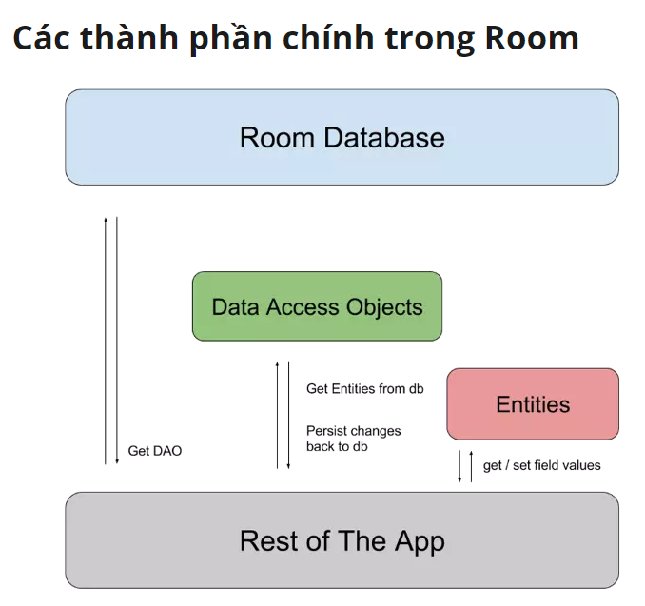

**Rule for declare DatabaseClass**

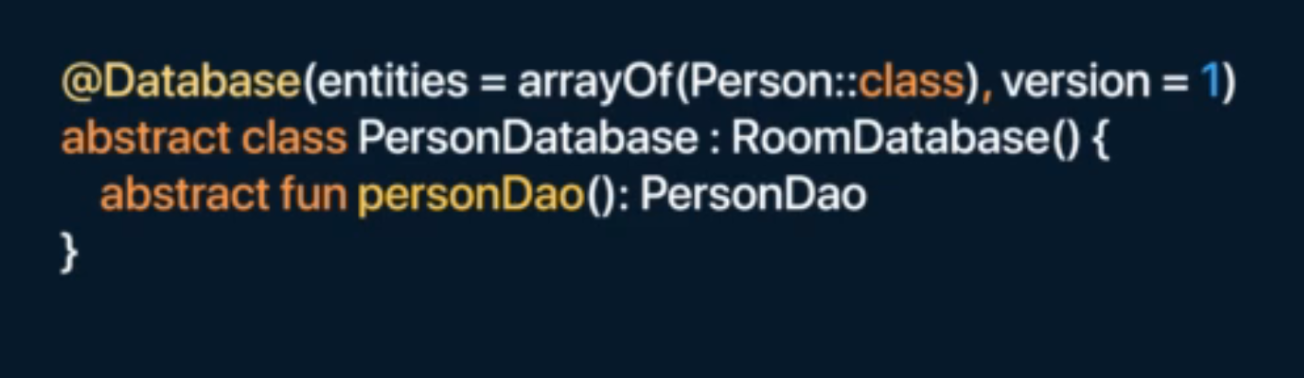

* The class database has to be annotatation with “@Database” annotation
* This class has to be abstraction class and extend RoomDatabase ( for getting all library and function of Room)
* Each Dao class has to associated with the database

**Single Annotation**

**Part 2: Dagger-Hilt ( Dependency Injection)**

Dagger-Hilt is a framework for the DI (Depedency Injection). To use Dagger-Hilt we has to declare on the top of the roof of app. Beause it’s will implementation all the application

One of the reason we create a DI (DatabaseModule because we do not own the room libarary and it’s hard to inject the depedencies into our project).

*Hilt Library is using that* ***return type*** *to decide which one of those provide function*

**Hilt Module:**

A place to define how to provide instance of a certain type

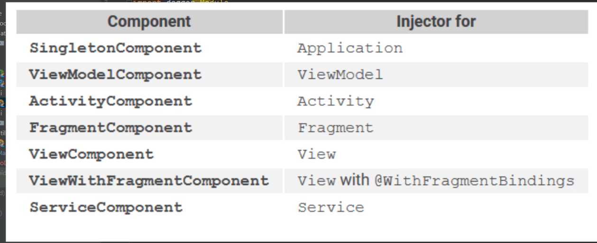

Part 3 : NavController

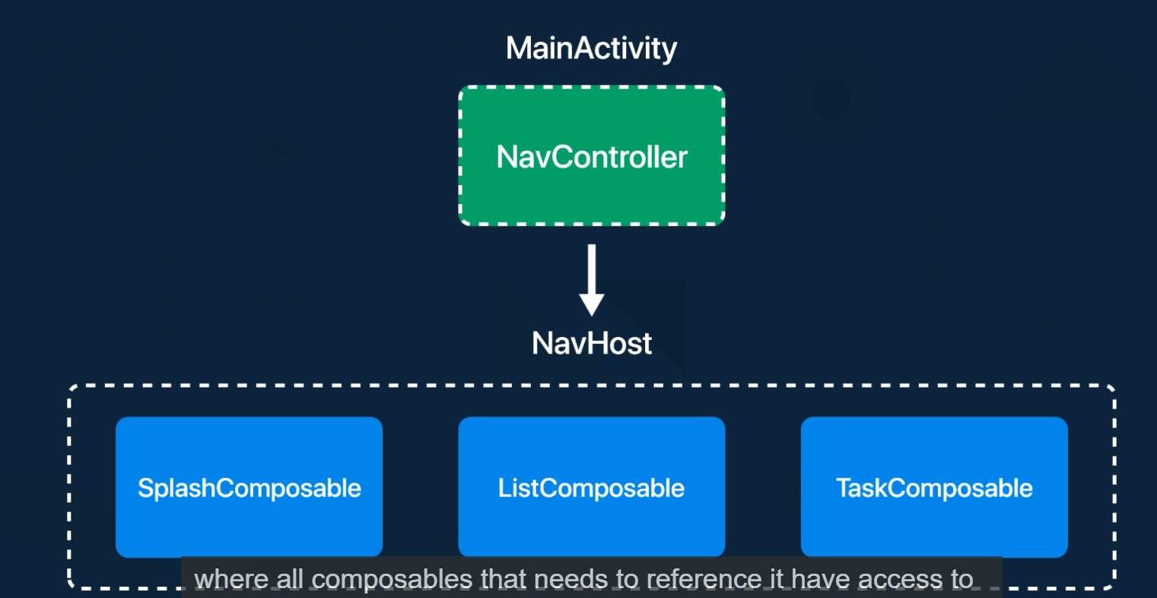

Frontend Code:

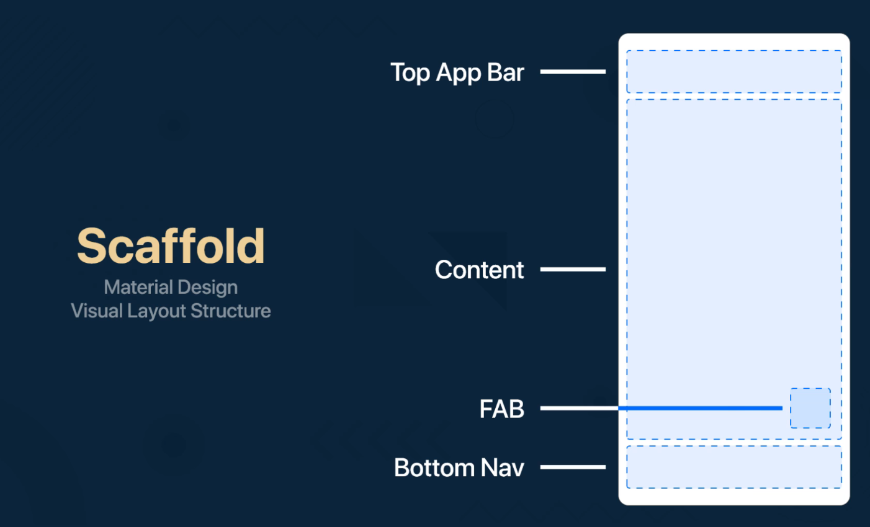

Scaffold component

Mui-3

ColorSchemes: A place to contained all the color component in our app. It’s location in

“*package* com.example.{tenProject}.ui.theme”

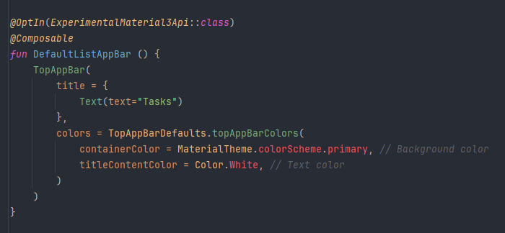

Example usaged

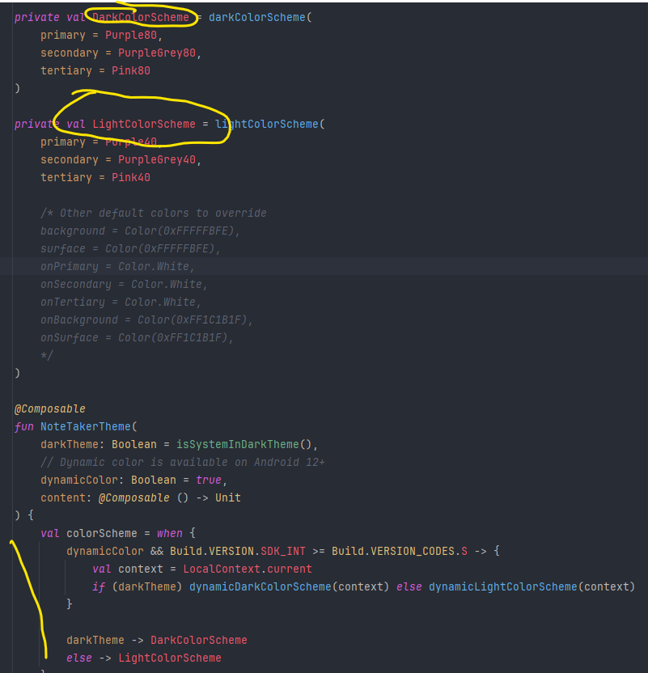

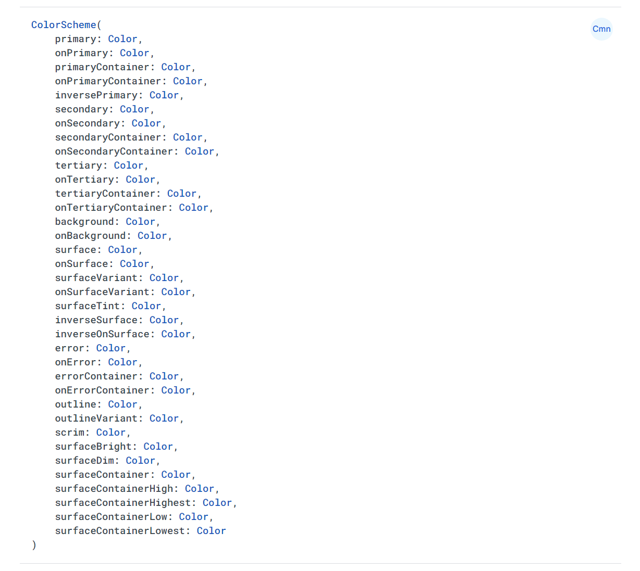

Trong JetPack Compose

Modifier : hàm khá giống style trong className css ngay trong component

Modifier.padding : (start ,end, top, bottom)

Modifier.size :

Modifier.alpha : là setup transparent

