

Laboratory Report

**LAB 2**



**April 1, 2022**

Instructor: Thai Vu Hien

Class : 19ES

Group 5 : Tran Ngoc Nguyen

Luu Dinh Dai Duc

Functions in MATLAB and the Groove Station

# **Introduction**

# **Sound in MATLAB**

# **Function Files**

## **Exercise 1:** Fader

1. **Modify the fade function so that you can adjust the slope of the ramp which will affect the level of the fade. Use the variable level (which is already in the parameter list for you in the function) to represent the strength of the fade as a decimal fraction. The function should make sure that the value is between 0 and 1.**

1. **Like in the code example above, plot your function with the cosine wave to see its effect. Throughout this lab you may and it helpful to plot functions (use the plot command)**

## **Exercise 2:** Repeater

1. **Create a function that repeats a sound N times. Use a for loop for this. Inside the for loop you will need to concatenate sound signals. For example, if you have two vectors x and y, you can concatenate them like this:**

1. **Demonstrate your repeater using an N specified by the TAChart, bar chart

   Description automatically generated**
2. **Optional: Add an argument that let's you insert silence in between each repetition**

## **Exercise 3:** Delay (Shift)

1. **Create a function to time-delay a signal. Because we are working with digital data, you can do this by simply adding zeros (zero pad) in the front. The inputs to the function should be the signal and the amount of time-delay. The number of zeros to add will depend on the time-delay and the sample rate. The sound signals from the resource page have a sample rate of 8,000 Hz, but it is good coding style not to assume this and to still have the sample rate (Fs) be an input to the function in case you wanted to change it later**

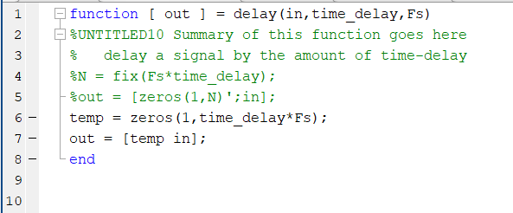

## **Exercise 4:** Mixer

1. **Create a function that adds two sound vectors together; your function should be able to handle inputs that are not the same size. The output values cannot be outside of the range [-1, 1], so you will have to re-scale them. One option is to re-scale the summed sound if it goes out of this range. You may want to look at the source code to the soundsc function for a way to do this. What happens if you let the sounds go out of this range and you try to play them with the sound command?**

## **Exercise 5:** Groove Station

1. **Create a script (not a function) to build your groove. You can use any combination of the above functions, or even create additional functions if you want. Use concatenation to combine the sounds together to make your groove. When you are finished save your groove with the wavwrite command (Remember to specify the sample rate (Fs), which for the sounds on the resource page is 8000 Hz).**

