Báo Cáo Đồ Án

Đề Tài : Quan lý vật tư

Thành Viên : Võ Văn Chiến

Đào Duy Phương

Sơ đồ UML :

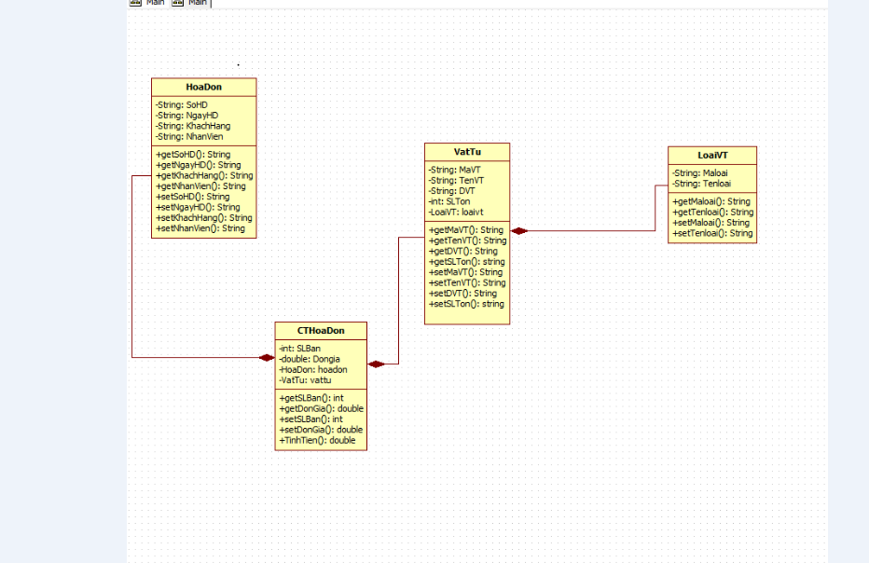

Các Class:

Class LoaiVT :

public class LoaiVT implements Comparable<LoaiVT> {

/\*\*

\* @return the key

\*/

private String maLoai = " ";

private String tenLoai = " ";

/\*\*

\* @return the maLoai

\*/

public LoaiVT(String maloai, String tenloai) {

this.maLoai = maloai;

this.tenLoai = tenloai;

}

public String getMaLoai() {

return maLoai;

}

/\*\*

\* @param maLoai the maLoai to set

\*/

public void setMaLoai(String maLoai) {

this.maLoai = maLoai;

}

/\*\*

\* @return the tenLoai

\*/

public String getTenLoai() {

return tenLoai;

}

/\*\*

\* @param tenLoai the tenLoai to set

\*/

public void setTenLoai(String tenLoai) {

this.tenLoai = tenLoai;

}

Class VatTu :

public class VatTu implements Comparable<VatTu>{

/\*\*

\* @return the maLoai

\*/

public String getMaLoai() {

return maLoai;

}

/\*\*

\* @param maLoai the maLoai to set

\*/

public void setMaLoai(String maLoai) {

this.maLoai = maLoai;

}

private String maVT = "";

private String TenVT = "";

private String DVT = "";

private String maLoai = "";

/\*\*

\* @return the maVT

\*/

//constructor khong tham so

public VatTu()

{

}

//constructor co tham so

public VatTu(String mavt, String tenvt, String dvt, String maloai) {

maVT = mavt;

TenVT = tenvt;

DVT = dvt;

maLoai = maloai;

}

public String getMaVT() {

return maVT;

}

/\*\*

\* @param maVT the maVT to set

\*/

public void setMaVT(String maVT) {

this.maVT = maVT;

}

/\*\*

\* @return the TenVT

\*/

public String getTenVT() {

return TenVT;

}

/\*\*

\* @param TenVT the TenVT to set

\*/

public void setTenVT(String TenVT) {

this.TenVT = TenVT;

}

/\*\*

\* @return the DVT

\*/

public String getDVT() {

return DVT;

}

/\*\*

\* @param DVT the DVT to set

\*/

public void setDVT(String DVT) {

this.DVT = DVT;

}

/\*\*

\* @return the slTon

\*/

String setMaVT() {

throw new UnsupportedOperationException("Not supported yet."); //To change body of generated methods, choose Tools | Templates.

}

Class CTHoaDon:

public class CTHoaDon implements Comparable<CTHoaDon>{

/\*\*

\* @return the slBan

\*/

public String getSlBan() {

return slBan;

}

/\*\*

\* @param slBan the slBan to set

\*/

public void setSlBan(String slBan) {

this.slBan = slBan;

}

/\*\*

\* @return the donGia

\*/

public String getDonGia() {

return donGia;

}

/\*\*

\* @param donGia the donGia to set

\*/

public void setDonGia(String donGia) {

this.donGia = donGia;

}

/\*\*

\* @return the soHD

\*/

public String getSoHD() {

return soHD;

}

/\*\*

\* @param soHD the soHD to set

\*/

public void setSoHD(String soHD) {

this.soHD = soHD;

}

/\*\*

\* @return the maVT

\*/

public String getMaVT() {

return maVT;

}

/\*\*

\* @param maVT the maVT to set

\*/

public void setMaVT(String maVT) {

this.maVT = maVT;

}

private String slBan;

private String donGia;

private String soHD;

private String maVT;

private HoaDon hoadon;

private VatTu vattu;

//constructor khong tham so

public CTHoaDon()

{

}

//constructor co tham so

public CTHoaDon(String sohd,String mavt,String slban,String dongia)

{

this.soHD = sohd;

this.maVT =mavt;

this.slBan = slban;

this.donGia = dongia;

}

Class HoaDon

public class HoaDon {

private String soHD;

private String ngayHD;

private String khachHang;

private String NhanVien;

public HoaDon()

{

}

public HoaDon(String sohd,String ngayhd,String khachhang,String nhanvien)

{

this.soHD = sohd;

this.ngayHD = ngayhd;

this.NhanVien = nhanvien;

this.khachHang = khachhang;

}

/\*\*

\* @return the soHD

\*/

public String getSoHD() {

return soHD;

}

/\*\*

\* @param soHD the soHD to set

\*/

public void setSoHD(String soHD) {

this.soHD = soHD;

}

/\*\*

\* @return the ngayHD

\*/

public String getNgayHD() {

return ngayHD;

}

/\*\*

\* @param ngayHD the ngayHD to set

\*/

public void setNgayHD(String ngayHD) {

this.ngayHD = ngayHD;

}

/\*\*

\* @return the khachHang

\*/

public String getKhachHang() {

return khachHang;

}

/\*\*

\* @param khachHang the khachHang to set

\*/

public void setKhachHang(String khachHang) {

this.khachHang = khachHang;

}

/\*\*

\* @return the NhanVien

\*/

public String getNhanVien() {

return NhanVien;

}

/\*\*

\* @param NhanVien the NhanVien to set

\*/

public void setNhanVien(String NhanVien) {

this.NhanVien = NhanVien;