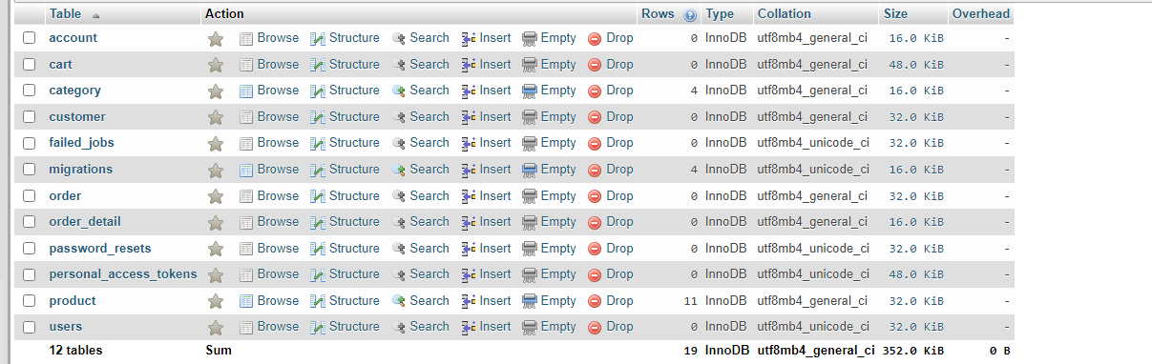

Account

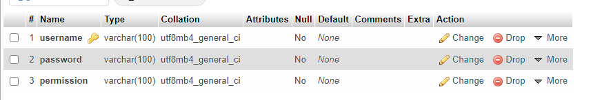

Cart

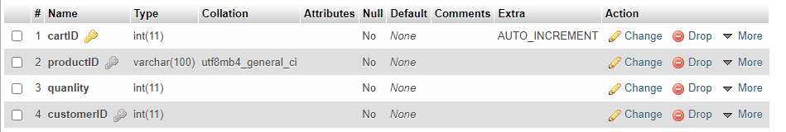

Category

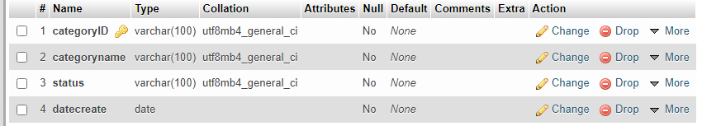

Customer

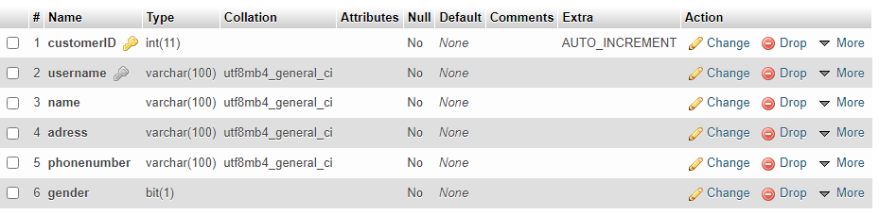

Order

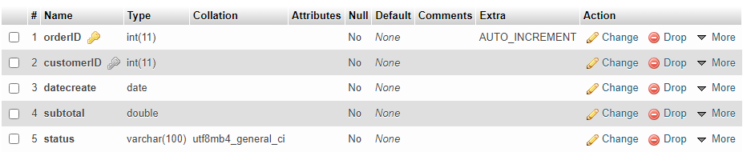

Order detail

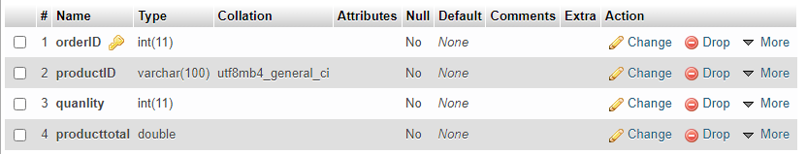

Product

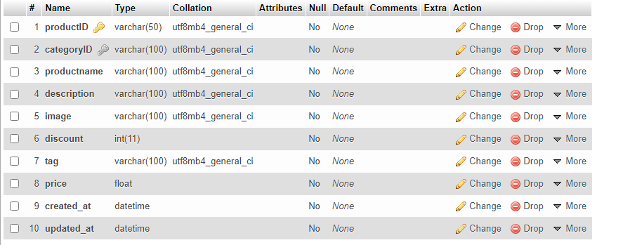

Mấy cái kia k cần