TIKI VIETNAM E-COMMERCE
Market Analysis Report
Product performance, pricing strategy, and seller operations across the fashion & accessories market

Prepared by Nguyen Trong
github.com/Nguyentrong243/Tiki-E-commerce-Analysis

Executive Summary
This report analyzes 41,572 product listings scraped from Tiki, one of Vietnam's largest e-commerce platforms, across six fashion and accessory categories: backpacks & suitcases, fashion accessories, men's and women's bags, and men's and women's shoes. The analysis covers the full pipeline from raw data to business insight - Python-based data cleaning, PostgreSQL business queries, and an interactive Power BI dashboard - with the goal of identifying what drives sales, where quality risk hides, and which sellers and brands are shaping the marketplace.
86bn VND  Total GMV | 41,572  Products Analyzed | 739K  Units Sold | 3,806  Sellers

Top-Line Findings
GMV is highly concentrated: backpacks & suitcases generates the most GMV despite having fewer listings than fashion accessories - value comes from average order size, not catalog volume.
A significant share of the platform's best-selling products fall into a 'High Demand – Low Satisfaction' segment, generating more GMV than genuinely well-rated 'Star Products' - a potential quality risk worth addressing.
Larger discounts are associated with higher average sales, but full-price listings still generate the most total GMV due to sheer volume (~78% of the catalog).
Video-enabled listings are associated with the strongest sales performance among the product content features analyzed, more than doubling average GMV per product.
Several top-GMV sellers carry ratings below 2.0, echoing the same quality-risk pattern seen at the product level - high revenue does not guarantee customer satisfaction.
A cluster of sellers with 20+ listings recorded zero units sold, suggesting dormant accounts that may warrant operational review.

Methodology

1. Data Preparation (Python)
Six category-level CSV exports (41,603 raw rows) were merged into a single dataset using pandas. Cleaning steps included: removing a redundant leftover index column, resolving 27 duplicate product IDs, replacing an unreliable 'category' field (40% generic placeholder values) with a category label derived from the source file, dropping rows with invalid zero pricing, fixing whitespace/tab corruption in brand names, correcting one HTML-corrupted brand value, and removing three rows with an implausible fixed value in the product-age field. The cleaned dataset (41,572 rows) was exported and loaded into PostgreSQL via SQLAlchemy, with credentials managed through environment variables rather than hardcoded values.

2. Business Analysis (SQL)
Eight PostgreSQL queries were written to answer specific business questions rather than to demonstrate syntax for its own sake: GMV Analysis, a Product Performance Matrix, Discount Effectiveness, Seller Performance, Customer Engagement Analysis, Product Content Quality, Pricing Strategy, and Brand Positioning. Statistical thresholds were chosen deliberately - medians and percentiles were used where GMV, review counts, and sales are right-skewed, while simple averages were used for straightforward group comparisons - and every claim in this report uses associative rather than causal language, since the underlying data is observational.

3. Interactive Dashboard (Power BI)
A three-page Power BI report was built on top of the cleaned dataset: an Executive Overview for a five-second read of platform health, a Product & Pricing Drill-down centered on a GMV-vs-rating performance matrix with a bookmark-driven toggle between pricing and content-quality views, and a Partner & Operational Performance page covering seller GMV concentration and dormant-account risk.

Key Findings
1. Gross Merchandise Value (GMV) Analysis
Business question: Which product categories and brands generate the highest GMV on the Tiki marketplace?
Backpacks & suitcases drives the highest GMV (~29B VND) despite ranking only fourth by product count - its high average price (~497K VND) more than compensates for lower volume. Fashion accessories, by contrast, has by far the most listings (16,005) but the lowest GMV (~14B VND), reflecting a very low average price (~82K VND). Among named brands, HARAS leads with ~3.7B VND GMV from just 54 products, driven by a high-volume, mid-price strategy, while Converse achieves similar GMV through a premium, lower-volume approach - showing there is more than one viable path to driving revenue as a branded seller.
2. Product Performance Matrix
Business question: Which products are Star Products, Hidden Gems, High-Demand but Low-Satisfaction products, and Underperformers?
Products were classified into four segments by comparing each product's GMV and rating against the market median (median chosen because GMV is right-skewed). 'High Demand – Low Satisfaction' is the single largest GMV contributor of the four segments - larger even than genuine 'Star Products' - meaning a meaningful share of the platform's best-selling products carry below-average ratings. This represents a potential quality risk: with only a rating field available, the exact cause (product quality, delivery, packaging, or warranty experience) cannot be confirmed from this data alone, but the pattern is large enough to warrant investigation before it affects customer retention.
3. Discount Effectiveness
Business question: Do discounts actually increase sales performance, or do they simply reduce selling prices without generating meaningful sales growth?
Products with large discounts (30%+) are associated with the highest average sales (45.1 units) and the highest average rating (2.20) among all discount tiers. However, full-price listings ('No Discount') still generate the highest total GMV (~44B VND), simply because they make up roughly 78% of the catalog. Discounting appears effective per product, but most of the platform's GMV still comes from full-price, high-volume generic listings.
4. Seller Performance Analysis
Business question: Which sellers contribute the most to marketplace performance, and which large sellers are underperforming?
The top seller, HARASMALL, generates ~3.85B VND in GMV - more than the next two sellers combined - with a strong average rating of 3.99. Several other top-15 sellers by GMV, including House Of Luggage and WearVN, show low average ratings (1.6–2.0) despite high revenue, echoing the High-Demand/Low-Satisfaction pattern seen at the product level. Separately, a cluster of sellers with 20+ listings recorded zero units sold, a signal consistent with dormant or inactive accounts that operations teams may want to flag for review.
5. Customer Engagement Analysis
Business question: Where does customer engagement (reviews and ratings) fail to align with actual sales performance?
A small number of products (17 out of 41,572) show zero reviews alongside unusually high sales volume (300+ units) - given how rare this combination is, these cases likely reflect data collection timing or product relisting rather than genuine 'reviewless bestsellers,' and should be treated as a data-quality caveat rather than an actionable insight. On the other side, several products with high review counts but very low sales point to potential pricing or stock issues worth investigating individually.
6. Product Content Quality
Business question: Does richer product content (videos, images, and Buy Now Pay Later availability) improve sales performance?
Video-enabled listings are associated with the strongest sales performance among the content features analyzed: products with a video average 34.3 units sold versus 15.9 for those without, alongside a notably higher average rating (2.35 vs 1.27). Listing image count shows a smaller but consistent pattern - listings with 10+ images average 42.1 units sold, compared to 14.3–15.6 for listings with 4–10 images. Buy Now Pay Later availability is associated with a large price gap (513K VND average vs 79K VND for listings without it), suggesting it is offered mainly on higher-ticket items rather than functioning as a broad sales driver.
7. Pricing Strategy
Business question: Which price segments perform best within each product category?
Budget-tier products (under 100K VND) consistently drive the highest sales volume across nearly every category, most notably in men's bags (70.5 average units) and women's shoes (47.9 average units). Luxury-tier products (700K+ VND) show a steep drop-off in both volume and rating in every category - in fashion accessories, luxury items average just 0.4 units sold with a 0.35 rating, suggesting this price segment is poorly matched to what Tiki's fashion accessory buyers are looking for.
8. Brand Positioning
Business question: How are brands positioned across the marketplace in terms of pricing, customer satisfaction, and sales performance?
Mass-market brands dominate GMV generation: HARAS, ANANSHOP688, and BAMOZO combine moderate prices with high sales volume to lead brand-level revenue. Premium brands such as Sakos and KAMILIANT generate meaningful GMV per product but at far lower volume, reflecting a smaller, higher-value customer segment. Notably, several well-known international brands (Timberland, Skechers, Samsonite) show near-zero sales on the platform, likely reflecting price points that don't convert well against Tiki's generally price-sensitive fashion buyers.

Interactive Dashboard (Power BI)
The full three-page dashboard is available as a downloadable .pbix file in the project repository. Key views are shown below.

Page 1 - Executive Overview
A five-second snapshot of platform health: total GMV, units sold, product count, seller count, and average rating, alongside GMV by category, GMV by fulfillment type, top brands, and the impact of video content on sales.
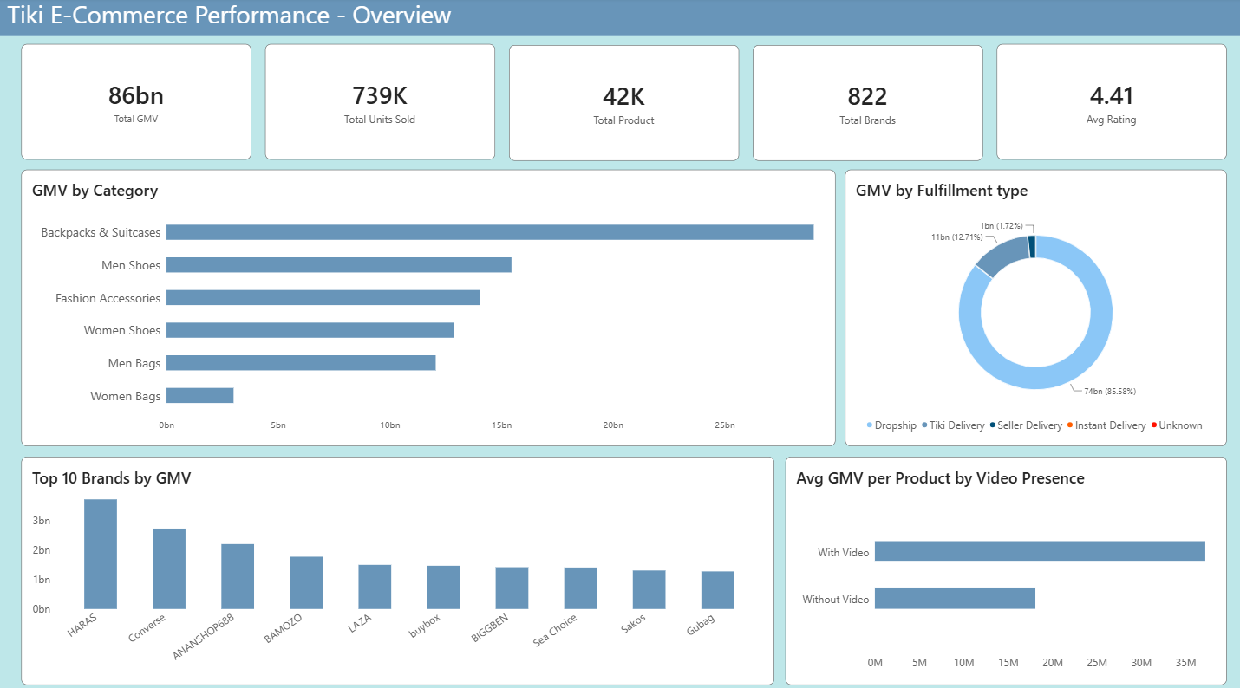
Figure 1. Executive Overview page.

Page 2 - Product & Pricing Drill-down
The centerpiece of the dashboard: a GMV-vs-rating scatter plot classifying every reviewed product into one of four performance quadrants, paired with a table of top 'High Demand – Low Satisfaction' products. A bookmark-driven toggle switches the lower section between a Pricing view (discount tiers, price bands by category, price vs. quantity) and a Content Quality view (video presence, image count).
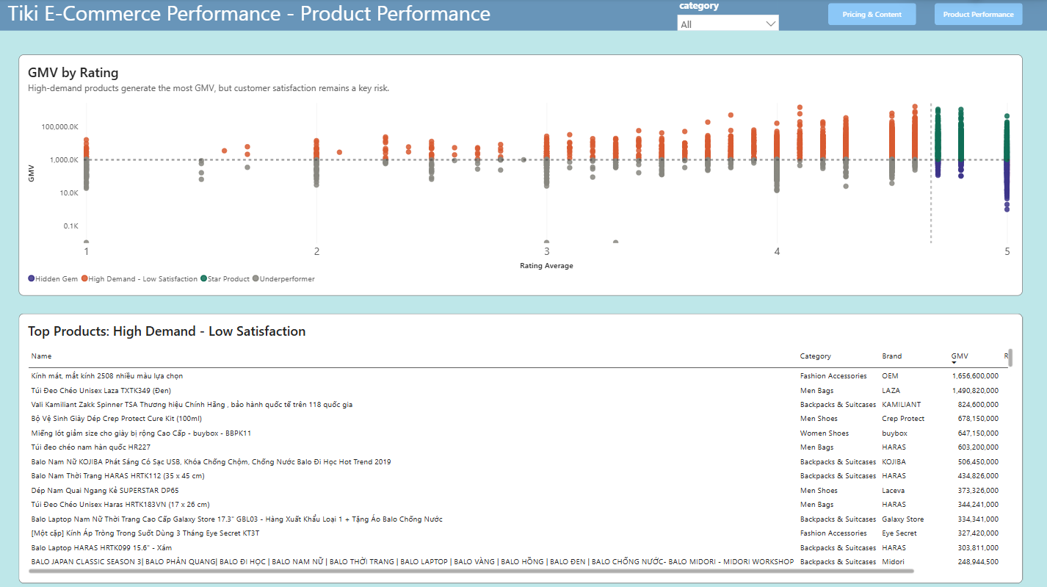
Figure 2a. Product & Pricing Drill-down - Product Performance view.
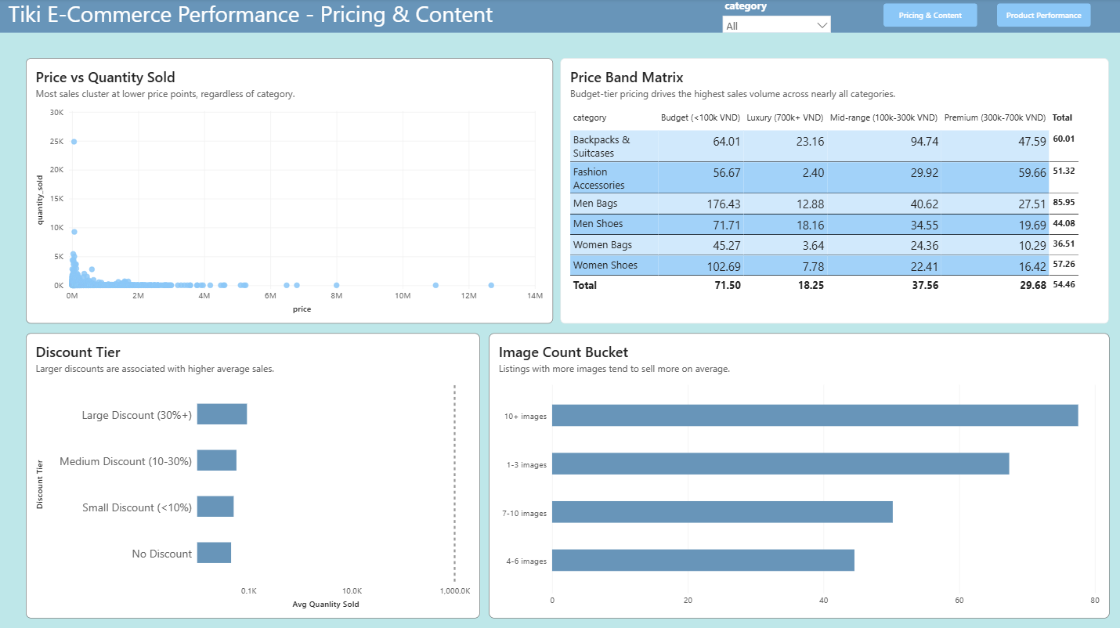
Figure 2b. Product & Pricing Drill-down - Pricing & Content view (toggled via bookmark).

Page 3 - Partner & Operational Performance
Seller-level view of GMV concentration and operational risk: top 15 sellers by GMV, a table of underperforming sellers (20+ listings, zero units sold), and the share of sellers with no recorded sales.
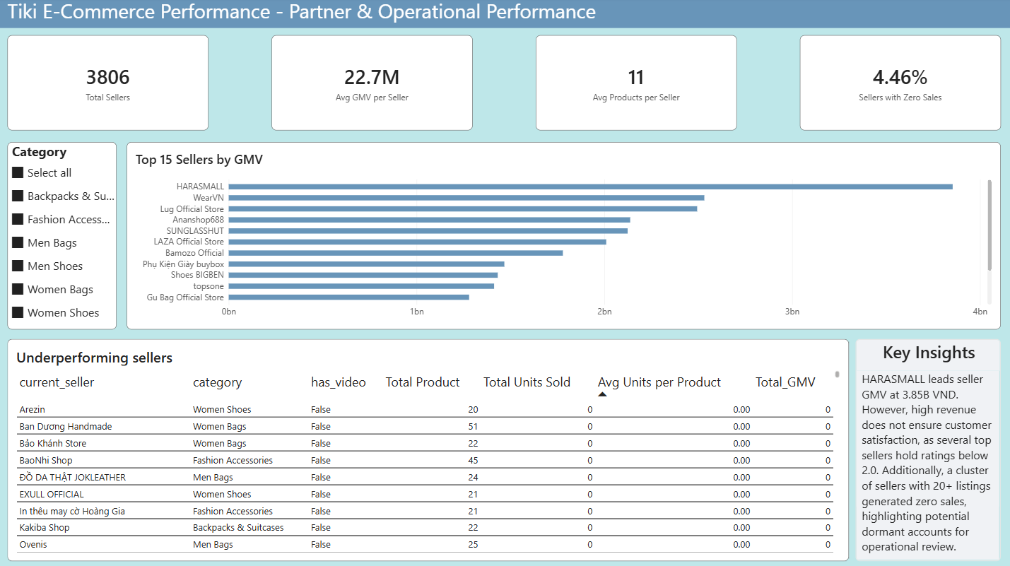
Figure 3. Partner & Operational Performance page.

Recommendations
Investigate the 'High Demand – Low Satisfaction' product segment first - it contributes more GMV than any other segment and represents the platform's largest concentrated quality-risk exposure.
Encourage or require sellers to add product videos where feasible, given the strong association between video content and both sales volume and rating.
Flag sellers with 20+ listings and zero recorded sales for account-status review, as these are likely dormant rather than genuinely underperforming.
Prioritize category-appropriate pricing for new listings - budget-tier pricing consistently outperforms premium and luxury tiers across nearly every category in this dataset.
Treat the 'zero review, high sales' anomaly (17 products) as a data-quality flag rather than a merchandising opportunity, pending further investigation into its cause.

Limitations
This dataset captures a snapshot of popular, actively-ranked Tiki listings rather than the full catalog, so findings should be read as representative of high-visibility products rather than the entire marketplace. GMV is estimated from list price and recorded quantity sold; it does not reflect Tiki's actual commission-based revenue, discounts applied at checkout, or returns. Rating is the only quality signal available, so 'quality risk' findings are necessarily associative - this report does not claim to identify the specific cause (e.g., product defects vs. delivery experience) behind low-rated, high-selling products.

