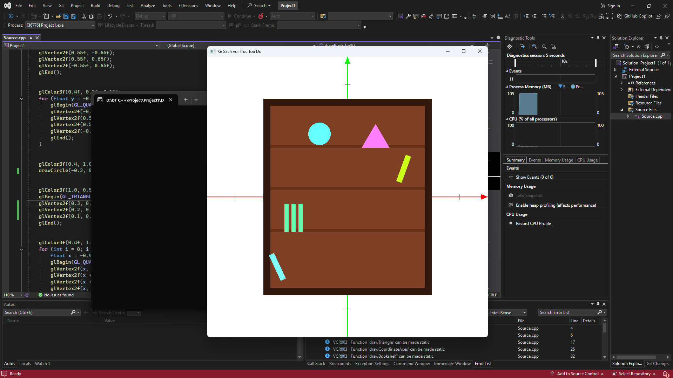
#include <GL/glut.h>
#include <cmath>

#define PI 3.14159265

void drawCircle(float cx, float cy, float r, int num_segments) {
glBegin(GL_POLYGON);
for (int i = 0; i < num_segments; i++) {
float theta = 2.0f * PI * float(i) / float(num_segments);
float x = r * cosf(theta);
float y = r * sinf(theta);
glVertex2f(x + cx, y + cy);
}
glEnd();
}

void drawTriangle() {
glBegin(GL_TRIANGLES);
glVertex2f(-0.05f, 0.55f);
glVertex2f(0.05f, 0.55f);
glVertex2f(0.0f, 0.65f);
glEnd();
}

void drawCoordinateAxes() {

glLineWidth(1.5f);

glColor3f(1.0f, 0.0f, 0.0f);
glBegin(GL_LINES);
glVertex2f(-1.0f, 0.0f);
glVertex2f(1.0f, 0.0f);
glEnd();

glBegin(GL_TRIANGLES);
glVertex2f(0.95f, 0.02f);
glVertex2f(1.0f, 0.0f);
glVertex2f(0.95f, -0.02f);
glEnd();

glColor3f(0.0f, 1.0f, 0.0f);
glBegin(GL_LINES);
glVertex2f(0.0f, -1.0f);
glVertex2f(0.0f, 1.0f);
glEnd();

glBegin(GL_TRIANGLES);
glVertex2f(-0.02f, 0.95f);
glVertex2f(0.0f, 1.0f);
glVertex2f(0.02f, 0.95f);
glEnd();

glColor3f(0.5f, 0.5f, 0.5f);
glLineWidth(1.0f);

for (float x = -0.8f; x <= 0.8f; x += 0.2f) {
if (fabs(x) > 0.01f) {
glBegin(GL_LINES);
glVertex2f(x, -0.02f);
glVertex2f(x, 0.02f);
glEnd();
}
}

for (float y = -0.8f; y <= 0.8f; y += 0.2f) {
if (fabs(y) > 0.01f) {
glBegin(GL_LINES);
glVertex2f(-0.02f, y);
glVertex2f(0.02f, y);
glEnd();
}
}
}

void drawBookshelf() {

glColor3f(0.2f, 0.1f, 0.05f);
glBegin(GL_QUADS);
glVertex2f(-0.6f, -0.7f);
glVertex2f(0.6f, -0.7f);
glVertex2f(0.6f, 0.7f);
glVertex2f(-0.6f, 0.7f);
glEnd();

glColor3f(0.5f, 0.25f, 0.15f);
glBegin(GL_QUADS);
glVertex2f(-0.55f, -0.65f);
glVertex2f(0.55f, -0.65f);
glVertex2f(0.55f, 0.65f);
glVertex2f(-0.55f, 0.65f);
glEnd();

glColor3f(0.4f, 0.2f, 0.1f);
for (float y = -0.25f; y <= 0.45f; y += 0.3f) {
glBegin(GL_QUADS);
glVertex2f(-0.55f, y);
glVertex2f(0.55f, y);
glVertex2f(0.55f, y + 0.02f);
glVertex2f(-0.55f, y + 0.02f);
glEnd();
}

glColor3f(0.4, 1.0, 1.0);
drawCircle(-0.2, 0.45f, 0.08, 100);

glColor3f(1.0, 0.5, 1.0);
glBegin(GL_TRIANGLES);
glVertex2f(0.3, 0.35);
glVertex2f(0.2, 0.52);
glVertex2f(0.1, 0.35);
glEnd();

glColor3f(0.4f, 1.0f, 0.7f);
for (int i = 0; i < 3; ++i) {
float x = -0.45f + i * 0.05f;
glBegin(GL_QUADS);
glVertex2f(x, -0.25f);
glVertex2f(x + 0.03f, -0.25f);
glVertex2f(x + 0.03f, -0.05f);
glVertex2f(x, -0.05f);
glEnd();
}

glPushMatrix();
glTranslatef(0.4f, 0.2f, 0);
glRotatef(-20, 0, 0, 1);
glColor3f(0.8f, 1.0f, 0.1f);
glBegin(GL_QUADS);
glVertex2f(-0.02f, -0.1f);
glVertex2f(0.02f, -0.1f);
glVertex2f(0.02f, 0.1f);
glVertex2f(-0.02f, 0.1f);
glEnd();
glPopMatrix();

glPushMatrix();
glTranslatef(-0.5f, -0.5f, 0);
glRotatef(25, 0, 0, 1);
glColor3f(0.5f, 1.0f, 1.0f);
glBegin(GL_QUADS);
glVertex2f(-0.02f, -0.1f);
glVertex2f(0.02f, -0.1f);
glVertex2f(0.02f, 0.1f);
glVertex2f(-0.02f, 0.1f);
glEnd();
glPopMatrix();
}

void display() {
glClear(GL_COLOR_BUFFER_BIT);

drawCoordinateAxes();

drawBookshelf();

glFlush();
}

void init() {
glClearColor(1.0, 1.0, 1.0, 1.0);
gluOrtho2D(-1.0, 1.0, -1.0, 1.0);
}

int main(int argc, char** argv) {
glutInit(&argc, argv);
glutInitWindowSize(800, 800);
glutCreateWindow("Ke Sach voi Truc Toa Do");
init();
glutDisplayFunc(display);
glutMainLoop();
return 0;
}

