ĐÀO TIẾN DŨNG
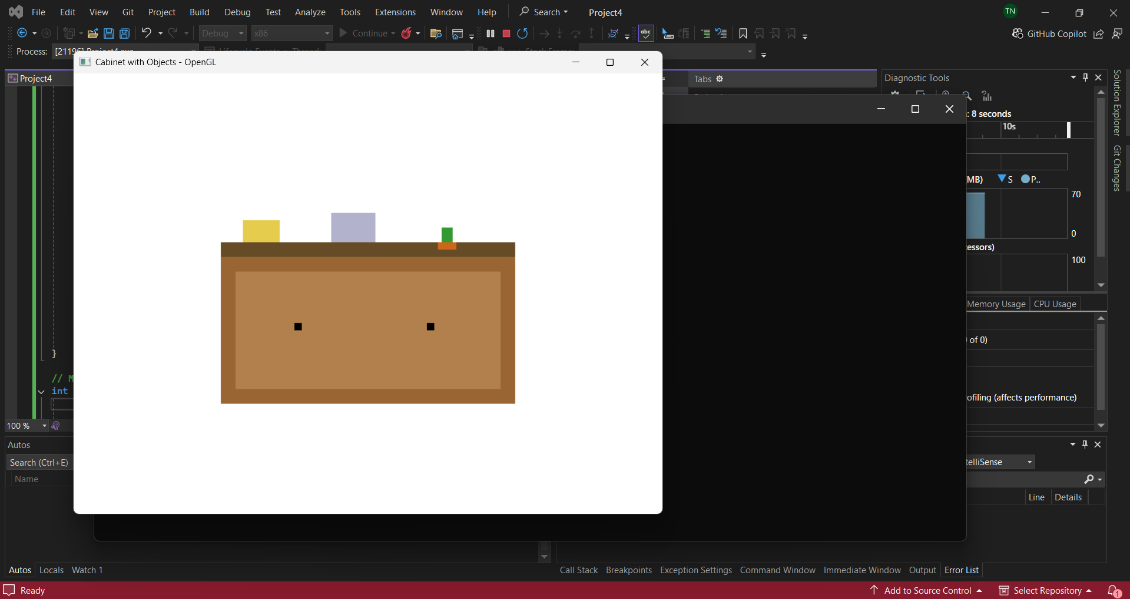
#include "GLUT.H"

// Function to initialize OpenGL settings
void init() {
glClearColor(1.0f, 1.0f, 1.0f, 1.0f); // White background
glMatrixMode(GL_PROJECTION);
gluOrtho2D(0.0, 800.0, 0.0, 600.0); // 2D coordinate system
}

// Function to draw a rectangle (used for cabinet and drawer)
void drawRectangle(float x, float y, float width, float height, float r, float g, float b) {
glColor3f(r, g, b);
glBegin(GL_QUADS);
glVertex2f(x, y);
glVertex2f(x + width, y);
glVertex2f(x + width, y + height);
glVertex2f(x, y + height);
glEnd();
}

// Function to draw the cabinet and objects
void display() {
glClear(GL_COLOR_BUFFER_BIT);

// Draw cabinet base
drawRectangle(200, 150, 400, 200, 0.6f, 0.4f, 0.2f); // Brown base

// Draw cabinet top
drawRectangle(200, 350, 400, 20, 0.4f, 0.3f, 0.15f); // Darker brown top

// Draw drawers
drawRectangle(220, 170, 180, 160, 0.7f, 0.5f, 0.3f); // Left drawer
drawRectangle(400, 170, 180, 160, 0.7f, 0.5f, 0.3f); // Right drawer

// Draw drawer handles
drawRectangle(300, 250, 10, 10, 0, 0, 0); // Left handle
drawRectangle(480, 250, 10, 10, 0, 0, 0); // Right handle

// Draw teapot (simplified)
drawRectangle(230, 370, 50, 30, 0.9f, 0.8f, 0.3f); // Yellow teapot

// Draw box (simplified)
drawRectangle(350, 370, 60, 40, 0.7f, 0.7f, 0.8f); // Light grey box

// Draw plant
drawRectangle(500, 370, 15, 20, 0.2f, 0.6f, 0.2f); // Green plant
drawRectangle(495, 360, 25, 10, 0.8f, 0.4f, 0.1f); // Brown pot

glFlush();
}

// Main function
int main(int argc, char** argv) {
glutInit(&argc, argv);
glutInitDisplayMode(GLUT_SINGLE | GLUT_RGB);
glutInitWindowSize(800, 600);
glutInitWindowPosition(100, 100);
glutCreateWindow("Cabinet with Objects - OpenGL");

init();
glutDisplayFunc(display);

glutMainLoop();
return 0;
}

