ĐỀ LẺ

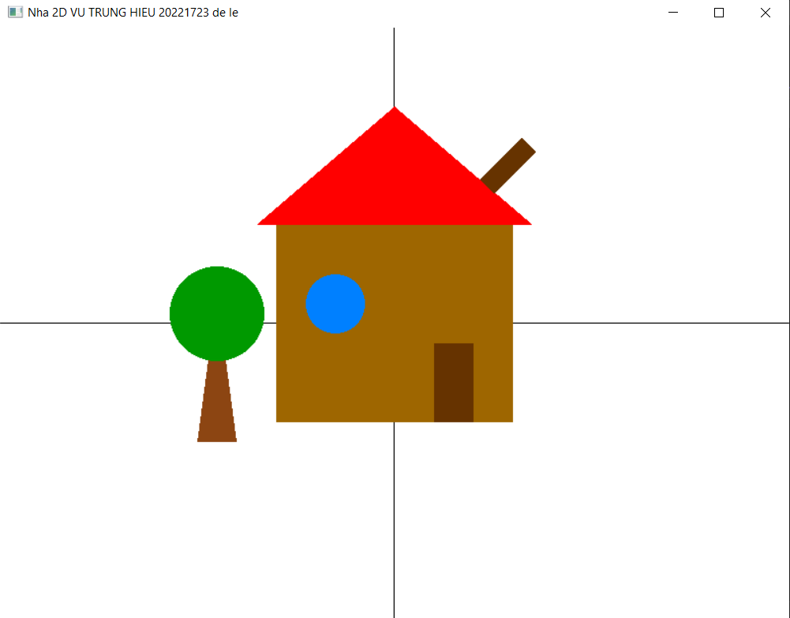

#include "glut.h"
#include <cmath>

void init() {
glClearColor(1.0, 1.0, 1.0, 1.0); // Nền
glMatrixMode(GL_PROJECTION);
gluOrtho2D(0, 800, 0, 600); // Không gian 2D
}

void drawCircle(float cx, float cy, float r, int num_segments) {
glBegin(GL_POLYGON);
for (int i = 0; i < num_segments; i++) {
float theta = 2.0f * 3.1415926f * i / num_segments;
float x = r * cosf(theta);
float y = r * sinf(theta);
glVertex2f(cx + x, cy + y);
}
glEnd();
}

void drawAxes() {
glColor3f(0.0f, 0.0f, 0.0f);
glBegin(GL_LINES);
// Trục X
glVertex2i(0, 300); glVertex2i(800, 300);
// Trục Y
glVertex2i(400, 0); glVertex2i(400, 600);
glEnd();
}

void display() {
glClear(GL_COLOR_BUFFER_BIT);
drawAxes();

glColor3f(0.55f, 0.27f, 0.07f); // Thân cây
glBegin(GL_TRIANGLES);
glVertex2i(200, 180);
glVertex2i(220, 330);
glVertex2i(240, 180);
glEnd();

glColor3f(0.0f, 0.6f, 0.0f); // Tán cây
drawCircle(220, 310, 48, 100);

glColor3f(0.62f, 0.40f, 0.0f); // Tường nhà
glBegin(GL_QUADS);
glVertex2i(280, 200);
glVertex2i(520, 200);
glVertex2i(520, 400);
glVertex2i(280, 400);
glEnd();

// Mái nhà
glColor3f(1.0f, 0.0f, 0.0f);
glBegin(GL_TRIANGLES);
glVertex2i(260, 400);
glVertex2i(540, 400);
glVertex2i(400, 520);
glEnd();

// Ống khói
glColor3f(0.4f, 0.2f, 0.0f);
glPushMatrix();
glTranslatef(487, 446, 0);
glRotatef(-45, 0, 0, 1);
glBegin(GL_QUADS);
glVertex2i(0, 0);
glVertex2i(20, 0);
glVertex2i(20, 60);
glVertex2i(0, 60);
glEnd();
glPopMatrix();

// Cửa sổ
glColor3f(0.0f, 0.5f, 1.0f);
drawCircle(340, 320, 30, 100);

// Cửa
glColor3f(0.4f, 0.2f, 0.0f);
glBegin(GL_QUADS);
glVertex2i(440, 200);
glVertex2i(480, 200);
glVertex2i(480, 280);
glVertex2i(440, 280);
glEnd();

glFlush();
}

int main(int argc, char** argv) {
glutInit(&argc, argv);
glutInitWindowSize(800, 600);
glutInitDisplayMode(GLUT_SINGLE | GLUT_RGB);
glutCreateWindow("Nha 2D VU TRUNG HIEU 20221723 de le");
init();
glutDisplayFunc(display);
glutMainLoop();
return 0;
}

