Wordpress Basic Document
https://www.youtube.com/watch?v=hulzJQnpxE8
1. Set up source Wordpress
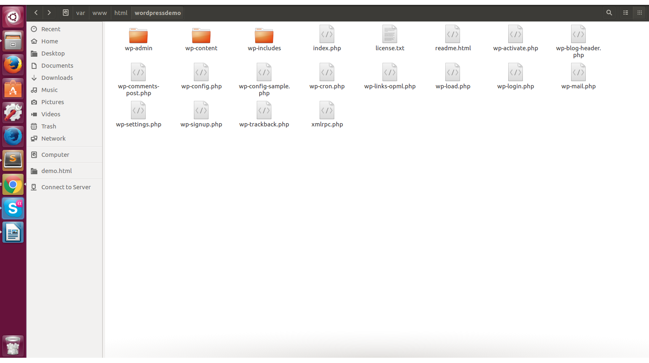
Image 1: Source code
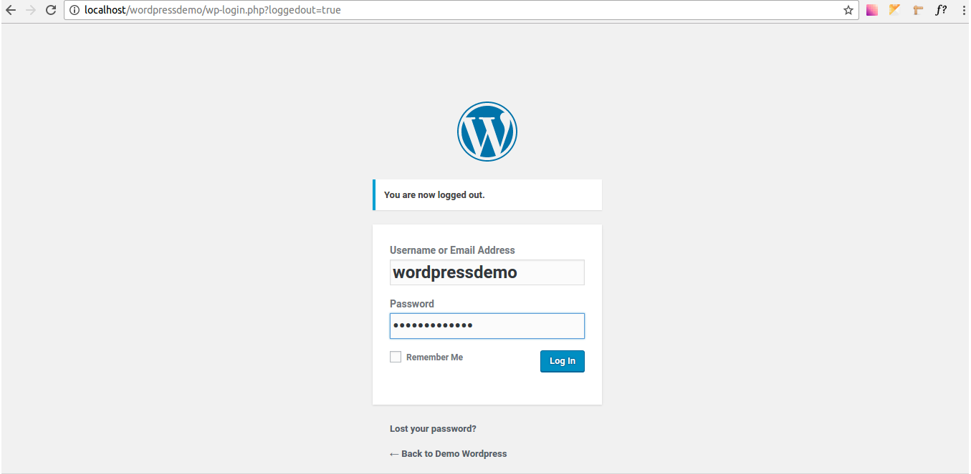
Image 2: Login Wordpress

2. Active theme
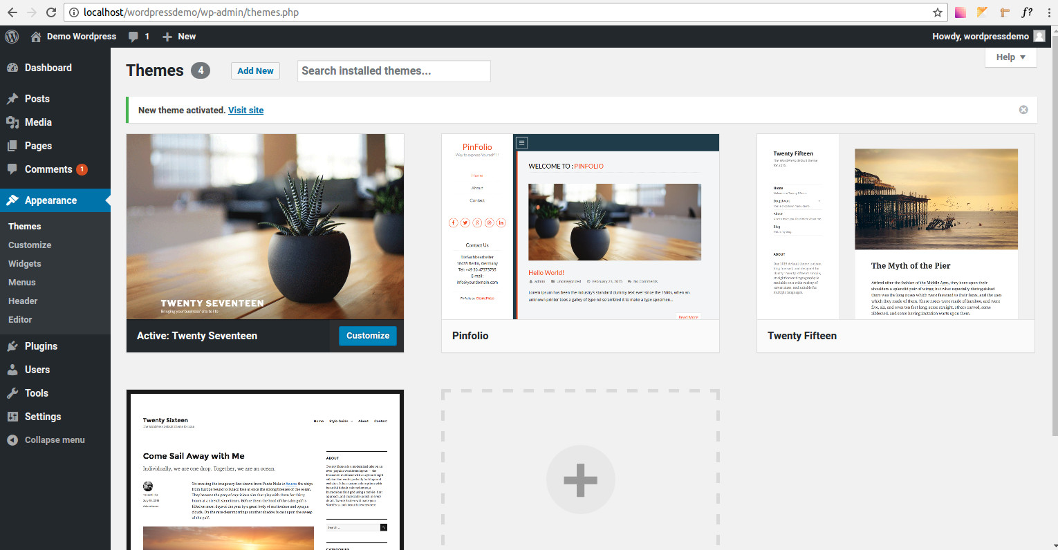
Image 3: Default theme

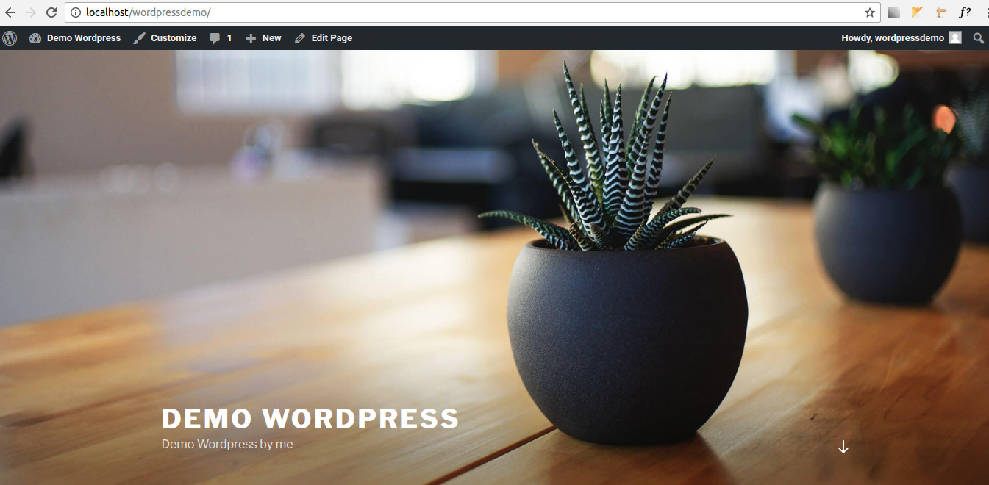
Image 4: Show Wordpress
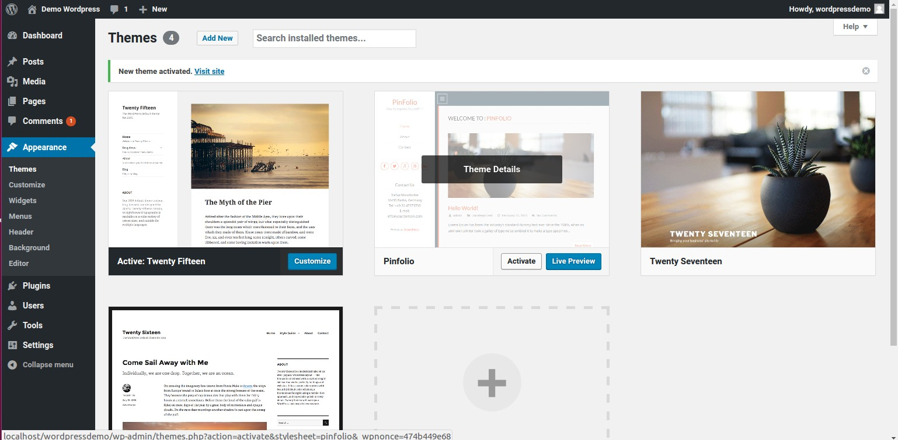
Image 5: Active Theme
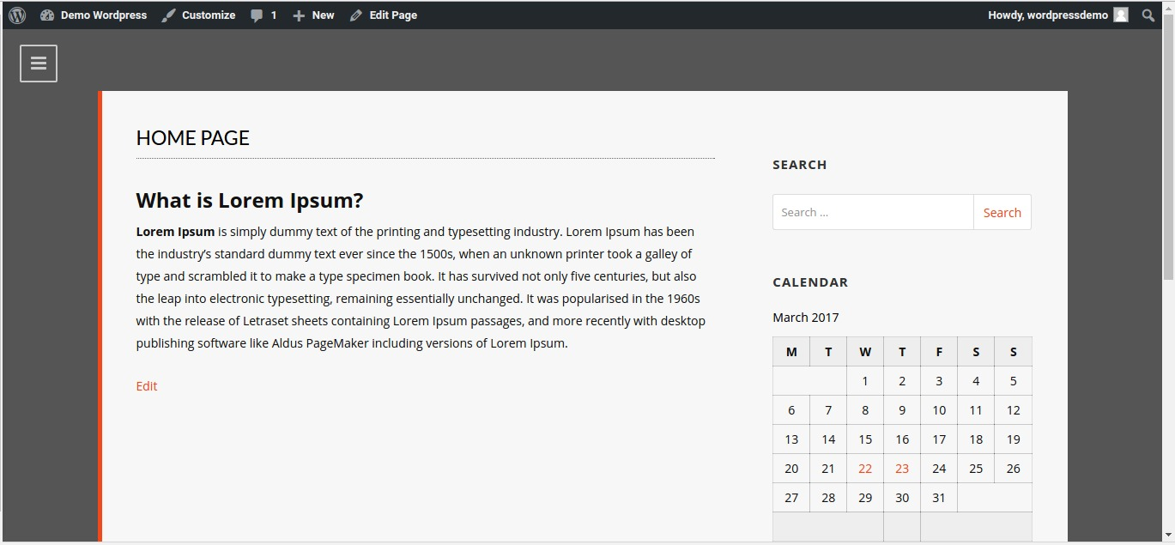
mage 5: Update Theme

3. POSTS
- Post management: add new, edit, add image,..
http://localhost/wordpressdemo/wp-admin/edit.php
- Categories:
http://localhost/wordpressdemo/wp-admin/edit-tags.php?taxonomy=category
- Tags:
http://localhost/wordpressdemo/wp-admin/edit-tags.php?taxonomy=post_tag

4. MEDIA
http://localhost/wordpressdemo/wp-admin/upload.php

- Library:
http://localhost/wordpressdemo/wp-admin/upload.php

5. PAGE:
- Page management: add new, edit,..
http://localhost/wordpressdemo/wp-admin/edit.php?post_type=page

6. COMMENTS:
- Comments management:
http://localhost/wordpressdemo/wp-admin/edit-comments.php

7. APPEARANCE:
- Themes:
http://localhost/wordpressdemo/wp-admin/themes.php
- Customize:
http://localhost/wordpressdemo/wp-admin/customize.php?return=%2Fwordpressdemo%2Fwp-admin%2Fthemes.php
- Widgets:
http://localhost/wordpressdemo/wp-admin/widgets.php
- Menu:
http://localhost/wordpressdemo/wp-admin/nav-menus.php
- Header:
http://localhost/wordpressdemo/wp-admin/customize.php?return=%2Fwordpressdemo%2Fwp-admin%2Fnav-menus.php&autofocus%5Bcontrol%5D=header_image
- Background:
http://localhost/wordpressdemo/wp-admin/customize.php?return=%2Fwordpressdemo%2Fwp-admin%2Fnav-menus.php&autofocus%5Bcontrol%5D=background_image
- Editor:
http://localhost/wordpressdemo/wp-admin/theme-editor.php

8. PLUGINS
- Plugins management:
http://localhost/wordpressdemo/wp-admin/plugins.php
- Set up plugin “TinyMCE Advanced”

9. USERS
- User management:
http://localhost/wordpressdemo/wp-admin/users.php

10. TOOLS
- Tools management:
http://localhost/wordpressdemo/wp-admin/tools.php

11. SETTINGS
- Setting management:
http://localhost/wordpressdemo/wp-admin/options-media.php
+ General
+ Writing
+ Reading
+ Discussion
+ Media
+ Permalinks

