Up to this point, the game has some basic functionality:
- SkiaLine can move when touch with hit detection and reverse animation upon hits
- Back button and restart Button
- Grid space
Now I want to build something that make the MOAT for the game
Milestone 1: User takes a picture, we convert that picture to 125px x125px image, and then we map each coordinates in the picture to the grid that we currently have or in this case, the “gridPicture” - the color corresponding to the pixel from the image.
Milestone 2: The interesting part now is how to automatically create LINES-DATA that make it actually playable.
- But How?
Back to the point of the game, all SkiaLine have to “escape” in order to win what the arrows data has to satisfy is that:
- RULE 1: Each SkiaLine MUST HAVE NO SELF-LOOP. Explanation, and example:
Take a look at these datas for example, notice how the head (has the pointy arrow, at point A) hit its own body in (0,3).
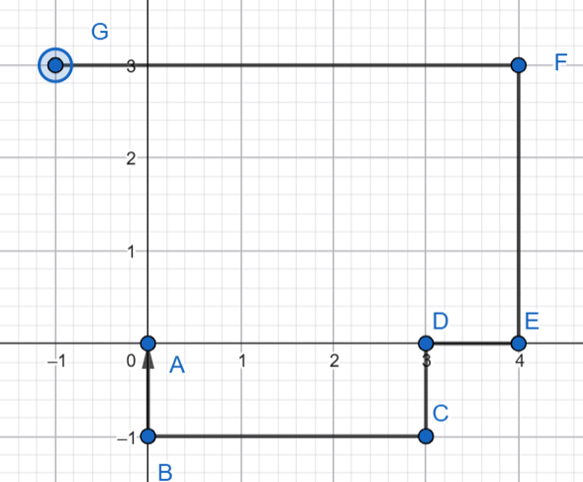
Arrow’s coordinates at this case is (only corner and end point coordinates, from start to end)
A (0,0) - B (-1,0) - C(3,-1) - D(0,3) - E(4,0) - F(4,3) - G(-1,3)
- RULE 2: MUST NOT HAVE BLOCKING-RELATIONSHIP IN A LOOP EXISTING BETWEEN 2 OR MORE SkiaLine.
“What the hell does that mean, Blocking-relationship in a loop” – ok, says SkiaLine 1 block SkiaLine 2 and SkiaLine 2 block SkiaLine 1, this is a pairwise blocking-relationship.
And of course, SkiaLine 1 block SkiaLine 2, SkiaLine 2 block SkiaLine 3 . . . SkiaLine N block SkiaLine 1, THIS is a N blocking-relationship
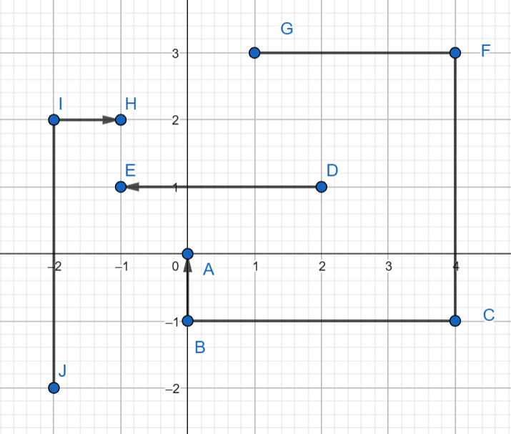
In this case, SkiaLine 1 is ABCFG, SkiaLine 2 is ED, SkiaLine 3 is HIJ, notice how SkiaLine 2 blocks SkiaLine 1, SkiaLine 1 blocks SkiaLine 3 and SkiaLine 3 blocks back SkiaLine 1. This means the 3 lines have blocking-relationship and we don’t want that, since it would make the game unplayable.
- RULE 3: The arrow MUST ONLY HAVE 1 COLOR / ONE ARROW MUST SPAN A SET OF GRID POINTS THAT ARE ALL SAME COLOR
- RULE 4: SkiaLine MUST CONTAIN AT LEAST 2 CONSECUTIVE GRID CELLS, if in the process of creating arrow, there is one cell that is left with all its neighboring cell occupied by other arrow, different in colors with it, that cell is left blank, but we’ll try to make this situation appear as rare as possible.
Now this is my thought process on how to solve the Milestone 2, says we completed MileStone 1:
Ok, we can first see that each color owns its own set of grid cells, and that set can scatter, like when we take picture, its possible that theres a bit black here and there, blue, here and there, take a simple example, take picture of 2 water bottles stand 5 inches far from each other, there’s bit blue on right side of picture separate by the background and a bit blue of the other bottle on the left side.
Uhm, ok, we will remember that, notice how the game is built like this, at every state of the game there has to be at least one arrow that is escapable. Remember that in mind, so this is how I’m going to build the data. So we are going to draw the arrow from the finished state. Each of them one by one.
So to ensure that: exist one escapable arrow at any state of the game, the escaping arrow at that state has to have the coordinates of the arrowhead at the extreme points of the available grid cell + pointing outward, since we treat it as an escapable arrow so if the arrowhead is not at extreme point and/or points towards some of the available grid cells on its way, the next state we have to make all point that are pointed to blanked, making it unavailable to place other arrows in the states after (so this arrow can escape, if we were to make some arrows in the states after occupy those grid points, WE VIOLATES RULE 2, and this broke our flow, since we make the data from finish to start so the arrows after shall not block the current one or the one before). And we want to avoid that since we want to keep the color of the image, the purpose is to some how make the grand scheme looks like original image so making points blank really destroy the purpose. And by “blanked” I mean blanked as in RULE 4.
Oh and by extreme points, its just a stricter case of “points don’t have any available points (or having blank space) on top of it (can move up / point up), or below it (can move down / point down), or to the left or right (point or move the sides”. I personally would prefer this one compared to the latter. Lets just call all of them “place-head” points. And since the arrowhead are choose to place in those positions + pointing outward, we don’t afraid to VIOLATE RULE 1.
Ok now we finished finding the constraints of the arrow head, the arrow body will be find like this,, it depends on 2 parts, one coordinate that is consecutive to the head coordinate and one coordinate is the end point:
- Depends on the direction of the arrow, where we decide the arrowhead is pointing to, the coordinate that is consecutive to the head will be placed in the opposite direction, for example if the head is at (0,0), and it is pointing to the right, then the coordinate is (-1,0). We call these type of points “direction-define” points.
- For the end point, we can choose what ever cell that is same color with the head point so RULE 3 IS SATISFIED, but there might be situations where the head is in one set of points that is divided by blank space from the set of points that the end point is in, then there is no way to connect them, so the head have to be placed in the same set of points that is not separated from blank space with the head, take an example
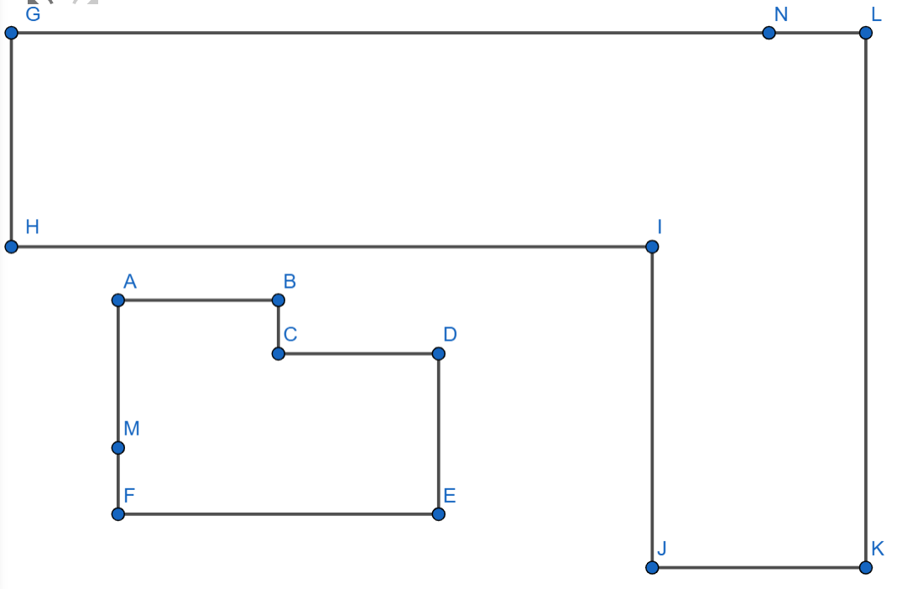
Imagine, inside polygon ABCDEF all the points has color white, the same as GLKJH also contains points with white color only, then the head is select at point M and the tail is selected at point N, apparently there is no way to connect them, since between the two polygon, there is blank space, so point N has to be somewhere in ABCDEF this is just an illustration for the real case but I hope you get what I mean. That blank space between the two polygon could have different colors or might be occupied by other arrows at previous states.
But there is also case, where, the “place-head” point has blank space both on the top and bottom, then we cannot place the “direction-defined” point to the above or below it, and these “place-head” points are only narrow down to the one that has free space to the left or right. Example:
Imagine there is the set of available point on line AB, and inside rectangle CDFE (including edges).
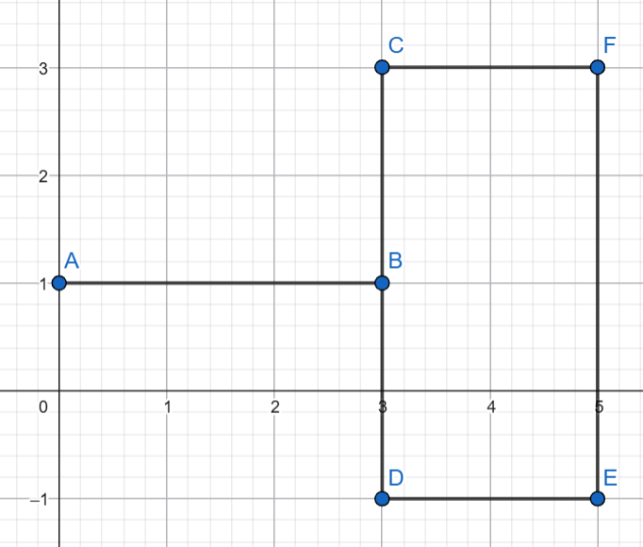
Notice if we choose point on line AB, the only point we can choose is point A, same case for “place-head” point has blank space to the right and left. So now for the same of time complexity, “place-head” points are now in this case:
- Points have odd numbers of free direction (ex. top – down – left, left – down – right, . . ., only left, only right, only top, only down)
- Points have 2 free directions but these 2 directions musn’t be opposite (ex. Left – top, left down, right - down, right – left, . . .)
- . . . and ofcourse point with all 4 free directions is blanked.
After find all “place-head” points, “direction-define” points and tail, the path is connected using the library “l1-path-finder”, after the path is created, all grid points that the path cover are considered “blank” or “unavailable” the process keep looping until all points are placed by one arrow or left blank with neighbor points occupied or have different color.
So this is the final algorithm:
- Scan for “place-head” points
- Choose “direction-defined" points (or choose the direction of the arrow)
- Find tail points
- Draw path
- All points on that path are considered free space now
- Do it again until only blank points / all points occupied left.
So that’s my thought process, I’m quite worry about the time complexity tho, lucky this is just upon creation not per frame as the SkiaLine moving forward and reverse on hit do.
Demonstration:
Suppose these are the set of points that have same color and separated by blank space or points that are different color.
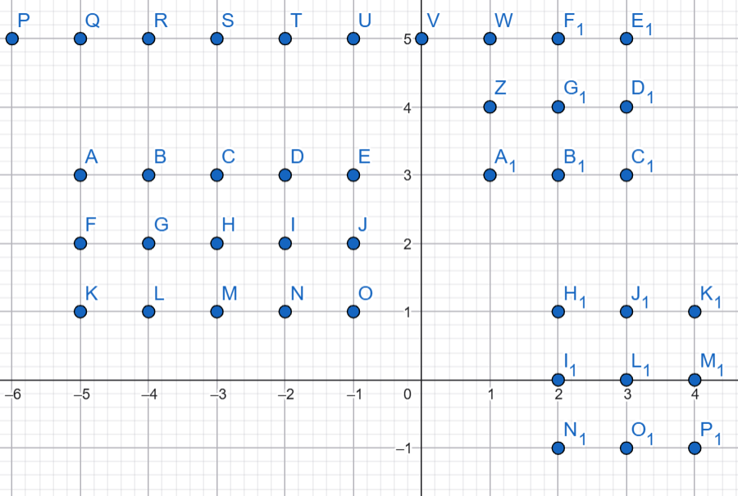
- Step 1: choose “place-head” point, in this case I chose point O (1 free direction, downward, since on the right we have H1,J1,K1 and on the left we have N,M,L,K and on the upper side we have I,D,T)
- Step 2: choose “direction-define” point, since the direction is facing down so the only choice left is now point J
- Step 3: Notice that I can’t choose point P or H1, since they are separated with the head point with blank space, the point I chose is A
- Step 4: Suppose the path algorithm chose line as A F J O
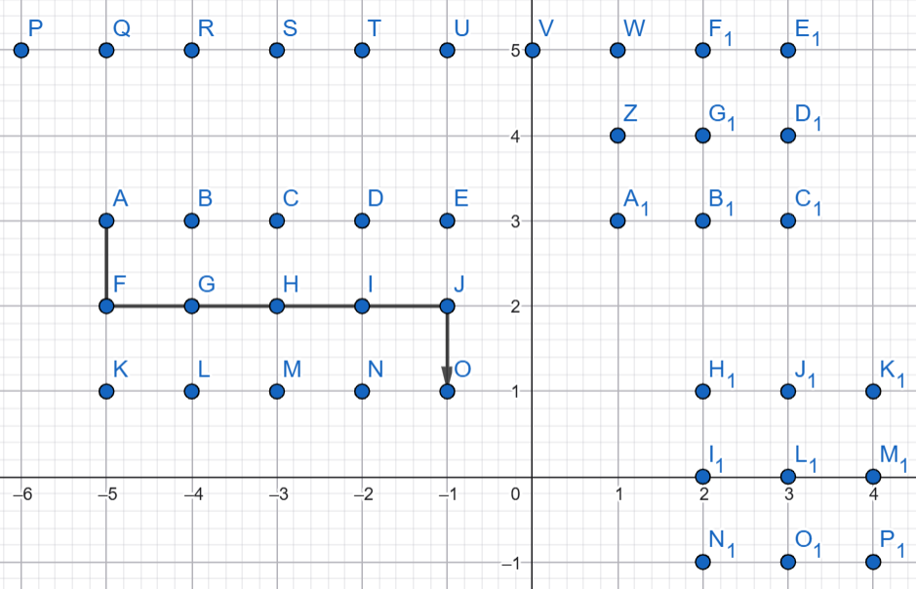
- Step 5, freed up the point the line occupied
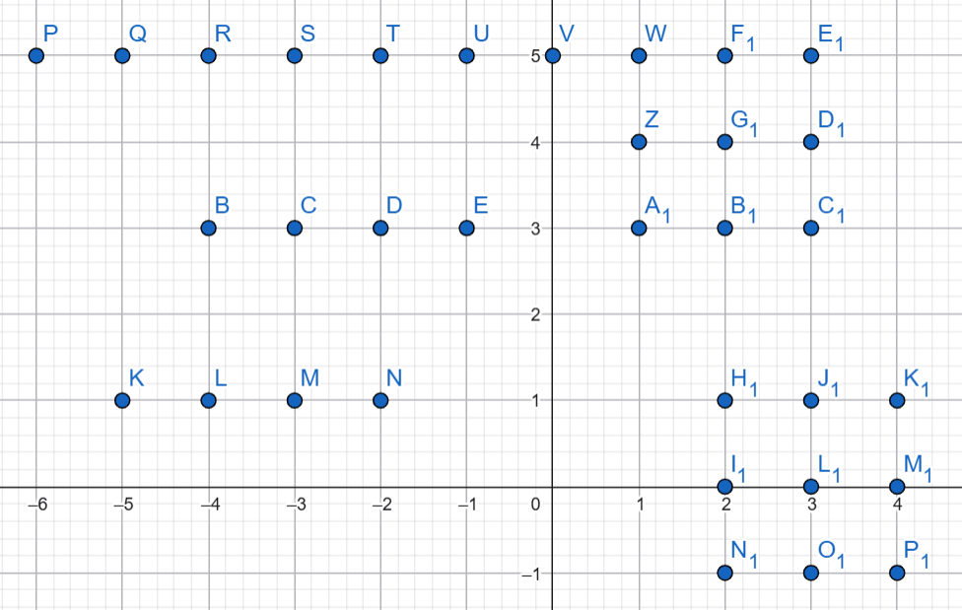
Says the second line is D C B
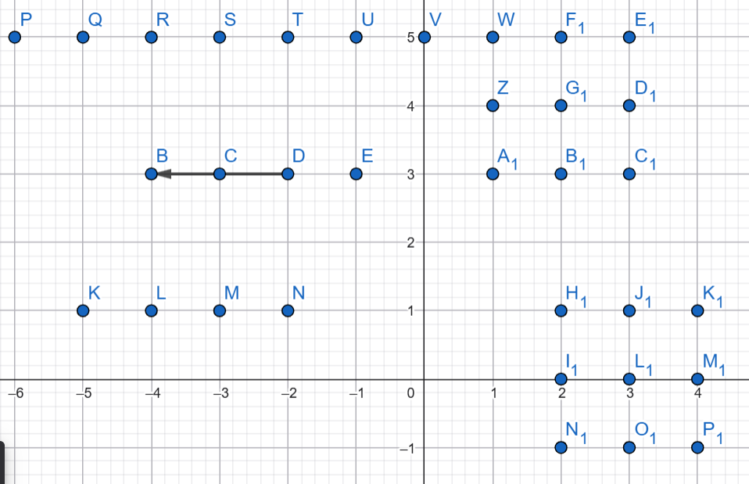
Now point E is left alone with all blank space, and since we don’t want to violate RULE 4 (all line has to occupy at least 2 points) so now point E is considered blank.
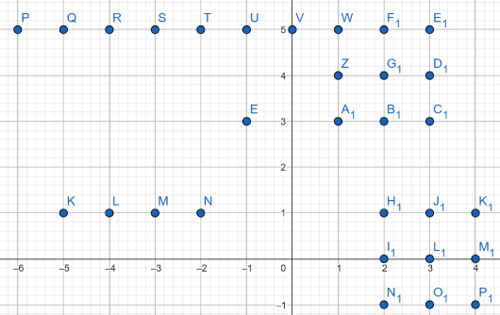

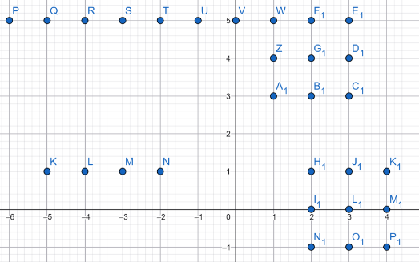
- Step 6: Repeat
Finally all data point are store and drawn.

