2280601411-Nguyên Khang-Week4

Bài 2 thực hành

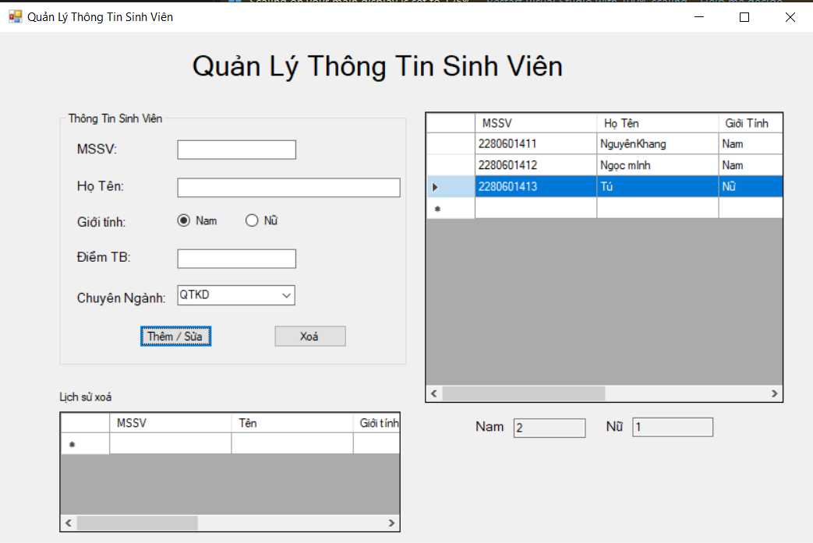

Bài 3 thực hành

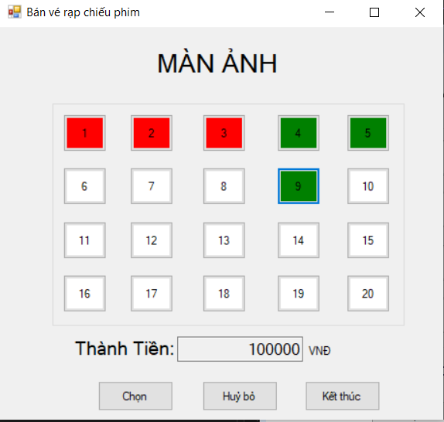

Lab6:

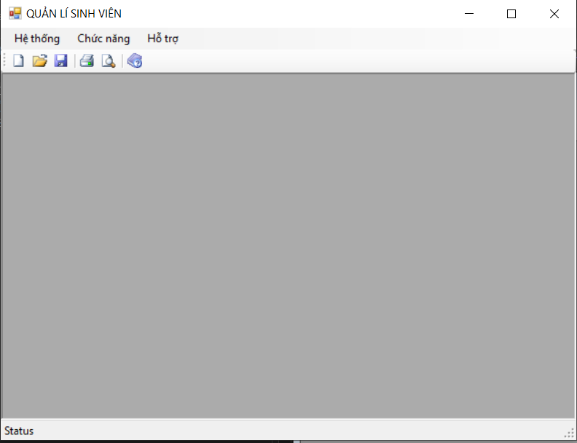

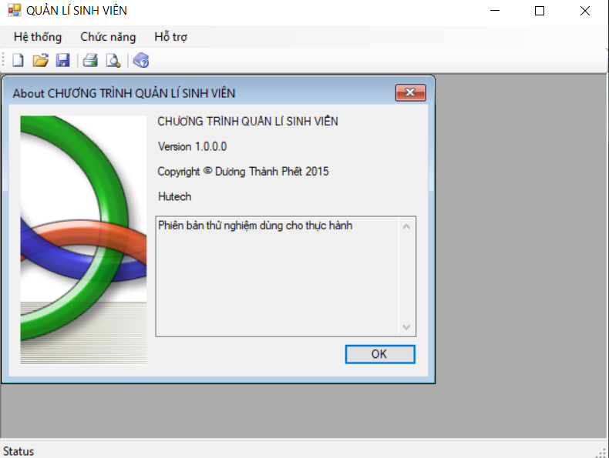

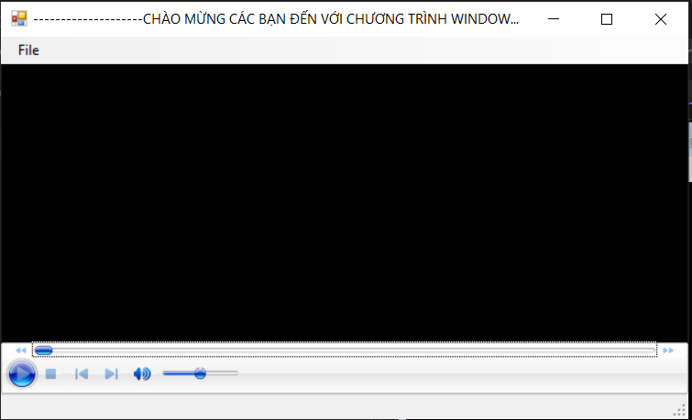

Link source code: <https://github.com/NguynKng/LapTrinh_Window/tree/main/Week4>