*Lab hướng dẫn thực hành Xây dựng Website Bán sách với ASP.Net MVC 5*

**Lab 01:**

**THIẾT KẾ CSDL VÀ XÂY DỰNG LAYOUT WEBSITE BOOKS STORE**

✔ **Tạo CSDL và các Table trong CSDL QLBansach**

o **Tạo CSDL**

|  |
| --- |
| ---Xoa CSDL QLBansach neu da co use master  Drop Database QLBansach  -----Tao CSDL QLBansach  create database QLBANSACH  GO  use QLBANSACH |

o **Bảng Khách hàng: KHACHHANG**

|  |  |  |  |
| --- | --- | --- | --- |
| **Field Name** | **Data Type** | **Constraint** |  |
| **MaKH** | Int (Auto) |  |  |
| HoTen | nVarchar(50) | Not Null |
| Taikhoan | Varchar(50) | Unique |
| Matkhau | Varchar(50) | Not Null |
| Email | Varchar(100) | Unique |
| DiachiKH | nVarchar(200) |  |
| DienthoaiKH | Varchar(50) |  |
| Ngaysinh | Datetime |  |
| GO  CREATE TABLE KHACHHANG  (  MaKH INT IDENTITY(1,1),  HoTen nVarchar(50) NOT NULL,  Taikhoan Varchar(50) UNIQUE,  Matkhau Varchar(50) NOT NULL,  Email Varchar(100) UNIQUE,  DiachiKH nVarchar(200),  DienthoaiKH Varchar(50),  Ngaysinh DATETIME  CONSTRAINT PK_Khachhang PRIMARY KEY(MaKH)  ) | | | |

o **Bảng Chủ đề : CHUDE**

|  |  |  |  |
| --- | --- | --- | --- |
| **Field Name** | **Data Type** | **Constraint** |  |
| **MaCD** | Int (Auto) |  |  |
| Tenchude | nVarchar(50) | Not Null |
| GO  Create Table CHUDE  (  MaCD int Identity(1,1),  TenChuDe nvarchar(50) NOT NULL,  CONSTRAINT PK_ChuDe PRIMARY KEY(MaCD)  ) | | | |

o **Bảng Nhà xuất bản: NHAXUATBAN**

|  |  |  |  |
| --- | --- | --- | --- |
| **Field**  **Name** | **Data Type** | **Constraint** |  |
| **MaNXB** | Int(Autonumber) |  |  |
| TenNXB | nVarchar(50) | Not Null |
| Diachi | nVarchar(200) |  |
| Dienthoai | Varchar(50) |  |
| GO  Create Table NHAXUATBAN  (  MaNXB int identity(1,1),  TenNXB nvarchar(50) NOT NULL,  Diachi NVARCHAR(200),  DienThoai VARCHAR(50),  CONSTRAINT PK_NhaXuatBan PRIMARY KEY(MaNXB)  ) | | | |

o Bảng Sách: **SACH**

|  |  |  |  |
| --- | --- | --- | --- |
| **Field Name** | **Data Type** | **Constraint** |  |
| **Masach** | Int(Auto) |  |  |
| Tensach | Nvarchar(100) | Not Null |
| Giaban | Decimal(18,0) | Giabana>=0 |
| Mota | nVarchar(Max ) |  |
| Anhbia | Varchar(50) |  |
| Ngaycapnha t | SmallDateTim e |  |
| Soluongton | Int | Soluongban> 0 |
| MaCD | Int |  |
| MaNXB | Int |  |
| Go  CREATE TABLE SACH  (  Masach INT IDENTITY(1,1),  Tensach NVARCHAR(100) NOT NULL,  Giaban Decimal(18,0) CHECK (Giaban>=0),  Mota NVarchar(Max),  Anhbia VARCHAR(50),  Ngaycapnhat DATETIME,  Soluongton INT,  MaCD INT,  MaNXB INT,  Constraint PK_Sach Primary Key(Masach),  Constraint FK_Chude Foreign Key(MaCD) References | | | |

|  |
| --- |
| CHUDE(MaCD),  Constraint FK_NhaXB Foreign Key(MaNXB)References  NHAXUATBAN(MANXB)  ) |

o Bảng Tác giả: **TACGIA**

|  |  |  |  |
| --- | --- | --- | --- |
| **Field Name** | **Data Type** | **Constraint** |  |
| **MaTG** | Int(Autonumber) |  |  |
| TenTG | nVarchar(50) | Not Null |
| Diachi | nVarchar(100) |  |
| Tieusu | nVarchar(Max) |  |
| Dienthoai | Varchar(15) |  |
| GO  CREATE TABLE TACGIA  (  MaTG INT IDENTITY(1,1),  TenTG NVARCHAR(50) NOT NULL,  Diachi NVARCHAR(100),  Tieusu nVarchar(Max),  Dienthoai VARCHAR(50),  CONSTRAINT PK_TacGia PRIMARY KEY(MaTG)  ) | | | |

o Bảng Viết Sách : **VIETSACH**

|  |  |  |  |
| --- | --- | --- | --- |
| **Field Name** | **Data Type** | **Constraint** |  |
| **MaTG** | Int |  |  |
| **Masach** | Int |  |
| Vaitro | nVarchar(50) |  |
| Vitri | nVarchar(50) |  |
| GO  CREATE TABLE TACGIA  (  MaTG INT IDENTITY(1,1),  TenTG NVARCHAR(50) NOT NULL,  Diachi NVARCHAR(100),  Tieusu nVarchar(Max),  Dienthoai VARCHAR(50),  CONSTRAINT PK_TacGia PRIMARY KEY(MaTG)  ) | | | |

o Bảng Đơn đặt hàng : **DONDATHANG**

|  |  |  |  |
| --- | --- | --- | --- |
| **Field Name** | **Data Type** | **Constraint** |  |
| **MaDonHang** | Int (Auto) |  |  |
| MaKH | Int |  |
| NgayDH | Datetime |  |

|  |  |  |  |
| --- | --- | --- | --- |
| Ngaygiao | Datetime |  |  |
| Dathanhtoan | Bit | Default 0 |
| Tinhtranggiaohang | Bit | Default 0 |
| GO  CREATE TABLE DONDATHANG  (  MaDonHang INT IDENTITY(1,1),  Dathanhtoan bit,  Tinhtranggiaohang bit,  Ngaydat Datetime,  Ngaygiao Datetime,  MaKH INT,  CONSTRAINT FK_Khachhang FOREIGN KEY MaKH  REFERENCES Khachhang(MaKH),  CONSTRAINT PK_DonDatHang PRIMARY KEY Dondathang(MaDonHang) ) | | | |

o Bảng Chi tiết đặt hang: **CTDATHANG**

|  |  |  |  |
| --- | --- | --- | --- |
| **Field Name** | **Data Type** | **Constraint** |  |
| **MaDonHang** | Int |  |  |
| **Masach** | Int |  |
| Soluong | Int | Soluong>0 |
| Dongia | Decimal(18,0) | Dongia>=0 |
| Go  CREATE TABLE CHITIETDONTHANG  (  MaDonHang INT,  Masach INT,  Soluong Int Check(Soluong>0),  Dongia Decimal(18,0) Check(Dongia>=0),  CONSTRAINT PK_CTDatHang PRIMARY KEY(MaDonHang,Masach), CONSTRAINT FK_Donhang FOREIGN KEY Madonhang  REFERENCES Dondathang(Madonhang),  CONSTRAINT FK_Sach FOREIGN KEY Masach  REFERENCES Sach(Masach)  ) | | | |

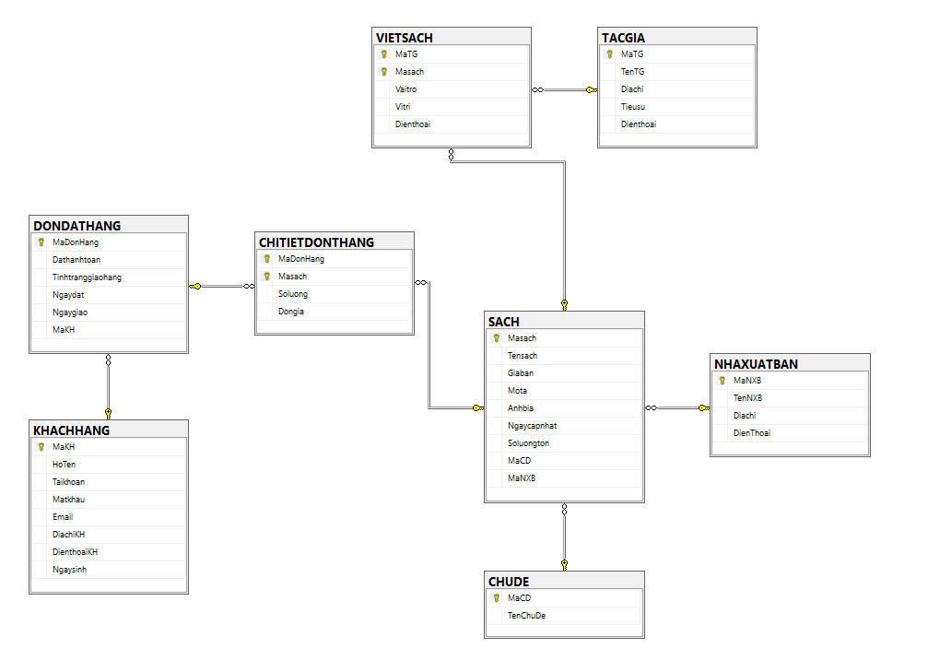✔ **Diagram của CSDL QLBansach**

**Kết quả**

