Title of the Paper in English, Be Concise, Specific and Relevant, Bold, Times New Roman, Size 13
Full name (in English Order: EO; for example: Van A Tran NOT Tran Van A) of first author^{1*}, Full name (in EO) of second author², Full name (in EO) of third author¹
¹Affiliation for first author (just write the name of the university and the country, for example: Ho Chi Minh City University of Technology and Education, Vietnam)
² Affiliation for second author (more detailed information such as department, faculty, or the university's address should not be provided here, but in the authors’ biography section)
* Corresponding author. Email: abc@xyz.com
ARTICLE INFO |  | ABSTRACT
Received: |  | The abstract must be 150 to 250 words and NOT include formatted equations. The abstract should be a single paragraph, without abbreviations, comments and references (If references are required, enter the author's name and year in brackets). It should follow the style of structured abstracts, but without headings and numberings, including the following aspects: 1) Questions and purpose of the study 2) Research methods: Describe the way/method to solve the problem(s), such as develop theory/ methods of data collection, data processing... 3) Results: Summarize the articles main findings, including data that may be taken as essential remarks of the study. The results must be presented in a way that addresses the proposed research questions. 4) Conclusion: One or two sentences to conclude the research results and their possible applications. The abstract must provide information briefly, include data to illustrate, and get straight to the point. Keywords: immediately after the abstract; provide a minimum of 5 keywords; avoid general and plural terms and multiple concepts (avoid, for example, 'and', 'of'); be sparing with abbreviations (only abbreviations firmly established in the field may be eligible). These keywords will be used for indexing purposes, separated by a semicolon, end by a dot.
Revised:
Accepted:
Published:
KEYWORDS
Keyword 1;
Keyword 2;
Keyword 3;
Keyword 4;
Keyword 5.
Doi: https://doi.org/10.54644/jte.2026.xxxx
Copyright © JTE. This is an open-access article distributed under the terms and conditions of the Creative Commons Attribution-NonCommercial 4.0 International License which permits unrestricted use, distribution, and reproduction in any medium for non-commercial purpose, provided the original work is properly cited.

1. Introduction
The Introduction provides the background and motivation for the research. It explains why the study was conducted, what problem it addresses, and how it contributes to existing knowledge. A well-written Introduction in IEEE format usually includes five key elements as in Table 1.
Table 1. IEEE-Style Introduction Outline.
Part | Content | Example phrase
Background | What is the topic? Why is it important? | “Recently, ... has attracted considerable attention.”
Problem | What is missing or unsolved? | “However, ... remains a significant challenge.”
Related work | What has been done before? | “Several studies have addressed this issue [1]–[3], but ...”
Objective | What does this paper propose or achieve? | “In this paper, we propose ...”
Paper organization | How is the paper structured? | “The rest of this paper is organized as follows…”
This article template lets you quickly format your article and helps with the placement of specific elements, such as title, author list, abstract, keywords and the paper structure. It would be noted that all manuscripts must contain the essential elements needed to convey your manuscript.
  - The article outline
The article must include: Front matter, Maintext/body, Back matter.
1.1.1. Front matter
The front matter has to include: Title, Authors’ Fullname and Affiliation, Abstract, Keywords (at least 5)
1.1.2. Maintext/body
The front matter must contain: Introduction, Materials and Methods, Results and Discussions, and Conclusions.
The article must be written in the IMRAD structure (Introduction – Methods/Materials – Results – Discussion). The IMRAD structure is a standard format in the international scientific community.
1.1.3. Back matter
The back matter must contain: Acknowledgments, Conflict of Interest, Data Availability Statement, References, and Authors’ Biography.
  - The article layout
1.2.1. The article format
The layout format must be set to A4 size, portrait orientation, with the following Page Setup parameters: Top: 3.0 cm, Bottom: 2.5 cm, Left: 3.0 cm, Right: 2.0 cm, Header from Top: 1.0 cm, Footer from Bottom: 1.2 cm. Article content uses 11-point Times New Roman font.; line spacing: single, before 0; after 3; justified margin. Figure 1 shows the demonstration of JTE article layout.
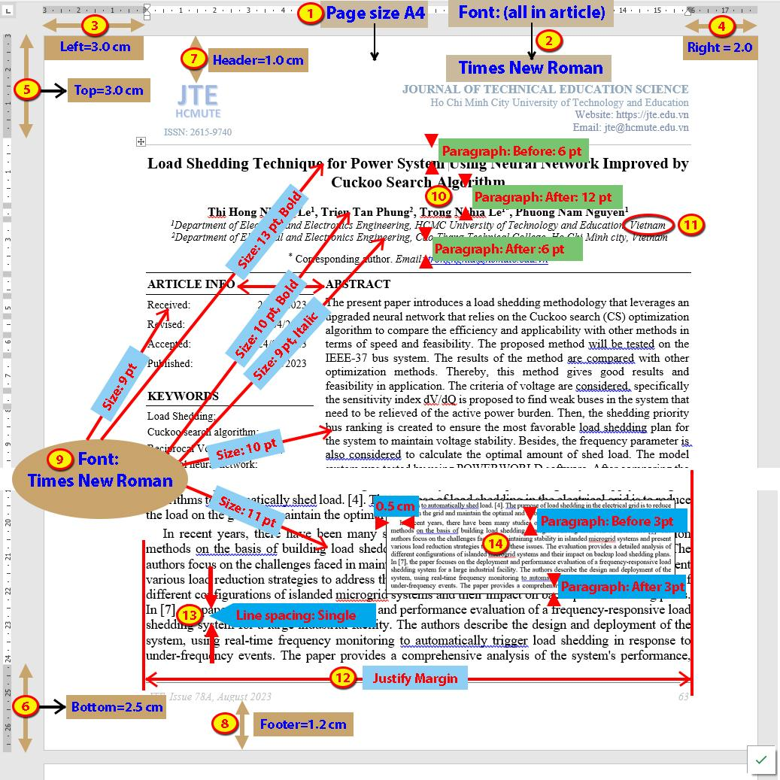
Figure 1. Guidelines of page setup, font name and size, paragraph margin, and spacing.
1.2.2. The article section headings
Major section headings (Level 1) are left-aligned, in bold, with initial capitals (11 pt). Subsection headings (Level 2) are left-aligned, in bold, in italic, with initial capitals. Sub-subsection headings (Level 3) are left-aligned, in italic, with initial capitals. All headings and main text use 11-point Times New Roman font, do not use the automatic numbering. The number of heading levels should not exceed three. The headings of any sections must set the line spacing: single, before 6; after 6. See Figures 1, 2 for reference. Figure 2 shows the setup of the windows of the JTE section headings.
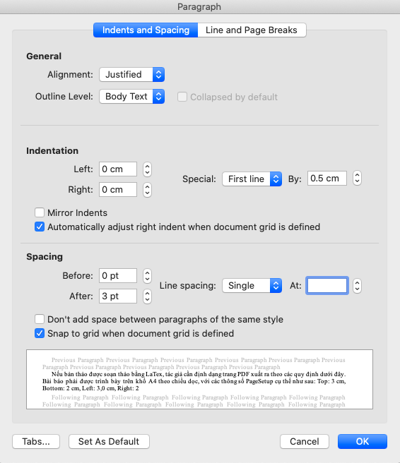 | 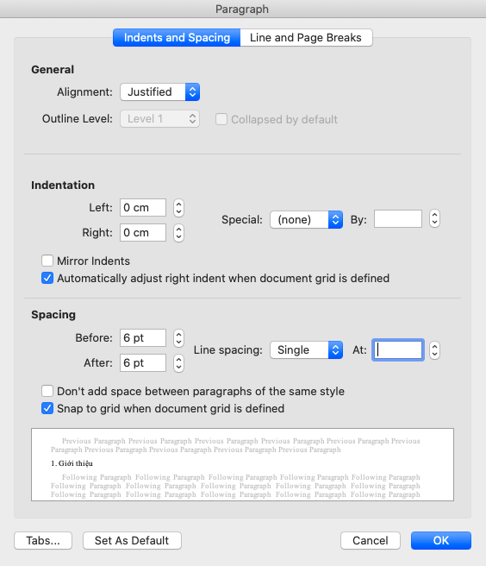
(a) | (b)
Figure 2. Paragraph setup for (a): Content text and (b) Heading of any section
1.2.3. The article length
The paper must not exceed 10 pages in length (excluding the references and author's biography). If the content exceeds this limit, less essential materials should be placed in a separate supplementary file. The supplementary information should be made available online through a link provided in the Data Availability Statement section.
1.2.4. The article title
In the title, all nouns, pronouns, adjectives, verbs, adverbs, and subordinating conjunctions (If, Because, That, Which) should be capitalized. Capitalize abbreviations that are otherwise lowercase (i.e., use DC, not dc or Dc) except for unit abbreviations and acronyms. Articles (a, an, the), coordinating conjunctions (and, but, for, or, nor), and most short prepositions are lowercase unless they are the first or last word. Prepositions of more than three letters (Before, From, Through, With, Versus, Among, Under, Between, Without) are capitalized.
Examples:
∙ Nonlinear Gain Coefficients in Semiconductor Lasers: Effects of Carrier Heating
∙ Self-Pulsation in an InGaN Laser—Part I: Theory and Experiment
1.2.5. The article structure
The article must be written in the IMRAD structure (Introduction – Methods/Materials – Results – Discussion). The IMRAD structure is a standard format in the international scientific community.
  - References, figure, and table
References should be numbered in the order of their appearance in the text and indicated by numerals in square brackets, e.g., [1], [2], [3], ... . The list of references should be arranged in the same numerical order as they are cited in the text. All figures and tables must also be referred to in the text in numerical order.
1.3.1. References
References are numbered in the order of their first appearance in the text. Each reference number is enclosed in square brackets, e.g., [1], [2], [3]. Multiple references are grouped together: [1]–[3] or [1], [4], [5]. The title of the section is “REFERENCES” in all caps and centered. Journal and book titles are in italics, article titles in regular font.
For example:
[1] J. M. Smith and K. Tan, “A survey of wireless sensor networks,” IEEE Communications Surveys & Tutorials, vol. 15, no. 3, pp. 987–1005, Sep. 2021.
[2] A. Brown, Modern Control Systems, 3rd ed., New York, NY, USA: McGraw-Hill, 2019.
1.3.2. Figures
Figures should be numbered consecutively in the order they are mentioned in the text: Figure 1, Figure 2, Figure 3, etc. Each figure must be cited in the text before or immediately after it appears. Figure captions are placed below the figure, centered, in 10-point Times New Roman with line spacing: single, before 6; after 6
Example:
Figure 3. Illustrative images based on ethical standard A.2.
Figures should be clear, legible, and of high resolution (≥300 dpi), use black and white unless color is necessary. All text in figures (labels, legends, etc.) should be readable at journal size.
According to ethical standard A.2, the information in the article must be presented concisely and clearly. Figures in the article should not contain blank areas or unnecessary details. Any text (if present) within the figures must have a readable font size that is proportional to the font size of the article (unless the author intends to emphasize a specific point). Composite images (for comparison purposes) should have consistent reference frames. The examples below illustrate figures that meet and do not meet these criteria. Examples of acceptable and unacceptable figures are shown in Figure 3.
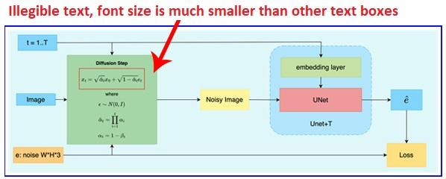
(a) Font size is not proportional.
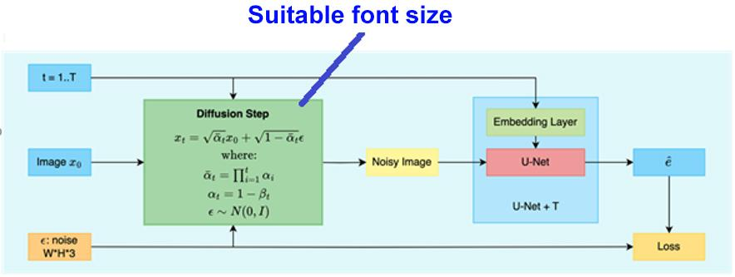
(b) Well-balanced font size.
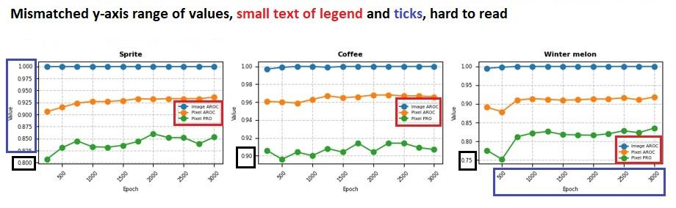
(c) Y-axis values are mismatched.
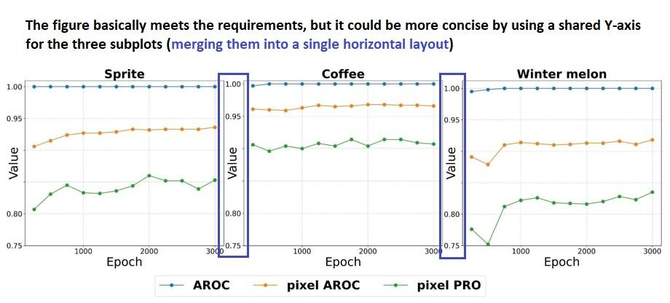
(d) Consistent Y-axis values make it easier for readers to compare and contrast the data.
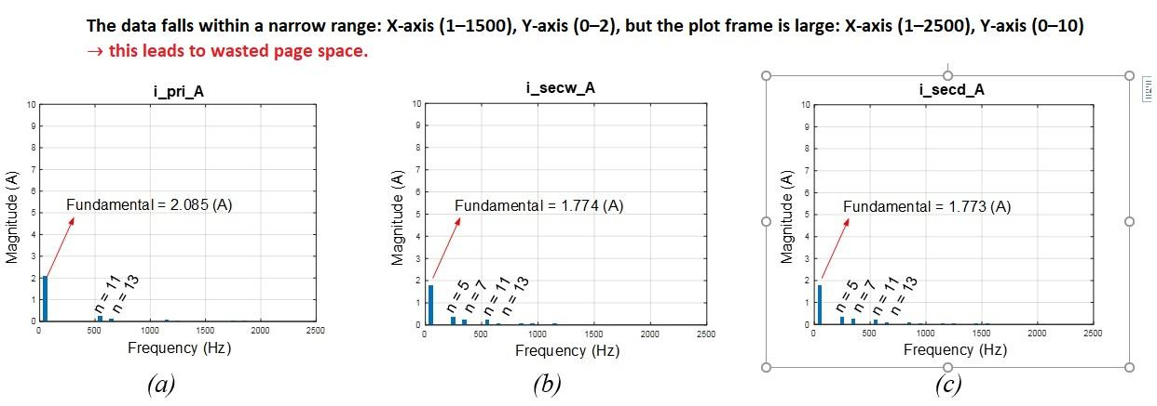
(e) The frame size is disproportionate to the content.
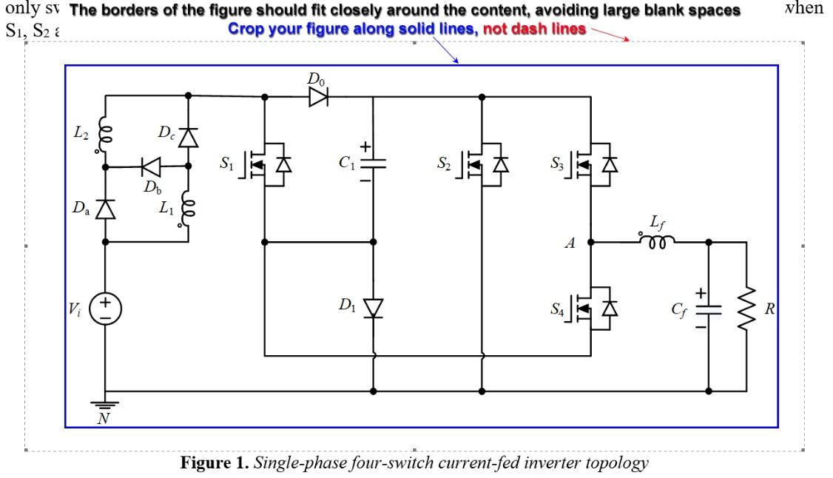
(f) The image is not tightly cropped to the content area, resulting in excessive empty space (above Figure 1), which makes editing and layout more difficult.
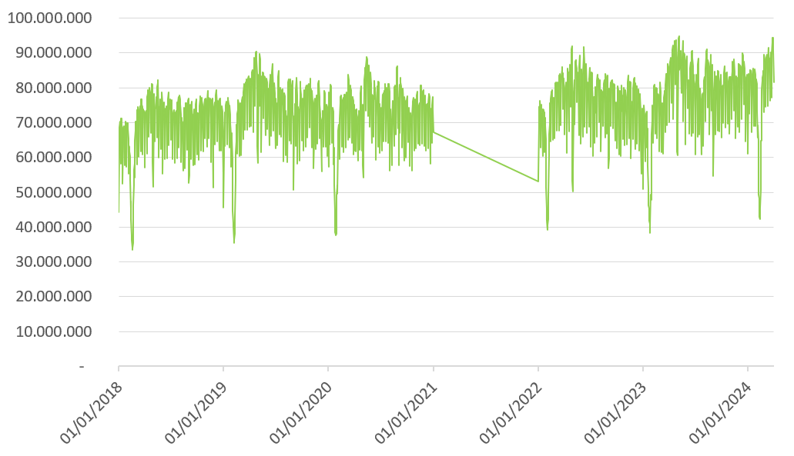
(g) The y-axis value is long and not scientifically shown.
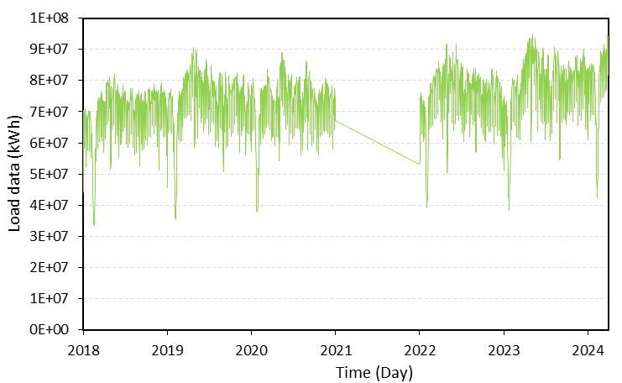
(h) The y-axis and x-axis are suitably shown.
Figure 3. Illustrative images based on ethical standard A.2
(a), (c), (e), (f), and (g): unacceptable images.
(b), (d), and (h): acceptable images.
1.3.3. Tables
Tables are numbered consecutively and cited in the text in numerical order: Table 1, Table 2, Table 3, etc. Table titles are placed above the table, left-aligned, in 10-point Times New Roman, with line spacing: single, before 6; after 6
Example:
Table 2. IEEE-Style Abbreviation and Acronym Guidelines.
The title should be concise and descriptive. Every figure or table must be mentioned in the text in ascending order. Avoid placing figures or tables before their first mention.
Note: table components must be in editable text, not as screenshots. Table Properties have Table tab with Preferred Width = 16 cm, Table options with Top = 0, Bottom = 0, Left = 0,05 Right = 0,05 cm, Row tab with Not check Specify height. Font size of text inside table = 10, Layout of Table with Spacing Before = 3pt, After = 3pt, Line Spacing: Single. No borders for the left and right edges of the table; the first row of the table (which is the title of each column) should not be left blank or missing information.
1.4. Equations
Important equations should be numbered consecutively throughout the paper. Only equations that are referenced in the text need to be numbered. When referring to an equation, use only the number in parentheses:
- Correct: as shown in (1)
- Correct (at the beginning of a sentence): Equation (1) shows that …
- Incorrect: as shown in Eq. (1) (avoid “Eq.” in the middle of a sentence)
The equation number should be right-aligned and enclosed in parentheses, line spacing: single, before 6; after 6. For example:
$x=\frac{-b±\sqrt{b^{2}-4ac}}{2a}$ | (1)
An example of figures, tables, section headings, subheadings, and an equation is shown in Figure 4.

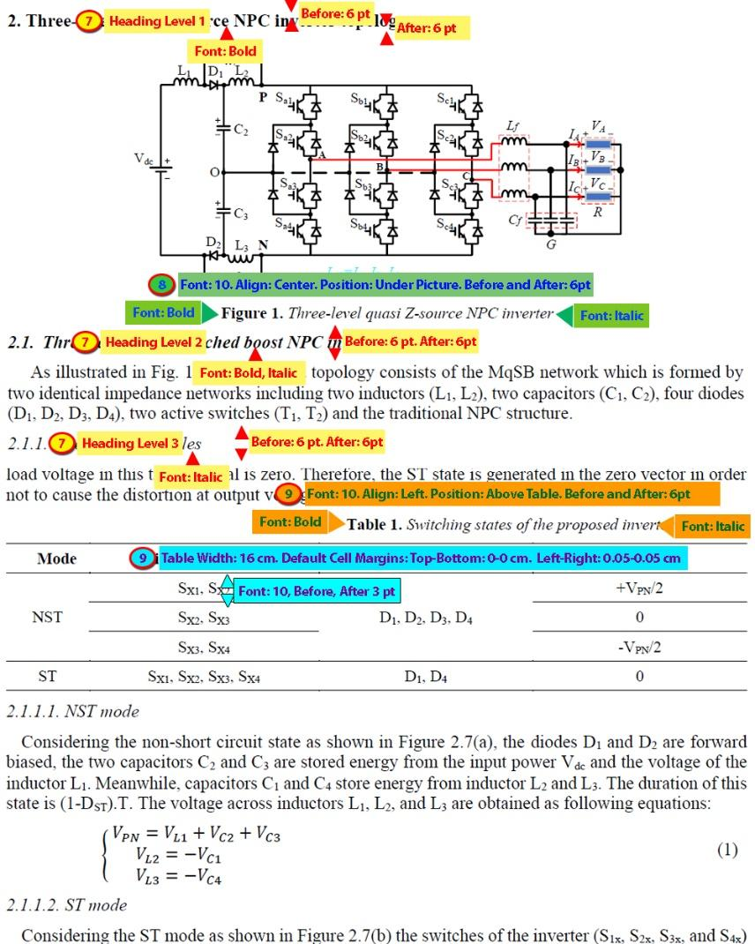
Figure 4. Guidelines of figures, of tables, section headings, and subheadings.
1.5. Abbreviation and acronym
When an abbreviation or acronym first appears in the text, spell out the full term, followed by the abbreviation in parentheses. Thereafter, you can use the abbreviation on its own.
For example, Orthogonal Frequency Division Multiplexing (OFDM) is widely used in modern communication systems. OFDM provides high spectral efficiency and robustness against multipath fading.
Regulations of abbreviations or acronyms are summarized as Table 2.
Table 2. IEEE-Style Abbreviation and Acronym Guidelines.
Rule | Description | Example
Define on first use | Full term + (abbreviation) | “Support Vector Machine (SVM)”
No need to define common terms | Use as is | “LED”, “GHz”, “IEEE”
Keep consistent | Same acronym throughout | Always use “SVM”, not “Support VM”
Plurals | Add “s” only | “CPUs”, not “CPU’s”
Titles & abstracts | Avoid or define immediately | “... using an ANN-based approach”
1.6. Unit and number
It must be consistently used International System of Units (SI Units) for the data in the article. Other kinds of units should be converted to SI units whenever possible. Italic format is applied for symbols of calculated quantities. Decimals presented in Vietnamese articles by "," and by "." in English articles. Use a space between the number and the unit symbol. For example:
✅ Correct: 10 mA, 5 V, 20 °C
❌ Incorrect: 10mA, 5V, 20°C

2. Materials and Methods
This part should describe in detail the ways or methods, materials, and devices necessary to solve the research problems. They should be described with sufficient detail so that other researchers can replicate and build on published results. New methods and protocols should be described in detail, while well-established methods can be briefly described and appropriately cited. The approach might involve theoretical development, empirical research, surveys, etc. The applied approach should explain its advantages and, if possible, compare it with previous studies. In theoretical research, there should be theoretical foundations for solving research problems.

3. Results and Discussion
This section shows the results obtained from doing research. Images or tables could be used to illustrate the results and support for discussions. Authors should discuss the results and how they can be interpreted in the perspective of previous studies and of the working hypotheses. The findings and their implications should be discussed in the broadest possible context, and the work's limitations should be highlighted. Future research directions may also be mentioned.
If necessary, one part of the article might be divided into several sections. It is possible to provide information introducing small parts between the main heading of the section and the subheading. Subheadings (Heading level 2) are in size 11, Bold and Italic as follows.

4. Conclusions
This section summarizes important outcomes drawn from Section 3: Results and Discussion. Note to avoid duplicating Abstract. It could be the orientations of research, development, and the application of research results.

Acknowledgments
All of contributing individuals and organizations of the study should be disclosed. The sponsors of the research are shown here. For example, authors can write: “This work belongs to the project in 2022 funded by the Ho Chi Minh City University of Technology and Education, Vietnam”

Conflict of Interest
Authors must confirm “no conflict of interest”, write down as “The authors declare no conflict of interest.”

Declaration of generative AI and AI-assisted technologies in the writing process
During the preparation of this work, the authors used ChatGPT for English-language editing. After using this tool/service, the authors reviewed and edited the content as needed and take full responsibility for the publication's content.

Data Availability Statement
If the article exceeds 10 pages, the excess will be provided as supporting information. You can display your supporting information on your own or institutional website. The authors describe how to provide readers with supporting information here. Authors can write: “The data that support the findings of this study are available from the corresponding author upon reasonable request.”
REFERENCES
Please ensure that every reference cited in the text is also present in the reference list (and vice versa). Any references cited in the abstract must be given in full. References must be numbered in order of appearance in the text and listed individually at the end of the manuscript. We recommend preparing the references with a bibliography software package, such as EndNote, Mendely, or Zotero... or use “Insert Citation” in MS Word to avoid typing mistakes and duplicated references.
Citations in the text should follow the referencing style of IEEE (see the reference guide at https://ieeeauthorcenter.ieee.org/wp-content/uploads/IEEE-Reference-Guide.pdf). Some important notes are given below.
References need not be cited in the text. When they are, they appear on the line, in square brackets, inside the punctuation. Grammatically, they may be treated as if they were nouns or footnote numbers, e.g.: According to [1]; as demonstrated in [2]; as shown by Brown [4], [5]; as mentioned earlier [2], [4], [5], [6], [7], [9]; Smith [4] and Brown and Jones [5]; Wood et al. [7]. Reference ranges in text will not include an en dash. All references will be written out. For example, “[1]–[4]” will now be “[1], [2], [3], [4]”.
**NOTE: Use “et al.” when three or more names are given for a reference cited in the text
References must be numbered in order of appearance in the article. The order of references should be manually typed, not use a numbered list in Word, and have Paragraph properties with Indentation Left = 0, Special = Hanging By = 0,75 cm. References have font size 8, Justify Alignment, Spacing Before and After = 0
All references must be presented in Roman characters, i.e., in English.
Some common examples of references in IEEE format are demonstrated as below: [1] for article without DOI ([2] is equivalent example), [3] for article with DOI (([4] is equivalent example)), [5] for article with ID ([6] is equivalent example), [7] for article in other Language ([8] is equivalent example), [9] for article with url (for example), [10] for unpublished paper (for example), [11] for article in conference proceedings without DOI ([12] is equivalent example), [13] for article in conference proceedings with DOI ([14] is equivalent example), [15] for Paper Presented at a Conference ([16] is equivalent example), [17] for book, [18] for book with chapter title ([19] is equivalent example), [20 for patent], [21] for dissertations (for example), [22] for standards (for example):
[1] J. K. Author, “Name of paper,” Abbrev. Title of Periodical, vol. x, no. x, pp. xxx-xxx, Abbrev. Month, year.
[2] T. T. C. Duong, C. C. Nguyen, and T. D. Tran, "Synchronization Sliding Mode Control of Closed-Kinematic Chain Robot Manipulators with Time-Delay Estimation," Appl. Sci., vol. 12, no. 11, p. 5527, 2022.
[3] J. K. Author “Name of paper,” Abbrev. Tite of Periodical, vol. x, no. x, pp. xxx-xxx, Abbrev. Month, year, doi: xxx
[4] G. R. Sheu et al., “Distribution of atmospheric mercury in northern Southeast Asia and South China Sea during Dongsha Experiment,” Atmos. Environ., vol. 78, pp. 174–183, Oct. 2013, doi: 10.1016/J.ATMOSENV.2012.07.002.
[5] J. K. Author, “Name of paper,” Abbrev. Title of Periodical, vol. x, no. x, Abbrev. month, year, Art. no. xxx.
[6] J. Zhang and N. Tansu, “Optical gain and laser characteristics of InGaN quantum wells on ternary InGaN substrates,” IEEE Photon. J., vol. 5, no. 2, Apr. 2013, Art no. 2600111.
[7] J. K. Author, “Name of paper,” (in Language), Abbrev. Title of Periodical, vol. x, no. x, Abbrev. month, year, Art. no. xxx
[8] E. P. Wigner, “On a modification of the Rayleigh–Schrodinger perturbation theory,” (in German), Math. Naturwiss. Anz. Ungar. Akad. Wiss., vol. 53, p. 475, 1935.
[9] J. K. Author, “Name of paper,” Abbrev. Title of Periodical, vol. x, no. x, pp. xxx–xxx, Abbrev. Month, year. Accessed: Month, Day, Year, doi: 10.1109.XXX.123456. [Online]. Available: site/path/file
(for example: [9] W. P. Risk, G. S. Kino, and H. J. Shaw, “Fiber-optic frequency shifter using a surface acoustic wave incident at an oblique angle,” Opt. Lett., vol. 11, no. 2, pp. 115–117, Feb. 1986. [Online]. Available: https://opg.optica.org/ol/abstract.cfm?uri=ol-11-2-115)
[10] J. K. Author, “Title of paper,” unpublished.
(for example: [10] B. Smith, “An approach to graphs of linear forms,” unpublished.)
[11] J. K. Author, “Title of paper,” in Abbreviated Name of Conf., (location of conference is optional), (Month and day(s) if provided) year, pp. xxx-xxx.
[12] T. V. Do, T. L. P. Nguyen, T. T. T. Nguyen, L. T. H. Lam, P. S. Thanh, and T. D. Nguyen, “Ankle joint rehabilitation system-the preliminary results,” in Proceedings of the Sixth International Conference on Research in Intelligent and Computing, 2021, pp. 33–37.
[13] J. K. Author, “Title of paper,” in Abbreviated Name of Conf., (location of conference is optional), year, pp. xxx–xxx, doi: xxx.
[14] G. Veruggio, “The EURON roboethics roadmap,” in Proc. Humanoids ’06: 6th IEEE-RAS Int. Conf. Humanoid Robots, 2006, pp. 612–617, doi: 10.1109/ICHR.2006.321337.
[15] J. K. Author, “Title of paper,” presented at the Abbreviated Name of Conf., City of Conf., Abbrev. State, Country, Month and day(s), year, Paper number.
[16] K. C. Dinh, N. S. Dao, H. D. Le, H. L. Le, T. D. T. Cam, and D. T. Tran, "Kinematics and Dynamics for a 4-DOF Parallel Robot," presented at the 2021 International Conference on System Science and Engineering (ICSSE), 2021.
[17] B. Klaus and P. Horn, Robot Vision. Cambridge, MA, USA: MIT Press, 1986.
[18] J. K. Author, “Title of chapter in the book,” in Title of Published Book, X. Editor, Ed., City of Publisher, State (only U.S.), Country: Abbrev. of Publisher, year, ch. x, sec. x, pp. xxx–xxx
[19] T. Ogura, “Electronic government and surveillance-oriented society,” in Theorizing Surveillance: The Panopticon and Beyond., Cullompton, U.K.: Willan, 2006, ch. 13, pp. 270–295.
[20] J. K. Author, “Title of patent,” Country Patent xxx, Abbrev. Month, day, year.
[21] J. K. Author, “Title of dissertation,” Ph.D. dissertation, Abbrev. Dept., Abbrev. Univ., City of Univ., Abbrev. State, year.
(for example: [21] J. O. Williams, “Narrow-band analyzer”, Ph.D. dissertation, Dept. Elect. Eng., Harvard Univ., Cambridge, MA, USA, 1993.)
[22] Title of Standard, Standard number, date.
(for example: [22] IEEE Criteria for Class IE Electric Systems, IEEE Standard 308, 1969.)
[23] A. Harrison, private communication, May 1995.

First Author Full Name (the same as authors’ names section). The first paragraph may contain author’s educational background is listed. The degrees should be listed with type of degree in what field, which institution, city, state, and country, and year the degree was earned.
The second paragraph lists work experience (including being awarded prizes, honors,…), the previous job and the current job must have year and location (Lab, Department, Faculty, University, Country).
The third paragraph lists all research interests as detailed as possible (keywords).
The last paragraph is author’s contact (at least, including email address) Email: abcd@hcmute.edu.vn.
ORCID: https://orcid.org/0000-000X-XXXX-XXXX. Tel (of CoAuthor): 090XXXXXXX
Second Author: Authors’ Biography was included in a table with one columns as this demonstration. The Table Properties with Preferred Width = 16 cm, Table Option Top = 0, Bottom = 0, Left = 0,05 cm Right = 0,05 cm, No Border. All authors must verify their authorship of the article using their ORCID, so the ORCID of each author must be provided here.
Email: abcd@hcmute.edu.vn. ORCID: https://orcid.org/0000-000X-XXXX-XXXX

Note: To easily look up the scientific identities, authors should fill in the ORCID number in the “user details” section when submitting the manuscript. For details regarding the author's ORCID number, please refer to: https://info.orcid.org/what-is-orcid/. If the author does not have one yet, please register at: https://orcid.org/register. In the manuscript, change the ORCID link of the icon right after the contact author in the template (author1*) to your ORCID link and include the ORCID number immediately after the email in the biography section.

