**UNIVERSITY OF BUEA**

**SCHOOL MANAGEMENT SYSTEM: ACADEMIA VERSION 2**

­

P.O Box 63

P.O Box 6

University of Buea

Prof Elie Fute

***Supervisor***

CAMEROUN

Buea, Sud Quest Region

**REPUBLIQUE DU CAMEROUN**

P.O Box 63

**REPUBLIC OF CAMEROON**

**Option:** Software Engineering

Matriculation Number : FE21A266

***Professional Supervisor***

Mr Nfor Nde

Zinger Systems Limited

NGWASIRI RYAN TANIFORM ONGA

**By :**

**Academic Year 2024/2025**

*Internship Report Submitted to the Department of Computer Engineering, Faculty of Engineering and Technology, University of Buea, in Partial Fulfilment of the Requirements for the Award of the Bachelor of Engineering (B.Eng.) Degree in Computer Engineering*

**ACADEMIA VERSION 2**

**DEPARTMENT OF COMPUTER ENGINEERING**

**FACULTY OF ENGINEERING AND TECHNOLOGY**

PAIX - TRAVAIL - PATRIE

CAMEROON

Buea, South West Region

P.O Box 63

PEACE – WORK - FATHERLAND



TABLE OF CONTENT

CHAPTER 1: INTRODUCTION 8

1.1 Definition of Internship 8

1.2 Goals and Objectives of the Internship 8

1.3 Posting/Application for Internship 9

1.3.1. Finding the Internship 9

1.3.2. Application Process 9

1. Submitting My CV with Internship documents and Interview 9

2. Joining Communication Platforms 9

3. Completing Assigned Entry Tasks 9

4. Starting the Internship 10

1.3.3. Acceptance and Duration 10

1.4 Presentation of the Company 10

1.4.1 Name and Location 10

1.4.2 Objective of the Company 10

1.4.3 History of the Company 10

1.4.4 Organizational Structure 10

1.4.5 Activities/Services Provided by the Company 11

1.5 Relevance of the Internship to Academic and Career Goals 11

Chapter 2: Internship Activities 12

2.1 First day at Internship 12

1. Orientation and Office Introduction 12

2. Project Briefing: Academia Version 2 12

3. Onboarding to Tools and Resources 12

4. Setting Up the Development Environment 13

5. Team Interactions 13

2.2 Technical Supervisor 13

2.2.1. Name and Position 13

2.2.2. Role in Guiding Me During the Internship 13

2.3 Departments Assigned and Function 14

2.4 Tasks Assigned 15

I. Minor Tasks 15

**1. Frontend Dashboard Development** 15

**2. Mobile Task Management Application** 15

**3. Study and Implementation of BEM Architecture** 15

**4. Quasar CRUD application** 15

**5. Testing of Motowa Version 2** 15

II. Major Tasks 16

Academia V2 (Main Task) 16

1.Introduction 16

1.1. Background and Evolution of Academia 16

2. Overview of Academia V2 16

2.1. Problem Statement 16

2.2. Goals of Academia V2 16

2.3. Features of Academia V2 17

2.4. Tech Stack of Academia V2 and Details 17

3. Methodology and Design 18

3.1. Development Diagrams 18

3.1.1. Class Diagrams 18

3.1.2. Use Case Diagram 21

3.1.3 ER Diagram 22

3.2. UI/UX Design 22

3.2.1. Branding 22

3.2.1. Color Palette and Typography 22

3.2.1. UI Designs 23

2.5 Task Execution 24

2.6 Workplace Relationships 25

Chapter 3: Extra-Curricular Activities 25

3.1 Introduction 25

3.2 Activities Organized by the Company 26

3.3 My Role in the Activities 27

3.4. Administrative Task with Managers 27

3.5 Lessons and Benefits 28

Chapter 4: Difficulties and Challenges Encountered 28

4.1 Introduction 28

Chapter 5: Conclusion and Recommendations 29

5.1. Conclusion 29

5.2 Recommendations 30

5.2.1 For the Company: 30

5.2.2 For Future Interns: 30

5.2.3 For Academic Institutions: 30

References 31

Appendices 32

**TABLE OF FIGURES**

Figure 1:Class Diagram 18

Figure 2: Use Case Diagram 21

**LIST OF ABREVATIONS**

**1. UI/UX Design: User Interface/User Experience Design**

UI focuses on the visual layout of an app or website, while UX ensures the product is user-friendly and provides a seamless experience.

**2. B.E.M Architecture: Block-Element-Modifier Architecture**

A CSS methodology for organizing styles by breaking interfaces into blocks, elements, and modifiers to ensure reusable and scalable code.

**3. C.V.: Curriculum Vitae**

A document summarizing education, skills, and work experience, used to apply for jobs or internships.

**4. E.R. Diagram: Entity-Relationship Diagram**

A visual representation of data in a database, showing entities (objects), their attributes, and relationships.

**5. V2 : Version 2**

The second iteration of a product, incorporating improvements and new features.

**6. CRUD : Create, Read, Update, Delete**

A set of operations on an application implying a user is able to create, read, update and delete an entity.

**DEDICATION**

I dedicate this report to my family and mentors, whose unwavering support and encouragement have been a constant source of motivation throughout my internship journey. Their belief in me has helped me navigate the challenges and embrace the opportunities that came my way. I also dedicate this work to my colleagues and the entire team at Zinger Systems Limited, who made this internship experience an enriching learning journey. Their collaboration and shared knowledge have been invaluable in shaping my professional growth.

**ACKNOWLEDGEMENT**

I would like to begin by expressing my deepest gratitude to God for His guidance and blessings throughout my journey, enabling me to complete this internship successfully.

My sincere thanks to Zinger Systems Limited and co-founder Mr. Valery Colong for providing me with the opportunity to learn and grow professionally. I am especially grateful to my technical supervisor, Mr. Nfor Nde, whose expertise, guidance, and support were invaluable during my time at the company. I also appreciate the efforts of my academic supervisor, Prof. Elie Fute, who gave me guidance on creation of this report and structuring of its content.

I would like to extend my heartfelt thanks to all the employees at Zinger Systems Limited, particularly [Employee Name 1], [Employee Name 2], and [Employee Name 3], whose teamwork, support, and shared knowledge made my internship experience meaningful. Their contributions enriched my learning process and enabled me to develop practical skills in software engineering.

Finally, I would like to thank my family and friends for their constant support and encouragement. Their belief in me gave me the strength to overcome challenges and succeed in this internship.

# CHAPTER 1: INTRODUCTION

## 1.1 Definition of Internship

This report outlines my internship journey at Zinger Systems Limited, a craftsmanship and technology-focused company in Buea, Cameroon. From June 7, 2023, to January 7, 2024, I gained invaluable experience in software engineering, concentrating on both frontend and backend development. I collaborated with developers and interns to create version 2 of an in-house school management software, Academia, already used by several schools in Cameroon. This experience not only honed my technical skills but also fostered my teamwork, communication, and problem-solving abilities, reinforcing the understanding that tools and frameworks are simply means to achieve innovative tech solutions.

Internships provide a practical bridge between academic learning and professional application, equipping participants with real-world skills, exposure to workplace dynamics, and opportunities for growth. This program allowed me to apply theoretical knowledge in a professional setting, refine my expertise as a full-stack developer, and prepare for future challenges in the tech industry.

## 1.2 Goals and Objectives of the Internship

Internships aim to serve both educational and professional purposes, which include:

* **Applying Academic Knowledge:** Interns get an opportunity to bridge the gap between theoretical concepts learned in classrooms and their practical application in real-world scenarios.
* **Skill Development:** Enhance technical, analytical, and interpersonal skills required to succeed in the professional world.
* **Career Exploration:** Provide interns with exposure to specific career paths, helping them make informed decisions about their future aspirations.
* **Professional Networking:** Foster relationships with industry professionals, mentors, and peers, which can be instrumental in career growth.
* **Understanding Workplace Culture:** Learn about workplace ethics, team dynamics, time management, and organizational structures.
* **Contributing to Organizational Goals:** Participate in meaningful projects and deliver value to the host organization while gaining invaluable experience

## 1.3 Posting/Application for Internship

**Securing an internship at Zinger Systems Limited involved a systematic process:**

### 1.3.1. Finding the Internship

I discovered this opportunity through the management and marketing officer. Zinger Systems was a compelling choice due to its reputation for rendering quality services such as Motowa and its innovative environment.

### 1.3.2. Application Process

The application process for my internship at Zinger Systems Limited was organized to test my skills and prepare me for the work ahead. It included submitting documents, completing tasks, and integrating into the company’s communication system.

#### 1. Submitting My CV with Internship documents and Interview

I began by submitting my CV alongside the internship documents handed by the faculty justifying my educational institution. The CV outlined my education, technical skills, and achievements. After this, I attended an interview where I discussed personal projects I had worked on outside of school. I shared my GitHub account to showcase my work and explained how I assessed my own skills.

#### 2. Joining Communication Platforms

After the interview, the other interns and I joined the company’s communication channels, including WhatsApp groups, Gmail, Discord servers, and Skype. These platforms were used for sharing updates and staying connected with the team.

#### 3. Completing Assigned Entry Tasks

To demonstrate our skills, we were given three tasks:

* **Task 1:** Build a mobile app frontend for a food manager with a given UI/UX design using a tech stack of our choice. I used React Native, Expo, and CSS for this project.
* **Task 2:** Create a frontend dashboard with Next.js, which included local storage, CRUD features, and authentication.
* **Task 3:** Learn and understand the BEM (Block Element Modifier) architecture for writing clean and organized CSS.

#### 4. Starting the Internship

Once I completed these tasks, my internship officially began. These activities helped me prepare for the real projects I would work on and allowed me to transition smoothly into the company.

### 1.3.3. Acceptance and Duration

Following the successful application, I was offered a position to intern from July 7th 2024 to January 7th 2024, spanning a period of [duration]. This time frame allowed me to immerse myself in diverse tasks and projects at Zinger Systems

## 1.4 Presentation of the Company

### 1.4.1 Name and Location

* **Company Name:** Zinger Systems Limited
* **Location:** The company is headquartered in Great Soppo, Buea, Cameroon, near the 7th Day Adventist Hospital.

### 1.4.2 Objective of the Company

Zinger Systems Limited’s mission is to deliver high-quality, innovative IT solutions that address business challenges and drive digital transformation. The company is committed to:

* Developing customized software solutions for enterprises.
* Empowering businesses through technology and automation.
* Providing professional IT consultancy to foster growth and efficiency.

Their vision is to remain at the forefront of technological advancements, helping organizations achieve their objectives through seamless, reliable, and sustainable solutions.

### 1.4.3 History of the Company

Founded in 2010 by Fua Tse and Valery Colong, Zinger Systems Limited began as a small IT consultancy in Buea. Over the years, it expanded into software development, mobile application services, and enterprise solutions. With a strong emphasis on quality and innovation, Zinger Systems has established itself as a trusted partner for businesses in Cameroon and beyond. Notable milestones include launching their first enterprise resource planning (ERP) software and partnering with international clients to deliver cutting-edge solutions.

### 1.4.4 Organizational Structure

The company is organized into several key departments:

* **Management:** Provides strategic direction and oversees overall operations.
* **Development Team:** Responsible for software and mobile app creation.
* **DevOps:** Handles system integration, infrastructure, and automation.
* **Quality Assurance:** Ensures product quality through rigorous testing and feedback.
* **Support Team:** Offers customer and technical support to clients.

### 1.4.5 Activities/Services Provided by the Company

Zinger Systems Limited offers a wide range of services, including:

* **Custom Software Development:** Designing and implementing tailored solutions for businesses.
* **Mobile Application Development:** Creating user-friendly apps for Android and iOS platforms.
* **IT Consultancy:** Advising clients on leveraging technology to optimize operations.
* **Digital Marketing Services:** Providing online marketing strategies to enhance brand visibility.
* **Enterprise Solutions:** Developing ERP systems for efficient resource management.

## 1.5 Relevance of the Internship to Academic and Career Goals

The internship at Zinger Systems Limited was a pivotal step in aligning my academic studies with my career aspirations.

* **Academic Relevance:** It provided a platform to apply theoretical knowledge from my coursework, such as [specific subjects, e.g., software engineering principles, algorithms, and project management], to real-world projects.
* **Skill Acquisition:** Working with the development team allowed me to enhance my skills in web development and app development, teamwork, and problem-solving.
* **Career Preparation:** The experience solidified my interest in pursuing a career in [your chosen field, e.g., software development or IT consultancy], equipping me with the confidence to tackle future challenges.
* **Networking and Mentorship:** The internship helped me build professional connections and receive guidance from experienced mentors.

# Chapter 2: Internship Activities

## 2.1 First day at Internship

My first day at the company was a structured and insightful experience, introducing me to the office environment, project expectations, and technical workflows.

### 1. Orientation and Office Introduction

I was warmly welcomed and participated in an orientation session, where I was introduced to working hours, break schedules, office rules and practice, office culture and daily routines.

### 2. Project Briefing: Academia Version 2

During the onboarding session, we were briefed on our primary project, Academia Version 2.

**What is Academia?**

Academia is a school management system that simplifies and digitizes school operations. Its purpose is to:

* Automate repetitive tasks, saving time and effort.
* Streamline data retrieval, making statistical and academic information easily accessible.
* Produce detailed academic reports quickly and efficiently.
* The system enhances organization and operational efficiency for schools.

We were introduced to the technologies that form the foundation of Academia Version 2, categorized into frontend and backend components:

### 3. Onboarding to Tools and Resources

* **GitLab Repository:**

We provided our Gmail accounts to access the GitLab repository, which housed the Academia Version 2 Quasar Project. The repository was organized into various branches, facilitating code overviews, pulls, commits, pushes, and merges, all reviewed by the lead developer.

* **Figma Designs:**

We joined the Academia Figma designs online, gaining access to the visual designs and layout of the platform. These resources served as a guide for aligning development with the intended user interface and experience.

### 4. Setting Up the Development Environment

We were tasked with setting up the development environment for Academia Version 2. This process involved:

* Pulling the frontend code from the develop branch of the Academia Quasar Project.
* Pulling the backend code from the same project.
* Installing all necessary dependencies.
* Setting up Docker to containerize and manage the project’s backend services.
* Running the server locally on our personal computers to ensure the environment was operational.

This was our first technical assignment and a crucial step in preparing us for active contribution to the project.

### 5. Team Interactions

I had opportunities to interact with team members who offered valuable insights into the company’s workflow and collaborative dynamics.

The first day was both informative and engaging, equipping me with the knowledge and tools needed to effectively contribute to Academia Version 2.

## 2.2 Technical Supervisor

### 2.2.1. Name and Position

My technical supervisor Mr. Nfor Nde who held the position of Software Engineer for the development team.

### 2.2.2. Role in Guiding Me During the Internship

As the Technical Lead, [Supervisor's Name] played a pivotal role in ensuring my successful onboarding, skill development, and contribution to the team. They provided technical guidance and oversight in the following areas:

1. **Project Onboarding:**

* During my first week, they conducted a detailed walkthrough of the Academia Version 2 project, explaining the goals, structure, and expectations.
* They introduced me to the codebase, GitLab repository, and version control processes, ensuring I understood the workflow for pulling, committing, pushing, and merging code.

1. **Technical Guidance:**

* Provided clear explanations of the tech stack, including Vue.js, Quasar, Parse Server, Firebase, and Docker, and how these tools integrated to form the project ecosystem.
* Organized weekly check-ins to address any challenges I faced while working on tasks such as implementing CRUD operations, managing local storage, and debugging issues.

1. **Code Review and Feedback:**

* Reviewed my code regularly, offering constructive feedback on areas for improvement while highlighting best practices for clean, efficient, and maintainable code.
* Ensured my work aligned with the project’s coding standards and UI/UX guidelines from the Figma designs.

1. **Problem-Solving and Mentorship:**

* Actively encouraged me to solve challenges independently but provided support when needed, fostering a balance between autonomy and learning.
* Suggested additional learning resources, such as documentation and tutorials, to deepen my understanding of the tech stack.

Their mentorship was a defining aspect of my internship, contributing greatly to my professional growth

## 2.3 Departments Assigned and Function

I was assigned to the Software Engineering Department, which plays a crucial role in the company by designing, developing, and maintaining software solutions to meet organizational and client needs.

The Software Engineering Department is responsible for:

* **Developing Software Applications**: Building, testing, and deploying robust software solutions tailored to specific requirements.
* **Project Collaboration:** Coordinating with other departments to ensure seamless integration of software into the overall business process.
* **Code Maintenance:** Regularly updating and maintaining existing applications for performance optimization.

## **2.4 Tasks Assigned**

During my internship, I was assigned several key tasks and projects designed to build my technical expertise and contribute to the organization’s goals. Below is a detailed outline of these tasks:

### I. Minor Tasks

#### **1. Frontend Dashboard Development**

* **Objective:** To create an interactive and responsive admin dashboard. This task was assigned to me test my frontend development skills with JavaScript.
* **Technologies/Tools Used:** Next.js, Tailwind CSS, Local Storage API.
* **Duration:**1 week.

#### **2. Mobile Task Management Application**

* **Objective:** To develop a mobile application based on UI design provided by the company allowing users to create, update, and track tasks in real time. The
* **Technologies/Tools Used:** React Native, Expo, Tailwind CSS.
* **Duration:** 2 weeks.

#### **3. Study and Implementation of BEM Architecture**

* **Objective:** To understand the Block Element Modifier (BEM) methodology and use it to improve CSS scalability and maintainability.
* **Technologies/Tools Used:** SCSS, BEM Guides.
* **Duration:** 1 week.

#### **4. Quasar CRUD application**

* **Objective:** This task was purposed at building a frontend CRUD application to understand the company’s tech stack for the main internship project. This project was meant to manage digital products such as laptops and games by creating, reading, updating and deleting products
* **Technologies/Tools Used:** SCSS, BEM Guides.
* **Duration:** 1 week.

#### **5. Testing of Motowa Version 2**

* **Objective:** To perform system testing for Motowa V2, ensuring it met performance, reliability, and usability standards. Motowa a mobile application which is a long-term software product of Zinger Systems Ltd involved in transportation services.
* **Technologies/Tools Used:** Firebase App Tester, Google Docs
* **Duration:** 2 days.
* **Test cases Performed**
* **Checking translation files.**
* **Checking geolocation and live tracking on Flutter maps.**
* **Checking authentication such as logging in via Google, Gmail and OTP using phone numbers.**
* **Checking user profile settings and setups.**
* **Checking responsiveness and compatibility of mobile application across multiple Android.**
* **Checking bugs and possible fixes from test cases performed by senior developers.**

### **II. Major Tasks**

#### Academia V2 (Main Task)

##### 1.Introduction

Academia V2 is a comprehensive school management system designed to facilitate seamless and efficient digitization of academic processes. By automating repetitive administrative tasks and enabling easy access to critical school data, Academia ensures that institutions can manage their resources effectively and focus on their core educational objectives.

###### **1.1. Background and Evolution of Academia**

Academia is a school management software widely used in schools across the South West Region. The first version, **Academia V1**, was developed using outdated technologies like **PHP 7.03** and **Drupal**, which are no longer supported. While functional, V1 has several drawbacks :

* **Outdated Technologies:** Limited security and maintenance support.
* **No Mobile Compatibility:** It cannot be converted into a mobile application.
* **Restricted Growth:** It lacks scalability and enterprise-level capabilities.

To overcome these issues, **Academia V2** is being developed to modernize and improve the system. It aims to:

* Use updated technologies for better performance and security.
* Enable mobile app integration for easier access.
* Provide advanced features to support larger institutions and complex requirements.

##### 2. Overview of Academia V2

###### **2.1. Problem Statement**

Traditional school management practices often involve cumbersome manual processes, leading to inefficiencies, delays, and inaccuracies in reporting. Academia V2 addresses these issues by:

* Automating repetitive tasks like attendance tracking, report generation, and fee management.
* Simplifying the retrieval of key statistical data.
* Ensuring that schools can produce accurate and timely academic reports.

###### **2.2. Goals of Academia V2**

* To streamline academic and administrative operations by reducing manual intervention.
* To provide instant access to vital information such as statistical data and academic reports.
* To enhance operational efficiency and user satisfaction by leveraging modern technologies.

###### **2.3. Features of Academia V2**

1. **User Management**

* **User Authentication**: Secure login/logout for Admins, Staff, Students, and Guardians.
* **Role Assignment**: Assign specific roles and permissions to users (Admin, Staff, Student, Guardian).
* **Profile Management**: Update user details like name, email, phone, and location.

2. **Academic Structure Management**

* **Institution Setup**: Define institution details like name and location.
* **Faculty Management**: Add and manage faculties within the institution.
* **Department Management**: Create and manage departments within faculties.
* **Program Management**: Set up academic programs within departments.
* **Course Management**: Define and manage courses for programs, including assigning instructors.

3. **Classroom and Scheduling**

* **Timetable Management**: Assign and manage class schedules for students and staff.
* **Classroom Management**: Assign classrooms to courses and manage their capacities.
* **Class Scheduling**: Schedule specific classes with instructors and allocate classrooms.

4. **Attendance Tracking**

* Record attendance for scheduled classes.
* View and report attendance records for students.

5. **Grading and Performance**

* **Exam Scheduling**: Schedule exams for specific courses.
* **Grading**: Assign grades to students for exams or assignments.
* **Score Management**: Calculate raw scores and percentages for student assessments.

6. **Student Services**

* **Course Enrollment**: Allow students to enroll in courses within their program.
* **Fee Payment**: Enable students to pay tuition and other fees online.
* **Grade Viewing**: Allow students to view their grades and performance.
* **Schedule Access**: Provide students with access to their academic timetable.

7. **Guardian Features**

* View a student’s progress, including attendance and grades.
* Receive notifications about the student’s activities and updates.
* Communicate directly with staff regarding the student.

8. **Notifications**

* Send notifications to users about key events (e.g., fee payment reminders, class schedules, and exam results).

9. **Reporting and Analytics**

* Generate reports on student performance, attendance, and enrollment.
* Provide insights into academic trends for Admin and Staff.

10. **Administrative Control**

* Manage users and their roles across the platform.
* Monitor and oversee academic and operational reports.
* Create new programs, courses, and departments.

###### **2.4. Tech Stack of Academia V2 and Details**

**a) Frontend Tools**

1. **Quasar Framework**: Facilitates the development of responsive web apps with a strong integration of Vue.js.
2. **Vue.js**: Handles the interactive and dynamic user interface components.
3. **SCSS (Sassy CSS)**: Enhances styling with features like variables, nesting, and promoting modular and maintainable code.

**b) Backend Tools**

1. **Parse Server**: Manages APIs, database operations, and user authentication effectively.
2. **Firebase**: Provides a real-time database and backend services for data synchronization.
3. **Firebase Authentication**: Ensures secure, multi-method user authentication.
4. **Docker**: Enables containerized development environments, making deployment more consistent and efficient.

**c) Programming and Tools**

1. **TypeScript**: Adds static typing to JavaScript for better debugging and maintainability.
2. **Git**: Facilitates version control for collaborative development.

##### **3. Methodology and Design**

###### 3.1. Development Diagrams

Academia V2 ‘s development is designed to go across all educational institutions which are primary, secondary and university institutions. The names of the various models with respect to the institutions in the development are synonyms to each other, an example to this are:

In this section, our focus will be emphasized on the university standard and this section will emphasize on the development diagrams

* Class Diagram
* Use case Diagram
* ER Diagram

3.1.1. Class Diagrams

Here is a description of the class diagram

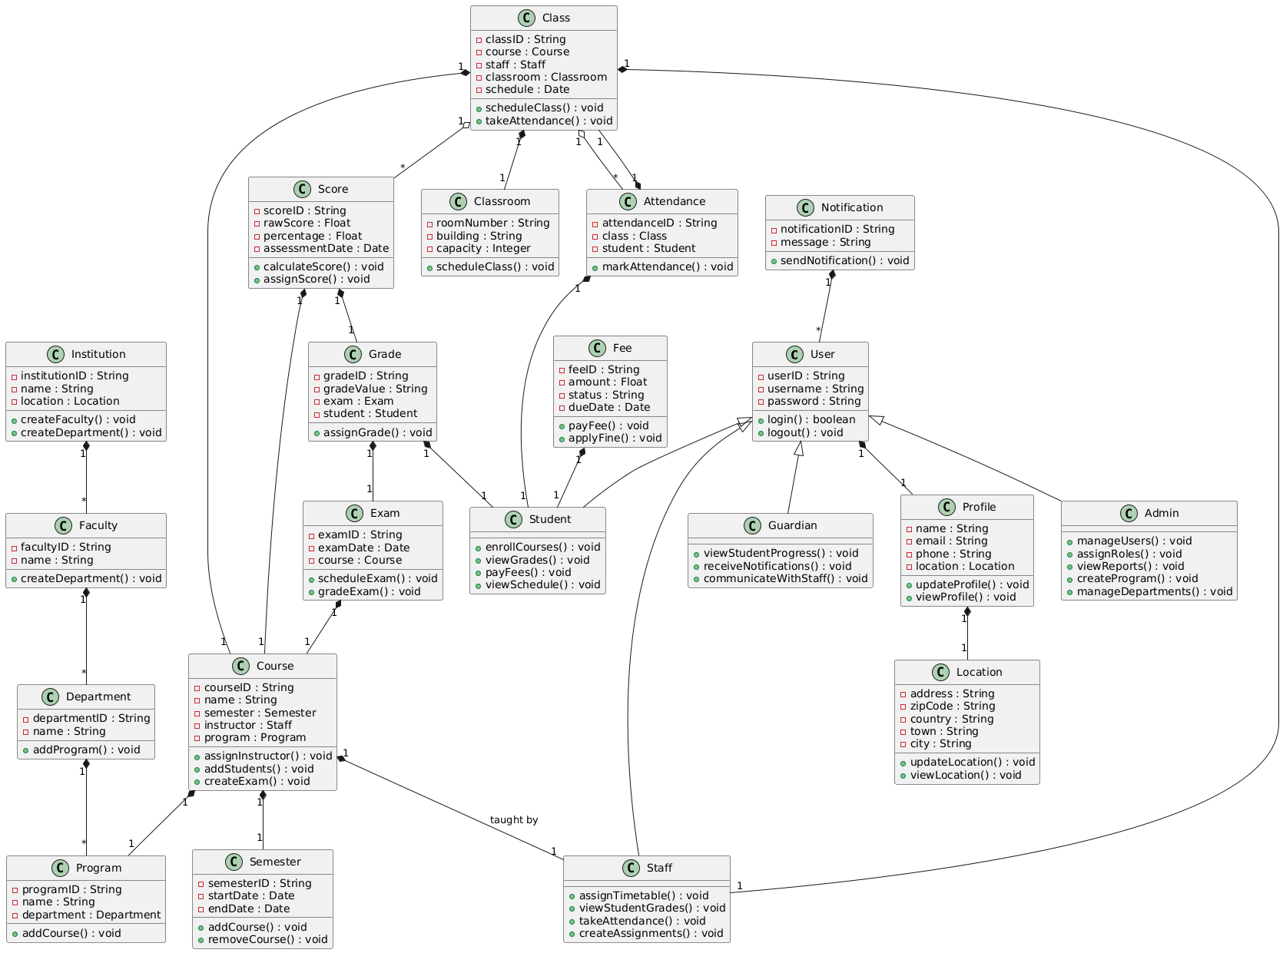

Figure 1:Class Diagram

**Class Diagram Classes, Attributes and Methods**

|  |  |  |  |
| --- | --- | --- | --- |
| **S/N** | **Classes** | **Attributes** | **Methods** |
| 1 | User Class | userID  username  password | • login(): Logs in the user.  • logout(): Logs out the user. |
| 2 | Admin Class | inherits from User | • manageUsers(): Add, edit, or delete user accounts.  • assignRoles(): Assign roles to users.  • viewReports(): View system reports.  • createProgram(): Add new programs.  •manageDepartments():Manage academic departments. |
| 3 | Staff Class | inherits from User | • assignTimetable(): Schedule classes.  • viewstudentGrades(): Access grade records.  • takeAttendance(): Record attendance.  • createAssignments(): Assign student tasks. |
| 4 | Student Class | Inherits from User | • enrollCourses(): Register for courses.  • viewGrades(): View grades.  • payFees(): Pay fees.  •viewSchedule():Check class schedules. |
| 5 | Guardian Class | Inherit from User | • viewStudentProgress():Monitor student performance.  • receiveNotifications():Get updates about the student  communicateWithStaff(): Contact staff. |
| 6 | Profile Class | name, email, phone, Location | updateProfile(): Edit profile details.  viewProfile(): View profile details. |
| 7 | Location Class | address, zipCode, country, town, city | updateLocation(): Edit location details.  viewLocation(): View location details. |
| 8 | Course Class | courseID, name, semester, instructor, program | assignInstructor(): Link course to instructor.  addStudents(): Enroll students. |
| 9 | Semester Class | semesterID, startDate, endDate | addCourse(): Add course to the semester.  removeCourse(): Remove course from the semester. |
| 10 | Program Class | programID, name, department | addCourse(): Add courses to the program. |
| 11 | Department Class | departmentID, name | addProgram(): Link program to department. |
| 12 | Classroom Class | roomNumber, building, capacity | scheduleClass(): Assign classes to the room. |
| 13 | Class Class | classID, course, staff, classroom, schedule | scheduleClass(): Assign class time and room.  takeAttendance(): Record student attendance. |
| 14 | Exam Class | examID, examDate, course | scheduleExam(): Assign exam dates.  gradeExam(): Assign exam grades. |
| 15 | Grade Class | gradeID, gradeValue, exam, student | assignGrade(): Assign grades to students |
| 16 | Attendance Class | attendanceID, class, student | markAttendance(): Record attendance. |
| 17 | Fee Class | feeID, amount, status, dueDate | payFee(): Process payments.  applyFine(): Add fines for late payments. |

* + 1. Use Case Diagram

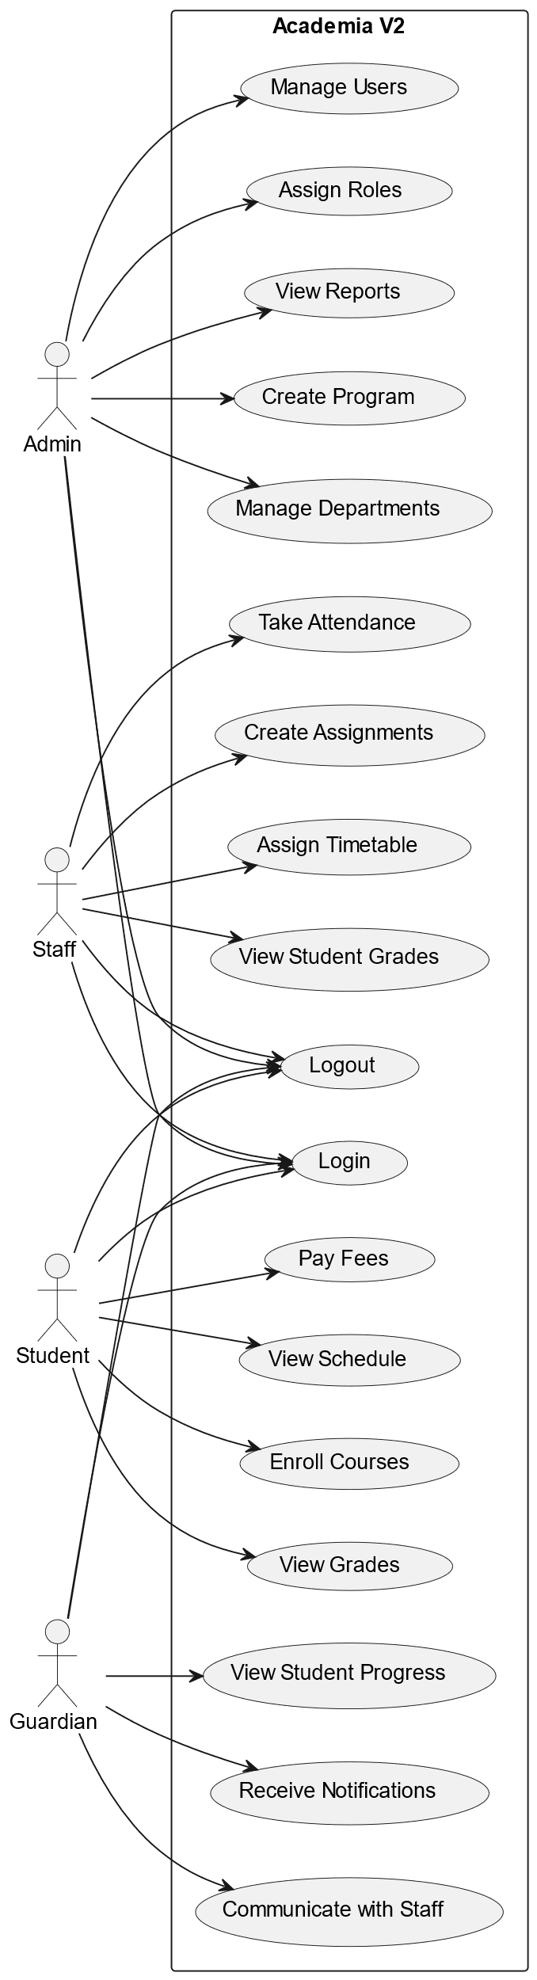

Figure 2: Use Case Diagram

3.1.2.1. Use Case Diagram Description

I. Actors (Users)

Admin

* Manages users, programs, and departments.
* Assigns roles and oversees reports.
* Sets up the institution's academic structure.

Staff

* Manages academic tasks like attendance, assignments, and schedules.
* Views and grades student performance.

Student

* Enrolls in courses and accesses grades.
* Pays fees and views schedules.

Guardian

* Monitors student progress.
* Communicates with staff and receives notifications.

II. Use Cases

Admin Use Cases

* Manage Users: Add, update, or remove users in the system.
* Assign Roles: Assign roles to staff, students, or other users.
* View Reports: Access reports on system usage, performance, or attendance.
* Create Program: Define academic programs under specific departments.
* Manage Departments: Create and manage faculty and departmental structures.

Staff Use Cases

* Assign Timetable: Allocate classes and timetables for students.
* View Student Grades: Check and update student performance.
* Take Attendance: Record attendance for scheduled classes.
* Create Assignments: Assign and manage coursework for students.

Student Use Cases

* Enroll in Courses: Register for courses under a program.
* View Grades: Check grades for completed exams and assignments.
* Pay Fees: Make tuition and other fee payments.
* View Schedule: Access the academic timetable.

Guardian Use Cases

* View Student Progress: Check grades, attendance, and performance of their ward.
* Receive Notifications: Get updates on attendance, grades, or fee payments.
* Communicate with Staff: Interact with staff regarding the student’s progress.

III. Relationships

* Admin and Staff both have access to the institution management system, but Admin has a broader scope (e.g., managing users, roles, and reports).
* Student is primarily focused on academic activities like enrolling in courses, viewing grades, and paying fees.
* Guardian has limited interaction, primarily to monitor the student's progress and communicate with the staff.

3.1.3 ER Diagram

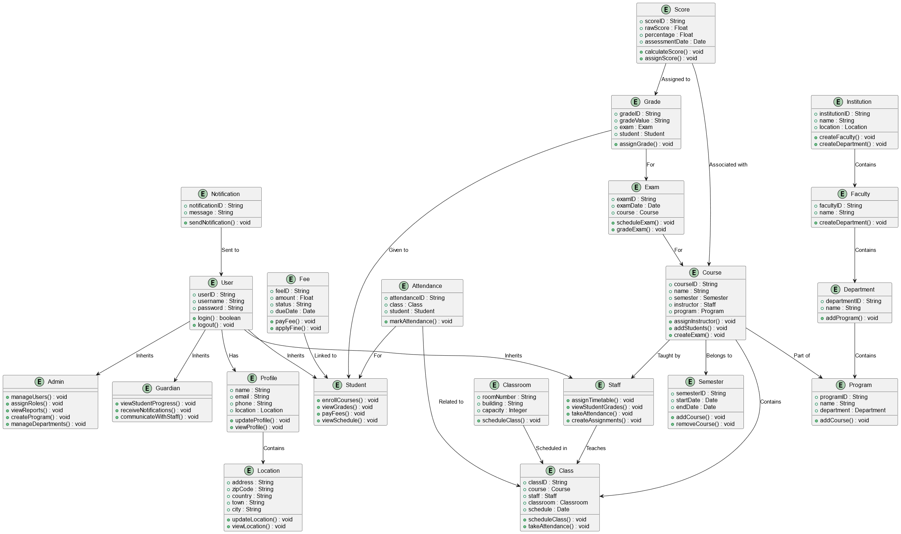

Figure 4: ER Diagram

###### 3.2. UI/UX Design

3.2.1. Branding

**Logo Design**

For the **ACADEMIA** logo:

* A clean and minimal design integrating **Steel Blue (#597ABD)** and **Golden Yellow (#FFC107).**
* Incorporate academic symbols such as **a book, graduation cap, or laurel wreath**, combined with modern geometric shapes.
* Use **Merriweather Sans** for the logotype to reinforce brand consistency.
* The design should radiate **trust, knowledge, and professionalism**.



Figure 5: Academia Logo

3.2.1. Color Palette and Typography

**Color Palette**

1. **Steel Blue (#597ABD)**

Represents calmness, trust, and professionalism.

1. **White (#FFFF)**

Symbolizes purity, simplicity, cleanliness, and peace.

1. **Charcoal black (#1E1E1E)**

Evokes sophistication, elegance, and formality.

1. **Golden Yellow (#FFC107)**

Conveys energy, optimism, and modern sophistication.

**Typography**

* **Font:** **Merriweather Sans**
  + Clean and modern sans-serif typeface.
  + Combines readability with a touch of sophistication.
  + Use for headings, subheadings, and body text to maintain brand consistency.

3.2.1. UI Designs

##### 4. Personal Tasks Assigned on Academia

* 1. **UI implementation**

1. **Login Page**

**I worked on implementing the Login Page of Academia V2. This task involved doing a smooth transition between the login and sign up options along with responsive design of the page across all devices (desktops, laptops, tablets and mobile devices).**

1. **Analytic Widgets**

**The analytic widgets give the user a feel of experience. The widget’s sole purpose is to visually represent data for the registered institution across all it’s models. The widgets also allow the user do more actions with respect to the model in which data is virtualized based on the data values the widget represents.**

**The Analytic widgets composed of donut charts, progress bars, graphs and color indicators. The actions, color indicators and charts differ with the data possessed by the virtualized model.**

**Here is a list of widgets personally assigned to me**

1. **Student Enrollment Widget**

**This widget gives detail on the male and female students registered in that institution showing the number of males, females, total number of students in dual progress bar and donut chart.**

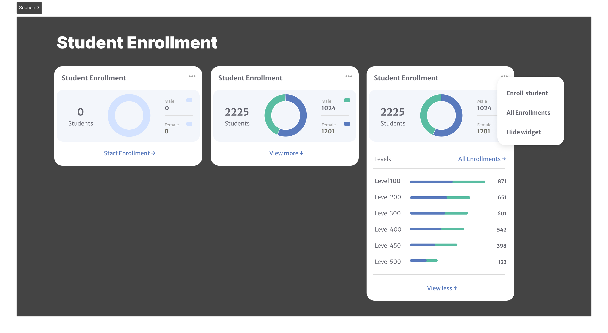

1. **Staff Overview Widget**

**This widget gives detail on the male and female students registered in that institution showing the number of males, females, total number of lecturers in donut chart and various staff status with their numbers.**

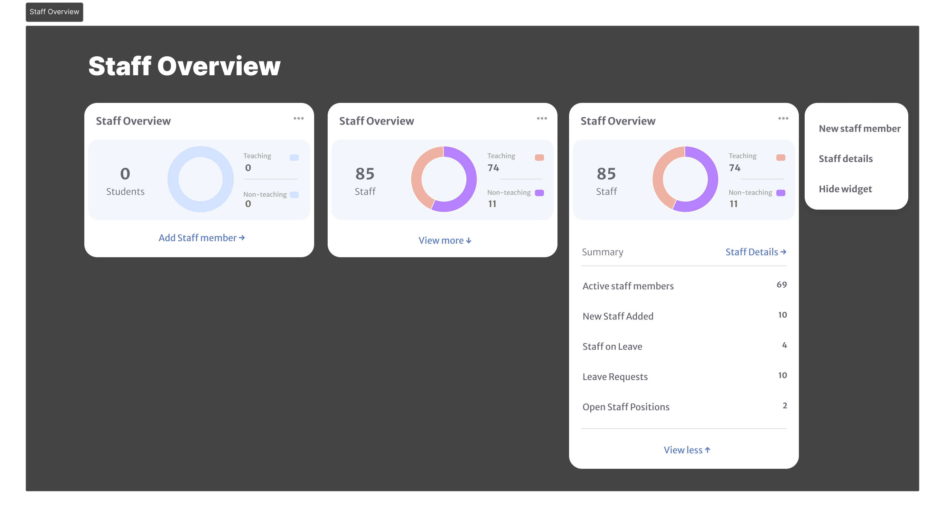



1. **Hostel/Dormitory Occupancy**

**This widget gives detail on the beds that have been occupied in various dorms in the boys and girl’s camp respectively. number of male dorms, female dorms, total number of dorms shown in donut chart. It also gives data on the occupancy of every bed in both camps.**

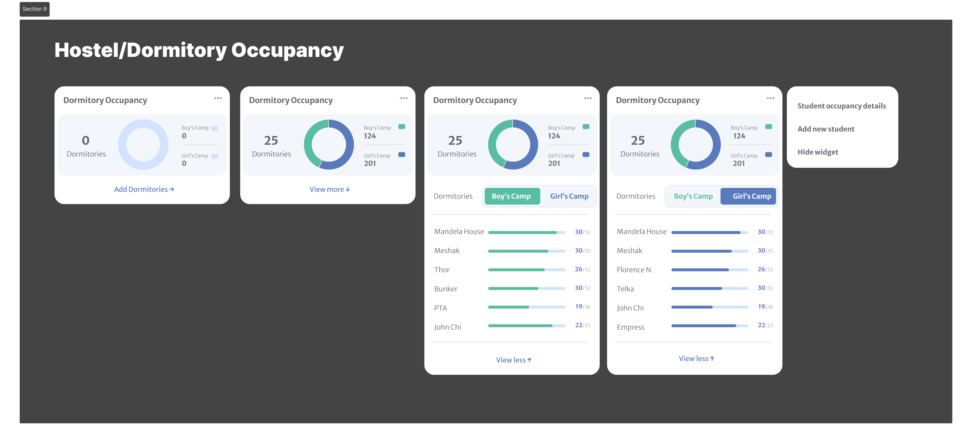

1. **Institution Models**
2. **Model Forms**
   1. **CRUD Operations**
   2. **Parse Backend Functionalilties**



* 1. **Code Refactoring**

## **2.5 Task Execution**

The execution of assigned tasks involved methodical planning, effective communication, and collaboration. Below is an overview of how these tasks were carried out:

**Approach and Methodology:**

* For technical challenges, I employed a problem-solving approach involving research, experimenting, and consultation
* Agile principles guided my workflow. I broke tasks into smaller milestones, tracked progress, and adapted based on feedback.

**Collaboration with Team Members and Interns:**

* I worked closely with team members to refine task objectives and align them with organizational goals. For example, while testing Motowa V2, I collaborated with senior developers to understand the system architecture and test coverage.

**Innovative Solutions and Improvements :**

* Suggested the use of context-based state management for the dashboard project, which improved performance and reduced state-related bugs.
* Proposed the use of user feedback sessions for the task management app, which significantly enhanced its UI/UX design.

## **2.6 Workplace Relationships**

Building and nurturing relationships at the workplace was a critical aspect of my internship. These relationships not only enriched my experience but also contributed to my professional growth.

**Relationship with Supervisors :**

* I maintained a professional and respectful relationship with my technical supervisor, who provided regular feedback and mentorship. Their guidance was instrumental in helping me navigate challenges, especially during the dashboard development project.
* My academic supervisor Prof Elie Fute ensured that my internship experience aligned with my academic goals and provided valuable insights during progress reviews.

**Relationship with Team Members :**

* Team members were supportive and approachable. I participated in team activities such as the Friday Share and company outings, which fostered a sense of belonging and helped me understand team dynamics.

**Relationship with Other Interns :**

* Collaborating with fellow interns allowed us to share ideas and experiences, which enhanced our collective learning. We worked together on several projects, including the initial phases of the mobile task management app, where we brainstormed feature ideas.

# Chapter 3: Extra-Curricular Activities

## 3.1 Introduction

**Definition:**  
Extra-curricular activities are non-work-related events organized within or by a professional setting. These activities often involve team-building exercises, social events, workshops, volunteering, or recreational programs aimed at fostering personal development and enhancing workplace relationships.

**Importance in a Professional Setting:**

1. **Team Building**: Encourages collaboration and strengthens relationships among colleagues, leading to better workplace cohesion.
2. **Skill Development**: Provides opportunities to develop soft skills like communication, leadership, and problem-solving outside regular job tasks.
3. **Stress Relief**: Offers a break from routine work, promoting mental well-being and reducing burnout.
4. **Networking Opportunities**: Creates informal platforms for employees to connect, share ideas, and build stronger professional networks.

## 3.2 Activities Organized by the Company

**Extra-Curricular Activities at Zinger Systems Limited**

Zinger Systems Limited organizes various activities to foster teamwork, build a strong work culture, and ensure mutual understanding among employees. These activities clarify shared goals and encourage collaboration. Below is a brief description of each activity:

1. **Friday Share**  
   Every Friday, the team gathers to reflect on the week’s progress. Discussions focus on achievements, challenges, and ways to overcome setbacks
2. **Monday Share**  
   Held every Monday at 9 AM, this meeting sets the tone for the week. The team discusses assigned tasks, individual responsibilities, and plans for the upcoming days, ensuring everyone is aligned with company objectives.
3. **New Man Task**  
   A unique cultural activity where new team members, whether interns or full-time employees, are welcomed into the company. They show appreciation to their predecessors by offering treats or organizing an outing, fostering inclusivity and camaraderie.
4. **Company Meetings**  
   Regularly scheduled meetings bring the entire workforce together to discuss organizational updates, ongoing projects, and strategic plans
5. **Company Outings**  
   Occasional outings are organized to encourage relaxation, strengthen interpersonal relationships, and improve team dynamics in a non-work setting.

## 3.3 My Role in the Activities

During my internship at Zinger Systems Limited, I actively participated in the various extra-curricular activities organized by the company and made significant contributions through participation and idea-sharing.

* **Friday Share and Monday Share:**  
  I attended these meetings and contributed by sharing updates on my tasks, discussing challenges I encountered, and suggesting potential solutions to improve workflow efficiency.
* **New Man Task:**  
  As a new intern, I participated in this activity by offering treats to my colleagues, which helped me build connections and integrate into the team.
* **Company Meetings:**  
  I was actively involved in discussions, provided feedback on ongoing projects, and learned from the insights shared by more experienced team members.
* **Company Outings:**  
  I participated in these outings, which allowed me to strengthen relationships with colleagues outside the work environment and gain a deeper understanding of team dynamics.3.4 Administrative Tasks with Managers

## 3.4. Administrative Task with Managers

During my internship at Zinger Systems Limited, I supported managers with various administrative and professional tasks. These included:

1. **Assisting with Planning and Organizing Activities:**  
   I helped organize team meetings, such as the Friday Share and Monday Share. My role involved preparing agendas, summarizing discussions, and ensuring meeting materials were available for all participants.
2. **Documentation:**  
   I contributed to maintaining project documentation by drafting reports on task progress and challenges faced during development. These reports were used to guide decision-making and improve project timelines.
3. **Technical Support:**  
   I provided support in setting up tools and platforms used for collaboration, such as ensuring team members were added to Discord servers and company email groups.
4. **Project Coordination:**  
   While working on the Academia V2 project, I coordinated with managers to ensure that my deliverables aligned with the company’s goals, regularly updating them on progress and discussing adjustments to timelines or scope.

## 3.5 Lessons and Benefits

Participating in various activities at Zinger Systems Limited provided me with valuable lessons and professional growth:

1. **Skill Development :**
   * **Teamwork:** Collaborating with colleagues during activities like Monday Share and Friday Share strengthened my ability to work in diverse teams.
   * **Communication:** Sharing ideas and discussing setbacks in team meetings improved my ability to express thoughts clearly and constructively.
2. **Networking and Connections:**  
   Engaging in team activities, such as company outings and the New Man Task, helped me build relationships with colleagues, creating a supportive professional network.
3. **Professional Insights:**  
   These activities offered a deeper understanding of workplace dynamics, emphasizing the importance of shared goals, mutual respect, and fostering a positive work culture.

# 

# Chapter 4: Difficulties and Challenges Encountered

During my internship at Zinger Systems Limited, I faced several challenges that helped me grow professionally. This section highlights the difficulties I encountered and how I addressed them.

**1. Technical Challenges**

* **Learning New Tools:** I had to quickly learn frameworks like Next.js and BEM architecture, which I hadn’t used before.

**Solution:** I studied online resources and asked colleagues for guidance.

* **Debugging Issues:** Errors in CRUD functionality and local storage integration slowed progress.

**Solution:** I collaborated with teammates and used technical forums.

**2. Task Management**

* **Balancing Assignments:** Managing multiple projects, including the mobile app and dashboard, was difficult.

**Solution:** I prioritized tasks and set milestones to stay on track.

* **Understanding Requirements:** Some task instructions were unclear at first.

**Solution:** I sought clarification from my supervisor to ensure accuracy.

**3. Communication Challenges**

* **Team Collaboration:** Coordinating with team members online sometimes caused delays.

**Solution:** I used company tools like Discord and WhatsApp to improve communication.

* **Handling Feedback:** Implementing feedback effectively was challenging at first.

**Solution:** I took notes during feedback sessions and worked systematically to make changes.

**4. Time Management**

* **Meeting Deadlines**: Some tasks took longer than expected due to unforeseen challenges.

**Solution:** I allocated extra time and tracked progress using task management tools.

# Chapter 5: Conclusion and Recommendations

## 5.1. Conclusion

The internship at Zinger Systems Limited was an invaluable experience that allowed me to bridge the gap between academic learning and professional practice. I gained hands-on exposure to frontend and backend development, enhanced my technical and problem-solving skills, and adapted to a professional work environment. The challenges I encountered helped me build resilience, while the guidance from my supervisor and collaboration with team members significantly contributed to my growth as a software developer. This experience has solidified my confidence in pursuing a career in software engineering.

## 5.2 Recommendations

### 5.2.1 For the Company:

* Enhance onboarding processes by providing detailed documentation or tutorials on tools and frameworks.
* Foster more structured mentorship programs to guide interns through complex tasks.
* Encourage regular feedback sessions to ensure clarity on expectations and progress.

### 5.2.2 For Future Interns:

* Be proactive in seeking guidance and learning new technologies.
* Manage time effectively by breaking down tasks into smaller, manageable steps.
* Maintain open communication with supervisors and team members for better collaboration.

### 5.2.3 For Academic Institutions:

* Collaborate with companies to align internship objectives with academic curricula.
* Prepare students for real-world tasks by introducing industry-relevant tools and frameworks in coursework.
* By addressing these recommendations, the internship experience can be more effective and rewarding for all parties involved.

# References

**Books and Manuals**

Martin, R. C. (2008). Clean code: A handbook of agile software craftsmanship. Prentice Hall.

Somerville, I. (2020). Software engineering (10th ed.). Pearson.

**Articles**

Bass, L., Clements, P., & Kazman, R. (2012). Software architecture in practice. IEEE Software, 29(4), 16-18. https://doi.org/10.1109/MS.2012.34

Greenfield, J., & Short, K. (2004). Software factories: Assembling applications with patterns, models, frameworks, and tools. Software Development Journal, 12(3), 35-42. https://doi.org/10.1016/j.software.2004.01.005

**Online Sources**

Atlassian. (2024). What is BEM methodology?. Retrieved from https://www.atlassian.com/git/tutorials/what-is-bem

Expo Documentation. (n.d.). Using Expo for React Native development. Retrieved from https://docs.expo.dev/

University of Buea. (2023). Department of Computer Engineering internship guidelines. Retrieved from https://www.ubuea.cm/

**Conference Papers**

Roberts, D. M., & Johnson, R. E. (2005). Strategies for refactoring software. In Proceedings of the 5th International Conference on Agile Development (pp. 100-112). IEEE. https://doi.org/10.1109/AGILE.2005.100

**Reports**

Zinger Systems Limited. (2023). Annual report on in-house software development projects. Buea, Cameroon: Zinger Systems Ltd.

World Economic Forum. (2023). The impact of technology on workplace collaboration. Retrieved from https://www.weforum.org/

# Appendices

More pictures from Document Content

1. Internship Tasks

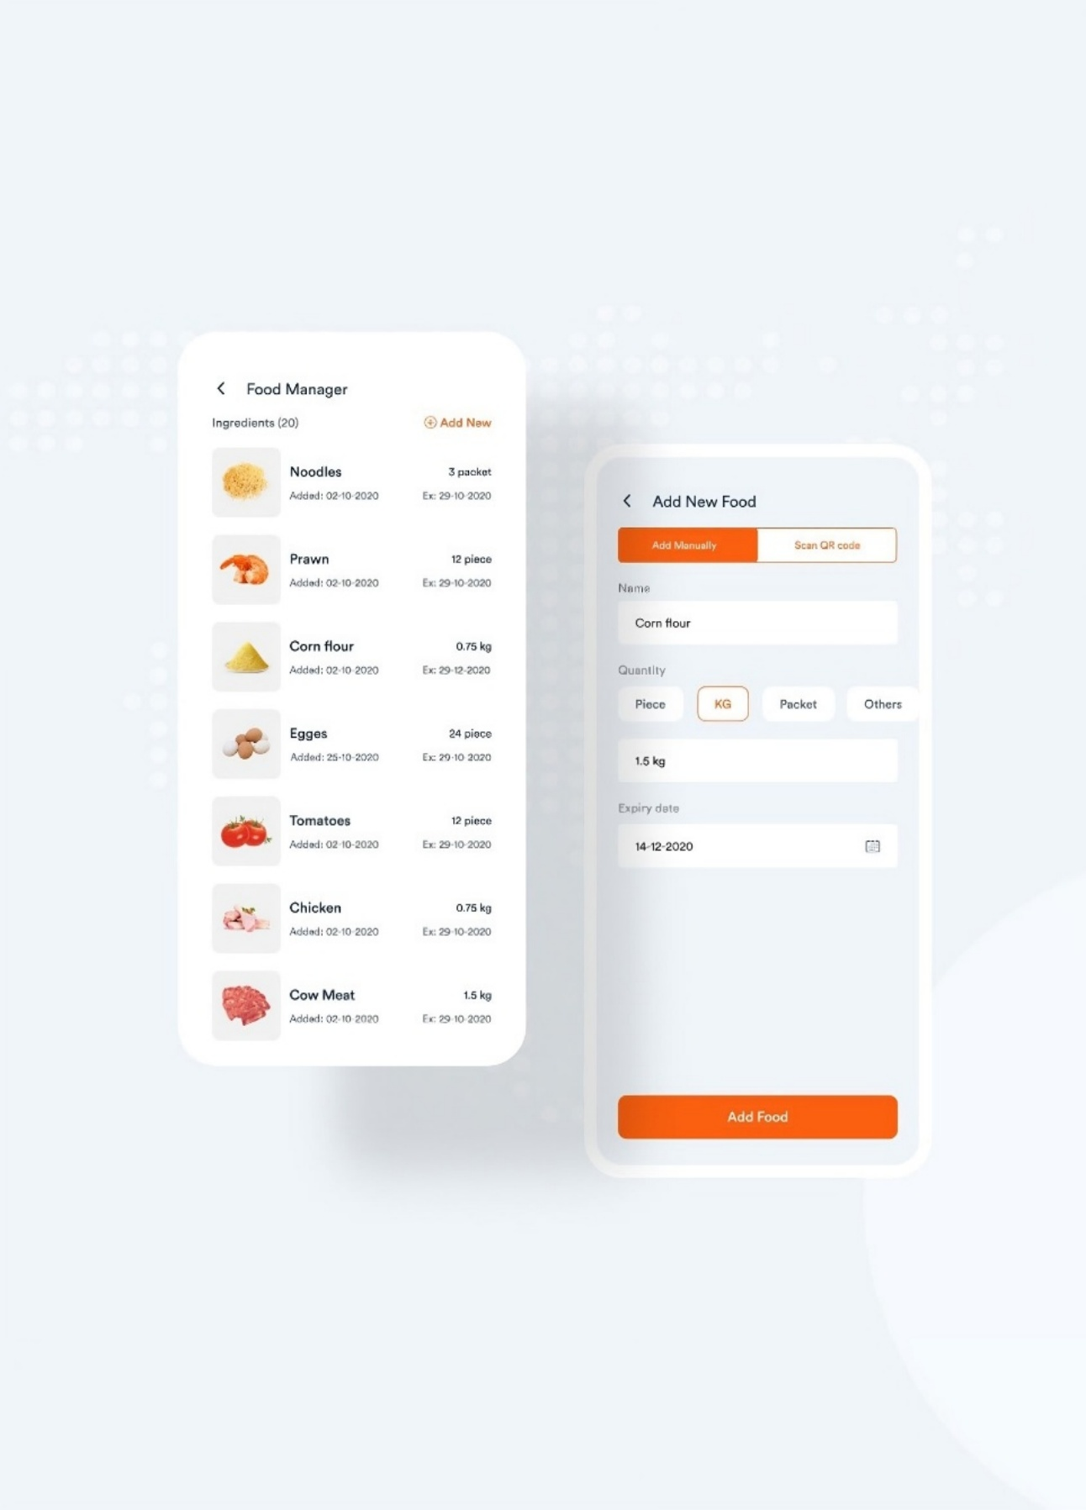

Figure 5: Food Manger App (Internship Enrollment Task 1)

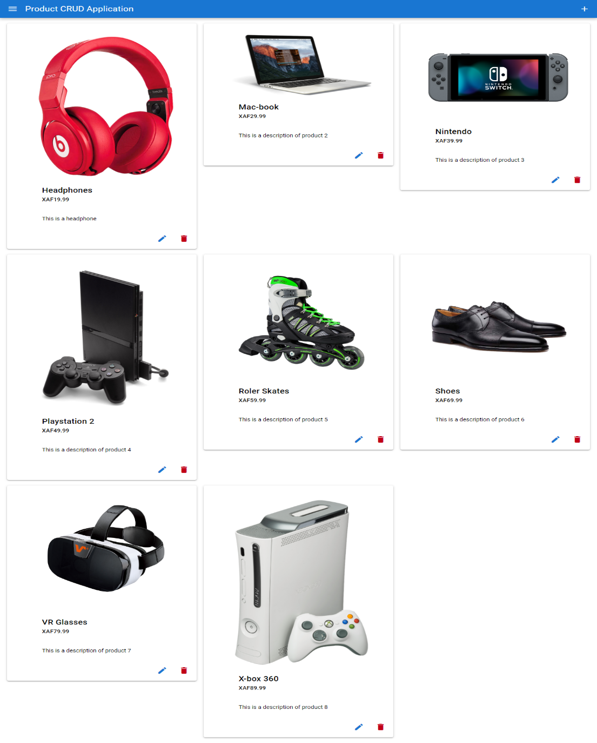

Quasar CRUD Application

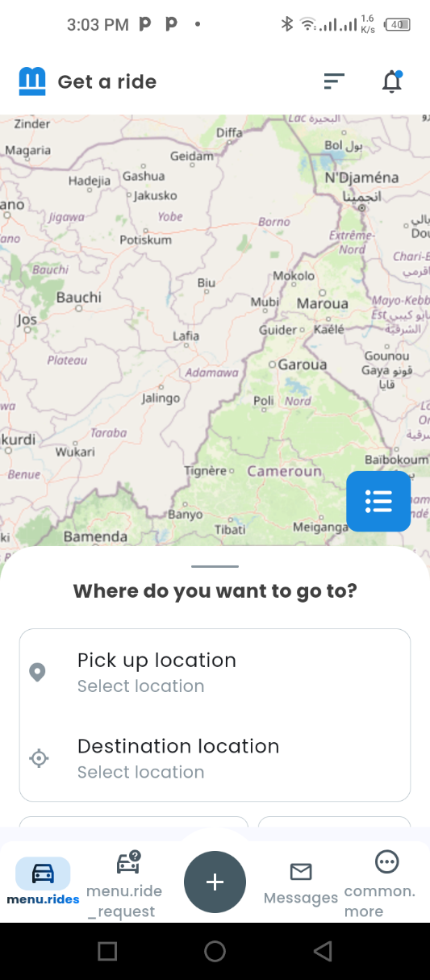

Motowa GPS Testing on Rides