API Testing Evidence

Test Summary
Endpoint | Test | Result
PUT /api/customers/1 | Valid customer update | 200 OK
PUT /api/customers/1 | Missing required field | 400 Bad Request
PUT /api/customers/9999 | Nonexistent customer | 404 Not Found
POST /api/orders | Valid order creation | 201 Created
POST /api/orders | Invalid order request | 400 Bad Request

1. PUT /api/customers/1 — 200 OK
Valid request. The customer information was successfully updated.
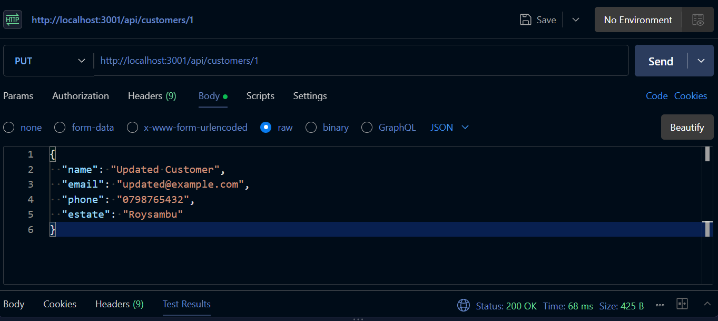

2. PUT /api/customers/1 — 400 Bad Request
Invalid request. A required field was omitted, so the API rejected the request.
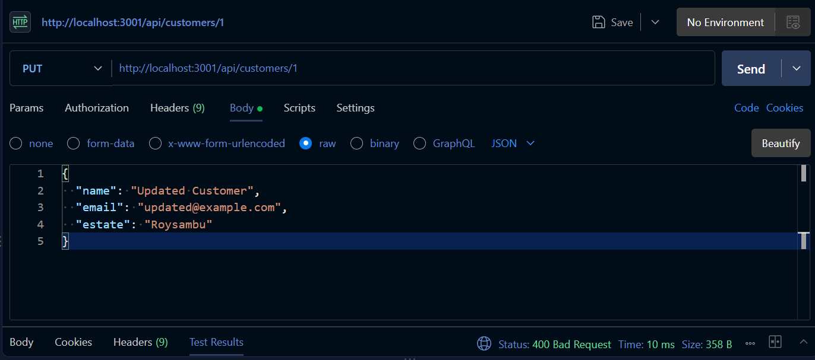

3. PUT /api/customers/9999 — 404 Not Found
The requested customer does not exist, so the API returned 404 Not Found.
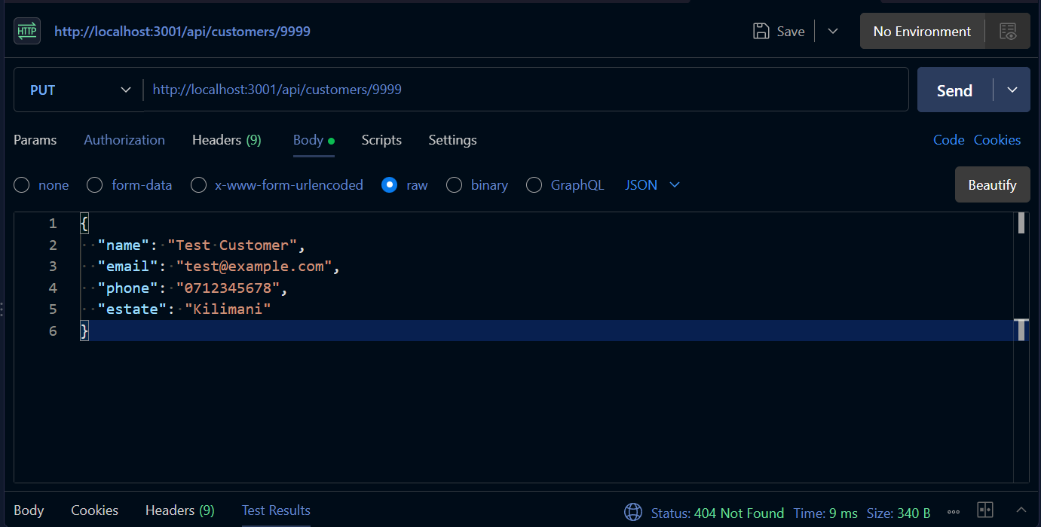

4. POST /api/orders — 201 Created
Valid request. A new order was successfully created.
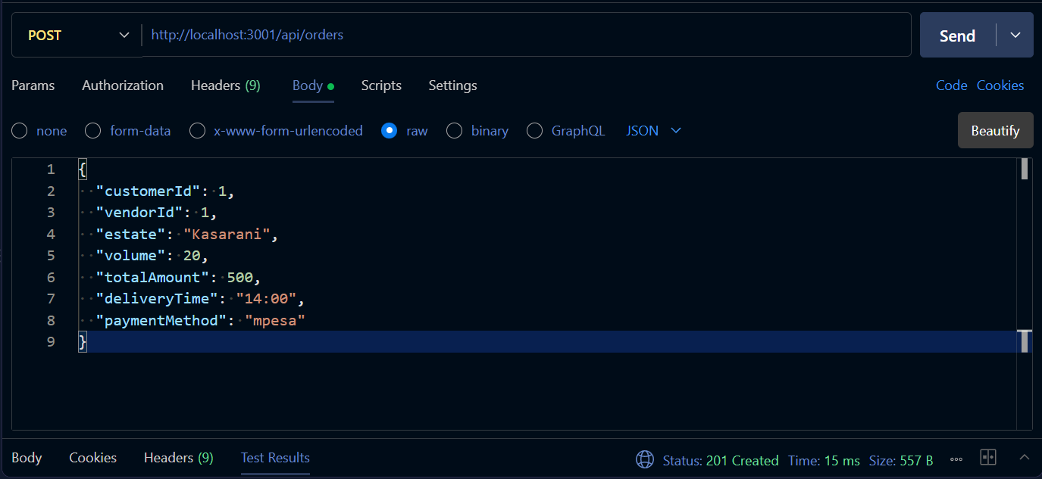

5. POST /api/orders — 400 Bad Request
Invalid order request. The API rejected the request with 400 Bad Request.
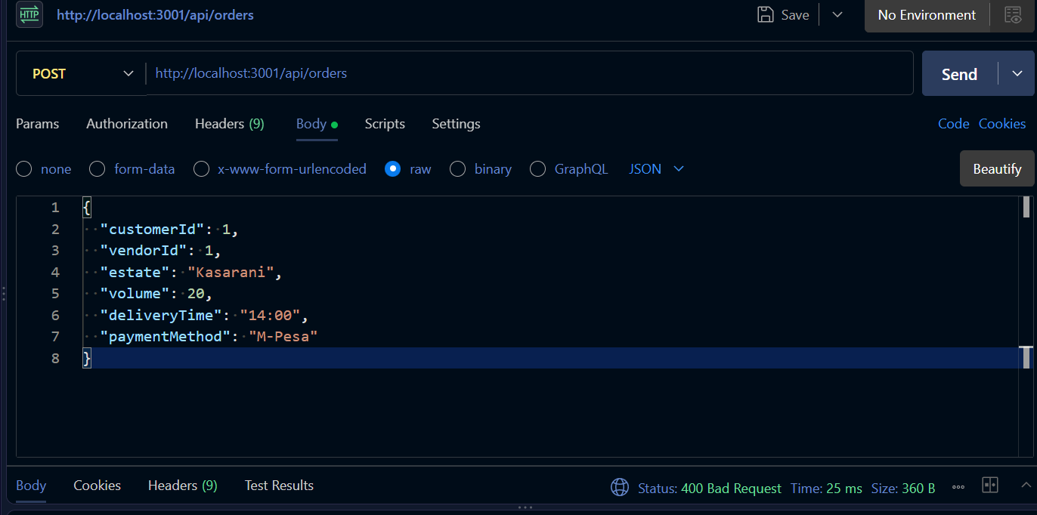

The DELETE vendor endpoint was also tested with an existing vendor, but the request returned a database error because that vendor is referenced by an existing order. A 204 No Content result was therefore not captured. The vendor was not deleted.
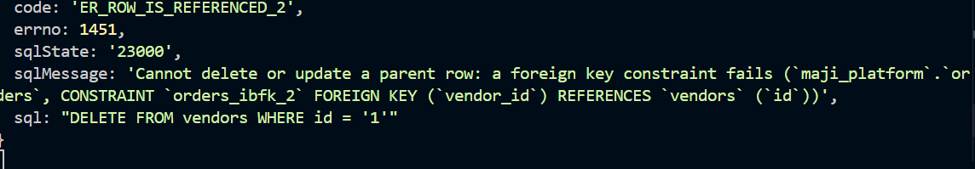

We have also encounter 500 Internal Server Error responses while testing and these screenshoot are not included in this document.

