# AI Agent Integration Reflection: Part 3

I used a ‘ChatGPT-4o’ to assist with improving my word code(step4) and enhancing my flowchart logic. This reflection report summarizes my insights by interacting with ‘Chat GPT’ including my question prompts and its responses and the better impact on my final solution.

## Prompt 1: Refine your logic or Word Code

My Question: Can you review my word code(step4) and suggest improvements? Response as report style for your answer.

Response:

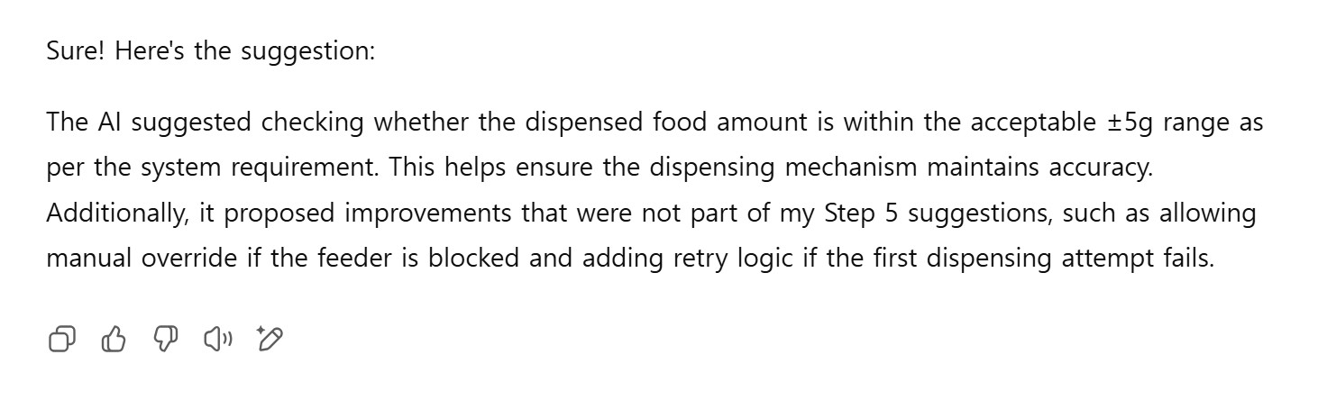

## Prompt 2: Generate alternative solutions or enhance flowchart logic

My Question: Can you propose different ways to solve the problem or enhance my flowchart logic? Response as report style for your answer.

Response:

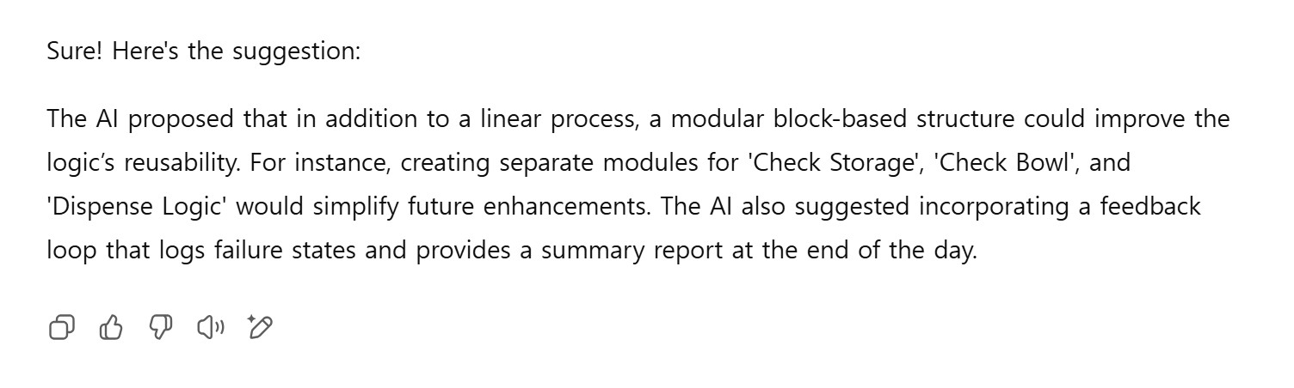

## My Reflection

The ‘ChatGPT’ helped me realise the realistic problems in my logic and improve the way I organise my system. The AI gave me useful and clear suggestions that made my structure stronger and easier to understand it. It felt like having another person review mine and give me useful advice.

One of the main improvements was learning to check whether the dispensed food amount was within the allowed ±5g range. I had included this as a sample value in step2 but not included in my logic. Adding the range of food amount check lets the system more accurate in reality. The ‘ChatGPT’ has also suggested allowing a manual overriding if the feeder is blocked and add retry logic in case the first attempt to dispense food fails. These provided me insights to prepare for real problems that may happen.

And the ‘ChatGPT’ provided me a better way to make the flowchart by breaking the logic into smaller sections like “Check Storage” and “Check Bowl” as process. This helped me to understand how to build a system is easier to arrange the steps, simulate test and improve in the future.